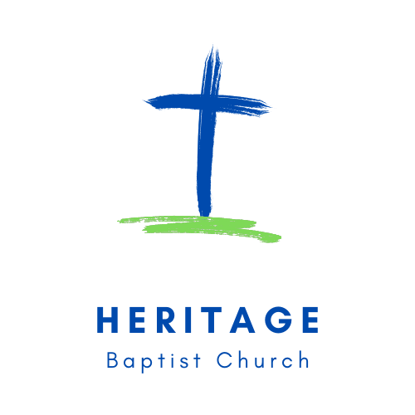
Address: 7777 Cogbill Road Chesterfield, VA 23832
Phone: 804.271.7626
Website: hbcministry.net
Vacation Bible School Consent and Release

Child’s Name___________________________ Birthdate_____________ Age ________Upcoming Grade ______
Address________________________________________________________________________________________________
Parent(s)______________________________________________________________________________________
Primary emergency contact person & phone_______________________________________________________
Alternative emergency contact person & phone___________________________________________________
Physician’s name ____________________________________________________Phone__________________________
Insurance company __________________________________________________________________________________
Insurance policy number_____________________________________________________________________________
Known allergies & type of reaction__________________________________________________________________
Plan of action in event of exposure/allergic reaction _____________________________________________
_________________________________________________________________________________________________________
Chronic illnesses_____________________________________________________________________________________
Long-term medications _____________________________________________________________________________

My child has my permission to participate in the Heritage Baptist Church (the “Ministry”) Vacation Bible School. I understand that my child will be participating in several activities, including but not limited to water activities, bounce house, sports, relay races, crafts, group games etc.

_________________________________________________________________________________________________________
Activities I do not want my child to be involved in are:
_________________________________________________________________________________________________________
I hereby authorize the Ministry staff or volunteers, and/or emergency and medical personnel to make emergency medical decisions for my child and for my child to be treated for such medical emergency.
I also authorize the Ministry, its representatives, contractors, employees and volunteers acting on behalf of the Ministry, to take and/or use, copyright, publish, edit, crop or treat images or likenesses of me or my child(ren), including photographs, videos or otherwise, for any lawful use on the Ministry’s website, social media pages, blogs, or in other official Ministry printed or electronic publications without further consideration. I understand that should photographs or videos of me or my child(ren) be used on the Ministry-owned or operated websites or webpages, they may be available for download.

I UNDERSTAND AND HEREBY AGREE TO ASSUME ALL THE RISKS WHICH MY CHILD MAY ENCOUNTER AT THE VACATION BIBLE SCHOOL ACTIVITIES SPONSORED BY THE MINISTRY.
In consideration of my child being permitted to participate in the event(s) described above and other valuable considerations the receipt of which is acknowledged, I HEREBY AGREE TO RELEASE, DEFEND, INDEMNIFY, AND HOLD HARMLESS the Ministry and its agents and employees from any and all past, present, and future, known and unknown liabilities, actions, causes of action, claims, expenses, personal injuries, and damages, INCLUDING THOSE CAUSED BY THE NEGLIGENCE OR FAULT OF THE MINISTRY, ITS LEADERS, EMPLOYEES, OR VOLUNTEERS, and including without limitation, interest, penalties, court costs, attorney's fees and expenses resulting from or on account of injury to my child, myself, or my property in connection with any event anticipated by this form. I FURTHER RELEASE any and all claims brought by or through me, including claims for loss of consortium and all similar claims based on relationships with other people. I EXPRESSLY AGREE that this release, waiver, and indemnity agreement is intended to be as broad and inclusive as permitted in the State of Virginia and that if any portion hereof is held invalid, it is agreed that the remainder shall, notwithstanding, continue in full legal force and effect. I ALSO AGREE that any controversy or claim, by or through me, arising out of or relating to the activities anticipated by this form shall be settled by binding Christian arbitration conducted by the National Center for Life and Liberty or another Christian arbitrator, and judgment on the award may be entered in any court having jurisdiction thereof. This release contains the entire agreement between the parties hereto and the terms of this release are contractual and not mere recitals.
I FURTHER STATE that I have carefully read the foregoing consent and release and know the contents thereof and I sign this document as my own free act. This is a legally binding agreement which I have read and understand.

Parent Print Name ________________________________Date ___________

Email ____________________________

Address ________________________________________________Telephone _______________________________

Signature ________________________________________________

