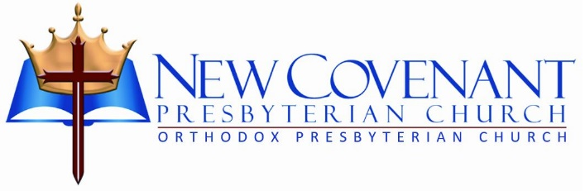

Holy Week

Friday, April 3, 2026



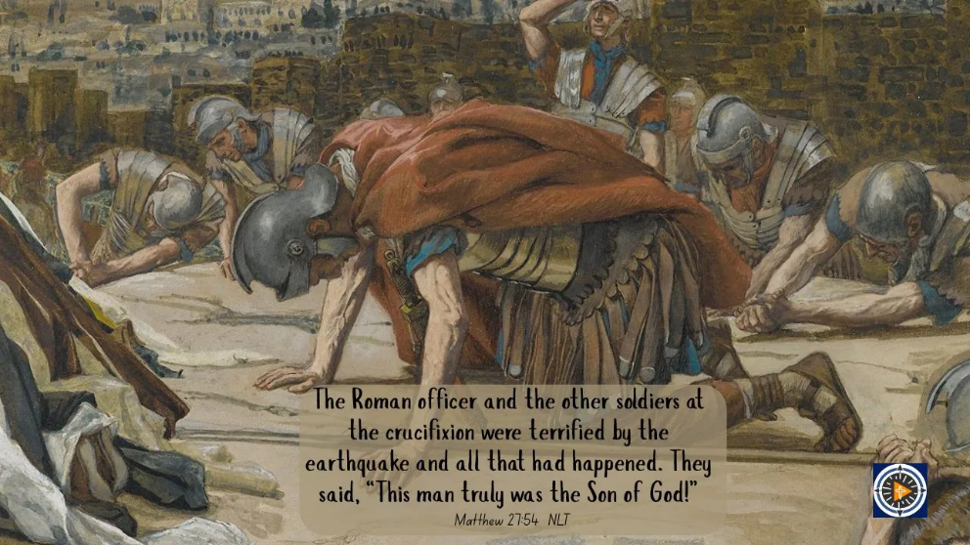

lightofchristjourney.com/2025/04/09/being-spiritually-blind-2

Cover Art Design: Scott Walker

Preaching God’s Sovereign Grace to a World of Need”

128 St. Mary’s Church Road • Abingdon, MD 21009

Dr. David G. Barker, Pastor • Nicholas Hathaway, Pastor • Kurt Scharping, Pastor
New Covenant Presbyterian Church
Good Friday Evening Worship
April 3, 2026

Welcome and Prayer of Invocation

Opening Hymn #248: Ah, Holy Jesus, How Hast Thou Offended

Trial 1: Luke 22:54-71

Hymn #247: O Sacred Head, Now Wounded

Trial 2: Luke 23:1-4

Responsive Reading: Psalm 22 Trinity Hymn Book, pages 790-791

Trial 3: Luke 23:6-12

Corporate Prayer of Confession
Responsive Reading of Daniel 9:4-11

O Lord, the great and awesome God, who keeps covenant and steadfast love with those who love him and keep his commandments,

we have sinned and done wrong and acted wickedly and rebelled, turning aside from your commandments and rules.

We have not listened to your servants the prophets, who spoke in your name to our kings, our princes, and our fathers, and to all the people of the land.

To you, O Lord, belongs righteousness, but to us open shame, as at this day, to the men of Judah, to the inhabitants of Jerusalem, and to all Israel, those who are near and those who are far away, in all the lands to which you have driven them, because of the treachery that they have committed against you.

To us, O Lord, belongs open shame, to our kings, to our princes, and to our fathers, because we have sinned against you.

To the Lord our God belong mercy and forgiveness, for we have rebelled against him and have not obeyed the voice of the LORD our God by walking in his laws, which he set before us by his servants the prophets.

All Israel has transgressed your law and turned aside, refusing to obey your voice. And the curse and oath that are written in the Law of Moses the servant of God have been poured out upon us, because we have sinned against him.

Trial 4: Luke 23:18-25

Hymn #257: Stricken, Smitten, and Afflicted

Trial 5: Luke 23:26-49

Sermon Title: Five Trials Pastor Nicholas Hathaway

Closing Hymn Worship Hymn Book, pages 40-41
How Deep the Father’s Love for Us

Benediction



New Covenant Presbyterian Church is a growing family embracing biblical truth, worshiping the Lord Jesus Christ, and challenging our members to develop their gifts so that we can care for, strengthen, and bless others for God’s glory here and abroad.

For more information, check out our website:

www.ncpres.org

New Covenant Presbyterian Church
“Preaching God’s Sovereign Grace To A World Of Need”
128 St. Mary’s Church Road ~ Abingdon, MD 21009

410-569-0289 www.ncpres.org

