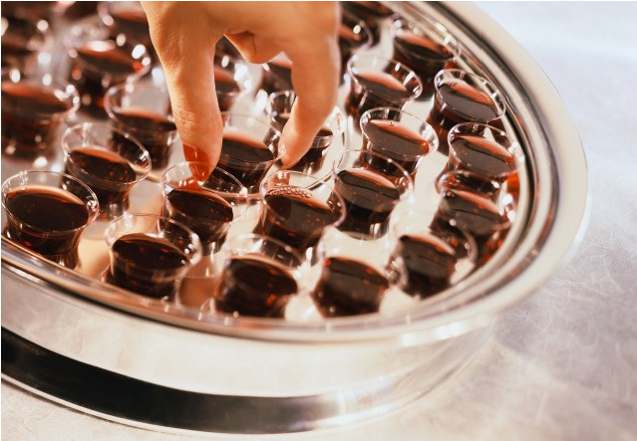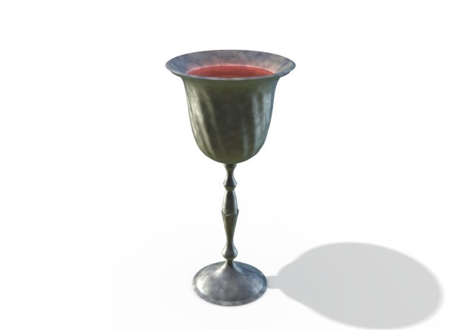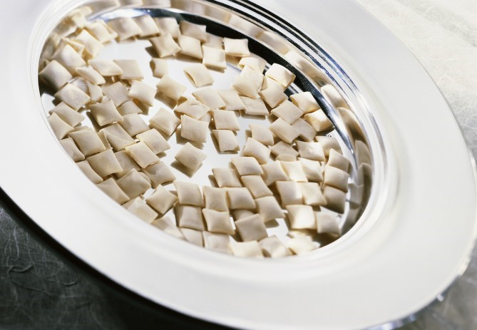

NOTES: | Is Your Child Ready for  Communion?

If you would like more information or want to have a further conversation with a pastor, please feel free to contact Kim Mundinger at 262-365-0980.
8



Dear Parents, Preparing for Communion

The Lord’s Supper, or Communion, is a special time to
remember Jesus’ sacrifice on the cross and its significance for
those who follow Him. Many parents may be confused about What should I do during the gathering to whether their child should take part in communion. It is my hope
that this pamphlet will be a tool for you to use to recognize where help my child prepare to take communion? your child is at on their spiritual journey. As I have faced this
Look
UP
to God and remember
to praise Him for who He is and to thank Him for your salvation (eternal life).

issue with my own children, the following questions have come to mind:

- Communion: What is it? Why do we observe it?
- Is my child old enough to take part in communion?
- How do I know if my child is ready to take part in
communion?
- What should I do before the Sunday gathering to help
my child prepare to take communion?
- What should I do during the Sunday gathering to help
my child prepare to take communion?



Maybe you have had these questions as well. In the next few pages,
Look

DOWN

at yourself to search
your heart and
con-
fess your mistakes
(
sins)
to God. Thank
Him for His for-
giveness.

Look

BACK

and
remember
what God has
done for you
. He
loves you so much
He sent His Son to
die for your sins.

Look

FORWARD

and remember
that Jesus is
com-
ing again and one
day you will be
eating with Him at
His table in Heav-
I am going to share my thoughts for you to consider as you determine what is best for your child.
If you have questions or would like to talk with me about this in more
detail, please feel free to contact me. It is a joy to join you in pointing
your child toward a life-changing, personal relationship with Jesus!

Partnering with You,


Kim

Kim Mundinger
Children’s & Family Pastor

Questions to consider:

What should I do before the gathering to help my child prepare to take communion?

If you have determined that your child is ready to take part in communion, there are some ways to help them focus on the meaning and seriousness of the occasion. A good passage of the Bible to examine together before the Sunday of communion is:

1 Corinthians 11:23-29
For I received from the Lord what I also passed on to you: The Lord Jesus, on the night he was betrayed, took bread, and when he had given thanks, he broke it and said, “This is my body, which is for you; do this in
remembrance of me.” In the same way, after supper
he took the cup, saying, “This cup is the new covenant in my blood; do this, whenever you drink it, in
remembrance of me.” For whenever you eat this bread and drink this cup, you proclaim the Lord’s death until he comes. Therefore, whoever eats the bread or drinks the cup of the Lord in an unworthy manner will be guilty of sinning against the body and blood of the Lord. A man ought to examine himself before he eats of the bread
and drinks of the cup. For anyone who eats and drinks
without recognizing the body of the Lord eats and drinks judgment on himself. 6
Communion:
What is it? Why do we observe it?

Communion is defined as “a joining together of mind and spirits”. It is a time for those who are in relationship with Jesus Christ to remember His death on the cross, and a practice that is meant to be observed continually throughout the life of a Christian. Believers take a piece of bread as a symbol of Jesus’ body broken for us and drink a small cup of juice, or wine, as a symbol of Jesus’ blood poured out as a sacrifice for us.

Communion is a way for us to obey and follow Jesus. When He was sharing the Last Supper with His disciples, He told them to “do this in remembrance of me.”* He wanted them, and us, to continue to remember His sacrifice for us. In observing Communion we are remembering Christ and all that He has done for us in his life, death and resurrection.

We take Communion together because it shows that we are one body, or one family, in Christ. In 1 Corinthians 10:16-18 it says, “When we bless the cup at the Lord’s Table, aren’t we sharing in the benefits of the blood of Christ? And when we break the loaf of bread, aren’t we sharing in the benefits of the body of Christ? And we all eat from one loaf, showing that we are one body.” Together as a faith community we are announcing the Lord’s death until He comes again(1 Corinthians 11:26).

*Matthew 26:17-30, Mark 14:12-26 and Luke 22:7-29 all share the story of the Last Supper. 3
Questions to consider:
Is my child old enough to take communion?

Kettlebrook is different from many other churches in that we believe there is no set age, grade level or a class that must be completed that can guarantee where someone is at in their spiritual journey, or whether they are ready to take part in communion.

We ask that those who take communion recognize two things:

- Jesus died on the cross to pay the penalty for their sins*
(Romans 5:8), and
- Jesus Christ is Savior and Lord, and they have made Him the leader of their lives. (2 Corinthians 5:17)

As you have probably experienced, children develop and mature at different rates physically, emotionally and spiritually. There is no set age when a child is able to understand and make a commitment to Christ. One child may be ready at an early age and another several years older.

It is important that your child is old enough to be able to understand the significance of the symbols used in communion. Because young children think concretely, be aware they may automatically think they are eating the actual body of Christ and drinking His blood and that might scare them. As parents who know the personalities of your children, you can help them understand, and remind them, the bread represents Jesus' body broken for us and the juice represents Jesus' blood shed for us. They are symbols and we use them as reminders of Jesus' sacrifice for each one of us each time we take part in communion.

* Sin can be defined as anything you do, say or think that breaks God’s law.
Questions to consider:
How do I know if my child is ready to take part in communion?

It is important to take some time to examine your child’s heart. While you may not know for sure where your child is at on their spiritual journey, there are some questions you can ask to get an idea.

- Is your child able to recognize and admit he/she disobeys God (sins) and is not perfect like God (Romans 3:23-24)?
- Has he/she admitted to God , i.e., said “I’m sorry” for disobeying Him (sinning) (2 Corinthians 7:10)?
- Does your child recognize that Jesus loves them so much that He died on the cross for his/her disobedience so that he/she can have a relationship with God (John 3:16)?
- Has your child made a commitment to follow Jesus and make Him the leader (Lord) of their life (Romans 10:9)?
- Do you see evidence of a commitment from your child to follow Jesus in their life? For instance, does he/she desire to know God more through prayer or reading, or asking you to read, the Bible?
- Does he/she try to behave in a way that pleases God (2 Corinthians 5:17)?
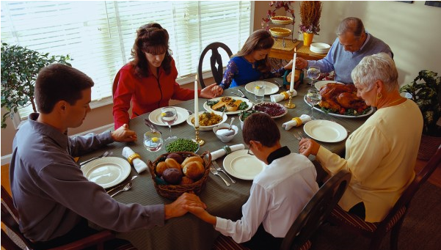
5

