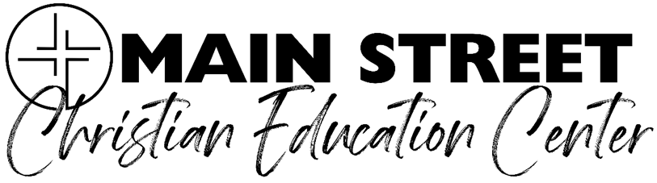

Miss Mikaela and Miss Camryn

All day 4s/5s Class

**School Supply List**

* Single roll of paper towels
* Spiral notebook
* Hand soap
* Tissues
* Lysol wipes
* Glue sticks
* Small pack of baby wipes
* Box of plastic spoons or forks
* Individual play doh

**In a crayon box they will need:**

* Markers
* Crayons
* Watercolor paints

**Boys: 5oz** bathroom cups

**Girls:** box of plastic spoons or forks

**Teacher Wish list items:**

* Stickers
* Small disposable bowls
* Paper plates
* Lysol spray
* Masking tape
* Scotch tape
* Glue sticks
* Laminating sheets
* Construction paper
* Box of birthday cards
* Ziploc bags (sandwich, gallon size, XL)
* Adult scissors
* Safety scissors
* Disposable bowls
* Expo markers

