CURIOSITY WORKSHEET!
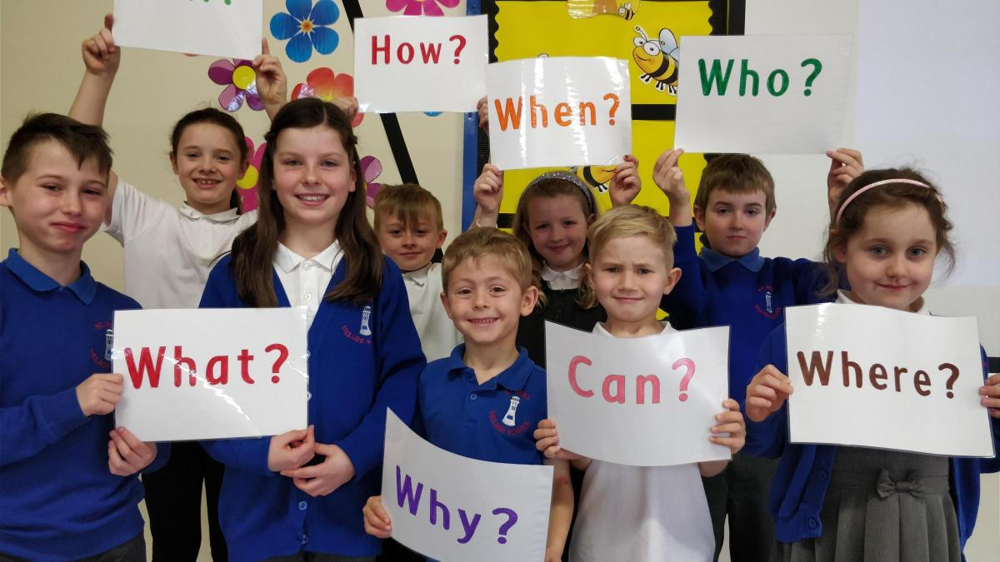
Be curious about someone in your house!
Ask them the answers to these questions.
- What is your favourite thing to read?

Answer: ______________________________
- Why do you like it?
Answer: _______________________________

- What is your favourite place?
Answer: _________________________________

- Why do you like it?
Answer: _________________________________
- (Make up your own question!)
_______________________________________

Answer: _________________________________

