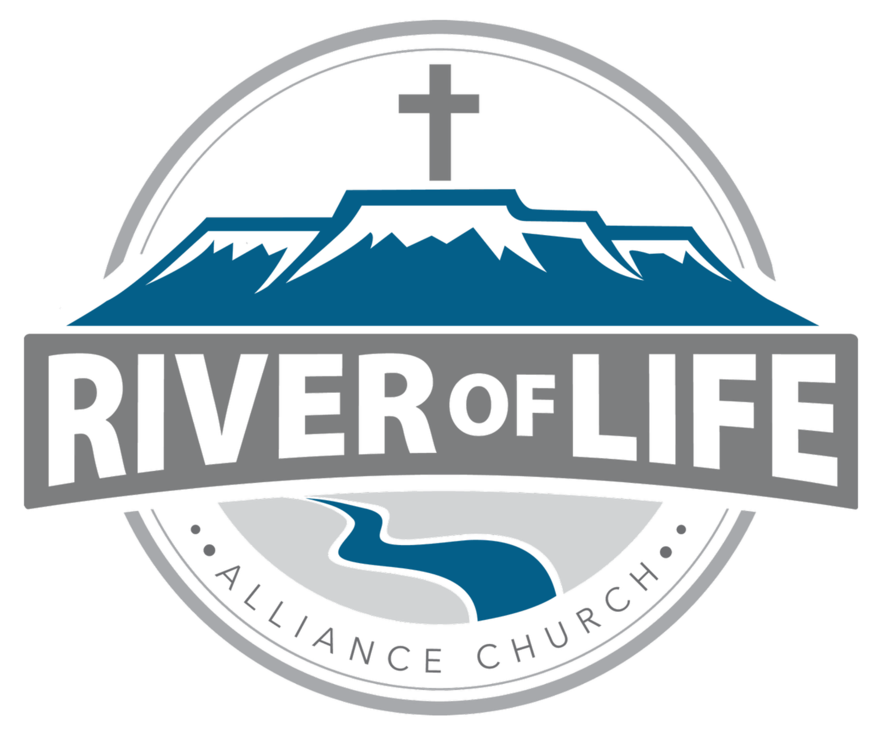
Communications & Support Coordinator
Part-Time (15–20 hrs/week) | Mon–Thurs, approx. 8:00 AM–1:00 PM | $20–22/hr DOE

Position Summary
The Communications & Support Coordinator supports the mission of ROL by helping communicate the life and ministry of the church clearly and effectively. This role combines creative media work with administrative and relational support, serving both staff and congregation.
Key Responsibilities
Communications (60–70%)
- Help maintain and improve church’s communication strategy
- Create graphics and materials for sermons, ministries, and events
- Produce weekly and monthly communications (e-newsletter, calendar, social media, video announcements)
- Manage and update website and social media platforms
- Assist in developing and improving communication strategy
- Produce and edit video content
- Maintain electronic signage
Sunday Media Support
- Prepare and organize service media (slides, videos, ProPresenter)
- Assist with weekly service communication elements
Administrative Support (30–40%)
- Expand use of Planning Center (database, calendar, scheduling, forms, etc.)
- Manage prayer chain and Connect Card workflow
- Provide general administrative support (data entry, reports, order supplies)
- Assist staff with projects as needed
Front Desk & Congregational Support
- Answer phones and greet visitors
- Receive and distribute mail
- Serve as a welcoming presence during office hours
Ministry & Team Support
- Participate in staff meetings (Mondays, 9-10:30)
- Collaborate with staff and volunteers
- Assist with events and ministry needs as assigned
Qualifications
Spiritual & Personal
- Growing relationship with Jesus Christ
- Strong character, relational, and servant-hearted
- Dependable, flexible, and detail-oriented
- Team player with initiative
- ROL member or willing to become one
Skills & Experience
- Graphic design and video editing skills
- Familiarity with social media, websites, and digital communication
- Comfortable learning church software (Planning Center, ProPresenter)
- Proficient in Microsoft Office
- Experience with Adobe Creative Suite (preferred)
Reporting & Evaluation
Reports to: Church Administrator
Works with: Pastors, staff, and volunteers
Evaluated on: communication quality, administrative accuracy, teamwork, and overall contribution to church effectiveness
To Apply
Submit an ROL Employment Application, resume, and samples of relevant work (design, social media, video, etc.).

