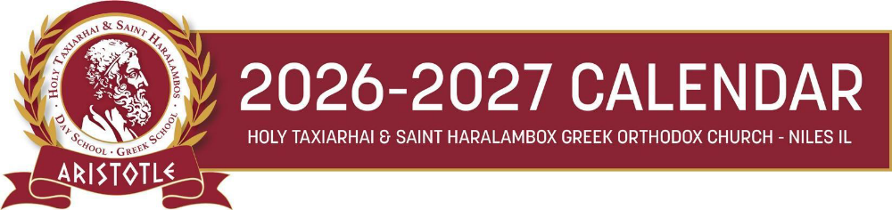
SATURDAY GREEK SCHOOL

Saturday, August 29th Teacher’s Institute Day - No School for students
Saturday, September 5th Labor Day Weekend - No School
Saturday, September 12th First Day of Classes - Agiasmos Service
Sunday, September 20th Welcome back party @ 3:00 p.m. for Saturday and Afternoon programs
Saturday, September 26th Open House & Orientation @ 9:15 am - 10:20 am
Saturday, October 3rd First Day of Greek Dance Class
Saturday, October 17th Picture Day for all Grades @ 9:00 am - 12:30 pm
Saturday, October 24th OXI Day Assembly - Picture make-up day @ 9:00 am - 10:30 am
Saturday, November 7th Metropolis Seminar for the teachers - No School for students
Saturday, November 28th Thanksgiving Break – No School
Saturday, December 19th Regular Classes followed by Christmas Program @ 11:00 am – No Dance Class
Last day of classes before Christmas break

Saturday, January 9th, 2027 Classes Resume – Cutting of the Vasilopita
Saturday, January 30th Church Service followed by Assembly for Three Hierarchs – Greek Language Day
Saturday, February 13th Parent-Teacher Conferences – No School for students
March - Saturday 6th Apokreatiko Glenti @ 6:00 pm
Saturday, March 13th Regular classes followed by the Greek Independence Day Program @ 11:00 am
No Greek Dance Class
Saturday, April 24th Church Service followed by Saturday of Lazaros and Easter activities in classrooms.
No Greek Dance Class
Saturday, May 1st Holy Saturday – No School
Saturday, May 8th Mother’s Day Event for Preschool – K @ 12:00 pm
Saturday, May 29th Memorial Day Weekend – No School
Saturday, June 5th Last Day of Classes – End-of-Year/Graduation Program @ 10:30 a.m.
No Greek Dance Class

