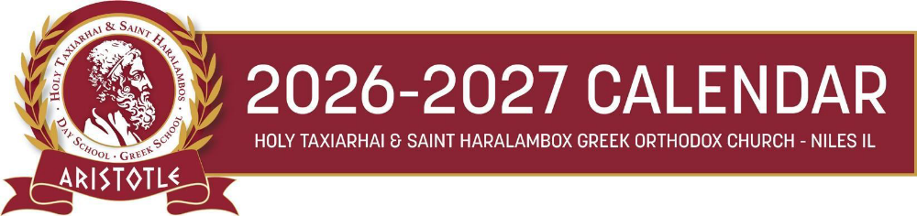

AFTERNOON GREEK SCHOOL

September 4th and 8th Staff Orientation - Teacher’s Institute Days - No School for students
Friday, September 11th Curriculum Night @ 5:00 p.m.- No School for students
Tuesday, September 15th First Day of Classes - Agiasmos Service
Sunday, September 20th Welcome back party @ 3:00 p.m. for Saturday and Afternoon programs
Friday, October 2nd First Day of Greek Dance Class
Tuesday, October 13th Picture Day (Preschool to 2nd)
Friday, October 16th Picture Day (3rd grade and up)
Friday, October 23rd Picture make-up day @ 5:30 pm - 6:30 pm
Friday, October 30th Student Assembly for OXI Day
Sunday, November 8th Feast of the Archangels
Friday, November 27th Thanksgiving Recess – No School
Friday, December 18th Christmas Program @ 5:00 pm (No Greek Dance Class)
Tuesday, December 22nd Last day of classes before Christmas break – Holy Unction Service @ 4:30 pm
Friday, January 8th, 2027 Classes resume – Cutting of the Vasilopita
Friday, January 22nd Parent-Teacher Conferences – No School for students
Friday, January 29th Student Assembly for Three Hierarchs – Greek Language Day
Friday, February 12th Teacher’s Institute Day – No School for students
Saturday, March 6th Apokreatiko Glenti @ 6:00 pm
Saturday, March 13th Greek Independence Day Program @ 4:00 pm
March 22-26 Spring Break – No School
Tuesday, March 30th Classes Resume
Friday, April 16th Akathist Hymn – No Dance Class
Tuesday, April 27th Holy Tuesday – No Dance Class
Friday, April 30th Holy Friday – No School
Friday, May 7th Mother’s Day Event for Preschool – K @ 6:00 pm
Friday, June 4th Last Day of Classes - Ice-cream social
Sunday, June 6th End of Year/Graduation Program @ 4:00 pm

