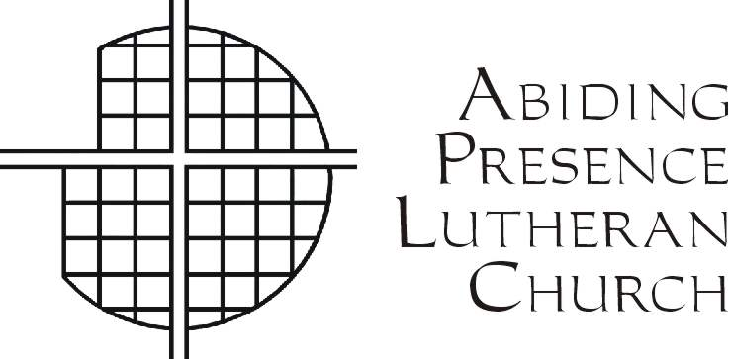 Abiding Presence Lutheran Church and Preschool

*Gathered by Christ. Growing in Faith. Sent to Serve. All are Welcome!*

August 5, 2024

Dear Parents and Friends,

We want to welcome you to a new year of Sunday school! Join us and “***Dive into friendship”*** at Rally Day on Sunday, September 8, 2024. Our Rally Day theme this year is “***Scuba- Diving into Friendship with God”.***

**Rally Day Schedule:** All Sunday School children will begin in church at 9:30 am.

After the***Welcoming Rally Day Message,*** a special ***Blessing of the Backpacks*** will take place***.*** All children are encouraged to bring their backpacks for a special blessing from Pastor

Schoepflin as they begin a new school year.Following the blessing, the children will be guided by the teachers to Good Shepherd Hall. There they will meet their teachers and participate in age-appropriate community service projects as a part of ***“God’s Work, Our Hands”*** Sunday. Parents, please meet your children in Good Shepard Hall after worship for pickup.

Is this your first-time hearing about Sunday school? Do you have friends or family members who might be interested in Sunday school? All are welcome to join us! Here, all children of God can “***Dive into friendship”*** and learn about God’s love for them***.***

Our Sunday school classes are designed for children 3 years old through 5th grade. Our

preschool class is for children turning 3 by December 1st though 5 years old. Grades K - 5 will

coincide with your child’s school grade this fall.

**Registration:** Please complete and return the Sunday School Health & Authorization form and Photo Release form **(*1 per child*)**. Forms can be returned to the church office by mail, in the offering plate on Sunday, or placed in the basket on the narthex table. Please return your completed forms by Sunday, September 1st.

**Sunday school envelopes:**Offering envelopes for all children in grades N3 – 5 will be

available during Sunday School each week. Please be sure to write your child’s name and

address so that offerings are accurately recorded.

If you have any questions, please do not hesitate to contact Aubrey Minton at

631-655-8228 or email [aubrey.minton@gmail.com](mailto:aubrey.minton@gmail.com).

Yours in Christ,

Aubrey Minton

Pastor Schoepflin

Ministers:

The People of God

Pastor:

Rev. Robert Schoepflin

Pastoral Associate:

Rev. Dr. Toby L. Tobias

Synodical Deacons:

Ms. Kathy Pucci

Mr. Gavin Schwen

Organist and

Director of Music:

Dr. Tom Zatorski

Office Administrator:

Ms. Je-Anne Martinsen

Parish Secretary:

Ms. Debra Nicholas

Ms. Diann Lastihenos

Preschool Director