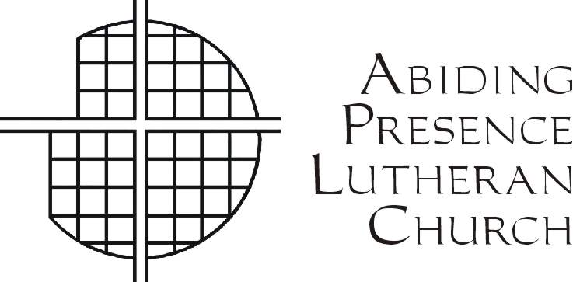 Abiding Presence Lutheran Church and Preschool

*Gathered by Christ. Growing in Faith. Sent to Serve. All are Welcome!*

Ministers:

The People of God

Pastor:

Rev. Robert Schoepflin

Pastoral Associate:

Rev. Dr. Toby L. Tobias

Synodical Deacons:

Ms. Kathy Pucci

Mr. Gavin Schwen

Organist and

Director of Music:

Dr. Tom Zatorski

Office Administrator:

Ms. Je-Anne Martinsen

Parish Secretary:

Ms. Debra Nicholas

Ms. Diann Lastihenos

Preschool Director

September 1, 2024

Dear Congregation,

Abiding Presence Lutheran Church is a certifying organization to recognize exceptional volunteers to receive the President’s Volunteer Service Award. This letter serves as a reminder of requirements to apply for the award.

Your approval is based on community service hours and eligibility

requirements provided by the President’s Council on Service and Civic Participation. **These hours need to be submitted and will be verified by the Abiding Presence Church Office. Eligible hours are during the 12-month period of September 1, 2024- August 31, 2025.**

Hours required to earn awards in each age group (age by 8/31/25)

|  |  |  |  |  |
| --- | --- | --- | --- | --- |
| **Age Group**  **(Years old)** | **Bronze**  **(hours)** | **Silver**  **(hours)** | **Gold**  **(hours)** | **Lifetime**  **(hours)** |
| 5-10 | 26-49 | 50-74 | 75+ | 4,000+ |
| 11-15 | 50-74 | 75-99 | 100+ | 4,000+ |
| 16-25 | 100-174 | 175-249 | 250+ | 4,000+ |
| 26+ | 100-249 | 250-499 | 500+ | 4,000+ |

**Worship service hours are not eligible**.

All unpaid acts of volunteering service in or outside of church are eligible **except during worship service or religious instruction (teaching or assisting Confirmation and Sunday School**). Additionally, donations of funds or supplies, political lobbying or service for family members

(Family members cannot sign for you) are not eligible for this award.

**Submission Requirements before 8/31/25:**

Email jmartinsenaplcoffice@gmail.com or hard copies mailed to the office

1. Submission Form
2. Record logs (keep one for your records)
3. Proof of Citizenship and Age (Birth certificate or passport copy)

Contact Je-Anne at 631-269-6454 Ext 10 or by email with any questions.

Warm Regards,

Je-Anne Martinsen