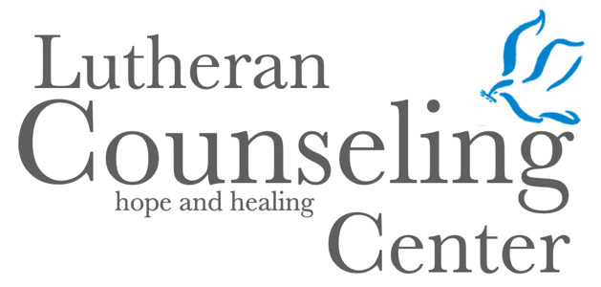
October 2026

WITH SECURE, VIRTUAL COUNSELING SESSIONS
AVAILABLE FOR ANY NEW YORK RESIDENT
Prepared especially for LCC Congregations & Schools

Who Am I and What is my Purpose?
By Janet Siry, LCSWR

A
s Christians, we are taught to love one another. This perspective was often seen in Jesus’ missions. Some of us believe, that to live the Christian life, we must sacrifice many things. Many times, we can be unaware of how this impacts our own mental health and well being. Although well intentioned, sometimes we harbor anger and resentment because we believe another person is taking advantage of us or does not appreciate what we have done for them. We believe our efforts are helping others cope when perhaps it is seen by them as control.

Codependent people are those who are overly invested in others’ lives rather than considering their own needs and wants. They may sacrifice themselves in order to please others. Their relationship patterns tend to be focused on others’ well being whether or not that person seeks their help.


Do you feel like you are doing it all? Do you ever say yes, when you want to say no? Do you sometimes wonder that if you don’t do something, it will not be done right? Are you the person others rely on to get the job done? If you answered yes to any or all of these questions, perhaps you need to explore how these thoughts impact your own life.
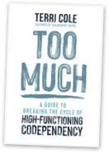
To discern how these actions have impacted you, there are many authors who have written extensively about this topic. Terri Cole, in her book, Too Much, explores how to recover from the effects of this behavior. We can break this cycle, if we become more self aware of how these behaviors can create stress for ourselves and those we care about. Nancy L. Johnston also writes about people who lose themselves in others. She outlines self recovery strategies to assist change that help those involved in the cycle of codependency to get back in touch with their own needs. Melody Beattie first wrote about codependency in 1986 and published 18 more books thereafter. Her website, melodybeattie.com is a wonderful resource to find information about many types of addiction and recovery.

Our Lord tells us in Matthew 11: 28: “Come to me, all you that are weary and are carrying heavy burdens and I will give you rest”.

This scripture reminds us that we must call upon the Lord to help us with any burdens – ours or others we worry about. In asking God for help and guidance, we may find “…the peace of God which surpasses all understanding, will guard your hearts and your minds in Christ Jesus.” (Philippians 4:7). Rely on God to help us and others in the hours of our needs.

To learn more about LCC Counselor Janet Siry, LCSWR and all LCC’s Counselors, go to https://www.lccny.org/meetourcounselors.
Call the Lutheran Counseling Center at 516-741-0994 or 1-800-317-1173 or e-mail us at Center@lccny.org to set an appointment.

