YOUTH & FAMILY DEVOTION & DISCUSSION – September 14, 2025

PRIMARY SCRIPTURE
1 Corinthians 6:12-20

SECONDARY SCRIPTURES
Romans 6:19 & Romans 1:21-25

Dear parents,
As we kick off our sermon series on 1 Corinthians we come up with our first topic, sex—one of the most awkward yet important topics for teenagers to discuss with trusted adults. This week’s lesson was built on 1 Corinthians 6:12-20. Many Christians in the Greek city of Corinth struggled because they seemed to be continuing their old, pagan practices while attempting to follow Jesus. Paul’s letter is filled with clear, pointed instructions in several areas—including sexual sin.

We particularly focused on verse 18: “Run from sexual sin! No other sin so clearly affects the body as this one does. For sexual immorality is a sin against your own body.” We shouldn’t just walk away from sexual temptations, or do our best to avoid those situations. We should RUN from them! That word clearly implies a definite decision and course of action. If we play with fire, we’re going to get burned. As verses 19 and 20 remind us, our bodies don’t belong to us—if we’re followers of Jesus, we belong to him.

Lies about sexuality can be hard to identify for our students—and sometimes even for us adults. It is important to help teenagers draw some lines between what is God’s plan and what isn’t, with the goal of helping our students SEE and choose God’s plan! We gain wisdom by praying, reading the Bible, talking with trusted friends and leaders, and observing the possible consequences of our decisions.

We also looked at Paul’s conversation with the Christians in Corinth about the way they were living (1 Corinthians 6:12-17). We saw how he wanted them to realize that just because they had freedom didn’t give them an excuse to abuse their freedom. Our goal this week was to help teenagers realize that God created sex as a gift and that it is designed to be experienced by a husband and wife. We concluded our discussion by talking about how our bodies are God’s temple (1 Corinthians 6:18-20).

As you find time to talk with your teenager about this week’s lesson, here are some questions you might want to ask:

- How can our thoughts about sex lead to unwise decisions and actions? How can we appropriately handle our thoughts about sex?
- Is there any difference between being wise when making choices about sex and being wise in other areas of life? Why or why not?
- Why do you think the Apostle Paul said to “run from sexual sin”? Why “run” from it?
- What are some wise choices you might make if you choose to follow God’s plan for sex, and what could I do to encourage or help you to make wise choices?
- How are you developing the wisdom to make wiser choices?
- What sources of temptation do you confront that you think other generations have never seen?

Thanks for your commitment to your child.
I pray that this is a blessed week for you and your family!
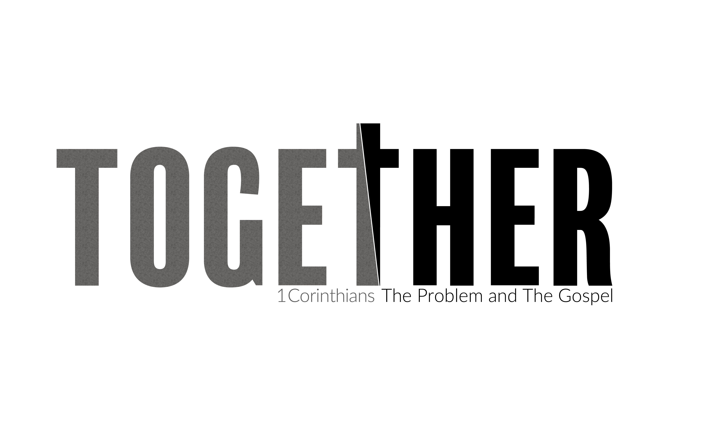
SERMON REFLECTION & DISCUSSION – September 14, 2025

PRIMARY SCRIPTURE
1 Corinthians 6:12-20

This week 1 Corinthians focuses on the theme of unity and the proper use of the body. In ancient Corinth, sexual immorality like sleeping with temple prostitutes was common and even seen as a form of worship. Some Christians adopted this mindset, believing their faith gave them the freedom to do whatever they wanted.

The sermon challenges this view by asserting that the human body is now the temple of the Holy Spirit. Just as Jesus cleansed the physical temple and became the new, perfect temple, Christians are called to be a new kind of temple—a place where God dwells and brings good news to the world.

The key takeaway is from 1 Corinthians 6:19-20: "You were bought with a price. So glorify God in your body." The speaker argues that while "all things are lawful," not all things are helpful. Our bodies are not meant for immorality but for the Lord. We are connected to Christ, not to sin, and we must use our bodies to serve others rather than for selfish desires. The sermon concludes by offering forgiveness for past mistakes and encouraging Christians to use their bodies to build up those around them.

Questions for reflection or Discussion.
- Paul says that while "all things are lawful," not all are "helpful." Can you think of a personal habit or behavior that might be technically "permissible," but isn’t actually "helpful" in living out your faith or serving others?
- Read 1 Corinthians 6:12-20. Paul reminds us that our bodies are the temple, a place for God to dwell and bring good news to others. How does this idea change the way we think about our physical and emotional health, and our relationships with others?
- We were "bought with a price" and therefore belong to God. What are some specific actions we can take this week to use our bodies and our lives to serve others and bring them good news, rather than just serving ourselves?
- Paul encouraged the Corinthians to "flee from sexual immorality." Beyond the obvious, what are some of the more subtle ways that selfishness or a desire for control can creep into our relationships, and how can we work to be more selfless and honoring to each other?

