
Glow Vibe Night Golf
Heroes for HER Golf Tournament
Join us for a one-of-a-kind glow in the dark golf experience designed to light up the entire course! From tee boxes to hazards to greens, LED Glow Blasters will illuminate every part of the game, ensuring a safe and fun adventure. Golf carts will also shine bright with attachable 1,000-lumen headlights and flashing tail lights for added safety. To make the night even more vibrant, we’ll provide LED golf balls, adding color and excitement to this best-in-class glow golf experience!
Are your students ready to be heroes for those who have survived domestic violence? If so, let’s see them on the links for the 6th Annual Heroes for HER Golf Tournament!
When: May 15, 2026
Where: Bide A Wee Golf Course
Time: Registration and dinner at 6PM. Tee off at 8:00 PM
Why: To support survivors of domestic violence, raise funds for YOUR team/club and to earn community service credits
Registration Fee: $100 for individual golfers
New for 2026 – Students will be able to raise money to pay for their registration fee with online fundraising. It’s simple! Build your own fundraising page. Students can send the link to family and friends and watch how quickly their network will support their desire to help the HER Shelter. Want to go above and beyond? Raise more than the $100 registration fee and 75% of the additional funds will be donated back to your team/school.
Example – Raise $200 = You play a round of golf plus $75 goes back to your school.
Raise $400 = You play a round of golf plus $225 goes back to your school.

It’s a great way to help survivors of domestic violence while earning money for your team to use as you need such as purchasing uniforms, equipment, supplies, etc. This opportunity is open to anyone related to your school- not just golfers but any students, faculty, parents and boosters, so recruit your supporters to join in the fun and raise important funds for your school, clubs or teams, while supporting the HER Shelter and having a fun night of golf!!

Please note that foursomes made up of all students will need to have at least one person on each golf cart with a driver’s license. If not, they are welcome to walk or have a licensed driver drive the golf cart for them.

If you have any questions or need help registering, please reach out.

Deborah Apperson
Community Engagement Manager
HER Shelter
PO Box 2187
Portsmouth VA 23702
Deborah@hershelter.com
757-485-1445

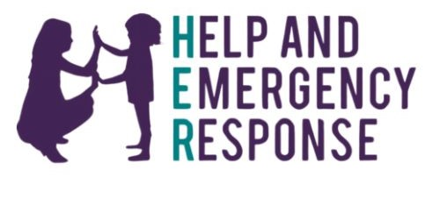
How to Register
- Coach/Teacher/Team Captain, scan the QR code at the bottom of the page to register foursome.
- Click “ I want to help fundraise”
- Click “Create Team”
- Add team name.
- Set target – Minimum should be $400 to cover registration fee but make it higher if you would like to fundraise for your school/team.
- Add optional picture.
- Fill in name and email.
- If you will be golfing, click “I will be joining the team”. If you are not golfing, disregard this step.
- Click “Create team”.
10. Share link with other players so they can build their own personal page.
Instructions for Team Members
1. Click “Join a team”.
2. Select team name from drop box.
3. Add individual goal which should be a minimum of $100 but make it higher if you would like to fundraise for your school/team.
4. Add optional profile picture.
5. Fill in name and address
6. Click “Join Team”
7. Share link with family, friends and personal network.


