

Further It:

In his sermon, Pastor Bruce highlighted the Samaritan woman’s position, or rather, lack of positon.

* She was a Samaritan…a race a people looked down upon by others.
* She was a woman…a gender looked down upon by men.
* She was divorced multiple times and living with a man not her husband…a situation looked down upon by the religious and everyone in her village.

Although not the same, similar situations happen

around the world. One such place is in India.

The majority of Indians practice the religion of

Hinduism. Within Hinduism is the Caste System.

People are born into this “level” of life with no hope

of ever escaping it in this life. It is particularly bad

for the Dalit, also known as the Untouchables. Dalit

means “oppressed, broken, or crushed” and that

is literally how these precious people live their

entire lives. They are considered by other Hindus

to be so low that they are even below the 4 main

levels of caste. They are not to be touched. In

the eyes of many, they are dirt and without worth.

People in the upper caste will not even touch

something that a Dalit has touched.

This is a video you can watch about the Dalit and their need for water. As you watch, reflect on how the Dalit are treated and how they meet their basic need of water. <https://www.youtube.com/watch?v=My9-A_UW97I>

Just as the Samaritan Woman, these people need water. But, more so, they need The Living Water. They need Jesus. Their life is filled with no hope and no peace. But, Jesus came for them…just as He did for you. He, too, offers them Living Water. They are not Untouchable to Him. Jesus wants to touch the Dalit…these precious people made in His image…in their very souls and give them hope and peace through forgiveness and a relationship with Him.

Will you pray for the Dalit in India today?

* Pray that they would be thirsty for Jesus and remain unsatisfied in their soul until they discover Jesus, the Living Water.
* Pray that they will readily accept Jesus as their Lord and Savior
* Pray that God calls and people respond to the command to “Go into all the world” including the Dalit
* Pray that the Dalit that become followers of Jesus go back to their village and share about how Jesus changed their lives.
* Pray that many in the village would also come to have The Living Water and become followers of Jesus.

After you’ve prayed, you can read an encouraging story about one church who traveled to India and ministered to the Dalit. <https://baptistcourier.com/2011/01/team-ministers-to-touches-indias-untouchables/>

Bringing Church Home

Sermon

Connection

Guide

**1.1.2023**

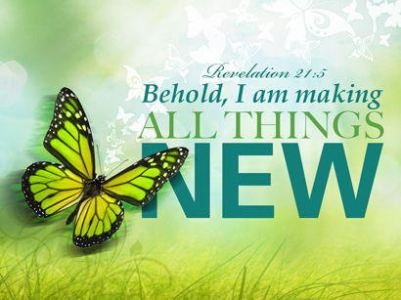

Memorize It:

“And He [God] who was seated on the throne said, ‘Behold, I am making all things new.’” Revelation 21:5a

**Happy New Year**Revelation 21:5a

This past Sunday we had the special treat of being together as the church on New Year’s Day, January 1, 2023. We also witnessed Mr. Stewart Sullivan give a presentation about the cross. He portrayed the Roman soldier who built the cross Jesus died upon.

Why did Jesus die on the cross? To make you new. Because of our sin problem, the Bible says we are spiritually dead. Jesus came to pay the penalty for our sin and give us spiritual life. He came to make us a new creation. 1 Corinthians 5:17 says, “The old is gone and the new has come.”

As we enter 2023, people often set goals or resolutions for themselves on how they will live in the new year. The most important thing you can do this year, if you haven’t already, is ask Jesus to make you new, accept the gift of grace that was given to you when He paid your sin penalty on the cross, repent of the bad things we do, and invite Him into your life so you can follow Him.

If you have already decided to follow Jesus, I encourage you to ask yourself how you can get to know Him better. Our new life in Jesus is instant the moment we follow Him, but He continues to make us new in our daily actions. Reading the Bible, prayer, gathering with other believers, and telling others about Him are all ways we can get to know him better and He can continue to make us new.

