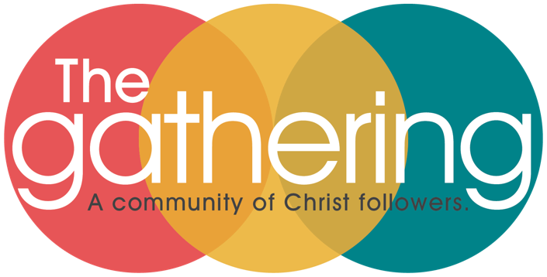

LEADERSHIP TEAM MINUTES
June 12, 2025 7:00 PM
Zoom Meeting ID: 81304336403

Welcome & Opening Prayer - Serena Barth

Leadership Team Present: Joe Skaff, Deb Mainard, Melody Roberson, Serena Barth, Michelle Low, Lonnie Johnstone, Jenny Van Blaricom, Lynn Camp

Incoming Leadership Team Members Present: Michael Roberson, Kimbre AmayaWood

Others Present: Steve Wilson, Linda Johnstone

Recognition of new Leadership Team Members/Positions: The church passed the recent budget and nominations of new Leadership team members. Those members and positions are: Michael Roberson - Children’s Ministry Leader, Deb Mainard - Discipleship Leader, Lynn Camp - continuing as Church Operations Leader, Kimbre AmayaWood - Finance and Stewardship Leader.

Election of Officers for 2025-26 (Chair. Vice-Chair, Treasurer, Secretary)
Secretary: Mel nominated Michelle to continue as secretary, Lonnie seconded, all in favor.
Treasurer: Jenny nominated Kimbre as treasurer, Joe seconded, all in favor.
Vice-Chair: Mel nominated Serena as vice chair, Lonnie seconded. All in favor.
Chair: Joe nominated Serena to be the chair, Serena declined and nominated Michael, Deb seconded, All in favor.

Discussion on Team Workshop July 1st 5-8 PM @ The Gathering Discussion on Vision Day: This will be in place of the Leadership Team meeting in July

Implementation Team Recommendations: Request was made for team members to come to the next meeting with your VDIT recommendations and thoughts to share.

Discussion on Ministry Teams: Please make sure that your ministry teams in Shelby are up to date for the incoming Leadership Team members.

Closing Prayer: Melody Roberson

- Future Meetings (7 PM via Zoom Meeting ID# 813 0433 6403)
• July 1 (in person @The Gathering, NOT on Zoom), August 4, and September 8th

