Saint Kateri Tekakwitha –

“The Lily of the Mohawks”

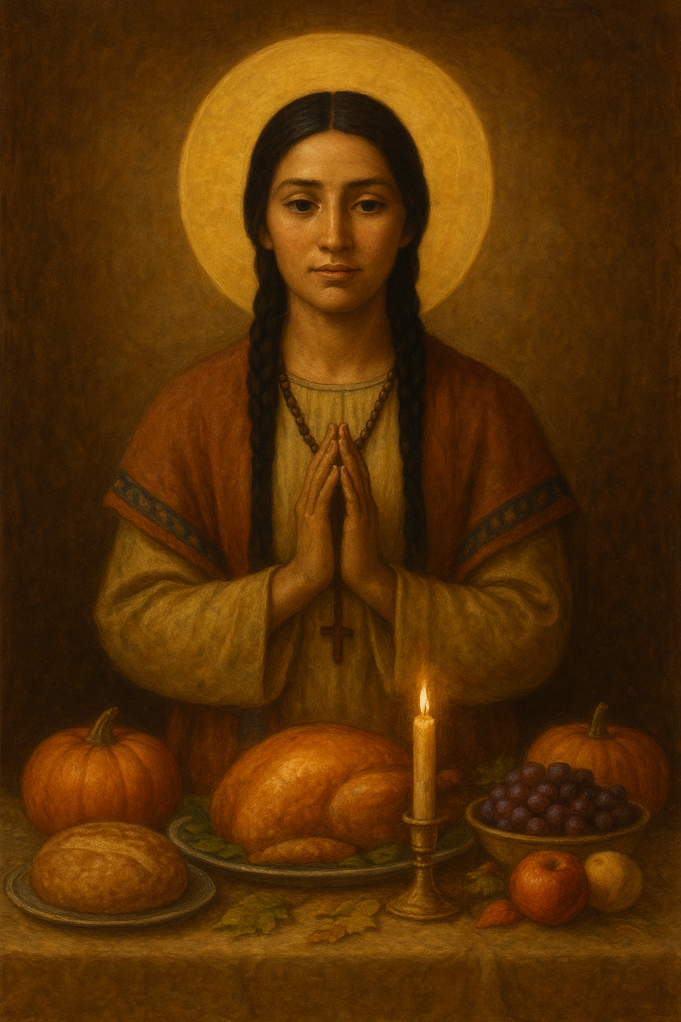
(Feast Day: July 14)
Today we honor Saint Kateri Tekakwitha (1656 – 1680) — the first Native American woman canonized by the Catholic Church.
Born in the Mohawk village of Ossernenon (present-day New York), Kateri’s early life was marked by both tragedy and grace. At age four, she survived a smallpox epidemic that claimed her parents and brother, leaving her with facial scars and impaired eyesight. Shunned by some, she found in silence and prayer the refuge of divine love.
A Life of Faith and Courage
Baptized at age 20 and given the name Kateri (after Saint Catherine of Siena), she devoted herself to Christ despite persecution within her own community. She took a personal vow of chastity and lived a life of humility, service, and deep prayer among the Jesuit mission at Kahnawake, near Montreal.
Her days were marked by fasting, charity, and tender care for the sick and elderly. In the early morning hours, she would walk alone into the woods to pray before the rising sun, offering her heart completely to God.
Why She Was Canonized
- A model of Christian purity, gentleness, and strength in adversity.
- Her unshakable faith reconciled Indigenous spirituality with Catholic devotion, showing that holiness transcends all cultures.
- A miraculous healing in 2006 of a young boy in Washington State was attributed to her intercession — a healing that defied medical explanation and led to her canonization by Pope Benedict XVI on October 21, 2012.
Psalm 25 [24]: 6–7
Remember, O Lord, thy bowels of compassion;
and thy mercies that are from the beginning of the world.
The sins of my youth and my ignorances do not remember.
According to thy mercy remember thou me:
for thy goodness’ sake, O Lord.
Saint Kateri’s heart echoed this psalm — a humble plea for divine mercy and remembrance. Her short life of quiet holiness continues to speak to those who seek peace, reconciliation, and steadfast faith amid suffering.
May her prayer guide us:
“I am not my own; I have given myself entirely to Jesus Christ.”

