Summary of Hope Lutheran Church Constitution Proposed Changes
Beginning in late 2024, Hope’s council began a review of our constitution, specifically how we are required to organize our church council and ministry boards. In recent years it has become more difficult to recruit members willing to serve as ministry board chairpersons, in part because the election to fill the chair also means they become a member of the church council. We have willing leaders that want to serve on council, and willing leaders who want to serve on ministry boards.
A taskforce was created to connect with other regional congregations that reflected our demographic, through which we learned the following:
- Many congregations are struggling to fill leadership positions
- Many congregations are restructuring leadership in response to ministry needs
- There is no “cookie cutter” approach for reorganizing
After an honest inventory of the challenges faced finding leaders over the last 6 years, which included long-tenured vacancies in both worship and education board chair positions, and an imaginative process exploring our strategic plan, we opted to propose the following:
- Removing the requirement that elected board chairs ALSO serve on council
  - This allows people to serve fully where their passions lie. This is the only change to the constitution required to do so.
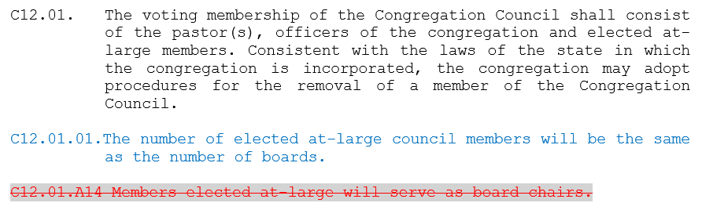

- Removing the Board of Education & Board of Stewardship & Finance from our Constitution
  - We have professional staff who shepherd these ministry areas, church council reviews all stewardship and financial reports, checks, and invoices, and both boards have been practically defunct for years.

- Restructuring the Nominating committee to include existing leadership.
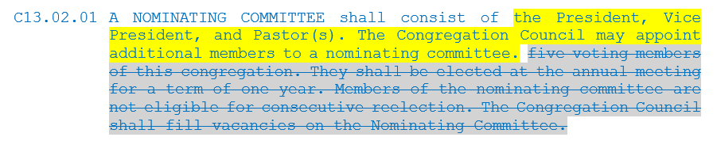
Our review of the constitution also revealed that in the ELCA, we are required to occasionally update our constitution so that it aligns with the Model Constitution for Congregations in the ELCA. These required updates are are partly semantic, partly in response to adminsitrative changes to ELCA rosters for pastors and deacons, and partly in response to a variety of other puposes and procedures relating to things like closing congregations, congregational affilations, etc.
Full constitutions are available that note all proposed changes. Please note these changes have been throughly vetted by the constitution taskforce, council, and will be reviewed by Northeastern MN Synod leadership. Please direct any questions or concerns to Pastor Matt or Congregational President Barb Sherman.

