Sunday | Monday | Tuesday | Wednesday |  |  | Thursday |  |  | Friday |  |  |  |  | Saturday
 |  |  |  | 1  10:00 am Women of Hope Board Mtg  1:00 pm Bone Builders  No Joyful Noise or Wednesday Kids  4:30 pm Celebration Handbells  5:30 pm Simple Supper  6:15 pm Wednesday worship  6:45 pm Confirmation classes |  | 2  8:30 am Quilters  9:30 Bone Builders  11:30 Women’s AA |  |  |  |  | 3 |  |  |  | 4
5  9:00 Communion Worship  10:00 Coffee & Fellowship  6:00 pm 6th-9th Youth Group | 6  9:30 AA  1:00 pm Bone Builders | 7  7:15 am HS Bible Study at Walker Bay Coffee  9:00 Card Makers  9:30 Bone Builders |  |  | 8  8:30 am Board of Outreach  11:00 Worship -May Creek Cottages  12:30 Worship at May Creek Lodge  1:00 pm K-2nd grade Release Time  1:00 pm Bone Builders  3:30 pm Joyful Noise practice  4:15 pm Wednesday Kids  4:30 pm Celebration Handbells  5:30 pm Simple Supper  6:15 pm Wednesday worship  6:45 pm Confirmation Classes |  | 9  8:30 am Quilters  9:30 Bone Builders  11:30 Women’s AA  1:00 pm 3rd-5th grade Release Time |  |  | 10 |  |  |  | 11
12  9:00 Communion Worship  10:00 Coffee & Fellowship | 13  9:30 AA  1:00 pm Bone Builders | 14  7:15 am HS Bible Study at Walker Bay Coffee  9:00 Card Makers  9:30 Bone Builders |  |  | 15  1:00 pm Bone Builders  No Joyful Noise or Wednesday Kids  4:30 pm Celebration Handbells  5:30 pm Simple Supper  6:15 pm Wednesday worship  No Confirmation classes |  | 16  8:30 am Quilters  9:30 Bone Builders  11:30 Women’s AA |  |  |  |  | 17 |  |  |  | 18
19  9:00 Communion Worship  10:00 Coffee & Fellowship  6:00 pm Confirmand Dinner | 20  9:30 AA  1:00 pm Bone Builders | 21  7:15 am HS Bible Study at Walker Bay Coffee  9:00 Card Makers  9:30 Bone Builders |  |  | 22  1:00 pm 3rd-5th grade Release Time  1:00 pm Bone Builders  3:30 pm Joyful Noise practice  4:15 pm Wednesday Kids  4:30 pm Celebration Handbells  5:30 pm Simple Supper  6:15 pm Wednesday worship  6:45 pm Confirmation classes |  | 23  8:30 am Quilters  9:30 Bone Builders  11:30 Women’s AA  1:00 pm K-2nd grade Release Time |  |  | 24 |  |  |  |  |  | 25
26  9:00 Communion Worship  w/Confirmation service  10:00 Coffee & Fellowship | 27  9:00 am Northwoods Quilters  9:30 AA  1:00 pm Bone Builders | 28  7:15 am HS Bible Study at Walker Bay Coffee  9:00 Card Makers  9:30 Bone Builders |  |  | 29  1:00 pm Bone Builders  3:30 pm Joyful Noise practice  4:15 pm Wednesday Kids  4:30 pm Celebration Handbells  5:30 pm Simple Supper  6:15 pm Wednesday worship  6:45 pm Confirmation classes |  |  | 30  8:30 am Quilters  9:30 Bone Builders  11:30 Women’s AA |  |  |  |  | 31  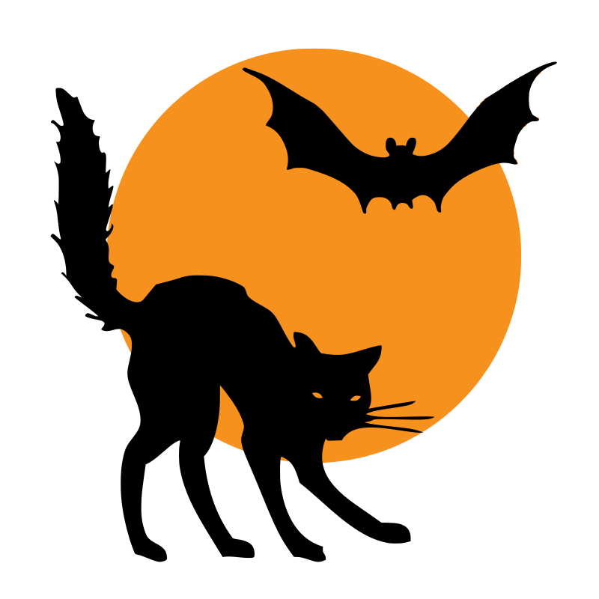 |  |  | ‘25

