RALLY SUNDAY
September 7, 2025

Please silence your phone.

Pre-sealed communion kits are available near the entrance if you prefer to remain in the pew during communion distribution.

Device available to assist the hearing impaired. Talk to the sound techs about its use.

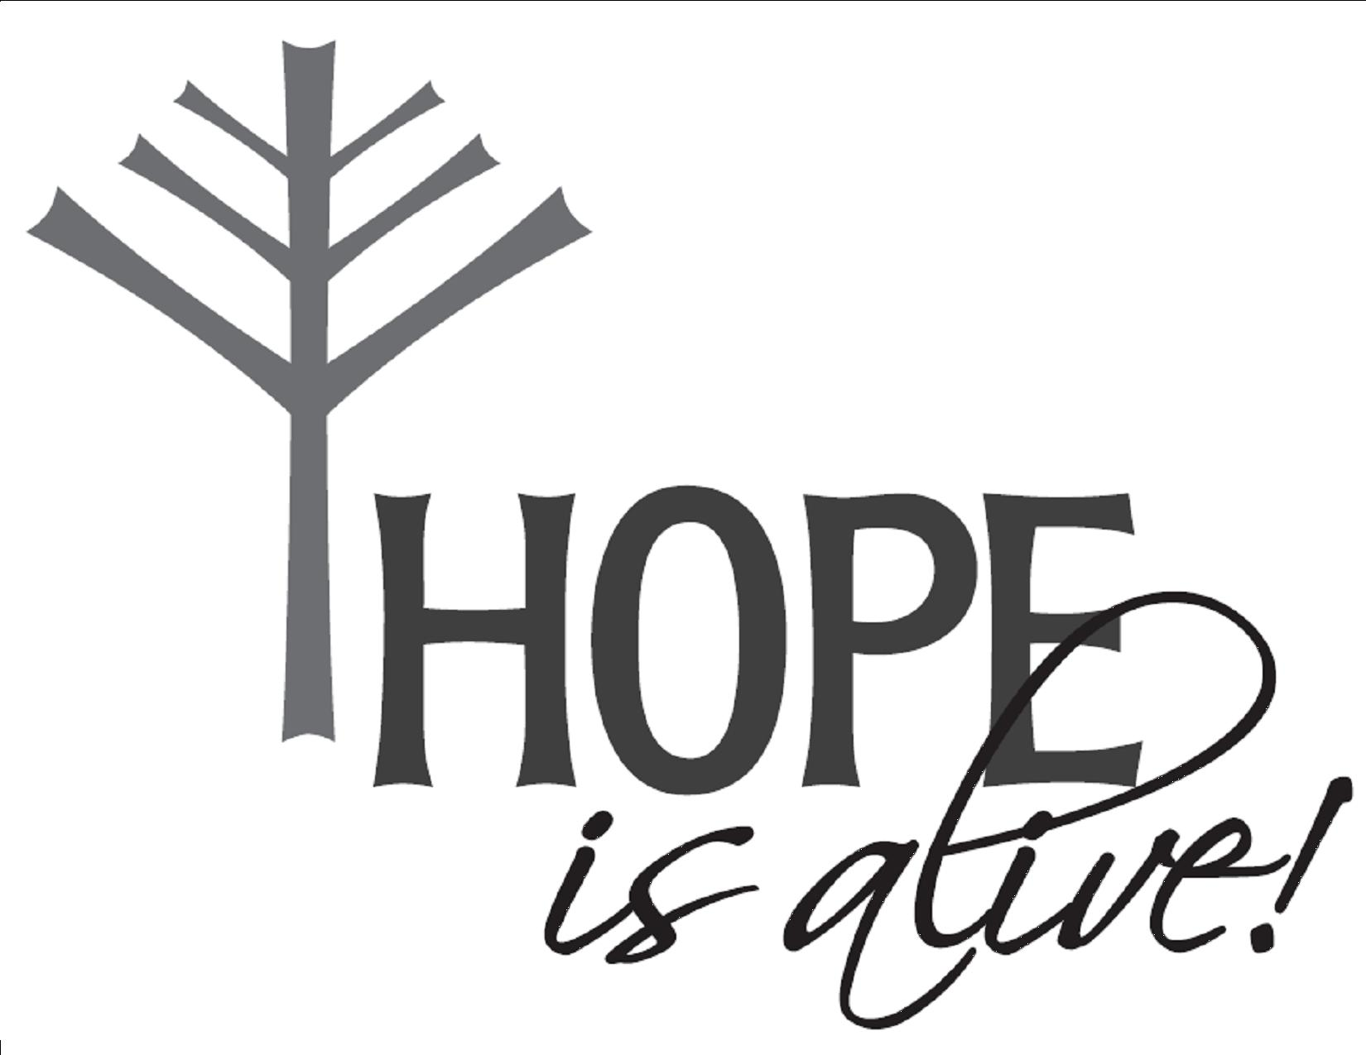

Hope Lutheran Church, ELCA
305 10th St. S Walker, MN 56484 218-547-1850
www.hopelutheranchurch-walker.com
Pastor Matt McWaters and Pastor Dave Smith
Youth Director Michelle Anderson
Accompanist: Mike Kerrigan Usher: Marty Cook

Offering will be taken in the pews today

WE INVITE YOU TO JOIN IN OUR MINISTRY at Hope Lutheran Church through membership. Both voting and associate memberships are possible. If you would like to become a member, please check the appropriate box on the Friendship Register or leave a message in the church office, including your phone number.

WE WARMLY WELCOME CHILDREN INTO WORSHIP! QUIET BAGS for little hands and busy minds are available near the sanctuary entrance.

Welcome to Worship
PRELUDE
WELCOME & ANNOUNCEMENTS
(please stand)
TWIST & SHOUT INVOCATION – Bible Campers & Day Camp VBS Kids
Campers: In the Name of the Father Congregation: In the Name of the Father
Campers: In the Name of the Son Congregation: In the Name of the Son
Campers: In the Name of the Spirit Congregation: In the Name of the Spirit
Campers: All three in one Congregation: All three in one
Campers: Surf it out! Awwww… Awwww… Awww… (Wipeout)
(REPEAT Twice, but on the last “Awwws” close with “Amen!”)
OPENING DIALOG - Olivia Undem & Everly Felton
God calls us to GATHER together- moving beyond the things that divide us to care for each other!
All: Let us consider how to provoke one another to love and good deeds, not neglecting to meet together (Hebrews 10:24-25a)

God calls us to LOVE our neighbor, no exceptions - through radical inclusion and service!
All: Which of these was a neighbor to the man who fell into the hands of robbers? The Samaritan, who showed him mercy. (from Luke 10:36)

God calls us to FORGIVE others and prioritize relationships as we live in community!
All: Forgive us our debts, as we also have forgiven our debtors. (Matthew 6:12)

God calls us the CHALLENGE all that is wrong in our world – standing up for what’s right!
All: Jesus entered the temple, and he overturned the tables of the money changers and the seats of those who sold doves. (from Matthew 21:12)

God calls us to PRAISE joyfully in hard times and good times, to spread the Gospel!
All: I will bless the LORD at all times; God’s praise shall continuously be in my mouth. (Psalm 34:1)

We are the Church, called to be the body of Christ! C: Amen!
(please be seated)
PRESCHOOL VBS ANTHEM “I Just Wanna Be a Sheep” and “It Was David”
DAY CAMP & CAMPERS VBS SONG (words below) “The Church Song”
Refrain: We are the church, the body of our Lord;
we are all God’s children. We have been restored.
1) The church is not a building where people go to pray;
it’s not made out of sticks and stones, it’s not made out of clay. Refrain
2) You can go to worship but you cannot go to church;
you can’t find a building that’s alive no matter how you search. Refrain
3) The church is not a business, a committee or a board;
it’s not a corporation for the business of the Lord. Refrain
4) The church, it is the people living out their lives,
CALLED, ENLIGHTENED, SANCTIFIED for the work of Jesus Christ. Refrain

LESSON: Romans 8:28 Lucy Kuechle
“Hug Machine” Skit
Lily Cairns, Sophia Undem, Trent Kuechle, Trevor Kuechle, Olivia Undem
CAMPER SUMMARIES –Maddy Beard, Everly Felton, Korbyn Stein Henderson
SONG (words below) “Who You Say I Am”
1 Who am I that the highest King would welcome me
I was lost but He brought me in. Oh His love for me, Oh His love for me

Chorus 1: Who the Son sets free - Oh is free indeed.
I'm a child of God, Yes I am

2 Free at last he has ransomed me. His grace runs deep
While I was a slave to sin Jesus died for me. Yes He died for me

Chorus 2: Who the Son sets free - Oh is free indeed.
I'm a child of God, Yes I am
In my Father's house there's a place for me. I'm a child of God, Yes I am

Bridge: I am chosen not forsaken, I am who You say I am
You are for me not against me, I am who You say I am.
Yes I am who You say I am. (Chorus 2)

KNOXVILLE MISSION TRIP – Anja Turney and Vada Yeats

BIBLE MILESTONES
3 Year Olds: Allison Anderson, Blake Hopen, Addison Fevold, Reese Ringle

3rd Graders: Hank Ehlenfeldt, Layla Forseman, Riley Gilbert, Amari Krueckeberg,
Avarie LaRose, Leia McCollough, Adaline McGill

6th Graders: Ava Brovold, Adelveiss Burns, Paislee Erickson, Ryla Johnson,
Keeton Malard, Benjamin McWaters, Elaine Townsdin

LYO INSTALLATION
Lily Cairns, Kayla Landt, Tori Pederson, Anja Turney, Sophia Undem, Vada Yeats
THE CREED
PRAYERS- Kayla Landt, Garret Turney, Layla Kruekeberg, Tori Pederson, Lily Cairns
God, you GATHER people of all ages, nations and abilities. Move us to seek those who are isolated or alone, who do not have family or a place to call their own – that we might welcome them into your community of grace. Lord in your mercy, All: Hear our prayer.

God, you LOVE the world and all that is in it. Your words says so in John 3:16. Inspire us by your love, so that we can love all our neighbors as ourselves. Lord in your mercy, All: Hear our prayer

God, you are always ready to FORGIVE us, making good the relationship we share with you. Empower us to forgive our friends, our family, enemies and strangers, so that we can all move forward in life without holding onto grudges or hate. Lord in your mercy, All: Hear our prayer.
God, you CHALLENGE all that is wrong in our world, including death, illness, and disease. We pray for all who have asked for our prayers, including – Tanis, Bri, Jim & Bev, Hazel, Judy, Dale & Harriet, Mary, Linda, Roger & Kay, Laurie, Wally, Dave, Tom, Pete, Linda, Rick, Jeff, Kari, Kristin, Martha, Brandon, Boyd, Jill, Lord in your mercy, All: Hear our prayer.

God, we PRAISE you for your unending goodness toward your people! Bless the ministries of your church, Sunday School, Wednesday Kids, Music, Confirmation, Outreach and more. We thank you for leaders, teachers, and all who participate in our life together. We offer these prayers to you, in the name of Jesus – our Lord, All: Amen.

SHARING OF THE PEACE – Lily Cairns
(please be seated)
OFFERING please pass the Friendship Register
WORDS OF INSTITUTION
LORD’S PRAYER

COMMUNION please sing along during communion

Come to the Table (twice)
Come to the table of mercy, prepared with the wine and the bread.
All who are hungry and thirsty, come, and your souls will be fed.
Come at the Lord's invitation; receive from his nail-scarred hand.
Eat of the bread of salvation; drink of the blood of the Lamb.

We Know that in Everything
We know that in everything God works for all our good. (x2)
For those who are called, according to God’s purpose.
We know that our God works for good.
The Lord is my shepherd, I shall not be in want. (x2)
For those who are called, according to God’s purpose.
We know that our God works for good.
For God so loved the world, that he gave his only Son. (x2)
For those who are called, according to God’s purpose.
We know that our God works for good.
I can do all things through Christ who strengthens me. (x2)
For those who are called, according to God’s purpose.
We know that our God works for good.
We know that in everything God works for all our good. (x2)
For those who are called, according to God’s purpose.
We know that our God works for good.

It is Well Medley
When peace like a river attendeth my way
When sorrows like sea billows roll
Whatever my lot thou hast taught me to say
It is well, It is well, with my soul.
It is well (it is well) With my soul (with my soul)
It is well, it is well with my soul.
Amazing grace how sweet the sound that saved a wretch like me
I once was lost but now am found, was blind but now I see
It is well (it is well) With my soul (with my soul)
It is well, it is well with my soul.
Children of the heavenly Father safely to his bosom gather
Nestling bird or star in heaven. Such a refuge ne’er was given.
It is well (it is well) With my soul (with my soul)
It is well, it is well with my soul.
Then sings my soul my savior God to thee
How great thou art, how great though art
Then sings my soul my savior God to thee
How great thou art, how great though art
It is well (it is well) With my soul (with my soul)
It is well, it is well with my soul.

Sanctuary
Lord prepare me to be sanctuary, pure and holy, tried and true.
With thanksgiving I’ll be a living, sanctuary for you.

BENEDICTION
SONG (words below) “My Lighthouse”
1) In my wrestling and in my doubts. In my failures You won't walk out
Your great love will lead me through.
You are the peace in my troubled sea whoa oh
You are the peace in my troubled sea

2) In the silence You won't let go. In the questions Your truth will hold
Your great love will lead me through
You are the peace in my troubled sea whoa oh
You are the peace in my troubled sea

Chorus: My Lighthouse my Lighthouse. Shining in the darkness
I will follow You oh
My Lighthouse my Lighthouse. I will trust the promise
You will carry me safe to shore. Safe to shore safe to shore safe to shore

3) I won't fear what tomorrow brings. With each morning I'll rise and sing
My God's love will lead me through
You are the peace in my troubled sea whoa oh
You are the peace in my troubled sea

Bridge: Fire before us. You're the brightest. You will lead us
Through the storms (hey) (REPEAT 3X)

P Go in peace. Serve the Lord. C Thanks be to God!

TODAY’S WORSHIP BROADCAST & FLOWERS are given by Bruce & Ardyce Pederson, in celebration of their 60th wedding anniversary. The 9:00 a.m. service is broadcast live on KQKK 102 FM radio, and also on Channel 21.5 Leech Lake TV. You can also log on to leechlaketv.org. You can sponsor the broadcast on the date of your choice for $75. Sign up on the bulletin board across from the church office.

Stick around following worship for coffee and fellowship, and then treat yourself to a delicious lunch at our Holy Smokes Cook Off!
TODAY following worship (around 11:00)
Enjoy a variety of meats and fabulous food from Hope’s smoke masters!
Suggested donation of $12/person or $30/family
Proceeds go to Christmas “Toys for Kids” program

Hope Lutheran Habitat for Humanity Workday in Cass Lake
There are currently four Habitat builds in various stages of construction in our neighboring community of Cass Lake and they need help. Currently the bulk of the work is being done by the construction supervisor and his sons. Securing enough volunteers to move the houses forward in a timely manner has been a challenge at best. But, hope is still alive.
Hope Lutheran is sponsoring a workday for Habitat on Monday, Sept 15. The day will begin at 9:00 am and run until about 3:00 pm. However, you can come for all or part of the day. Lunch will be provided. All are invited…all are needed. Tasks will range from cleaning to construction. There are tasks for every age (over 16) and every skill level or lack thereof. There is a sign-up sheet on a table in the Narthex. If you have any questions contact Pastor Dave 218-507-0190 or the church office.

Joyful Noise & Wednesday Kids

All P3-5th Graders are invited to join us on Wednesdays starting September 10. For those who want to participate in Joyful Noise Choir, the Turtle Bus will shuttle kids from WHA to Hope Lutheran- please indicate this is your child's transportation plan with the school. Otherwise, youth are welcome to arrive between 4:15-4:30pm for Wednesday Kids!
For more information, the full schedule and to register, scan the QR code!

High School Bible Study: 9th-12th graders, join us for Bible Study before school on Tuesdays at 7:15 a.m. at Walker Bay Coffee!
Release Time
9th-12th grade – first day Sept 10
6th-8th grade – first day Sept 17
MUST be pre-registered to be
released from school!

Wednesday Confirmation
Sept 10th 6:45-8:00pm: Info Meeting
for 6th-9th graders and parent/guardians
Sept 17th 6:45-8:00pm: 9th Grade (only)
Sept 24th 6:45-8:00pm: 6th-9th Grade

Wednesday Simple Supper & Worship begins September 10th!
Join the family of Hope for a light meal at 5:30
Menu
Sept 10: Pulled Pork Sandwich & Chips
Sept 17: Scalloped Potatoes & Ham
Sept 24: Chicken ala King on a biscuit

Followed by casual worship at 6:15

HOPE’S CELEBRATION HANDBELL CHOIR will begin Wednesday rehearsals on Sept 10th at 4:30. We could use more ringers! Anyone interested is encouraged to stop by.

WOULD YOU LIKE TO SERVE AS A SCRIPTURE READER or COMMUNION ASSISTANT during Sunday worship? Leave a message in the church office to be added to the next schedule, or email hope-michelle@arvig.net

GRIEVING A LOSS? Find hope and healing after the death of a loved one. Grief Share weekly grief support group will be meeting at Calvary Church in Walker on Thursdays from 1:00-3:00 September 25th-December18th. Pick up a brochure from the bulletin board near Hope’s restrooms, or go online to griefshare.org/findagroup. For more info, contact Cynthia Carlson carlsoncounseling@yahoo.com.

THis Week at Hope
Monday 9/8/25
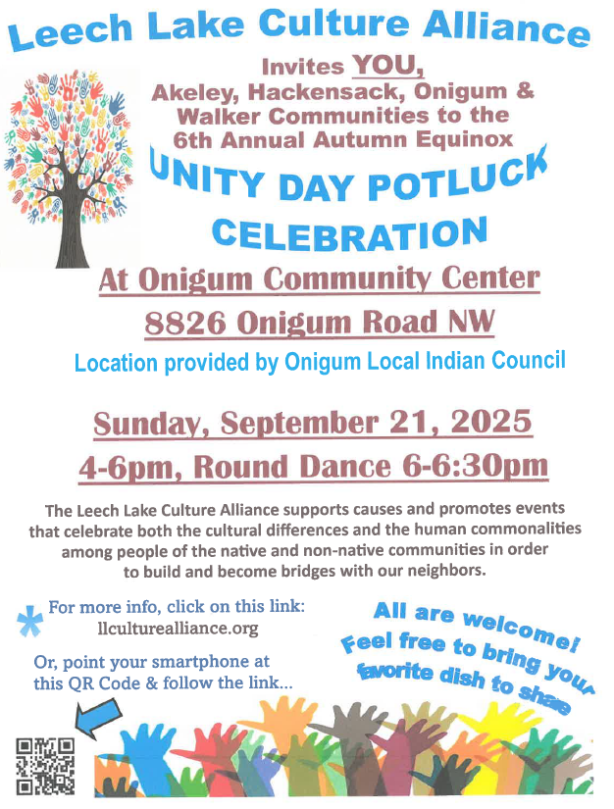
9:30 am – AA
1:00 pm – Bone Builders
5:30 pm – Board of Property

Tuesday 9/9/25
7:15 am – High School Bible Study
at Walker Bay Coffee
9:00 am – CardMakers
9:30 am – Bone Builders

Wednesday 9/10/25
8:30 am – High School Release Time
11:00 am – May Creek Cottages Worship
12:30 pm – May Creek Lodge Worship
1:00 pm - Bone Builders
3:30 pm – Joyful Noise Practice
4:15 pm – Wednesday Kids
4:30 pm – Celebration Handbell Practice
5:30 pm – Simple Supper – Pulled Pork
6:15 pm – Wednesday Worship
6:45 pm – Confirmation Parents Meeting

Thursday 9/11/25
8:30 am - Quilters
9:30 am – Bone Builders
11:30 am – Women’s AA

Sunday 9/14/25
9:00 am – Communion Worship
10:00 am – Coffee & Fellowship
6:00 pm –3rd Grade Bible Class

