16th Sunday after Pentecost
September 28, 2025

Please silence your phone.

Pre-sealed communion kits are available near the entrance if you prefer to remain in the pew during communion distribution.

Device available to assist the hearing impaired. Talk to the sound techs about its use.



Hope Lutheran Church, ELCA
305 10th St. S Walker, MN 56484 218-547-1850
www.hopelutheranchurch-walker.com

Pastor Matt McWaters and Pastor Dave Smith
Accompanist: Mike Kerrigan Liturgist: Ivan Paulsen
Usher: Reader: Joe Sherman
Communion: Joe & Barb Sherman

TODAY’S WORSHIP BROADCAST is given by Tom & Andrea Girtz. The 9:00 a.m. service is broadcast live on to leechlaketv.org. You can also tune in to KQKK 102 FM radio, or Channel 21.5 Leech Lake TV. BROADCAST SPONSORS ARE NEEDED. You can sponsor the broadcast on the date of your choice for $75. Sign up on the bulletin board across from the church office.

FLOWERS IN THE CHANCEL are given in honor of Kris Knowles’ 30 years of service to Hope Lutheran Church!

Welcome to worship
PRELUDE
WELCOME & ANNOUNCEMENTS
(please stand)
P In the name of the Father, and of the Son, and of the Holy Spirit. C Amen
(Silence for reflection and self-examination)
C We confess that we are in bondage to sin and cannot free ourselves. We have sinned against you in thought, word and deed, by what we have done and by what we have left undone. We have not loved you with our whole heart, we have not loved our neighbors as ourselves. For the sake of your Son, Jesus Christ, have mercy on us. Forgive us, renew us, and lead us, so that we may delight in your will and walk in your ways, to the glory of your holy name. Amen
OPENING HYMN (blue hymnal #718) “Gather Us In”
L: In peace, let us pray to the Lord. C: Lord, have mer-cy.
L: For the peace from above, and for our salvation, let us pray to the Lord.
C: Lord, have mer-cy.
L For the peace of the whole world, for the well-being of the Church of God, and for the unity of all, let us pray to the Lord.
C: Lord, have mer-cy.
L For this holy house, and for all who offer here their worship and praise, let us pray to the Lord.
C: Lord, have mer-cy.
L Help, save, comfort, and defend us gracious Lord. C: A-men
L Glory to God in the highest, and peace to his people on earth.
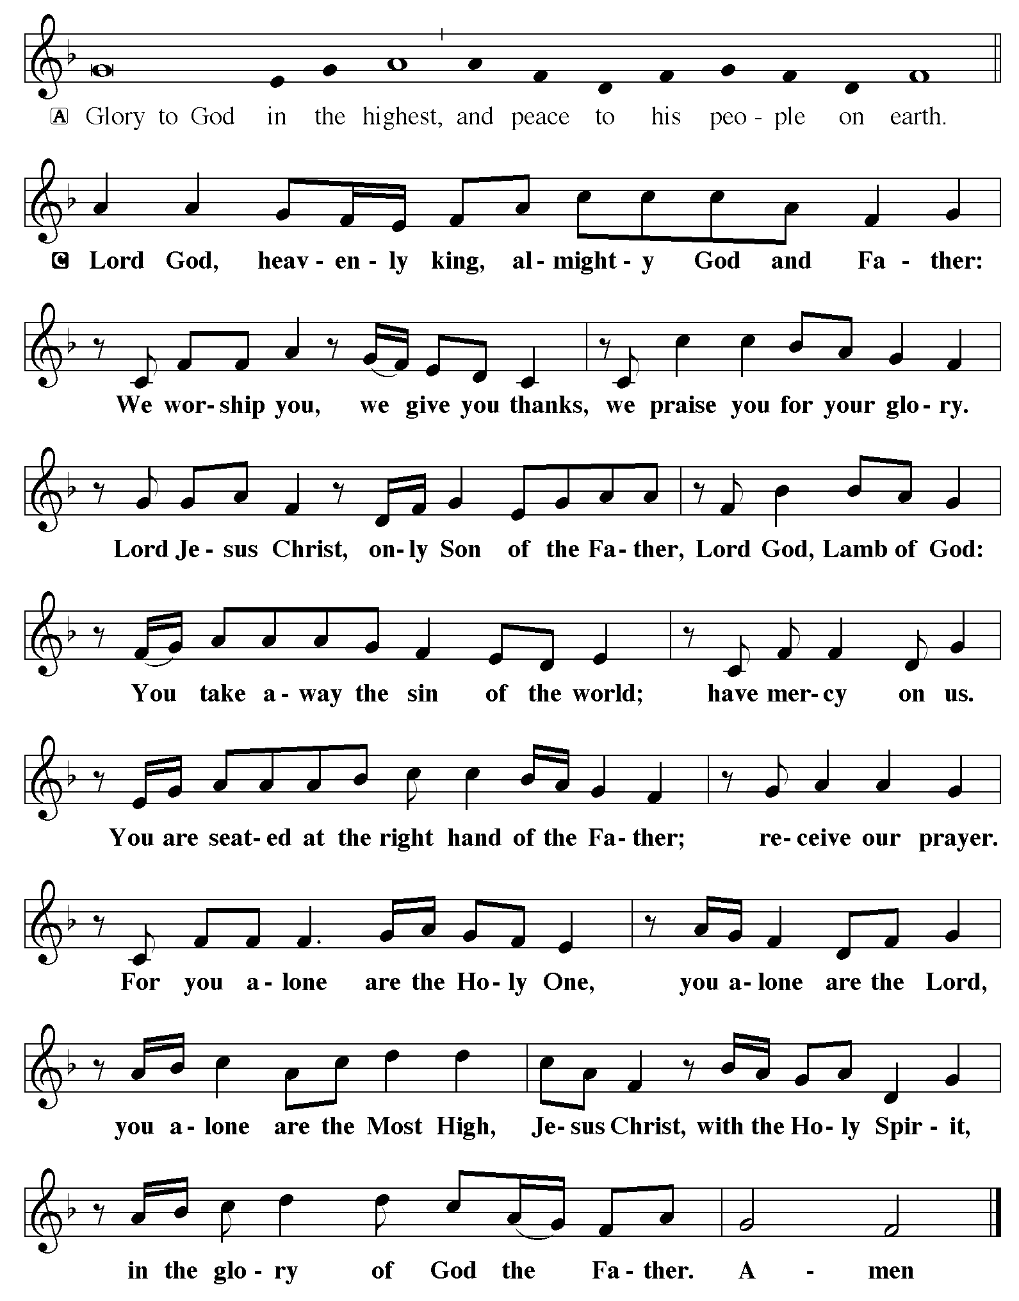
C O God, rich in mercy, you look with compassion on this troubled world. Feed us with your grace, and grant us the treasure that comes only from you, through Jesus Christ, our Savior and Lord. Amen (please be seated)

Kids minute Children are invited to the front of the sanctuary for a brief message
ANTHEM “A Blessing of Music Hope Lutheran Chancel Choir

LESSON: Amos 6:1a, 4-7
PSALM 146
Hallelujah! Praise the Lord, O my soul!
² I will praise the Lord as long as I live;
I will sing praises to my God while I have my being.
³ Put not your trust in rulers, in mortals in whom there is no help.
⁴ When they breathe their last, they return to earth,
and in that day their thoughts perish.
⁵ Happy are they who have the God of Jacob for their help,
whose hope is in the Lord their God;
⁶ who made heaven and earth, the seas, and all that is in them;
who keeps promises forever;
⁷ who gives justice to those who are oppressed, and food to those who hunger.
The Lord sets the captive free.
⁸ The Lord opens the eyes of the blind; the Lord lifts up
those who are bowed down; the Lord loves the righteous.
⁹ The Lord cares for the stranger;
the Lord sustains the orphan and widow, but frustrates the way of the wicked.
¹⁰ The Lord shall reign forever,
your God, O Zion, throughout all generations. Hallelujah!

(please stand)
Alleluia. Lord, to whom shall we go? You have the words of eternal life.
Alleluia. Alleluia.

GOSPEL: Luke 16:19-31
(please be seated)
MESSAGE Pastor Dave

(please stand)
HYMN “Canticle of the Turning”
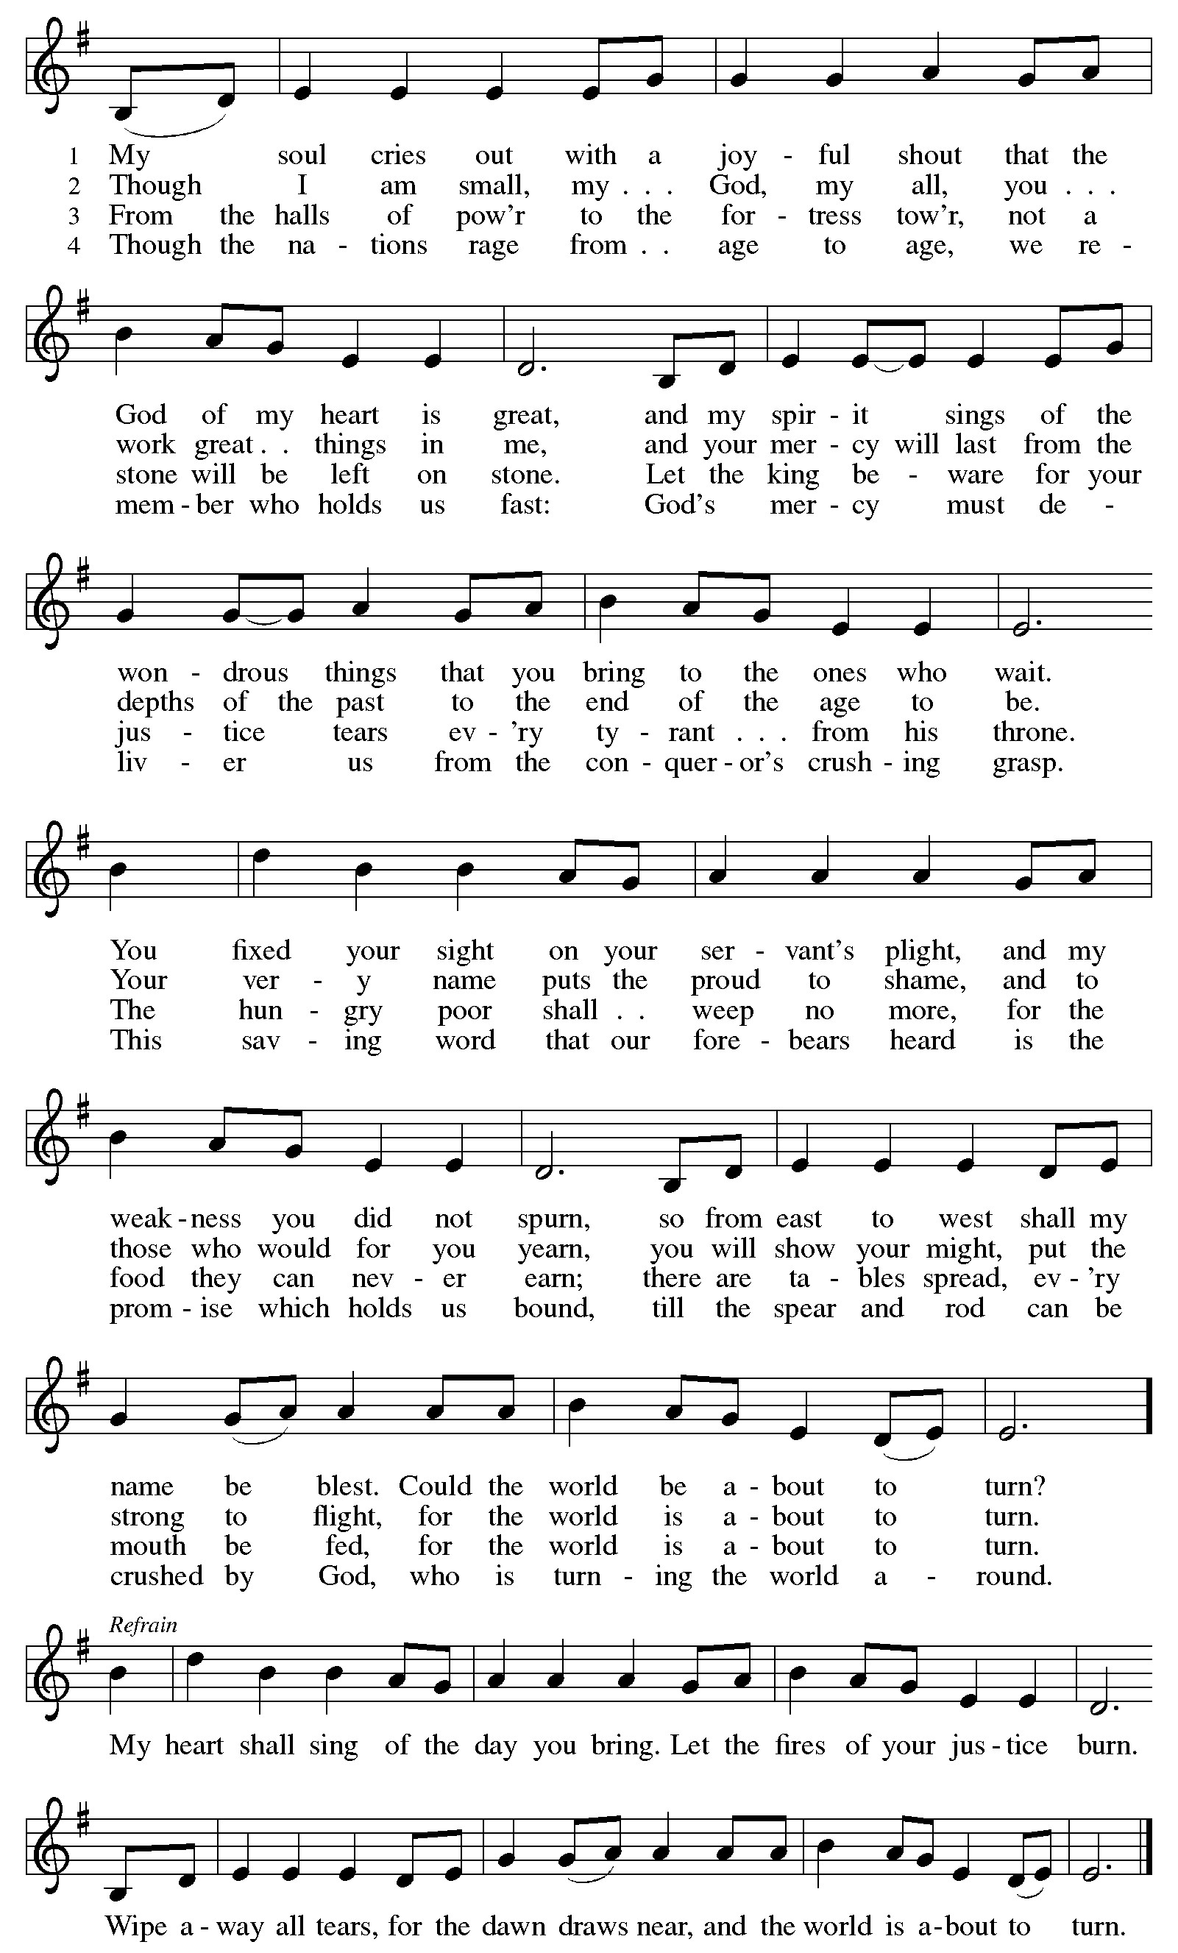
APOSTLES CREED
PRAYERS (each petition will end “Lord, in your mercy”. Please respond)
C hear our prayer.

SHARING OF THE PEACE please pass the Friendship Register

P The Lord be with you. C And also with you.
P Lift up your hearts. C We lift them to the Lord.
P Let us give thanks to the Lord our God. C It is right to give our thanks and praise.
P It is indeed right and salutary…join their unending hymn:
C Holy, holy, holy Lord, God of pow’r and might:
Heaven and earth are full of your glory.
Hosanna. Hosanna. Hosanna in the highest.
Blessed is he who comes in the name of the Lord. Hosanna in the highest.

WORDS OF INSTITUTION
LORD’S PRAYER
(please be seated)
THE COMMUNION please sing the following hymns during communion
(Blue hymnal #776) “Be Thou My Vision”
(Green hymnal #212) “Let Us Break Bread Together”
(please stand)
BLESSING
BENEDICTION
HYMN (see next page) “God Be With You till We Meet Again”

Everyone is invited for coffee in the Fellowship Hall following worship

WE INVITE YOU TO JOIN IN OUR MINISTRY at Hope Lutheran Church through membership. If you would like to become a member, please check the appropriate box on the Friendship Register or leave a message in the church office, including your phone number.

THIS WEEK WE ARE CELEBRATING 30 YEARS of service for Hope’s bookkeeper Kris Knowles! Besides keeping the books, Kris is an incredible team player – up for whatever task we throw her way – no matter how far outside her job description it falls! Thank you, thank you for three decades of great dedication and care to Hope’s ministry.
HYMN “God Be With You till We Meet Again”
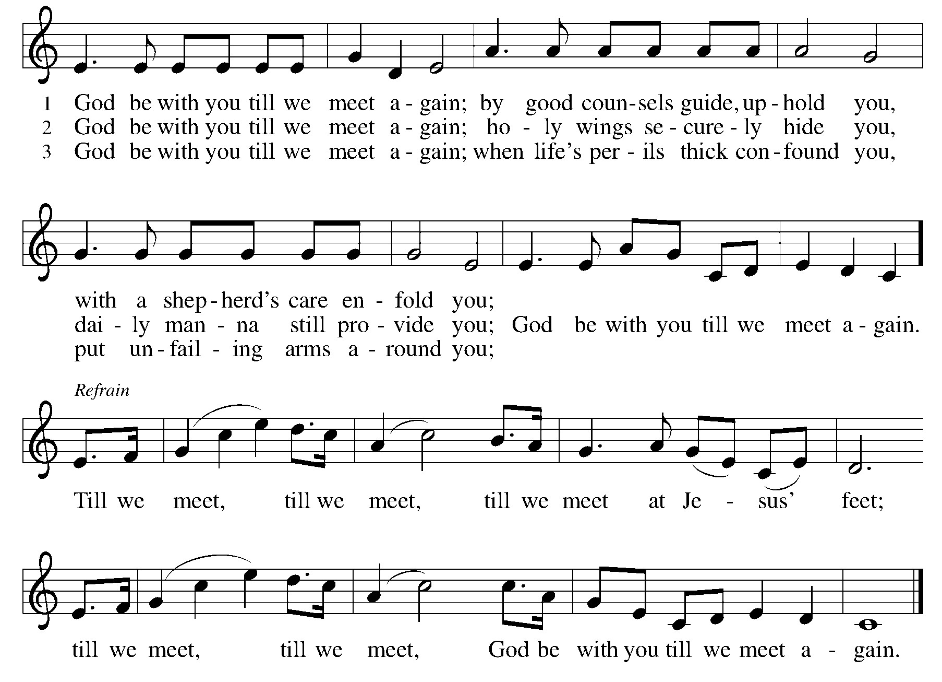
L Go in peace. Serve the Lord. C Thanks be to God!
POSTLUDE

Adult Ed discussion, Sundays October 5 & 12 following worship

Changing the Narrative on Mental Health and Suicide
Mental health and suicide are often difficult topics to discuss, especially within faith communities. This session invites open and honest conversation grounded in compassion, care, and Christian hope. Together, we will explore how our words and attitudes can bring life, reduce stigma, and reflect God’s love to those who are struggling.
We’ll learn how to talk about mental health and suicide in a way that is safe, respectful, and life-giving. We'll discuss how certain language can unintentionally cause harm or discourage people from seeking help and how we can instead speak hope, resilience, and truth into challenging situations.
Who is this for? This session is open to all ages (middle school to adult) who want to be part of creating a more understanding and life-affirming community.
THis Week at Hope
Monday 9/29/25
9:30 am – AA
1:00 pm- Bone Builders

Tuesday 9/30/25
7:15 am – HS Bible Study at WBC
October Simple Supper
Wednesdays at 5:30
Oct 1: Sloppy Joes
Oct 8: Roast Pork & Whipped Potatoes
Oct 15: Tator Tot Hotdish
Oct 22: Taco Salad
Oct 29: Chicken Nuggets & Tator Tots

9:00 am - Card Makers
9:30 am - Bone Builders
GREETING CARDS FOR ALL OCCASIONS are available near the church office for $2 each.
We have confirmation cards! Proceeds support the many ministries of the Women of Hope.

Wednesday 10/1/25
10:00 am – Women of Hope Board Mtg
1:00 pm – Bone Builders
No Joyful Noise or Wednesday Kids
5:30 pm – Simple Supper – Sloppy Joes
6:15 pm –Wednesday worship
6:45 pm – Confirmation Classes
6:45 pm - Sr. High Bible Dive
7:30 pm – Sr High Youth Group

Thursday 10/2/25
8:30 am – Quilters
9:30 am – Bone Builders
11:30 am – Women’s AA

Sunday 10/5/25
9:00 am – Communion Worship
10:00 am – Coffee & Fellowship
6:00 pm – 6th-9th Youth Group

WOULD YOU LIKE TO SERVE AS A SCRIPTURE READER or COMMUNION ASSISTANT during Sunday worship? Leave a message in the church office to be added to the next schedule, or email hope-michelle@arvig.net

USHERS ARE NEEDED for Sunday morning worship services. Not a difficult task – handing out bulletins and directing folks forward for communion. Leave a message in the church office if you would take a shift!

HOPE QUILTERS are in need of bed sheets for quilt backs. If you have any in decent condition that you’d like to donate, leave them in the church office.

Join the pastors for LECTIONARY BIBLE STUDY on Tuesdays at noon, starting in October. Discuss the scripture for the week’s upcoming worship services.
GREETING CARDS FOR ALL OCCASIONS are available near the church office for $2 each. We have confirmation cards! Proceeds support the many ministries of the Women of Hope. Card makers meet on Tuesday morning in the Fellowship Hall. Anyone is welcome to help. All supplies provided! Stop by any Tuesday.

Hope’s Trivia Night, October 16
The Board of Fellowship will be having another trivia contest on Thursday, October 16th starting at 6:00 at Benson's. Gather a team of 2-6 people, or come by yourself and join in with another team. Talk to Lynn Moen or email lydomoen@gmail.com to register your team. We are asking that everyone bring a cash or food donation to benefit the Walker Area Food Shelf. Plan on coming for free food, fellowship and fun with your neighbors. Hope to see you there.

THE WALKER AREA FOOD SHELF is looking for volunteers to join us! We have places for everyone! We need new members to join our board and help chart the course of the next phase of the food shelf. Can't commit that much time? Consider joining our volunteer or fundraising committees. The work done by those bodies will ensure a strong, vibrant food shelf for our community! If you are interested, please contact Andrew Soleta, Executive Director, Walker Area Food Shelf 218-547-1713 walkerfoodshelf@gmail.com

FAITH IN ACTION is in need of VOLUNTEER DRIVERS this fall and winter. Some area residents have no other options for transportation. Volunteers can choose when and how often they are able to help. Drivers can also drive our wheelchair accessible van. Volunteer training, liability insurance, and mileage reimbursement are provided. Call 218-675-5435 for more info.

