15th Sunday after Pentecost
September 21, 2025

Please silence your phone.

Pre-sealed communion kits are available near the entrance if you prefer to remain in the pew during communion distribution.

Device available to assist the hearing impaired. Talk to the sound techs about its use.



Hope Lutheran Church, ELCA
305 10th St. S Walker, MN 56484 218-547-1850
www.hopelutheranchurch-walker.com
Pastor Matt McWaters & Pastor Dave Smith
Hope’s House Band: Rick & Leslie James,
Jill Anderson & Mike Kerrigan
Reader: Nancy Bruns Usher: Harlan Anderson
Acolyte:

TODAY’S WORSHIP BROADCAST is given by Harley & Judy Melin, in celebration of their 55th wedding anniversary. The 9:00 a.m. service is broadcast live on KQKK 102 FM radio, and also on Channel 21.5 Leech Lake TV; or log on to leechlaketv.org. BROADCAST SPONSORS ARE NEEDED. You can sponsor the broadcast on the date of your choice for $75. Sign up on the bulletin board across from the church office.

Offering plates are located near the sanctuary entrance.

Welcome to Worship

PRELUDE Hope’s House Band
WELCOME & ANNOUNCEMENTS
TEMPLE TALK Stewardship Relay Kyle Duclos
(please stand)
CONFESSION
Silence for reflection and self-examination.
C We are the all, who have sinned and fall short of the glory of God. We have collectively and individually, knowingly and unknowingly, sinned against you and our neighbor. Forgive us we pray.
P Our faithful and just God, promises to forgive our sins, and cleanse us from all unrighteousness. In the name of Christ, your sins are forgiven. And all God’s people responded... Amen. Amen. Thanks be to God.

KYRIE (congregation join in refrain below)
C Kyrie eleison, on our world and on our way. Kyrie eleison, ev’ry day.
1. For peace in the world, for the health of the church, for the unity of all;
for this holy house, for all who worship and praise, let us pray to the Lord, let us pray to the Lord.
C Kyrie eleison, on our world and on our way. Kyrie eleison, ev’ry day.
2. For peace in our hearts, for peace in our homes, for friends and family;
for life and for love, for our work and our play, let us pray to the Lord, let us pray to the Lord.
C Kyrie eleison, on our world and on our way. Kyrie eleison, ev’ry day.
3. For your Spirit to guide; that you center our lives in the water and the word;
that you nourish our souls with your body and blood, let us pray to the Lord, let us pray to the Lord.
C Kyrie eleison, on our world and on our way. Kyrie eleison, ev’ry day.

HYMN OF PRAISE
Glory to God in the highest, the highest, and peace to God’s people on earth.
1) Lord God, heavenly King, almighty God and Father,
We worship you, we give you thanks, we praise you for your glory.
Glory to God in the highest, the highest, and peace to God’s people on earth.
2) For you alone are the Holy One, you alone are the Lord,
you alone are the Most High, Jesus Christ, with the Holy Spirit,
in the glory of God the Father. Amen. Amen. Amen
Glory to God in the highest, the highest, and peace to God’s people on earth.
Glory to God in the highest, the highest, and peace to God’s people on earth.

God among us, we gather in the name of your Son to learn love for one another. Keep our feet from evil paths. Turn our minds to your wisdom and our hearts to the grace revealed in your Son, Jesus Christ, our Savior and Lord. Amen. (please be seated)

ANTHEM “God So Loved” Hope’s House Band
Kids minute Children are invited to the front of the sanctuary for a brief message with the pastor. Afterwards, kids are invited to the Music Room for a video and story about the message. They will return to the sanctuary shortly after the sermon concludes.

LESSON: Amos 8:4-7

Psalm 113
¹ Hallelujah! Give praise, you servants of the Lord; praise the name of the Lord.
² Let the name of the Lord be blessed, from this time forth forevermore.
³ From the rising of the sun to its going down let the name of the Lord be praised.
⁴ The Lord is high above all nations; God’s glory above the heavens.
⁵ Who is like the Lord our God, who sits enthroned on high,
⁶ but stoops to behold the heavens and the earth?
⁷ The Lord takes up the weak out of the dust and lifts up the poor from the ashes,
⁸ enthroning them with the rulers of the people.
⁹ The Lord makes the woman of a childless house
to be a joyful mother of children. Hallelujah!

(please stand)
Alleluia. Lord to whom shall we go? You have the words of eternal life.
Alleluia. Alleluia, alleluia. Alleluia. Alleluia, alleluia.

P The Holy Gospel according to St. Luke, the 16th chapter.
C Glory to you, O Lord.
GOSPEL: Luke 16:1-13
(please be seated)
MESSAGE Pastor Matt
(please stand)
SONG “We Are an Offering”
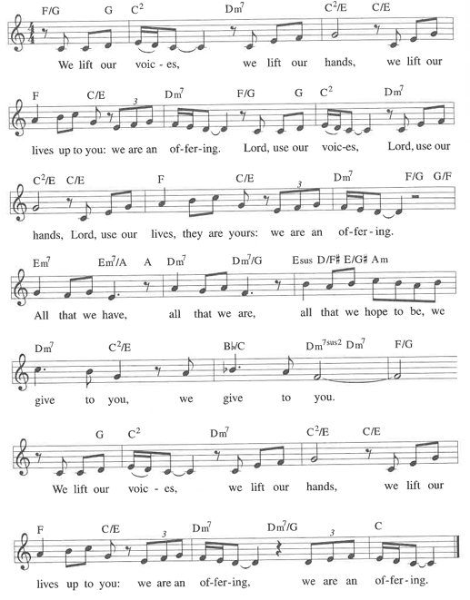
APOSTLES CREED
THE PRAYERS (each petition will end “Lord, in your mercy”. Please respond)
C Hear our prayer.
SHARING OF THE PEACE please pass the Friendship Register
P The Lord be with you. C And also with you.
P Lift up your hearts. C We lift them to the Lord.
P Let us give thanks to the Lord our God.
C It is right to give our thanks and praise.
WORDS OF INSTITUTION
LORD’S PRAYER
(please be seated)
THE COMMUNION music by Hope’s House Band
(please stand)
BLESSING
BENEDICTION
SENDING SONG “Shout to the Lord”
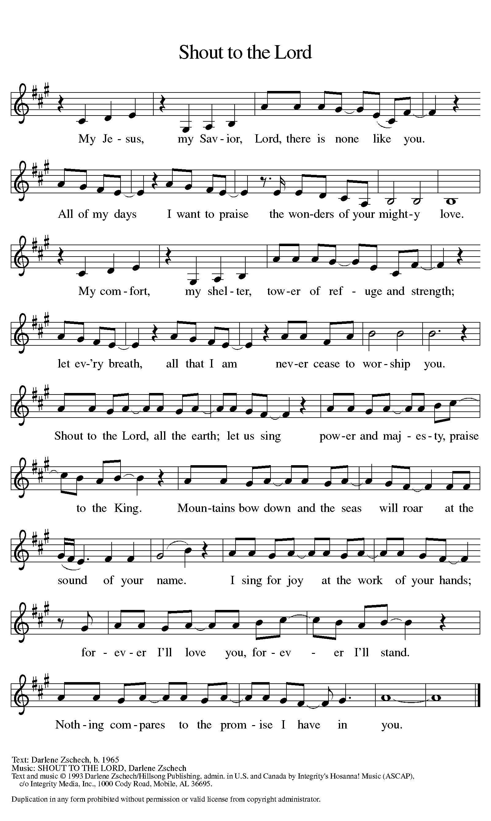

Everyone is invited for coffee in the Fellowship Hall following worship!

The Stewardship Relay begins TOday!
Sometime in the next few weeks a neighbor may deliver a packet to your home with an opportunity for you to make an estimate of your planned giving to Hope’s ministry during the upcoming year. Follow the instructions on the packet and deliver it to the next household.
Due to geographical logistics or health considerations, not every household was assigned to a relay route. You may receive your estimate of giving in the mail if we’ve determined it likely made more sense than adding you to a route.
All ladies are invited to the…
Living Waters Fall Gathering
Saturday, September 27th
On Saturday, September 27th, Hope Lutheran will be the host site for the Fall Women’s Gathering for the Living Waters Conference of our synod. The theme for the day is “Readiness, Stewardship, Compassion.” Morning coffee and registration begins at 8:30 a.m. Registration is $10, which includes lunch. Our program will be a presentation on world hunger by Jane Grundmeier of the Northeastern MN Synodical Women’s Organization. We encourage all ladies to attend and are hoping for a good turn out from our Hope gals! It is a good opportunity to meet other women from our conference and learn about what is happening in our churches, conference and synod.

THis Week at Hope
Monday 9/22/25
9:00 am – Northwoods Quilters
9:30 am – AA
1:00 pm- Bone Builders
5:30 pm – Hope Council

Tuesday 9/23/25
7:15 am – HS Bible Study at WBC

9:00 am - Card Makers
9:30 am - Bone Builders

Wednesday 9/24/25
1:00 pm – Bone Builders
3:30 pm – Joyful Noise practice
4:15 pm – Wednesday Kids
5:30 pm – Simple Supper – Chicken ala King
6:15 pm –Wednesday worship
6:45 pm – Confirmation Classes

Thursday 9/25/25
8:30 am – Quilters
9:30 am – Bone Builders
11:30 am – Women’s AA

Saturday 9/27/25
GREETING CARDS FOR ALL OCCASIONS are available near the church office for $2 each.
We have confirmation cards! Proceeds support the many ministries of the Women of Hope.
8:30 am – Women’s Fall Gathering

Sunday 9/28/25
9:00 am – Communion Worship
10:00 am – Coffee & Fellowship
WE INVITE YOU TO JOIN IN OUR MINISTRY at Hope Lutheran Church through membership. If you would like to become a member, please check the appropriate box on the Friendship Register or leave a message in the church office, including your phone number.

WOULD YOU LIKE TO SERVE AS A SCRIPTURE READER or COMMUNION ASSISTANT during Sunday worship? Leave a message in the church office to be added to the next schedule, or email hope-michelle@arvig.net

HOPE QUILTERS are in need of bed sheets for quilt backs. If you have any in decent condition that you’d like to donate, leave them in the church office.

Adult Ed discussion, Sundays October 5 & 12 following worship

Changing the Narrative on Mental Health and Suicide
Mental health and suicide are often difficult topics to discuss, especially within faith communities. This session invites open and honest conversation grounded in compassion, care, and Christian hope. Together, we will explore how our words and attitudes can bring life, reduce stigma, and reflect God’s love to those who are struggling.
We’ll learn how to talk about mental health and suicide in a way that is safe, respectful, and life-giving. We'll discuss how certain language can unintentionally cause harm or discourage people from seeking help and how we can instead speak hope, resilience, and truth into challenging situations.
Who is this for? This session is open to all ages (middle school to adult) who want to be part of creating a more understanding and life-affirming community.

Hope’s Trivia Night, October 16
The Board of Fellowship will be having another trivia contest on Thursday, October 16th starting at 6:00 at Benson's. Gather a team of 2-6 people, or come by yourself and join in with another team. Talk to Lynn Moen or email lydomoen@gmail.com to register your team. We are asking that everyone bring a cash or food donation to benefit the Walker Area Food Shelf. Plan on coming for free food, fellowship and fun with your neighbors. Hope to see you there.

GRIEVING A LOSS? Find hope and healing after the death of a loved one. Grief Share weekly grief support group will be meeting at Calvary Church in Walker on Thursdays from 1:00-3:00 September 25th-December18th. Pick up a brochure from the bulletin board near Hope’s restrooms, or go online to griefshare.org/findagroup. For more info, contact Cynthia Carlson carlsoncounseling@yahoo.com.

THE WALKER AREA FOOD SHELF is looking for volunteers to join us! We have places for everyone! We need new members to join our board and help chart the course of the next phase of the food shelf. Can't commit that much time? Consider joining our volunteer or fundraising committees. The work done by those bodies will ensure a strong, vibrant food shelf for our community! If you are interested, please contact Andrew Soleta, Executive Director, Walker Area Food Shelf 218-547-1713 walkerfoodshelf@gmail.com

FAITH IN ACTION is in need of VOLUNTEER DRIVERS this fall and winter. Some area residents have no other options for transportation. Volunteers can choose when and how often they are able to help. Drivers can also drive our wheelchair accessible van. Volunteer training, liability insurance, and mileage reimbursement are provided. Call 218-675-5435 for more info.


