14th Sunday after Pentecost
September 14, 2025

Please silence your phone.

Pre-sealed communion kits are available near the entrance if you prefer to remain in the pew during communion distribution.

Device available to assist the hearing impaired. Talk to the sound techs about its use.



Hope Lutheran Church, ELCA
305 10th St. S Walker, MN 56484 218-547-1850
www.hopelutheranchurch-walker.com

Pastor Matt McWaters and Pastor Dave Smith
Accompanist: Mike Kerrigan
Reader: Zac Virnig Usher: Wayne Osatiuk
Communion: Dave & Pam Johnson

Welcome to worship
PRELUDE
WELCOME & ANNOUNCEMENTS
(please stand)
P In the name of the Father, and of the Son, and of the Holy Spirit. C Amen
P: God of all mercy and consolation, come to the help of your people, turning us from sin to live for you alone. Give us the power of your Holy Spirit that we may confess our sin, receive your forgiveness, and glorify you, through Jesus Christ our Lord. Amen.

Silence is kept for reflection.
Gracious God,
Have mercy on us. We confess that we have turned from you and given ourselves into the power of sin. We are truly sorry and humbly repent. In your compassion forgive us our sins, known and unknown, things we have done and things we have failed to do. Turn us again to you, and uphold us by your Spirit, so that we may live and serve you in newness of life through Jesus Christ, our Savior and Lord. Amen.

Even when we are faithless, God remains faithful. Jesus Christ came into the world to save sinners. You who were lost have been found. In the name of ☩ Jesus, your sins are forgiven!
Amen, Thanks be to God!
OPENING HYMN (green hymnal #459) “O Holy Spirit Enter In”
L The grace of our Lord Jesus Christ, the love of God, and the communion of the Holy Spirit be with you all. C And also with you.

KYRIE congregation responds:
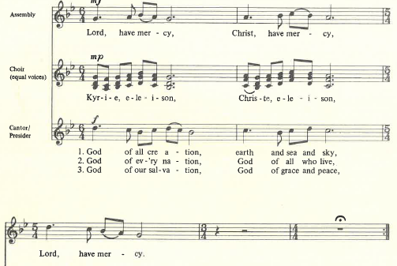

HYMN OF PRAISE congregation responds:
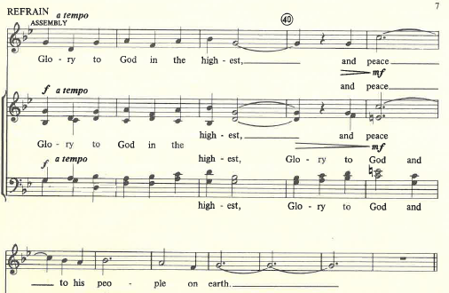

P: Lord God, heavenly King, almighty God and Father, we worship you,
we give you thanks, we praise you for your glory. Refrain (above)

P: Lord Jesus Christ, only Son of the Father, Lord God, Lamb of God, you take away the sin of the world: have mercy on us; you are seated at the right hand of the Father: Refrain (above)

P: For you alone are the Holy One, you alone are the Lord, you alone are the Most High,
Jesus Christ, with the Holy Spirit, in the glory of God, the Father Amen! Amen! Refrain (above)
L Let us pray.
C O God, overflowing with mercy and compassion, you lead back to yourself all those who go astray. Preserve your people in your loving care, that we may reject whatever is contrary to you and may follow all things that sustain our life in your Son, Jesus Christ, our Savior and Lord. Amen
(please be seated)

ANTHEM “The Lord Is My Shepherd” Hope Lutheran Chancel Choir
Kids minute Children are invited to the front of the sanctuary for a brief message with the pastor. Afterwards, kids are invited to the Music Room for a video and story about the message. They will return to the sanctuary shortly after the sermon concludes.

LESSON: Exodus 32:7-14

PSALM 51:1-10
¹ Have mercy on me, O God, according to your steadfast love;
in your great compassion blot out my offenses.
² Wash me through and through from my wickedness,
and cleanse me from my sin.
³ For I know my offenses, and my sin is ever before me.
⁴ Against you only have I sinned and done what is evil in your sight;
so you are justified when you speak and right in your judgment.
⁵ Indeed, I was born steeped in wickedness, a sinner from my mother’s womb.
⁶ Indeed, you delight in truth deep within me,
and would have me know wisdom deep within.
⁷ Remove my sins with hyssop, and I shall be clean;
wash me, and I shall be purer than snow.
⁸ Let me hear joy and gladness; that the body you have broken may rejoice.
⁹ Hide your face from my sins, and blot out all my wickedness.
¹⁰ Create in me a clean heart, O God, and renew a right spirit within me.

(please stand)
GOSPEL ACCLAIMATION congregation responds:
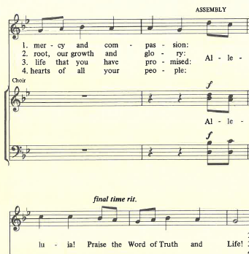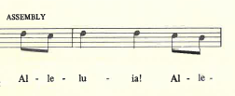

GOSPEL: Luke 15:1-10
(please be seated)
MESSAGE Pastor Matt

(please stand)
HYMN (blue hymnal #778) “O Christ the Same”
APOSTLES CREED
PRAYERS (each petition will end “Lord, in your mercy”. Please respond)
C hear our prayer.

SHARING OF THE PEACE please pass the Friendship Register

P The Lord be with you. C And also with you.
P Lift up your hearts. C We lift them to the Lord.
P Let us give thanks to the Lord our God. C It is right to give our thanks and praise.
WORDS OF INSTITUTION
LORD’S PRAYER
(please be seated)
THE COMMUNION please sing the following hymns during communion
“Savior Like a Shepherd Lead Us” and “We Remember You”
(please stand)
BLESSING
BENEDICTION
HYMN (green hymnal #557) “Let All Things Now Living”
L Go in peace. Serve the Lord. C Thanks be to God!

POSTLUDE
Everyone is invited for coffee in the Fellowship Hall following worship

TODAY’S WORSHIP BROADCAST is given by Gloria Niswonger, in loving memory of husband Bill. The 9:00 a.m. service is broadcast live on to leechlaketv.org. You can also tune in to KQKK 102 FM radio, or Channel 21.5 Leech Lake TV. Broadcast sponsors are needed. You can sponsor the broadcast on the date of your choice for $75. Sign up on the bulletin board across from the church office.

FLOWERS IN THE CHANCEL are given in celebration of Ann Harris’ 90th birthday!

WE INVITE YOU TO JOIN IN OUR MINISTRY at Hope Lutheran Church through membership. If you would like to become a member, please check the appropriate box on the Friendship Register or leave a message in the church office, including your phone number.

WOULD YOU LIKE TO SERVE AS A SCRIPTURE READER or COMMUNION ASSISTANT during Sunday worship? Leave a message in the church office to be added to the next schedule, or email hope-michelle@arvig.net

HOPE’S CELEBRATION HANDBELL CHOIR rehearses Wednesdays at 4:30. We could use more ringers! Anyone interested is encouraged to stop by.
THis Week at Hope
Monday 9/15/25
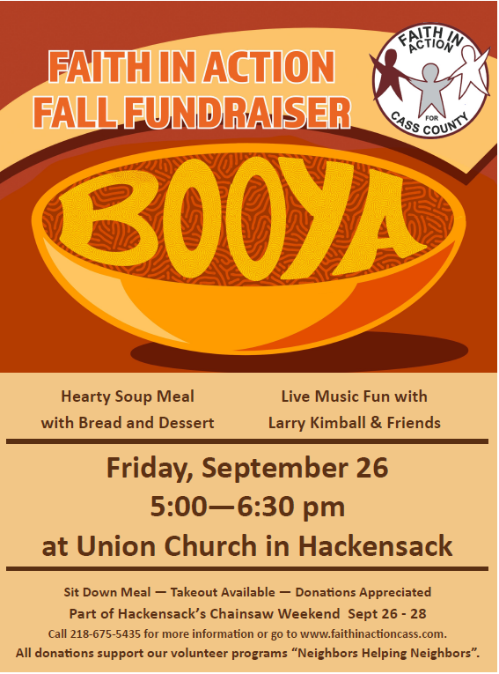

Wednesday Simple Supper & Worship
Join the family of Hope for a light meal
at 5:30
Menu
Sept 17: Scalloped Potatoes & Ham
Sept 24: Chicken ala King on a biscuit

Followed by casual worship at 6:15
9:00 am – Hope’s Habitat Crew in CL
9:30 am – AA
1:00 pm- Bone Builders

Tuesday 9/16/25
7:15 am – HS Bible Study at WBC
9:00 am - Card Makers
9:30 am - Bone Builders

Wednesday 9/17/25
8:30 am – 6th-8th grade Release Time
1:00 pm – Bone Builders
3:30 pm – Joyful Noise practice
4:15 pm – Wednesday Kids
4:30 pm – Celebration Handbells
5:30 pm – Simple Supper –
Scalloped Potatoes & Ham
6:15 pm –Wednesday worship
6:45 pm – 9th Grade Confirmation

Thursday 9/18/25
8:30 am – Quilters
9:30 am – Bone Builders
11:30 am – Women’s AA

Friday 9/19/25
9:00 am – Kitchen cleaning

Sunday 9/21/25
9:00 am – Communion Worship
10:00 am – Coffee & Fellowship

FAITH IN ACTION is in need of VOLUNTEER DRIVERS this fall and winter. Some area residents have no other options for transportation. Volunteers can choose when and how often they are able to help. Drivers can also drive our wheelchair accessible van. Volunteer training, liability insurance, and mileage reimbursement are provided. Call 218-675-5435 for more info.
HOPE QUILTERS are in need of bed sheets for quilt backs. If you have any in decent condition that you’d like to donate, leave them in the church office.
Hope Lutheran Habitat for Humanity
Workday in Cass Lake, TOMORROW.
There are currently four Habitat builds in various stages of construction in our neighboring community of Cass Lake and they need help. Currently the bulk of the work is being done by the construction supervisor and his sons. Securing enough volunteers to move the houses forward in a timely manner has been a challenge at best. But, hope is still alive. Tomorrow a crew from Hope Lutheran is heading to Cass Lake to help! The day will begin at 9:00 am and run until about 3:00 pm. If you’d like to join in, you can come for all or part of the day. Lunch will be provided. All are invited…all are needed. Tasks will range from cleaning to construction. There are tasks for every age (over 16) and every skill level or lack thereof. There is a sign-up sheet on a table in the Narthex. If you have any questions contact Pastor Dave 218-507-0190.

GRIEVING A LOSS? Find hope and healing after the death of a loved one. Grief Share weekly grief support group will be meeting at Calvary Church in Walker on Thursdays from 1:00-3:00 September 25th-December18th. Pick up a brochure from the bulletin board near Hope’s restrooms, or go online to griefshare.org/findagroup. For more info, contact Cynthia Carlson carlsoncounseling@yahoo.com.

The Stewardship Relay begins next Sunday!
Sometime in the next few weeks a neighbor may deliver a packet to your home with an opportunity for you to make an estimate of your planned giving to Hope’s ministry during the upcoming year. More info next Sunday…. which route will complete the relay first??

All ladies are invited to the NE MN Synod…
Living Waters Fall Gathering
Saturday, September 27th
On Saturday, September 27th, Hope Lutheran will be the host site for the Fall Women’s Gathering for the Living Waters Conference of our synod. The theme for the day is “Readiness, Stewardship, Compassion.” Morning coffee and registration begins at 8:30 a.m. Registration is $10, which includes lunch. Our program will be a presentation on world hunger by Jane Grundmeier of the Northeastern MN Synodical Women’s Organization. We encourage all ladies to attend and are hoping for a good turn out from our Hope gals! It is a good opportunity to meet other women from our conference and learn about what is happening in our churches, conference and synod.

THE WALKER AREA FOOD SHELF is looking for volunteers to join us! We have places for everyone! We need new members to join our board and help chart the course of the next phase of the food shelf. Can't commit that much time? Consider joining our volunteer or fundraising committees. The work done by those bodies will ensure a strong, vibrant food shelf for our community! If you are interested, please contact Andrew Soleta, Executive Director, Walker Area Food Shelf 218-547-1713 walkerfoodshelf@gmail.com

