12th Sunday after Pentecost
August 31, 2025

Please silence your phone.

Pre-sealed communion kits are available near the entrance if you prefer to remain in the pew during communion distribution.

Device available to assist the hearing impaired. Talk to the sound techs about its use.



Hope Lutheran Church, ELCA
305 10th St. S Walker, MN 56484 218-547-1850
www.hopelutheranchurch-walker.com

Pastor Matt McWaters and Pastor Dave Smith
Accompanist: Mike Kerrigan Reader: Al Sanford Usher: Harlan Anderson
Communion: Al Sanford & Tanis Beadle

TODAY’S WORSHIP BROADCAST is given by Juliane Proper, in loving memory of husband Greg. The 9:00 a.m. service is broadcast live on to leechlaketv.org. You can also tune in to KQKK 102 FM radio, or Channel 21.5 Leech Lake TV. You can sponsor the broadcast on the date of your choice for $75. Sign up on the bulletin board across from the church office.

Welcome to worship
PRELUDE
WELCOME & ANNOUNCEMENTS
(please stand)
HYMN (blue hymnal #734 vs 1&3) “Softly and Tenderly, Jesus is Calling”
P In the name of the Father, and of the Son, and of the Holy Spirit. C Amen
P: We confess, O God,
C Sin binds us. Our words, our hands, our feet, and our whole being. Individually we harm the lives of our neighbors, knowingly and unknowingly. Collectively, we participate in systems that oppress some and ignore others. We look to ourselves and not you. Forgive us we pray. Amen
P: Hear the good news! In the name of Jesus your sins are forgiven. To those who have faith in Jesus, God gives the power to become children of God, bestowing upon them the Holy Spirit!

(please be seated)
HYMN (below vs 1-4) “All Are Welcome”
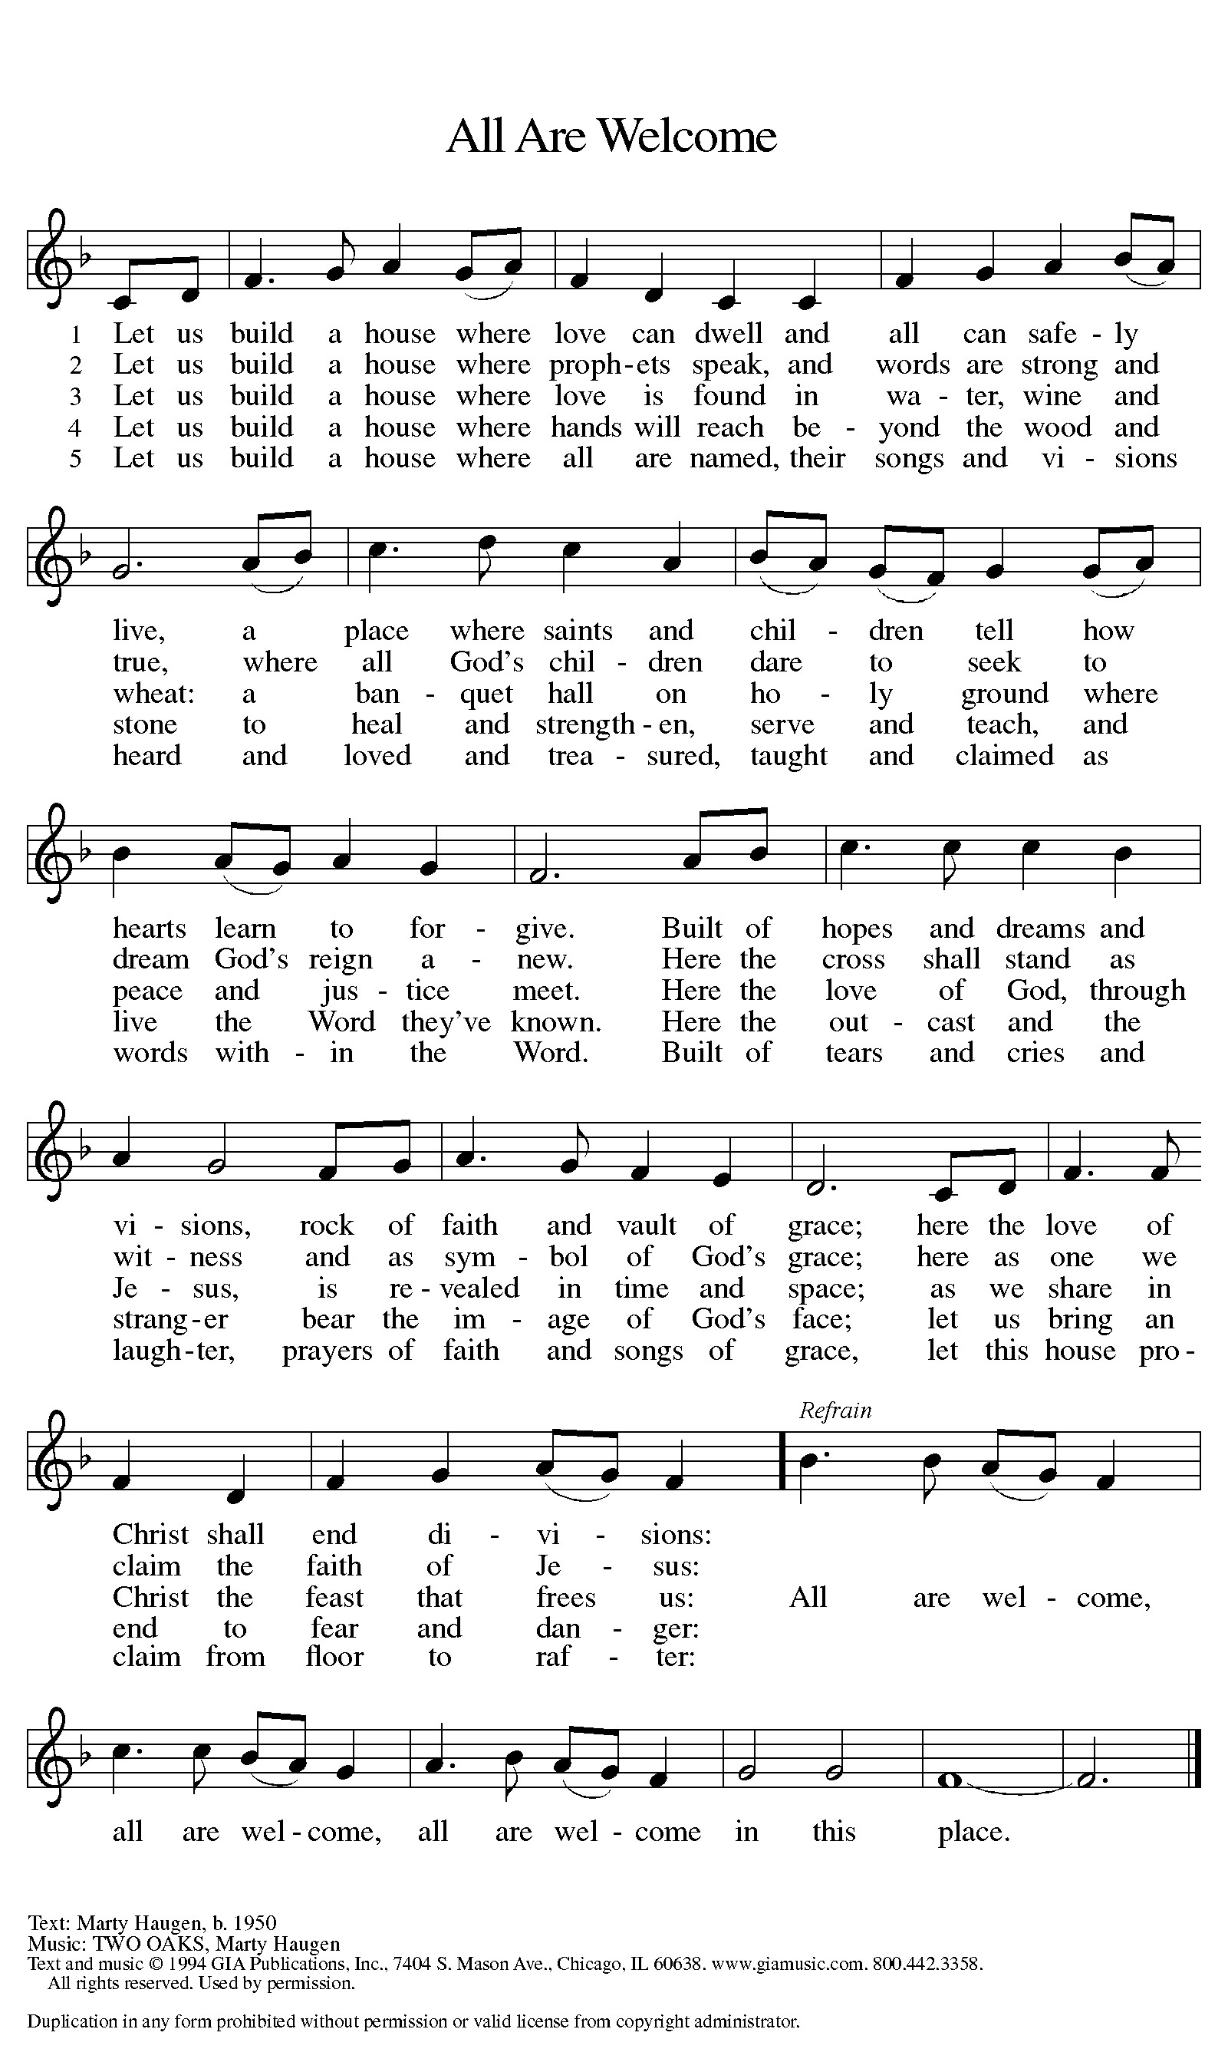

O God, you resist those who are proud and give grace to those who are humble. Give us the humility of your Son, that we may embody the generosity of Jesus Christ, our Savior and Lord. Amen

ANTHEM “There Is a Redeemer” Tom & Melissa O’Neill
CHILDREN’S MESSAGE kids are invited to the front of the sanctuary

LESSON: Proverbs 25:6-7a

Psalm 112
¹ Hallelujah! Happy are they who fear the Lord and have great delight in God’s commandments!
² Their descendants will be mighty in the land;
the generation of the upright will be blessed.
³ Wealth and riches will be in their house, and their righteousness will last forever.
⁴ Light shines in the darkness for the upright;
the righteous are merciful and full of compassion.
⁵ It is good for them to be generous in lending and to manage their affairs with justice.
They will never be shaken; the righteous will be kept in everlasting remembrance.
⁷ They will not be afraid of any evil rumors; their heart is steadfast, trusting in the Lord.
⁸ Their heart is established and will not shrink,
until they see their desire upon their enemies.
⁹ They have given freely to the poor, and their righteousness stands fast forever;
they will hold up their head with honor.
¹⁰ The wicked will see it and be angry; they will gnash their teeth
and pine away; the desires of the wicked will perish.
(please stand)

GOSPEL: Luke 14:1, 7-14
(please be seated)
MESSAGE Pastor Matt

(please stand)
HYMN (green hymnal #433) “The Church of Christ in Every Age”
APOSTLES CREED
PRAYERS (each petition will end “Lord, in your mercy”. Please respond)
C hear our prayer.
SHARING OF THE PEACE please pass the Friendship Register

P The Lord be with you. C And also with you.
P Lift up your hearts. C We lift them to the Lord.
P Let us give thanks to the Lord our God. C It is right to give our thanks and praise.
WORDS OF INSTITUTION
LORD’S PRAYER
(please be seated)
THE COMMUNION please sing the following hymns during communion
(Blue hymnal #765) “Jesu, Jesu, Fill Us With Your Love”
(Green hymnal #370) “Blest Be the Tie that Binds”
(please stand)
BLESSING
BENEDICTION
SENDING HYMN (blue hymnal #723) “The Spirit Sends us Forth to Serve”
L Go in peace. Serve the Lord. C Thanks be to God!

POSTLUDE
Everyone is invited for coffee in the Fellowship Hall following worship

WE INVITE YOU TO JOIN IN OUR MINISTRY at Hope Lutheran Church through membership. If you would like to become a member, please check the appropriate box on the Friendship Register or leave a message in the church office, including your phone number.

Hope Lutheran Habitat for Humanity Workday in Cass Lake
There are currently four Habitat builds in various stages of construction in our neighboring community of Cass Lake and they need help. Currently the bulk of the work is being done by the construction supervisor and his sons. Securing enough volunteers to move the houses forward in a timely manner has been a challenge at best. But, hope is still alive.
The Outreach committee of Hope Lutheran is sponsoring a workday for Habitat on Monday, Sept 15. The day will begin at 9:00 am and run until about 3:00 pm. However, you can come for all or part of the day. Lunch will be provided. All are invited…all are needed. Tasks will range from cleaning to construction. There are tasks for every age (over 16) and every skill level or lack thereof. There is a sign-up sheet on a table in the Narthex so we can have an idea, for planning purposes, of how many will participate in this special event. If you have any questions contact Pastor Dave 218-507-0190 or the church office.

All ladies are invited to…
Women of Hope Fall Meeting and Brunch
Saturday, September 6th at 11:00
Brunch provided by Hope’s circles.
CORRECTION! No need to bring your Gather magazine to this meeting. The last of the Gather series on “Relationships” features the story of Esther. Come to see the drama of the “star” in the biblical book of Esther. Perhaps you’ll be asked :) to play a part in the skit! All ladies are welcome!

THis Week at Hope
Monday 9/1/25 – OFFICE CLOSED

9:30 am – AA
1:00 pm- Bone Builders

Tuesday 9/2/25
7:30 am – High School Bible Study
at Walker Bay Coffee
9:00 am - Card Makers
9:30 am - Bone Builders

Wednesday 9/3/25
1:00 pm – Bone Builders

Thursday 9/4/25
8:30 am – Quilters
9:30 am – Bone Builders
11:30 am – Women’s AA

Saturday 9/6/25
9:00 am – Women of Hope Board Mtg
11:00 am – Women’s Brunch

Sunday 9/7/25 – Rally Sunday!
9:00 am – Communion Worship
10:00 am – Coffee & Fellowship
11:00 am – Holy Smokes Cook Out

Wednesday Simple Supper & Worship begins September 10th!
Join the family of Hope for a light meal at 5:30
Menu
Sept 10: Pulled Pork Sandwich & Chips
Sept 17: Scalloped Potatoes & Ham
Sept 24: Chicken ala King on a biscuit

Followed by casual worship at 6:15

