8th Sunday after Pentecost
August 3, 2025

Please silence your phone.

Pre-sealed communion kits are available near the entrance if you prefer to remain in the pew during communion distribution.

Device available to assist the hearing impaired. Talk to the sound techs about its use.

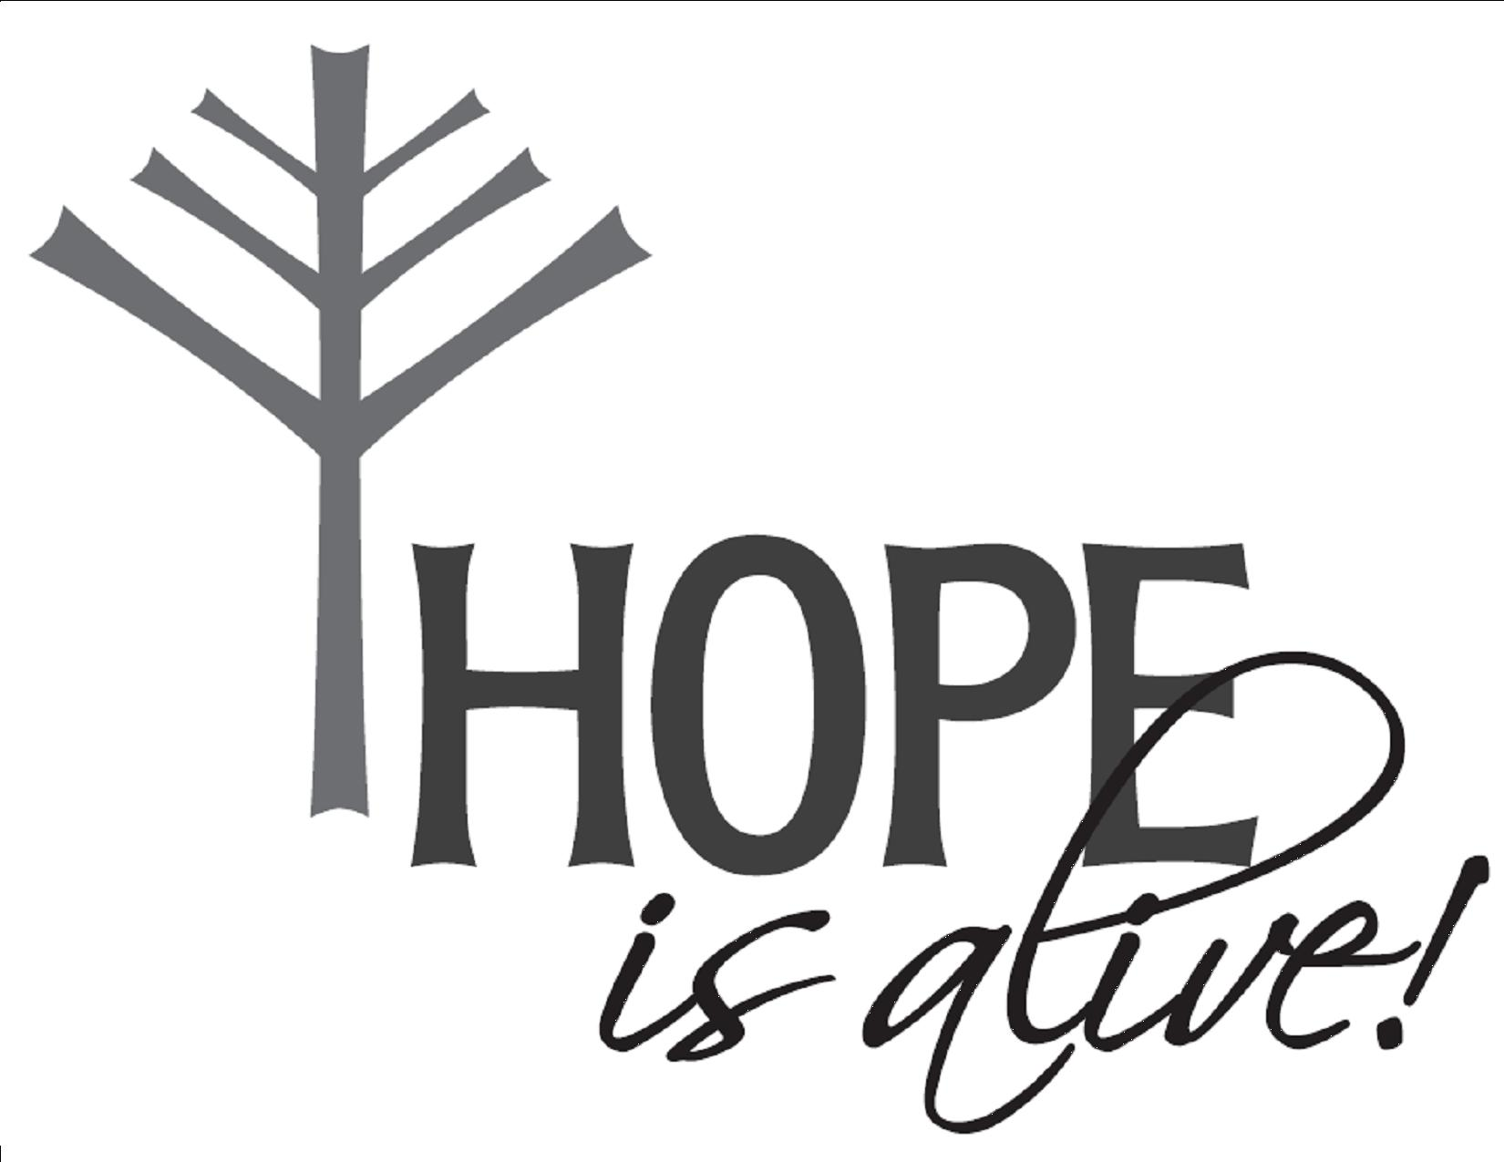

Hope Lutheran Church, ELCA
305 10th St. S Walker, MN 56484 218-547-1850
www.hopelutheranchurch-walker.com
Pastor Matt McWaters and Pastor Dave Smith
Liturgist: Pat Roush Accompanist: Mike Kerrigan
Ushers: Malard Family

Offering plates are located near the sanctuary entrance.

TODAY’S WORSHIP BROADCAST is given by Jan Filkins, with prayers for peace. The 9:00 a.m. worship service is broadcast live on KQKK 102 FM radio, and also on Channel 21.5 Leech Lake TV. You can also log on to leechlaketv.org.

Welcome to Worship

PRELUDE
WELCOME & ANNOUNCEMENTS
TEMPLE TALK National Night Out
HYMN (blue hymnal #756 vs 1,2,4,5) “Lord, You Give the Great Commission”
CONFESSION & FORGIVENESS
(Silence for reflection and self-examination)
C We are the all, who have sinned and fall short of the glory of God. We have collectively and individually, knowingly and unknowingly, sinned against you and our neighbor. Forgive us we pray.
P Our faithful and just God, promises to forgive our sins, and cleanse us from all unrighteousness. In the name of Christ, your sins are forgiven. And all God’s people responded...
C Amen. Amen. Thanks be to God.
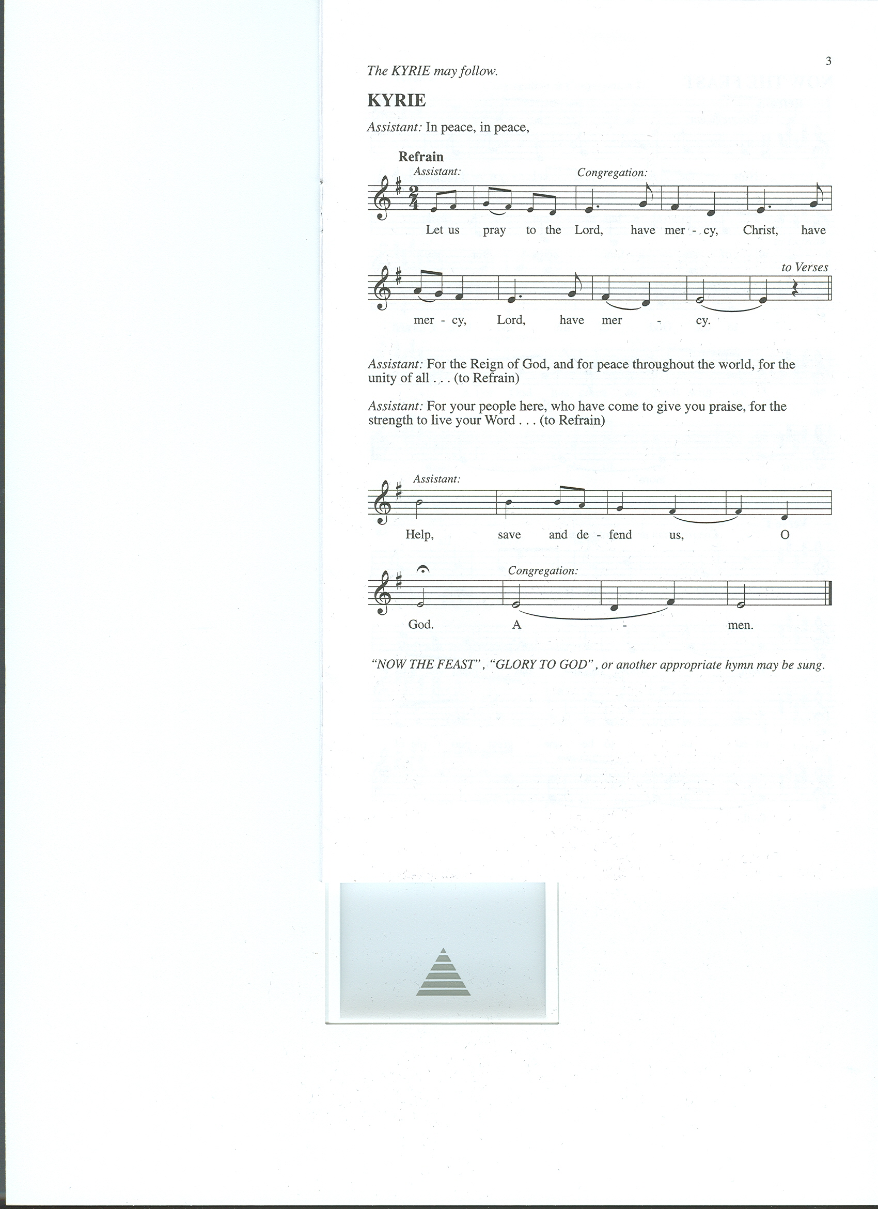
KYRIE (below)
L In peace, in peace let us pray to the...

Congregation Responds:

L For the Reign of God, and for peace throughout the world, for the unity of all, let us pray to the…
(Repeat Congregational Response)
L For your people here, who have come to give you praise, for the strength to live your Word, let us pray to the… (Repeat Congregational Response)
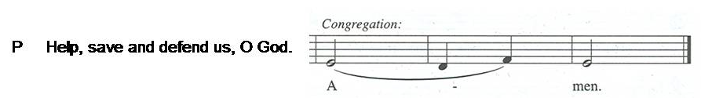
HYMN OF PRAISE (words below) “Now the Feast and Celebration”
Now the feast and celebration, all of creation sings for joy
To the God of life and love and freedom: praise and glory forevermore!
Now is the feast of the Lamb once slain,
whose blood has freed and united us to be one great people of God.
Now the feast and celebration, all of creation sings for joy
To the God of life and love and freedom: praise and glory forevermore!
For God has come to dwell with us, to make us people of God;
To make all things new.
Now the feast and celebration, all of creation sings for joy
To the God of life and love and freedom: praise and glory forevermore!

C Benevolent God, you are the source, the guide, and the goal of our lives. Teach us to love what is worth loving, to reject what is offensive to you, and to treasure what is precious in your sight, through Jesus Christ, our Savior and Lord. Amen (please be seated)

KIDS’ MINUTE Children are invited to the front of the sanctuary

LESSON: Ecclesiastes 1:2, 12-14; 2:18-23

Psalm 49:1-12
¹ Hear this, all you peoples; give ear, all you who dwell in the world,
² you of high degree and low, rich and poor together.
³ My mouth shall speak of wisdom, and my heart shall meditate on understanding.
⁴ I will incline my ear to a proverb and set forth my riddle upon the harp.
⁵ Why should I be afraid in evil days,
when the wickedness of those at my heels surrounds me,
⁶ the wickedness of those who put their trust in their own prowess,
and boast of their great riches?
⁷ One can never redeem another, or give to God the ransom for another’s life;
⁸ for the ransom of a life is so great
that there would never be enough to pay it,
⁹ in order to live forever and ever and never see the grave.
¹⁰ For we see that the wise die also; like the dull and stupid they perish
and leave their wealth to those who come after them.
¹¹ Their graves shall be their homes forever, their dwelling places
from generation to generation, though they had named lands after themselves.
¹² Even though honored, they cannot live forever;
they are like the beasts that perish.

(please stand)
Alleluia, alleluia. Lord to whom shall we go?
You have the words of eternal life. Alleluia!

GOSPEL: Luke 12:13-21
MESSAGE Pastor Matt McWaters
(please stand)
HYMN (green hymnal #518) “Beautiful Savior”
APOSTLES CREED
C I believe in God, the Father almighty, creator of heaven and earth.
I believe in Jesus Christ, his only Son, our Lord. He was conceived by the power of the Holy Spirit and born of the virgin Mary. He suffered under Pontius Pilate, was crucified, died, and was buried. He descended into hell. On the third day he rose again. He ascended into heaven, and is seated at the right hand of the Father. He will come again to judge the living and the dead.
I believe in the Holy Spirit, the holy catholic Church, the communion of saints, the forgiveness of sins, the resurrection of the body, and the life everlasting. Amen

PRAYERS (please sing the canticle below after each petition)
Lord, listen to your children praying,
Lord, send your Spirit in this place;
Lord, listen to your children praying,
send us love, send us pow’r, send us grace.

SHARING OF THE PEACE Please pass the Friendship Register
P The Lord be with you. C And also with you.
P Lift up your hearts. C We lift them to the Lord.
P Let us give thanks to the Lord our God.
C It is right to give him thanks and praise.
L It is indeed right, our duty and our joy…we praise your name and join their unending hymn:
Holy, holy, holy are you, God of power and might;
Heaven and earth are filled with your glory.
Hosanna in the highest!
Blessed is the One who comes in your name.
Hosanna in the highest, hosanna in the highest!

WORDS OF INSTITUTION
LORD’S PRAYER
(please be seated)
THE COMMUNION please sing the following hymns during distribution
(Green hymnal #406) “Take My Life that I May Be”
(Green hymnal #410) “We Give Thee but Thine Own”

(please stand)
COMMUNION BLESSING
BENEDICTION
SENDING HYMN (green hymnal #343) “Guide Me Ever, Great Redeemer”
P Go in peace, serve the Lord. C Thanks be to God.
POSTLUDE
Everyone is invited to the Fellowship Hall
for coffee following worship!
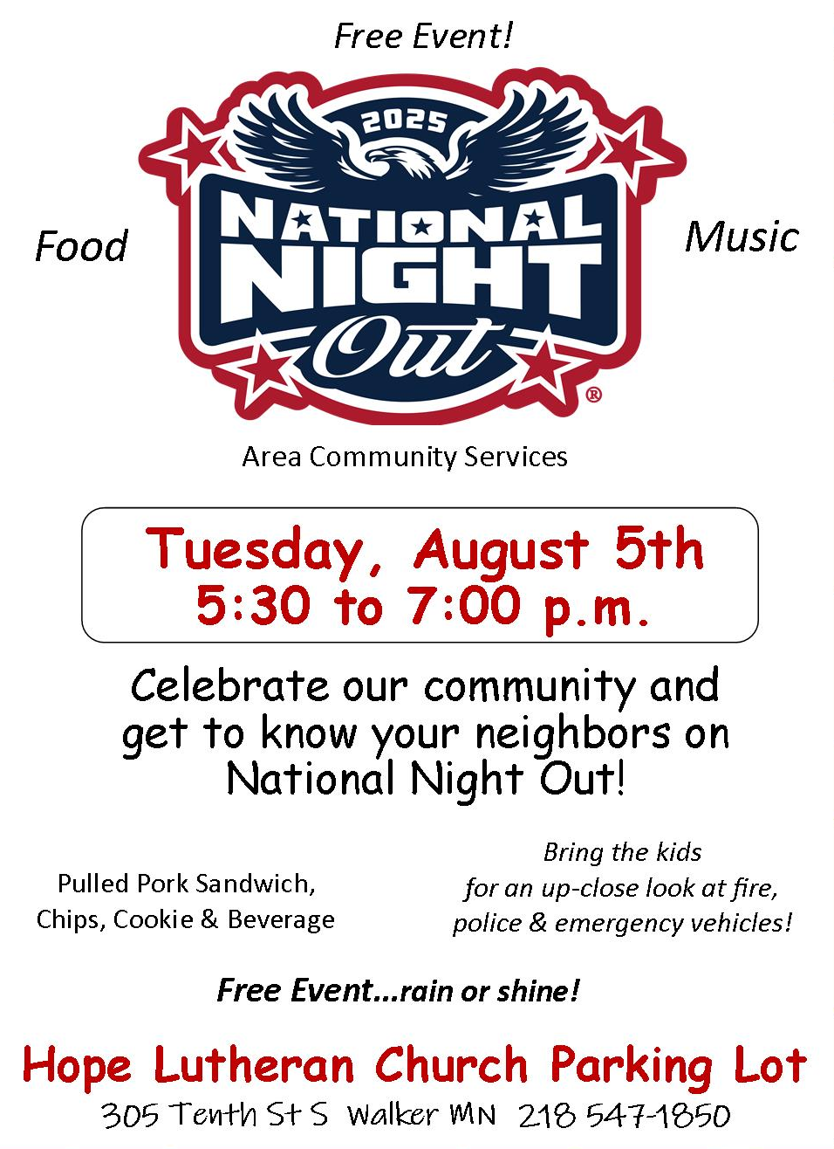
THis Week at Hope
Monday 8/4/25
9:30 am – AA
1:00 pm- Bone Builders

Tuesday 8/5/25
9:00 am - Card Makers
9:30 am - Bone Builders
5:30-7:00 – National Night Out

Wednesday 8/6/25
10:00 am – Women of Hope Board Mtg
Noon – Women’s Potluck & Bible Study
1:00 pm – Bone Builders

Thursday 8/7/25
8:30 am – Quilters
9:00 am – Memorial Gardeners
9:30 am – Bone Builders
11:30 am – Women’s AA

Sunday 8/10/25
9:00 am – Communion Worship
10:00 am – Coffee & Fellowship

All ladies are invited to…
Women’s Potluck & Bible Study
Wednesday, August 6th at noon
Bring something to share and your Gather magazine if you have one, and join the Women of Hope for our summer lunch and Bible Study in the Fellowship Hall. Kim Dickey of Global Health Ministries will be our Guest Speaker and will share with us where the diapers we made are going, as well as several other programs. Lydia Circle is our hostess; Shirley Nelson will be leading the study on Session Two in our Gather magazine. Invite a friend… summer visitors warmly welcomed!

Outdoor Worship Sun., August 17th at 9:00
Bring your own chair, if possible. Worship will be held indoors if weather necessitates.

