Eleventh Sunday after Pentecost
August 24, 2025

Please silence your phone.

Pre-sealed communion kits are available near the entrance if you prefer to remain in the pew during communion distribution.

Device available to assist the hearing impaired. Talk to the sound techs about its use.



Hope Lutheran Church, ELCA
305 10th St. S Walker, MN 56484 218-547-1850
www.hopelutheranchurch-walker.com

Pastor Matt McWaters and Pastor Dave Smith
Accompanist: Mike Kerrigan Liturgist: Ivan Paulsen
Reader: John Haas Usher: Tim Richardson
Communion: Ivan Paulsen and John & Jane Haas

TODAY’S WORSHIP BROADCAST is given in celebration of Don & Lynn Moen’s 45th wedding anniversary.. The 9:00 a.m. service is broadcast live on to leechlaketv.org. You can also tune in to KQKK 102 FM radio, or Channel 21.5 Leech Lake TV. You can sponsor the broadcast on the date of your choice for $75. Sign up on the bulletin board across from the church office.

Welcome to worship
PRELUDE
WELCOME & ANNOUNCEMENTS
TEMPLE TALK Habitat for Humanity
(please stand)
P In the name of the Father, and of the Son, and of the Holy Spirit. C Amen
(Silence for reflection and self-examination)
C We confess that we are in bondage to sin and cannot free ourselves. We have sinned against you in thought, word and deed, by what we have done and by what we have left undone. We have not loved you with our whole heart, we have not loved our neighbors as ourselves. For the sake of your Son, Jesus Christ, have mercy on us. Forgive us, renew us, and lead us, so that we may delight in your will and walk in your ways, to the glory of your holy name. Amen

OPENING HYMN “Praise to the Lord, the Almighty”
L: In peace, let us pray to the Lord. C: Lord, have mer-cy.
L: For the peace from above, and for our salvation, let us pray to the Lord.
C: Lord, have mer-cy.
L For the peace of the whole world, for the well-being of the Church of God, and for the unity of all, let us pray to the Lord.
C: Lord, have mer-cy.
L For this holy house, and for all who offer here their worship and praise, let us pray to the Lord.
C: Lord, have mer-cy.
L Help, save, comfort, and defend us gracious Lord. C: A-men
L Glory to God in the highest, and peace to his people on earth.
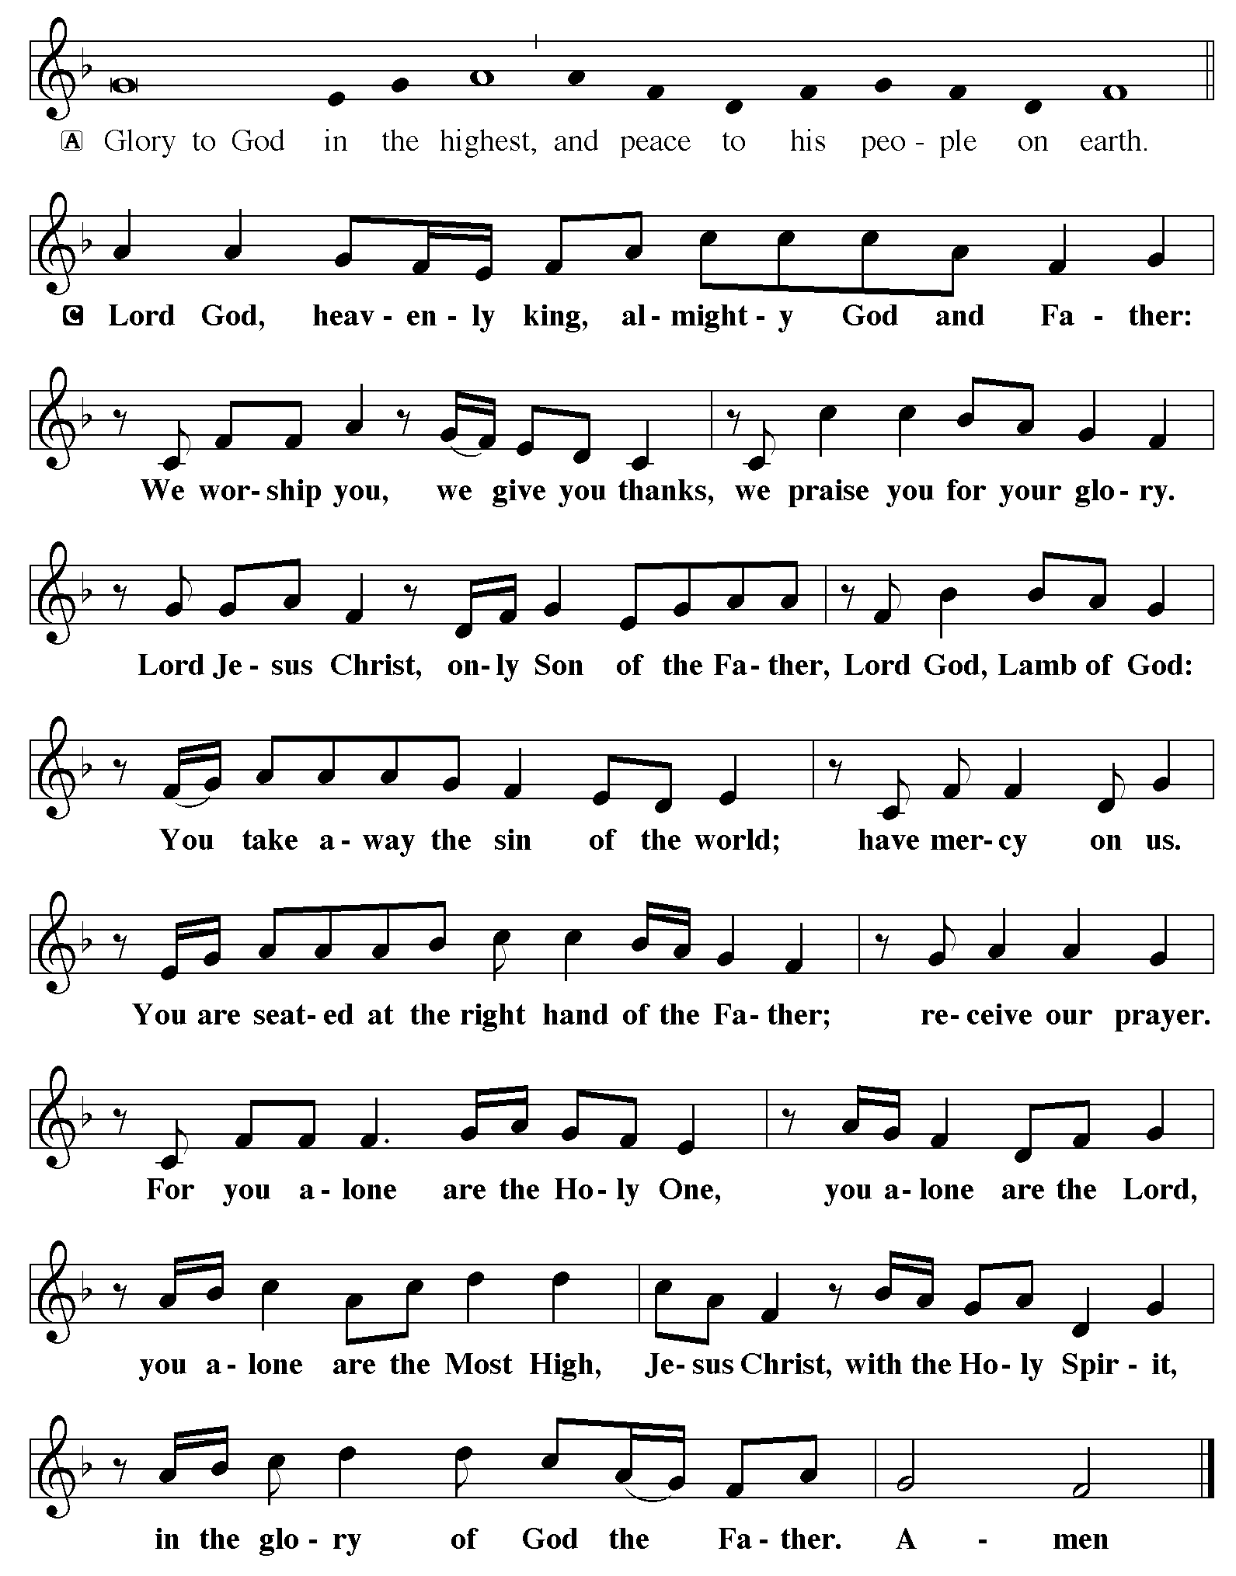

C O God, mighty and immortal, you know that as fragile creatures surrounded by great dangers, we cannot by ourselves stand upright. Give us strength of mind and body, so that even when we suffer because of human sin, we may rise victorious through your Son, Jesus Christ, our Savior and Lord. Amen (please be seated)

ANTHEM “He Never Failed Me Yet” Hope Lutheran Chancel Choir

w/soloists Murray Bright and Leslie James
Kids minute Children are invited to the front of the sanctuary for a brief message

LESSON: Isaiah 58:9b-14
PSALM 103:1-8

Bless the Lord, O my soul, and all that is within me, bless God’s holy name.
² Bless the Lord, O my soul, and forget not all God’s benefits—
³ who forgives all your sins and heals all your diseases;
⁴ who redeems your life from the grave

and crowns you with steadfast love and mercy;
⁵ who satisfies your desires with good things so that your youth is renewed like an eagle’s.
⁶ O Lord, you provide vindication and justice for all who are oppressed.
⁷ You made known your ways to Moses and your works to the children of Israel.
⁸ Lord, you are full of compassion and mercy,
slow to anger and abounding in steadfast love.

(please stand)
Alleluia. Lord, to whom shall we go? You have the words of eternal life.
Alleluia. Alleluia.

GOSPEL: Luke 13:10-17
(please be seated)
MESSAGE Pastor Matt

(please stand)
HYMN (green hymnal #364) “Son of God, Eternal Savior”
APOSTLES CREED
PRAYERS (each petition will end “Lord, in your mercy”. Please respond)
C hear our prayer.

SHARING OF THE PEACE please pass the Friendship Register

P The Lord be with you. C And also with you.
P Lift up your hearts. C We lift them to the Lord.
P Let us give thanks to the Lord our God. C It is right to give our thanks and praise.
P It is indeed right and salutary…join their unending hymn:
C Holy, holy, holy Lord, God of pow’r and might:
Heaven and earth are full of your glory.
Hosanna. Hosanna. Hosanna in the highest.
Blessed is he who comes in the name of the Lord. Hosanna in the highest.

WORDS OF INSTITUTION
LORD’S PRAYER
(please be seated)
THE COMMUNION please sing the following hymns during communion
(Blue hymnal #738) “Healer of Our Every Ill” and “Broken for Me”
(please stand)
BLESSING
BENEDICTION
HYMN “Go, Make Disciples”
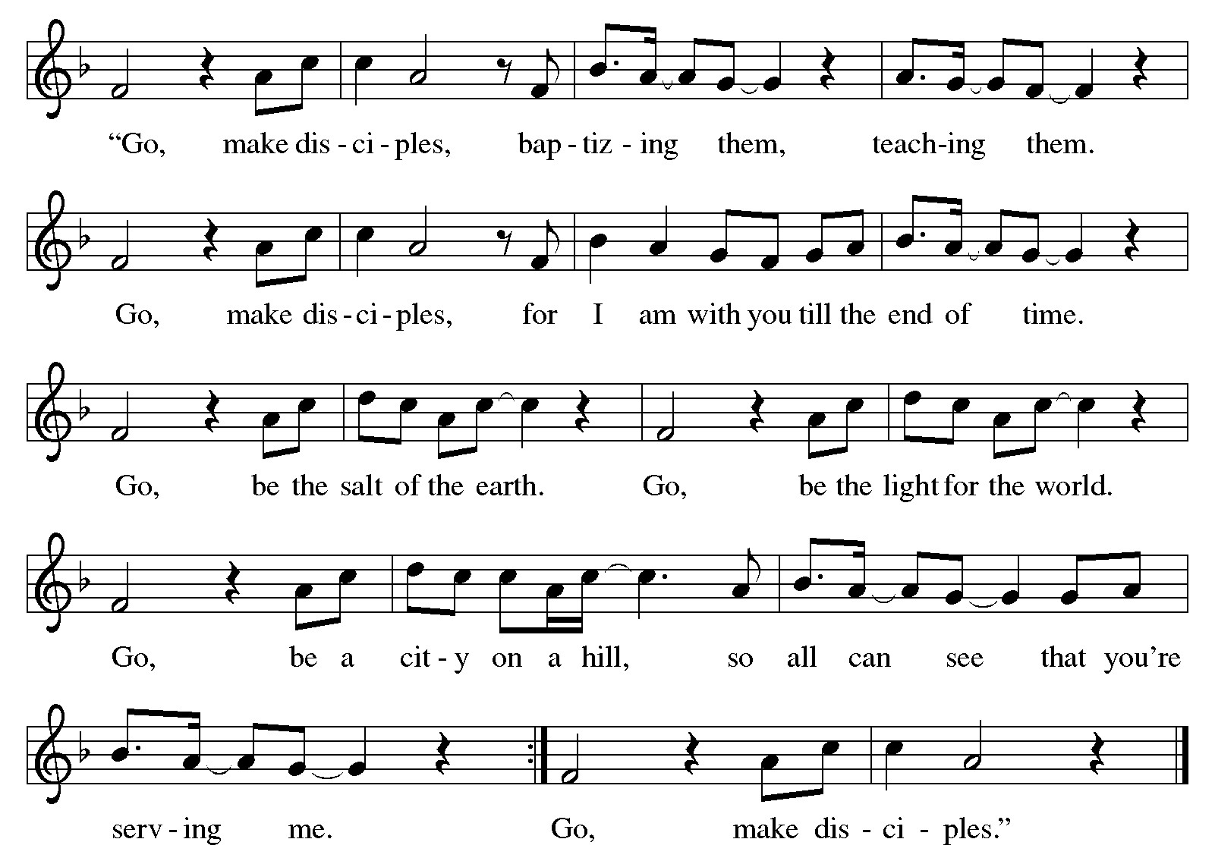
Everyone is invited for coffee in the Fellowship Hall following worship

Discussion on Freedom & Faith: TODAY after worship!
Freedom is kind of a big deal in our nation’s history. We are the “home of the FREE” and pursue LIBERTY for all. So what does freedom look like when we view it through the lens of faith? Grab some coffee and join Pastor Matt in the Music Room today after worship for a one session discussion around Freedom & Faith, guided by scripture, excerpts from Martin Luther’s treatise Freedom of a Christian, and the collective wisdom of the people of Hope.

WE INVITE YOU TO JOIN IN OUR MINISTRY at Hope Lutheran Church through membership. If you would like to become a member, please check the appropriate box on the Friendship Register or leave a message in the church office, including your phone number.

THis Week at Hope
Monday 8/25/25
9:00 am – Northwoods Quilters
9:30 am – AA
All ladies are invited to…
Women of Hope Fall Meeting,
Brunch & Bible Study
Saturday, Sept 6th at 11:00
Bring your “Gather” magazine if you have one.
Brunch provided by Hope’s circles.

Wednesday Simple Supper & Worship begins Sept 10th!
Join the family of Hope
for a light meal at 5:30
followed by casual worship at 6:15

1:00 pm- Bone Builders
6:00 pm – Church council

Tuesday 8/26/25
9:00 am - Card Makers
9:30 am - Bone Builders

Wednesday 8/27/25
1:00 pm – Bone Builders

Thursday 8/28/25
8:30 am – Quilters
9:00 am – Memorial Gardeners
9:30 am – Bone Builders
11:30 am – Women’s AA

Sunday 8/31/25
9:00 am – Communion Worship
10:00 am – Coffee & Fellowship
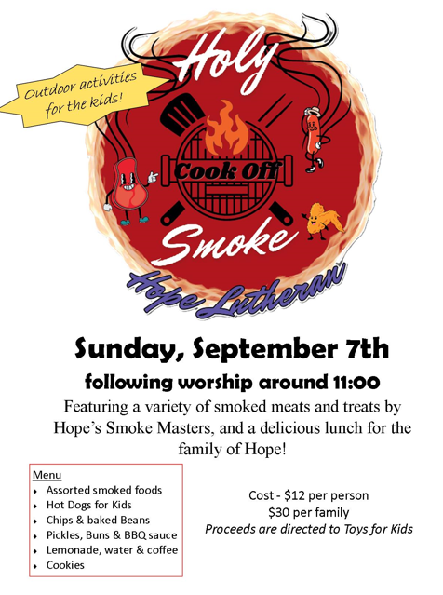

MEAL MINISTRY: Our freezer in the church kitchen has a supply of frozen homemade meals thanks to Chef Scott Skalisky and the Board of Outreach. If you know of a person or couple who might benefit from an easy meal to pop in the oven, please extend Hope’s hospitality with a homemade frozen meal. Give one to a neighbor undergoing or recovering from medical treatment, or an elderly friend who doesn’t cook much anymore.

