Hope Lutheran Church, ELCA
305 10th St. S Walker, MN 56484 218-547-1850
www.hopelutheranchurch-walker.com
Pastor Matt McWaters and Pastor Dave Smith

Hope’s House Band: Rick & Leslie James,
and Mike Kerrigan
Ushers: Wayne & Angie Osatiuk Reader: Mar Kuha
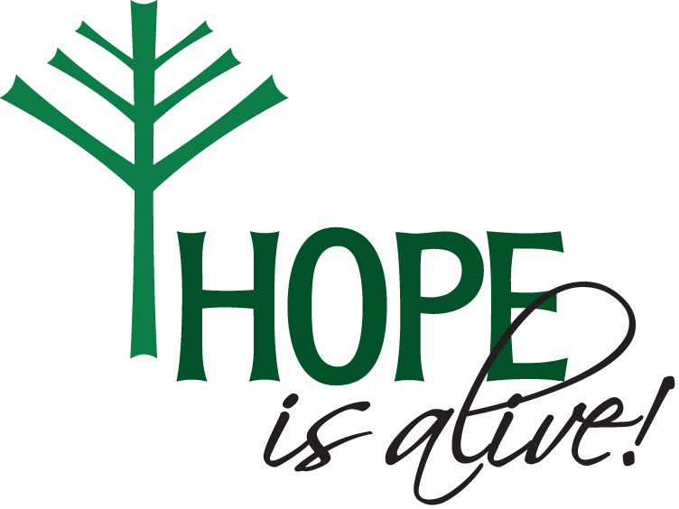

TODAY’S WORSHIP BROADCAST is given in celebration of Audrey Chelberg’s 95th birthday! The 9:00 a.m. service is broadcast live on KQKK 102 FM radio, and also on Channel 21.5 Leech Lake TV. You can also log on to leechlaketv.org. You can sponsor the broadcast on the date of your choice for $75. Sign up on the bulletin board across from the church office.

August 17, 2025

MORNING SING-ALONG!
Put a Little Love in Your heart
Think of your fellow man. Lend him a helping hand.
Put a little love in your heart
You see it's getting late, Oh, please don't hesitate. Put a little love in your heart
Chorus: And the world will be a better place
And the world will be a better place.
For you and me. You just wait and see.
Another day goes by and still the children cry. Put a little love in your heart
If you want the world to know, we won't let hatred grow
Put a little love in your heart. Chorus
Take a good look around and if you're looking down.
Put a little love in your heart.
I hope when you decide, kindness will be your guide.
Put a little love in your heart.
And the world (And the world) will be a better place
And the world (And the world) will be a better place
For you (For you) and me (and me). You just wait (Just wait) and see
Put a little love in your heart. Put a little love in your heart
Put a little love in your heart.
“Rock-a-my Soul/Whole World”
Rock-a my soul in the bosom of Abraham
Rock-a my soul in the bosom of Abraham
Rock-a my soul in the bosom of Abraham Oh, rock-a my soul!

So high, can't get over it, So low, can't get under it,
So wide, can't get 'round it, Oh rock-a my soul!

He's got the whole world in his hands,
He's got the whole wide world in his hands,
He's got the whole world in his hands, He's got the whole world in his hands.

He's got you and me, brother, in his hands,
He's got you and me, sister, in his hands,
He's got you and me, brother, in his hands,
He's got the whole world in his hands.

He's got the itty bitty baby in his hands...

He's got everybody in his hands...

“Jesus Loves Me!”
Jesus loves me! this I know, for the Bible tells me so;
little ones to him belong, they are weak, but he is strong.

Refrain: Yes, Jesus loves me, yes, Jesus loves me,
yes, Jesus loves me, the Bible tells me so.

Jesus loves me! he who died. Heaven's gates to open wide;
he will wash away my sin, let his little child come in. Refrain

Jesus loves me! he will stay close beside me all the way;
Thou hast bled and died for me, I will henceforth live for Thee. Refrain

“Shine, Jesus, Shine”
Refrain: Shine, Jesus shine, fill this land with the Father's glory.
Blaze, Spirit blaze, set our hearts on fire.
Flow, river flow, flood the nations with grace and mercy.
Send forth Your word, Lord and let there be light.
Lord, the Light of Your Love is shining, In the midst of the darkness shining,
Jesus, Light of the World, shine upon us,
Set us free by the truth You now bring us,
Shine on me. Shine on me. Refrain
As we gaze on Your kingly brightness. So our faces display Your likeness.
Ever changing from glory to glory, Mirrored here may our lives tell Your story.
Shine on me. Shine on me. Refrain

Welcome to Worship

WELCOME & ANNOUNCEMENTS
(please stand)
CONFESSION
(Silence for reflection and self-examination)
P Most merciful God,
C we confess that we are in bondage to sin and cannot free ourselves. We have sinned against you in thought, word and deed, by what we have done and by what we have left undone. We have not loved you with our whole heart, we have not loved our neighbors as ourselves. For the sake of your Son, Jesus Christ, have mercy on us. Forgive us, renew us, and lead us, so that we may delight in your will and walk in your ways, to the glory of your holy name. Amen

OPENING HYMN “As the Deer”

You’re my friend and you are my brother even though you are a King.
I love you more than any other, so much more than anything.
You alone are my strength, my shield, to you alone may my spirit yield;
you alone are my heart’s desire, and I long to worship you.

I want you more than gold or silver, only you can satisfy.
You alone are the real joy-giver and the apple of my eye.
You alone are my strength, my shield, to you alone may my spirit yield;
you alone are my heart’s desire, and I long to worship you.

KYRIE (congregation join in refrain below)
C Kyrie eleison, on our world and on our way. Kyrie eleison, ev’ry day.
1. For peace in the world, for the health of the church, for the unity of all;
for this holy house, for all who worship and praise, let us pray to the Lord, let us pray to the Lord.
C Kyrie eleison, on our world and on our way. Kyrie eleison, ev’ry day.
2. For peace in our hearts, for peace in our homes, for friends and family;
for life and for love, for our work and our play, let us pray to the Lord, let us pray to the Lord.
C Kyrie eleison, on our world and on our way. Kyrie eleison, ev’ry day.
3. For your Spirit to guide; that you center our lives in the water and the word;
that you nourish our souls with your body and blood, let us pray to the Lord, let us pray to the Lord.
C Kyrie eleison, on our world and on our way. Kyrie eleison, ev’ry day.
HYMN OF PRAISE
Glory to God in the highest, the highest, and peace to God’s people on earth.
1) Lord God, heavenly King, almighty God and Father,
We worship you, we give you thanks, we praise you for your glory.
Glory to God in the highest, the highest, and peace to God’s people on earth.
2) For you alone are the Holy One, you alone are the Lord,
you alone are the Most High, Jesus Christ, with the Holy Spirit,
in the glory of God the Father. Amen. Amen. Amen
Glory to God in the highest, the highest, and peace to God’s people on earth.
Glory to God in the highest, the highest, and peace to God’s people on earth.

O God, judge eternal, you love justice and hate oppression, and you call us to share your zeal for truth. Give us courage to take our stand with all victims of bloodshed and greed, and, following your servants and prophets, to look to the pioneer and perfecter of our faith, your Son, Jesus Christ, our Savior and Lord. Amen. (please be seated)

ANTHEM “Through It All” Hope’s House Band
LESSON: Jeremiah 23:23-29
Am I a God near by, says the Lord, and not a God far off? ²⁴ Who can hide in secret places so that I cannot see them? says the Lord. Do I not fill heaven and earth? says the Lord. ²⁵ I have heard what the prophets have said who prophesy lies in my name, saying, “I have dreamed! I have dreamed!” ²⁶ How long? Will the hearts of the prophets ever turn back—those who prophesy lies and who prophesy the deceit of their own heart? ²⁷ They plan to make my people forget my name by their dreams that they tell one another, just as their ancestors forgot my name for Baal. ²⁸ Let the prophet who has a dream tell the dream, but let the one who has my word speak my word faithfully. What has straw in common with wheat? says the Lord. ²⁹ Is not my word like fire, says the Lord, and like a hammer that breaks a rock in pieces?

R The Word of the Lord C Thanks be to God.

Psalm 82
God stands to charge the divine council assembled, giving judgment in the midst of the gods:
² “How long will you judge unjustly, and show favor to the wicked?
³ Save the weak and the orphan; defend the humble and needy;
⁴ rescue the weak and the poor; deliver them from the power of the wicked.
⁵ They do not know, neither do they understand; they wander about in darkness;
all the foundations of the earth are shaken.
⁶ Now I say to you, ‘You are gods, and all of you children of the Most High;
⁷ nevertheless, you shall die like mortals, and fall like any prince.’ ”
⁸ Arise, O God, and rule the earth, for you shall take all nations for your own.

(please stand)

Alleluia. Lord to whom shall we go? You have the words of eternal life.
Alleluia. Alleluia, alleluia. Alleluia. Alleluia, alleluia.
P The Holy Gospel according to St. Luke, the 12th chapter.
C Glory to you, O Lord.

GOSPEL: Luke 12:49-56
[Jesus said:] ⁴⁹ “I have come to cast fire upon the earth, and how I wish it were already ablaze! ⁵⁰ I have a baptism with which to be baptized, and what constraint I am under until it is completed! ⁵¹ Do you think that I have come to bring peace to the earth? No, I tell you, but rather division! ⁵² From now on five in one household will be divided, three against two and two against three; ⁵³ they will be divided: father against son and son against father, mother against daughter and daughter against mother, mother-in-law against her daughter-in-law and daughter-in-law against mother-in-law.”
⁵⁴ He also said to the crowds, “When you see a cloud rising in the west, you immediately say, ‘It is going to rain,’ and so it happens. ⁵⁵ And when you see the south wind blowing, you say, ‘There will be scorching heat,’ and it happens. ⁵⁶ You hypocrites! You know how to interpret the appearance of earth and sky, but why do you not know how to interpret the present time?”

P The Gospel of the Lord. C Praise to you, O Christ.
(please be seated)
MESSAGE Pastor Matt
(please stand)
HYMN “Seek Ye First”
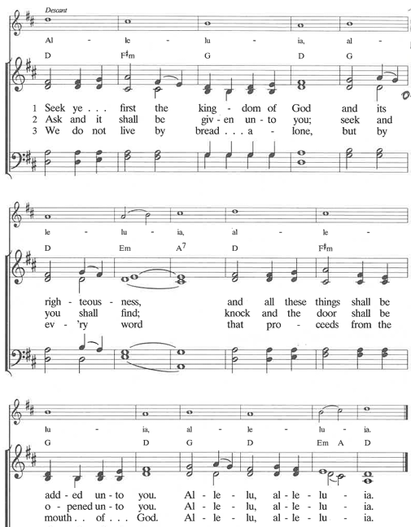
C I believe in God, the Father almighty, creator of heaven and earth.
I believe in Jesus Christ, his only Son, our Lord. He was conceived by the power of the Holy Spirit and born of the virgin Mary. He suffered under Pontius Pilate, was crucified, died, and was buried. He descended into hell. On the third day he rose again. He ascended into heaven, and is seated at the right hand of the Father. He will come again to judge the living and the dead.
I believe in the Holy Spirit, the holy catholic Church, the communion of saints, the forgiveness of sins, the resurrection of the body, and the life everlasting. Amen

PRAYERS (each petition will end “Lord, in your mercy”. Please respond)
C hear our prayer.
SHARING OF THE PEACE please pass the Friendship Register
P The Lord be with you. C And also with you.
P Lift up your hearts. C We lift them to the Lord.
P Let us give thanks to the Lord our God.
C It is right to give our thanks and praise.
WORDS OF INSTITUTION
C Our Father, who art in heaven, hallowed be thy name, thy kingdom come, thy will be done, on earth as it is in heaven. Give us this day our daily bread, and forgive us our trespasses, as we forgive those who trespass against us; and lead us not into temptation, but deliver us from evil. For thine is the kingdom, and the power, and the glory, forever and ever. Amen

(please be seated)
THE COMMUNION
(please stand)
P The body and blood of our Lord Jesus Christ strengthen you and keep you in His grace.
C Amen
BENEDICTION
SENDING HYMN “Go Out As People of God”
Go out as people of God. Go out as people of hope.Go out as people renewed.
Your sins are forgiven, You are made whole, Now walk in the light of God.
You are the people God made as his own. Made in His image, no longer alone. His seal is on us, His Spirit divine, Called to be people of God.
Go out as people of God Go out as people of hope. Go out as people renewed. Your sins are forgiven, You are made whole, Now walk in the light of God.

P Go in peace. Serve the Lord. C Thanks be to God!
P God is with us. C This changes everything!

POSTLUDE
Thank you for your continued support of Hope Lutheran’s ministry. For those joining us in person, offering buckets are located in the worship area. Offerings may also be mailed to PO Box 506, Walker MN 56484 or given electronically through our website.

Discussion on Freedom & Faith: Next Sunday, August 24th
Freedom is kind of a big deal in our nation’s history. We are the “home of the FREE” and pursue LIBERTY for all. So what does freedom look like when we view it through the lens of faith? Join Pastor Matt after worship on Sunday, August 24 for a one session discussion around Freedom & Faith, guided by scripture, excerpts from Martin Luther’s treatise Freedom of a Christian, and the collective wisdom of the people of Hope

This Week at Hope
All ladies are invited to…
Women of Hope Fall Meeting,
Brunch & Bible Study
Saturday, September 6th at 11:00
Bring your “Gather” magazine if you have one. Brunch provided by Hope’s circles.

Wednesday Simple Supper & Worship begins September 10th!
Join the family of Hope for a light meal at 5:30
followed by casual worship at 6:15

Monday 8/18/25
9:30 am – AA
1:00 pm – Bone Builders

Tuesday 8/19/25
9:00 am – Card Makers
9:30 am- Bone Builders

Wednesday 8/20/25
1:00 pm – Bone Builders

Thursday 8/21/25
8:30 am - Quilters
9:00 am – Memorial Gardeners
9:30 am – Bone Builders
11:30 am – Women’s AA

Sunday 8/24/25
9:00 am – Indoor Worship at Hope
10:00 am – Coffee & Fellowship
10:10 am – Freedom & Faith Discussion

The Board of Fellowship is excited to announce our 4th Annual Holy Smoke Cookoff on Rally Sunday, September 7th at 11:00. Featuring a variety of smoked meats and treats and a delicious lunch for the family of Hope! Plans are to hold this event indoors with outdoor activities for youth. If you are interested in participating as a smoke master, please contact Scott Skalisky at srskalisky@gmail.com.

