Ninth Sunday after Pentecost
August 10, 2025

Please silence your phone.

Pre-sealed communion kits are available near the entrance if you prefer to remain in the pew during communion distribution.

Device available to assist the hearing impaired. Talk to the sound techs about its use.



Hope Lutheran Church, ELCA
305 10th St. S Walker, MN 56484 218-547-1850
www.hopelutheranchurch-walker.com

Pastor Matt McWaters & Pastor Dave Smith
Accompanist: Mike Kerrigan Reader: Sally Hiner
Ushers: Mark & Rita Bovee
Communion: Sally & Cal Hiner

WE INVITE YOU TO JOIN IN OUR MINISTRY at Hope Lutheran Church through membership. If you would like to become a member, please check the appropriate box on the Friendship Register or leave a message in the church office, including your phone number.

Offering plates are located near the sanctuary entrance.
TODAY’S WORSHIP BROADCAST is given by Clayton Copple, in memory of wife Mary. The 9:00 a.m. service is broadcast live on KQKK 102 FM radio, and also on Channel 21.5 Leech Lake TV. You can also log on to leechlaketv.org. You can sponsor the broadcast in memory or honor of a loved one or event for $75. Sign up for the date of your choice on the bulletin board across from the church office.

Welcome to Worship

PRELUDE
WELCOME & ANNOUNCEMENTS
TEMPLE TALK Holy Smoke Scott Skalisky
(please stand)
P In the name of the Father, and of the Son, and of the Holy Spirit. C Amen

KYRIE (below)
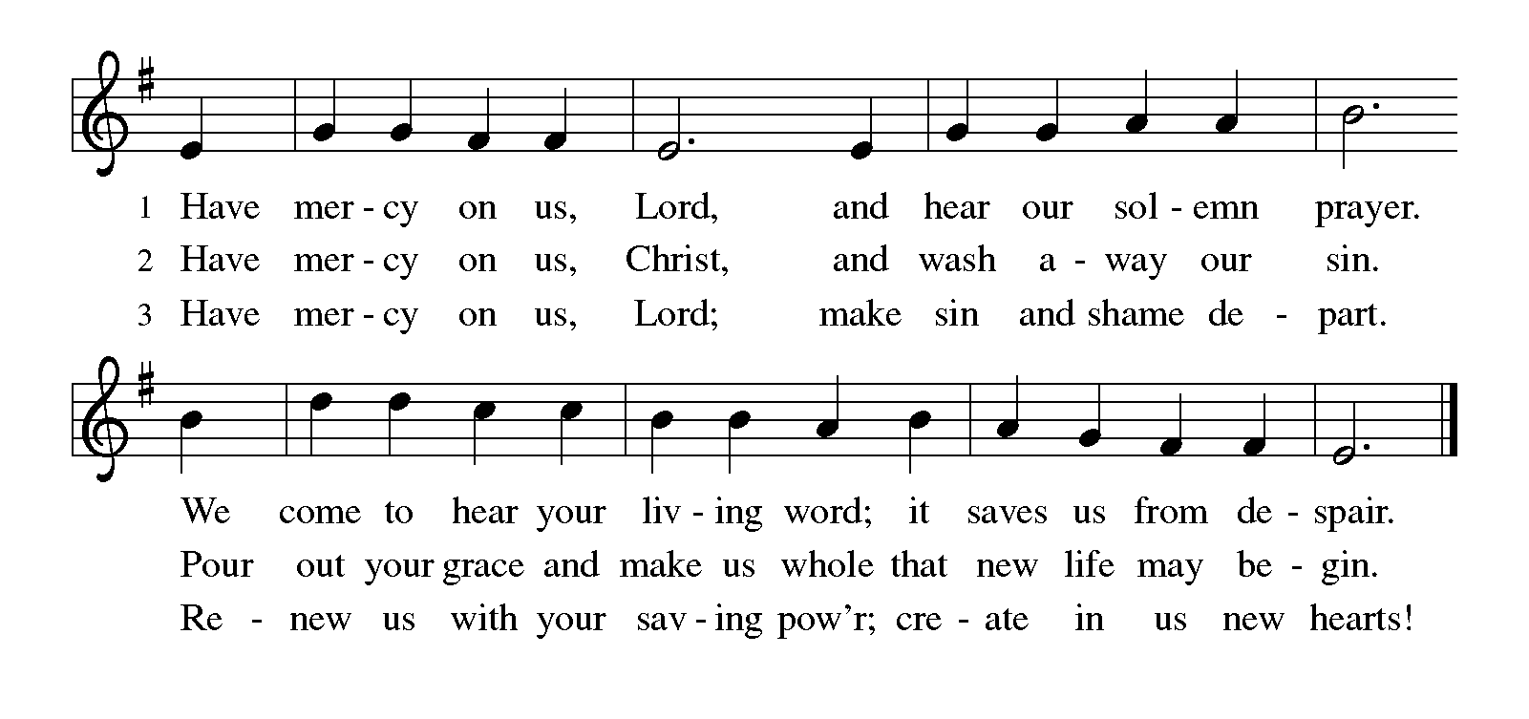
P: We confess, O God,
C Sin binds us. Our words, our hands, our feet, and our whole being. Individually we harm the lives of our neighbors, knowingly and unknowingly. Collectively, we participate in systems that oppress some and ignore others. We look to ourselves and not you. Forgive us we pray. Amen

HYMN OF PRAISE (below)
Glory be to God in heaven; peace, good-will to all the earth.
Mighty God of all creation, Father of surpassing worth:
We exalt you, we adore you, we lift high our thanks and praise.
Saints and angels bow before you; here on earth our songs we raise.
Glory be to Christ forever, Lamb of God and Lord of love.
Son of God and gracious Savior, you have come from heav’n above;
On the cross you died to save us; now you reign at God’s right hand.
Hear our prayer; restore, forgive us; in your promise firm we stand.
L Let us pray.
C Almighty God, you sent your Holy Spirit to be the life and light of your church. Open our hearts to the riches of your grace, that we may be ready to receive you wherever you appear, through Jesus Christ, our Savior and Lord. Amen (please be seated)

ANTHEM Fill-A-Me Up! Hope Chancel Choir

w/director Murray Bright and accompanist Julie Bright

KIDS’ MINUTE children are invited to the front of the sanctuary

FIRST LESSON: Genesis 15:1-6

Psalm 33:12-22
¹² Happy is the nation whose God is the Lord!
Happy the people chosen to be God’s heritage!
¹³ The Lord looks down from heaven, and sees all humankind.
¹⁴ God sits firmly enthroned and watches all who dwell on the earth.
¹⁵ God fashions all their hearts and observes all their deeds.
¹⁶ A king is not saved by the size of the army,
nor are warriors rescued by their great strength.
¹⁷ The horse gives vain hope for victory;
despite its great strength it cannot save.
¹⁸ Truly, your eye is upon those who fear you, O Lord,
upon those who wait for your steadfast love,
¹⁹ to deliver their lives from death, and to keep them alive in time of famine.
²⁰ Our innermost being waits for you, O Lord, our helper and our shield.
²¹ Surely, our heart rejoices in you, for in your holy name we put our trust.
²² Let your lovingkindness, O Lord, be upon us, even as we place our hope in you.

SECOND LESSON: Hebrews 11:1-3, 8-16

(please stand)
Alleluia! Lord and Savior: open now your saving word.
Let it burn like fire within us; speak until our hearts are stirred.
Alleluia! Lord, we sing for the good news that you bring.

GOSPEL: Luke 12:32-40
(please be seated)
MESSAGE Pastor Dave Smith
(please stand)
HYMN (green hymnal #296) “Just As I Am”
APOSTLES CREED
PRAYERS (each petition will end “Lord, in your mercy”. Please respond)
C hear our prayer.
SHARING OF THE PEACE
WORDS OF INSTITUTION
LORD’S PRAYER
(please be seated)
THE COMMUNION please sing the following hymns during communion
HYMN (green hymnal #320) “O God, Our Help in Ages Past”
HYMN (green hymnal #456) “The King of Love, My Shepherd Is”
(please stand)
BLESSING
BENEDICTION
HYMN (green hymnal #390) “I Love to Tell the Story”
P Go in peace. Serve the Lord. C Thanks be to God.
POSTLUDE
Lefse $8^{/3 rounds}
Stop by the church kitchen after worship!

THis Week at Hope
Monday 8/11/25
9:30 am – AA
10:00 am – Women’s Conf. Brd
1:00 pm- Bone Builders

Tuesday 8/12/25
9:00 am - Card Makers
9:30 am - Bone Builders

Wednesday 8/13/25
8:30 am – Board of Outreach
11:00 am – May Creek Cottages
12:30 pm – May Creek Lodge
1:00 pm – Bone Builder

Thursday 8/14/25
8:30 am – Quilters
9:00 am – Memorial Gardeners
9:30 am – Bone Builders
11:30 am – Women’s AA

Sunday 8/17/25
9:00 am – Outdoor Worship
Bring your own chair for outdoor worship, if possible.
Worship will be moved indoors if weather necessitates.

Everyone is invited to the Fellowship Hall
for coffee & rolls following worship.

Discussion on Freedom & Faith
Sunday, August 24th
Freedom is kind of a big deal in our nation’s history. We are the “home of the FREE” and pursue LIBERTY for all. So what does freedom look like when we view it through the lens of faith? Join Pastor Matt after worship on Sunday, August 24 for a one session discussion around Freedom & Faith, guided by scripture, excerpts from Martin Luther’s treatise Freedom of a Christian, and the collective wisdom of the people of Hope


The Board of Fellowship is excited to announce our
4th Annual Holy Smoke Cookoff on Rally Sunday, September 7th at 11:00. Featuring a variety of smoked meats and treats and a delicious lunch for the family of Hope! Plans are to hold this event indoors with outdoor activities for youth. If you are interested in participating as a smoke master, please contact Scott Skalisky at srskalisky@gmail.com.

