Seventh Sunday after Pentecost
July 27, 2025

Please silence your phone.

Pre-sealed communion kits are available near the entrance if you prefer to remain in the pew during communion distribution.

Device available to assist the hearing impaired. Talk to the sound techs about its use.



Hope Lutheran Church, ELCA
305 10th St. S Walker, MN 56484 218-547-1850
www.hopelutheranchurch-walker.com

Pastor Matt McWaters and Pastor Dave Smith
Accompanist: Mike Kerrigan Liturgist: Ivan Paulsen
Reader: Al Sanford Ushers: Mark & Rita Bovee
Communion: Ivan & Pat Paulsen, Al Sanford

WE INVITE YOU TO JOIN IN OUR MINISTRY at Hope Lutheran Church through membership. If you would like to become a member, please check the appropriate box on the Friendship Register or leave a message in the church office, including your phone number.

TODAY’S WORSHIP BROADCAST is given by Chuck & Shirley Nelson. The 9:00 a.m. service is broadcast live on to leechlaketv.org. You can also tune in to KQKK 102 FM radio, or Channel 21.5 Leech Lake TV. You can sponsor the broadcast on the date of your choice for $75. Sign up on the bulletin board across from the church office.

Welcome to worship
PRELUDE
WELCOME & ANNOUNCEMENTS
(please stand)
P In the name of the Father, and of the Son, and of the Holy Spirit. C Amen
(Silence for reflection and self-examination)
C We confess that we are in bondage to sin and cannot free ourselves. We have sinned against you in thought, word and deed, by what we have done and by what we have left undone. We have not loved you with our whole heart, we have not loved our neighbors as ourselves. For the sake of your Son, Jesus Christ, have mercy on us. Forgive us, renew us, and lead us, so that we may delight in your will and walk in your ways, to the glory of your holy name. Amen
OPENING HYMN “Sweet Hour of Prayer”
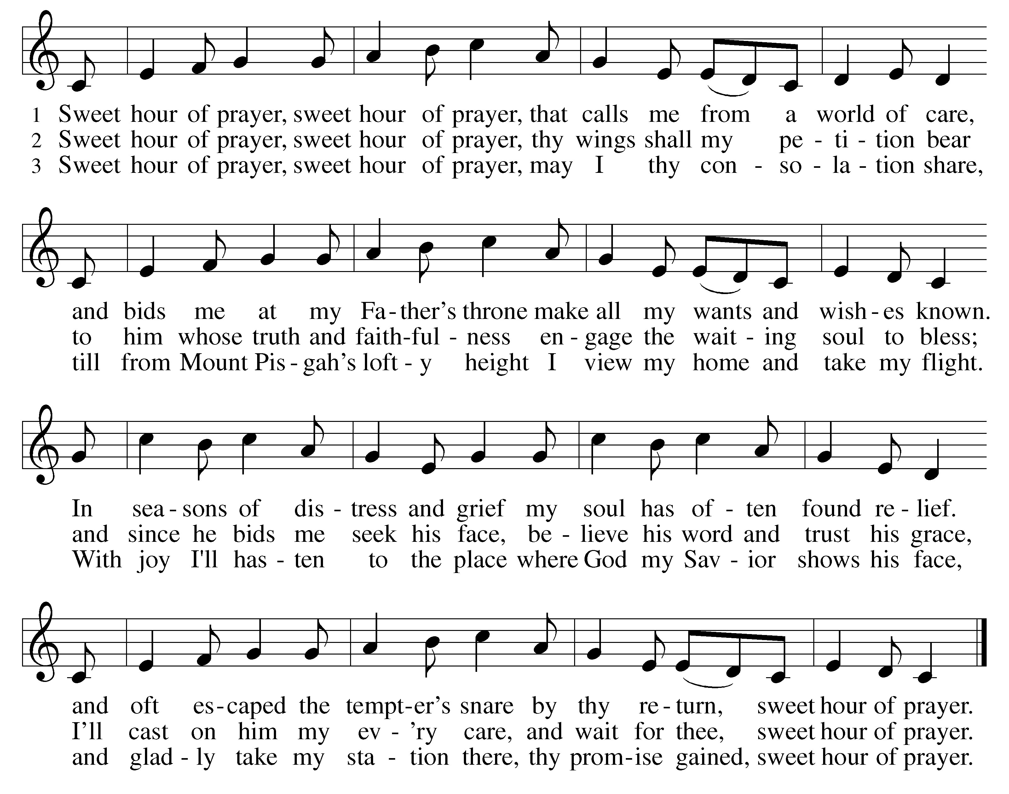

L: In peace, let us pray to the Lord. C: Lord, have mer-cy.
L: For the peace from above, and for our salvation, let us pray to the Lord.
C: Lord, have mer-cy.
L For the peace of the whole world, for the well-being of the Church of God, and for the unity of all, let us pray to the Lord.
C: Lord, have mer-cy.
L For this holy house, and for all who offer here their worship and praise, let us pray to the Lord.
C: Lord, have mer-cy.
L Help, save, comfort, and defend us gracious Lord. C: A-men
L Glory to God in the highest, and peace to his people on earth.
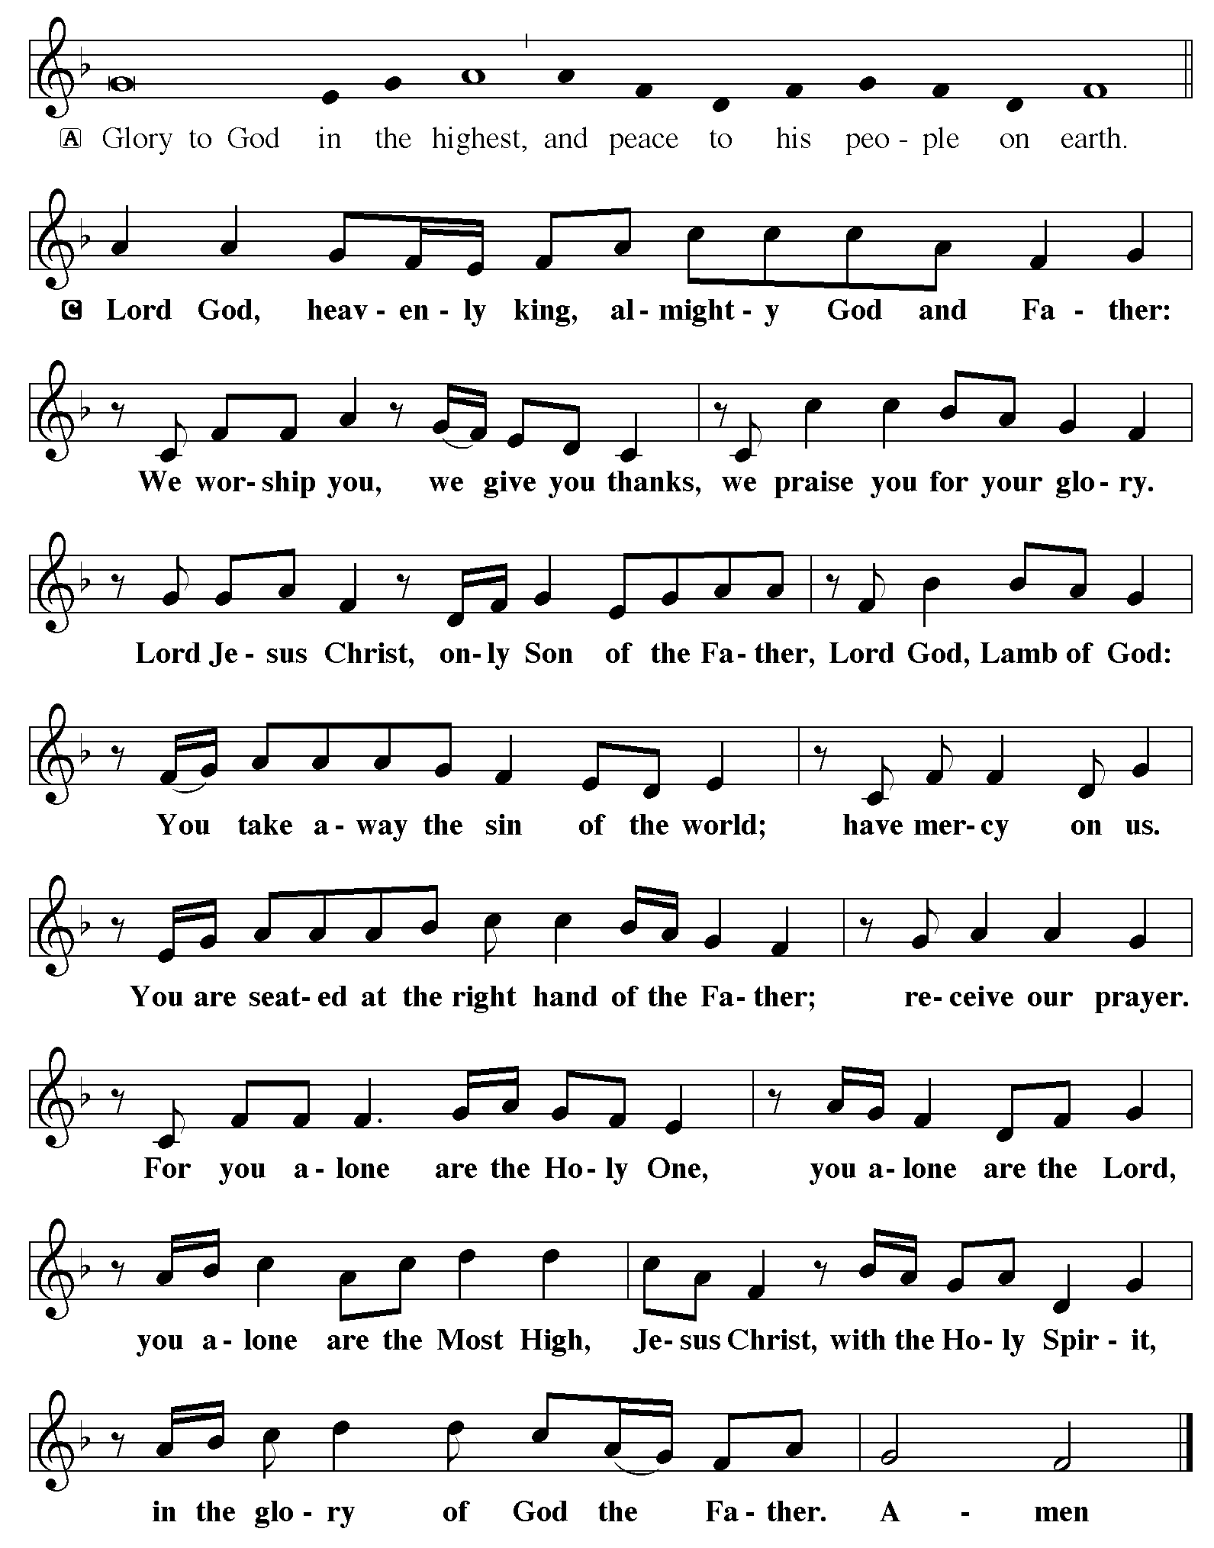

Almighty and ever-living God, you are always more ready to hear than we are to pray, and you gladly give more than we either desire or deserve. Pour upon us your abundant mercy. Forgive us those things that weigh on our conscience, and give us those good things that come only through your Son, Jesus Christ, our Savior and Lord. Amen (please be seated)

ANTHEM “Old Time Need of Prayer” Hope’s Chancel Choir
Kids minute Children are invited to the front of the sanctuary for a brief message

LESSON: Genesis 18:20-32

PSALM 138

I will give thanks to you, O Lord, with my whole heart; before the gods I will sing your praise.
² I will bow down toward your holy temple and praise your name,

because of your steadfast love and faithfulness;
for you have glorified your name and your word above all things.
³ When I called, you answered me; you increased my strength within me.
⁴ All the rulers of the earth will praise you, O Lord,
when they have heard the words of your mouth.
⁵ They will sing of the ways of the Lord, that great is the glory of the Lord.
⁶ The Lord is high, yet cares for the lowly, perceiving the haughty from afar.
⁷ Though I walk in the midst of trouble, you keep me safe;
you stretch forth your hand against the fury of my enemies; your right hand shall save me.
⁸ You will make good your purpose for me; O Lord,

your steadfast love endures forever; do not abandon the works of your hands.

(please stand)
Alleluia. Lord, to whom shall we go? You have the words of eternal life.
Alleluia. Alleluia.

GOSPEL: Luke 11:1-13
(please be seated)
MESSAGE Pastor Matt

(please stand)
HYMN (green hymnal #474) “Children of the Heavenly Father”
APOSTLES CREED
PRAYERS (each petition will end “Lord, in your mercy”. Please respond)
C hear our prayer.

SHARING OF THE PEACE please pass the Friendship Register

P The Lord be with you. C And also with you.
P Lift up your hearts. C We lift them to the Lord.
P Let us give thanks to the Lord our God. C It is right to give our thanks and praise.
P It is indeed right and salutary…join their unending hymn:
C Holy, holy, holy Lord, God of pow’r and might:
Heaven and earth are full of your glory.
Hosanna. Hosanna. Hosanna in the highest.
Blessed is he who comes in the name of the Lord. Hosanna in the highest.

WORDS OF INSTITUTION
LORD’S PRAYER
(please be seated)
THE COMMUNION music by Julie Bright & Mike Kerrigan
(please stand)
BLESSING
BENEDICTION
HYMN (blue hymnal #721) “Go, My Children, With My Blessing”
L Go in peace. Serve the Lord. C Thanks be to God!
POSTLUDE
Everyone is invited for coffee in the Fellowship Hall following worship!
All ladies are invited to…
Women’s Potluck & Bible Study
Wednesday, August 6th at noon
Bring something to share and your Gather magazine if you have one, and join the Women of Hope for our summer lunch and Bible Study in the Fellowship Hall. Kim Dickey of Global Health Ministries will be our Guest Speaker and will share with us where the diapers we made are going, as well as several other programs. Invite a friend… summer visitors warmly welcomed!

THis Week at Hope
Monday 7/28/25
9:00 am – Northwoods Quilters
9:30 am – AA
1:00 pm- Bone Builders

Tuesday 7/29/25
9:00 am - Card Makers
9:30 am - Bone Builders
3:00 pm – Visitation
4:00 pm – Memorial Service for Otto Ringle

Wednesday 7/30/25
1:00 pm – Bone Builders

Thursday 7/31/25
8:30 am – Quilters
9:00 am – Memorial Gardeners
Hope’s Chancel Choir welcomes all summer singers! Meet in the Music Room at 8:00 a.m. for rehearsal prior to worship. Tentative schedule: August 10th & 24th
Leave a message in the church office to be added to the choir email notice list for potential date changes.

9:30 am – Bone Builders
11:30 am – Women’s AA

Sunday 8/3/25
9:00 am – Communion Worship
10:00 am – Coffee & Fellowship

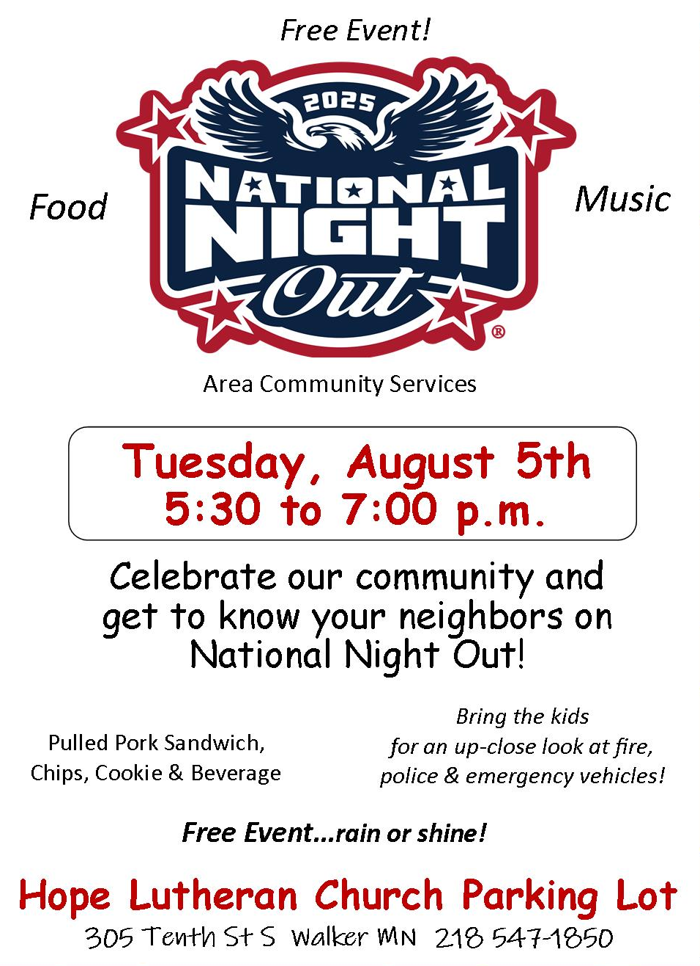

Hope Lutheran is again hosting Walker’s
NATIONAL NIGHT OUT
National Night Out is an annual community-building campaign that promotes community partnerships and neighborhood camaraderie to make our neighborhoods safer, more caring places to live. Come join your neighbors on AUGUST 5th , 5:30-7:00 pm in the Hope Lutheran parking lot. There will be representatives from local law enforcement, emergency services, and social agencies: all people who help make Walker a great place to live. There will also be free food so it’s a win-win evening out. See you on August 5th at 5:30 pm in our new parking lot.

KITCHEN VOLUNTEERS needed for funeral receptions! We’ve had quite the run of recent funerals, with some folks helping at every one. When you see the request in your inbox for funeral help, please don’t be shy to respond! Even if you only have an hour to spare or haven’t helped in the past, we’ve got some great leaders who will find a job for you!
MEAL MINISTRY: Our freezer in the church kitchen has a supply of frozen homemade meals thanks to Chef Scott Skalisky and the Board of Outreach. If you know of a person or couple who might benefit from an easy meal to pop in the oven, please extend Hope’s hospitality with a homemade frozen meal. Give one to a neighbor undergoing or recovering from medical treatment, or an elderly friend who doesn’t cook much anymore.

Hope Card Makers meet on Tuesdays at 9:00 a.m. in the Fellowship Hall to make cards as a fundraiser for the Women of Hope. Anyone is welcome to help! All materials and instructions provided. Greeting cards for all occasions are available near the church office for $2 each.

