17th Sunday after Pentecost
October 5, 2025

Please silence your phone.

Pre-sealed communion kits are available near the entrance if you prefer to remain in the pew during communion distribution.

Device available to assist the hearing impaired. Talk to the sound techs about its use.



Hope Lutheran Church, ELCA
305 10th St. S Walker, MN 56484 218-547-1850
www.hopelutheranchurch-walker.com
Pastor Matt McWaters and Pastor Dave Smith
Liturgist: Pat Roush Accompanist: Mike Kerrigan
Usher: Acolyte: Josie Holly
Reader: Alice Groth
Communion: Cal & Sally Hiner

Offering plates are located near the sanctuary entrance.

TODAY’S WORSHIP BROADCAST is given by the Dowson family, in loving memory of
Jim Dowson and in honor of all law enforcement personnel. The 9:00 a.m. worship service is broadcast live on KQKK 102 FM radio, and also on Channel 21.5 Leech Lake TV. You can also log on to leechlaketv.org. BROADCAST SPONSORS ARE NEEDED. You can sponsor the broadcast in memory or honor of a loved one or special occasion for $75. Sign up for the date of your choice on the bulletin board near the church office.

Welcome to Worship

PRELUDE
WELCOME & ANNOUNCEMENTS
HYMN (green hymnal #294 vs 1-3) “My Hope is Built on Nothing Less”
CONFESSION & FORGIVENESS
(Silence for reflection and self-examination)
C We are the all, who have sinned and fall short of the glory of God. We have collectively and individually, knowingly and unknowingly, sinned against you and our neighbor. Forgive us we pray.
P Our faithful and just God, promises to forgive our sins, and cleanse us from all unrighteousness. In the name of Christ, your sins are forgiven. And all God’s people responded...
C Amen. Amen. Thanks be to God.
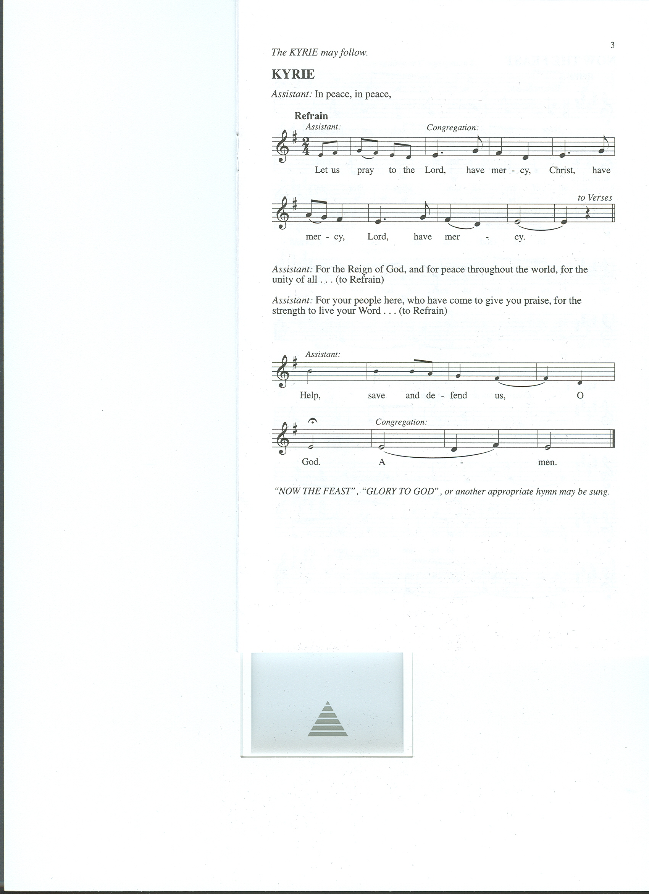
KYRIE (below)
L In peace, in peace let us pray to the...

Congregation Responds:

L For the Reign of God, and for peace throughout the world, for the unity of all, let us pray to the…
(Repeat Congregational Response)
L For your people here, who have come to give you praise, for the strength to live your Word, let us pray to the… (Repeat Congregational Response)
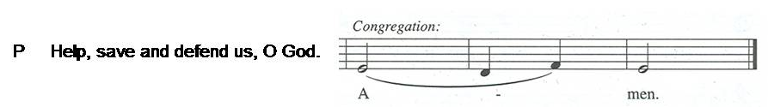
HYMN OF PRAISE (words below) “Now the Feast and Celebration”
Now the feast and celebration, all of creation sings for joy
To the God of life and love and freedom: praise and glory forevermore!
Now is the feast of the Lamb once slain,
whose blood has freed and united us to be one great people of God.
Now the feast and celebration, all of creation sings for joy
To the God of life and love and freedom: praise and glory forevermore!
For God has come to dwell with us, to make us people of God;
To make all things new.
Now the feast and celebration, all of creation sings for joy
To the God of life and love and freedom: praise and glory forevermore!

C Benevolent, merciful God: When we are empty, fill us. When we are weak in faith, strengthen us. When we are cold in love, warm us, that with fervor we may love our neighbors and serve them for the sake of your Son, Jesus Christ, our Savior and Lord. Amen (please be seated)

Kids minute Children are invited to the front of the sanctuary for a brief message with the pastor. Afterwards, kids are invited to the Music Room for a video and story about the message. They will return to the sanctuary shortly after the sermon concludes.

LESSON: Habakkuk 1:1-4; 2:1-4

Psalm 37:1-9
Do not be provoked by evildoers; do not be jealous of those who do wrong.
² For they shall soon wither like the grass, and like the green grass fade away.
³ Put your trust in the Lord and do good; dwell in the land and find safe pasture.
⁴ Take delight in the Lord, who shall give you your heart’s desire.
⁵ Commit your way to the Lord; put your trust in the Lord, and see what God will do.
⁶ The Lord will make your vindication as clear as the light
and the justice of your case like the noonday sun.
⁷ Be still before the Lord and wait patiently.
Do not be provoked by the one who prospers, the one who succeeds in evil schemes.
⁸ Refrain from anger, leave rage alone; do not be provoked; it leads only to evil
⁹ For evildoers shall be cut off, but those who hope in the Lord shall possess the land.

(please stand)
Alleluia, alleluia. Lord to whom shall we go?
You have the words of eternal life. Alleluia!

GOSPEL: Luke 17:5-10
MESSAGE Pastor Matt McWaters
(please stand)
HYMN (below) “Drawn to the Light”
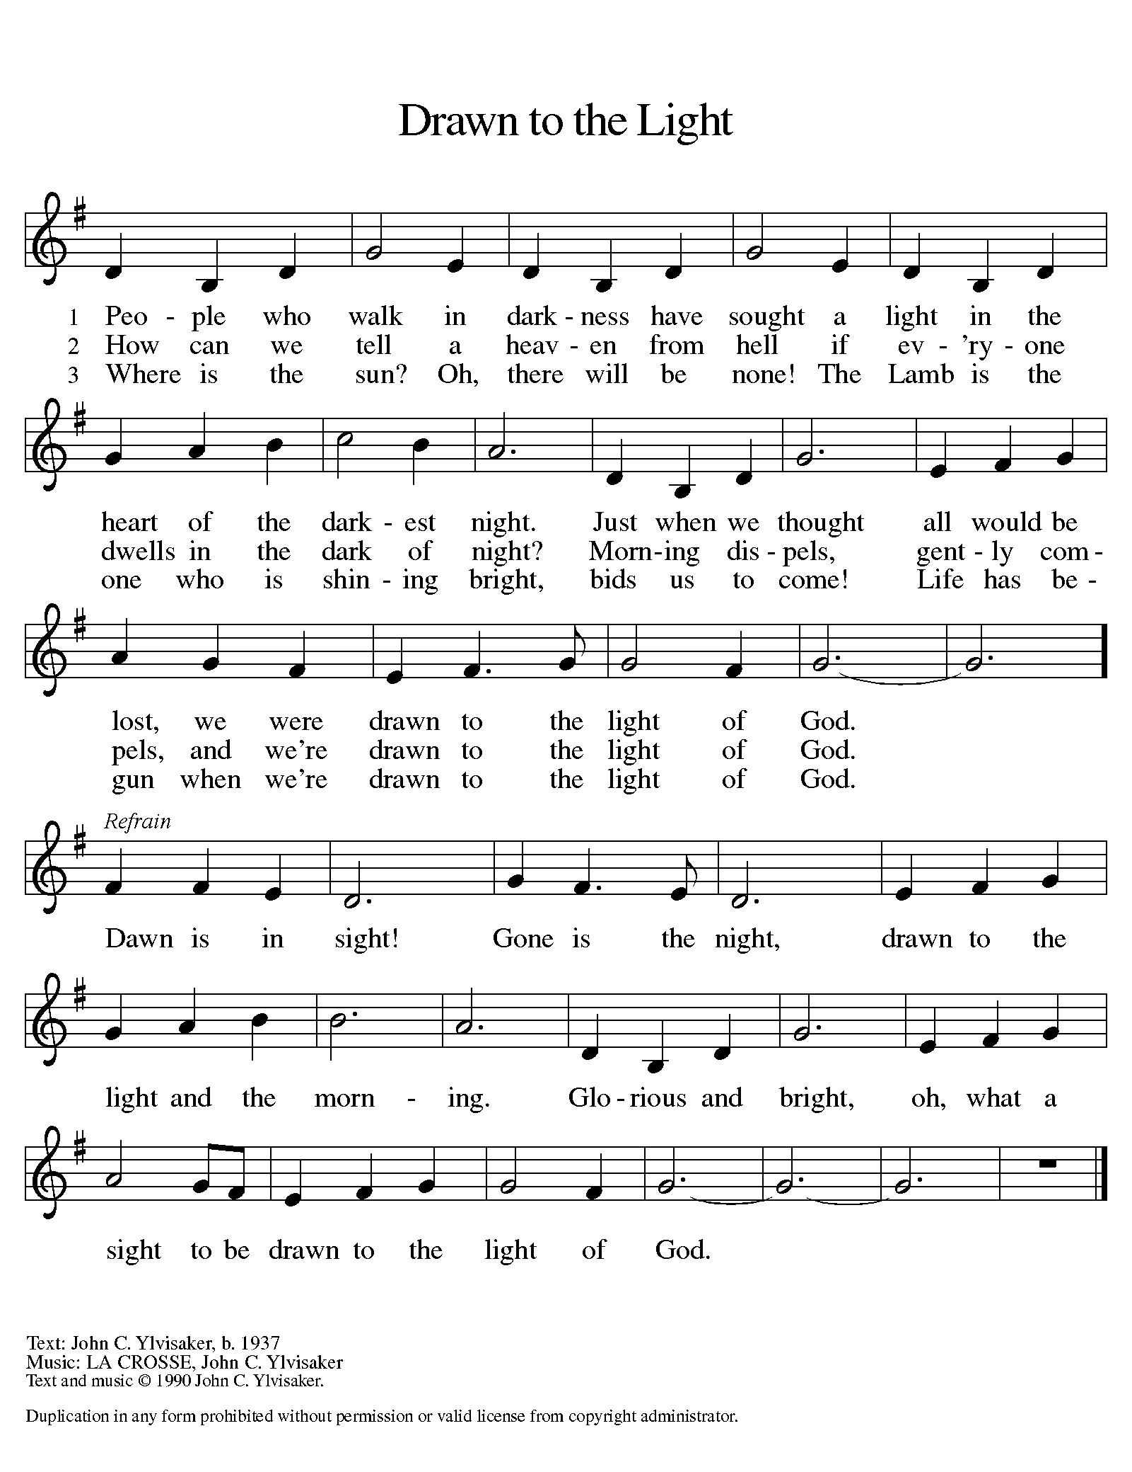
APOSTLES CREED
C I believe in God, the Father almighty, creator of heaven and earth.
I believe in Jesus Christ, his only Son, our Lord. He was conceived by the power of the Holy Spirit and born of the virgin Mary. He suffered under Pontius Pilate, was crucified, died, and was buried. He descended into hell. On the third day he rose again. He ascended into heaven, and is seated at the right hand of the Father. He will come again to judge the living and the dead.
I believe in the Holy Spirit, the holy catholic Church, the communion of saints, the forgiveness of sins, the resurrection of the body, and the life everlasting. Amen

PRAYERS (please sing the canticle below after each petition)
Lord, listen to your children praying,
Lord, send your Spirit in this place;
Lord, listen to your children praying,
send us love, send us pow’r, send us grace.

SHARING OF THE PEACE Please pass the Friendship Register
P The Lord be with you. C And also with you.
P Lift up your hearts. C We lift them to the Lord.
P Let us give thanks to the Lord our God.
C It is right to give him thanks and praise.
L It is indeed right, our duty and our joy…we praise your name and join their unending hymn:
Holy, holy, holy are you, God of power and might;
Heaven and earth are filled with your glory.
Hosanna in the highest!
Blessed is the One who comes in your name.
Hosanna in the highest, hosanna in the highest!

WORDS OF INSTITUTION
LORD’S PRAYER
(please be seated)
THE COMMUNION music by Julie Bright and Mike Kerrigan
(please stand)
COMMUNION BLESSING
BENEDICTION
SENDING HYMN (green hymnal #259) “Lord, Dismiss Us with Your Blessing”
P Go in peace, serve the Lord. C Thanks be to God.
POSTLUDE
Everyone is invited to the Fellowship Hall for coffee following worship!

Adult Ed discussion, TODAY and next Sunday following worship

Changing the Narrative on Mental Health and Suicide
Mental health and suicide are often difficult topics to discuss, especially within faith communities. This session invites open and honest conversation grounded in compassion, care, and Christian hope. Together, we will explore how our words and attitudes can bring life, reduce stigma, and reflect God’s love to those who are struggling.
We’ll learn how to talk about mental health and suicide in a way that is safe, respectful, and life-giving. We'll discuss how certain language can unintentionally cause harm or discourage people from seeking help and how we can instead speak hope, resilience, and truth into challenging situations.
Who is this for? This session is open to all ages (middle school to adult) who want to be part of creating a more understanding and life-affirming community.

Join the pastors for LECTIONARY BIBLE STUDY on Tuesdays at noon in the double classroom. Discuss the scripture for the week’s upcoming worship services.

Hope’s Trivia Night, Thursday, October 16
Gather a team of up to 6 people, or join in with another team at Benson’s on October 16th, any time after 5:30 for fellowship, free pizza and pop with trivia starting at 6:00. Bring a cash or food donation for the Walker Area Food Shelf. RSVP to Joe Sherman - joebarb@arvig.net.

THis Week at Hope
JOIN HOPE’S HABITAT CREW TOMORROW (Monday October 6) for a workday on the Cass Lake houses. There is some final painting to be done, but the main focus for the day will be siding, soffit, and facia. We are very close to having one of the houses completed and ready for their new family. Any and all help is appreciated. If you want to carpool, plan to be at Hope by 8:30 am. Otherwise come directly to 308 Basswood, Cass Lake at 9:00 or whenever you can make it. We will plan to work from 9-3. Whatever hours you can work will be a great help. Questions? Call Pastor Dave 218-507-0190.
Monday 10/6/25
8:30 am – Habitat Crew to CL
9:30 am – AA
1:00 pm- Bone Builders
5:30 pm – Board of Property

Tuesday 10/7/25
7:15 am – HS Bible Study at WBC
9:00 am - Card Makers
9:30 am - Bone Builders
GREETING CARDS FOR ALL OCCASIONS are available near the church office for $2 each.
We have confirmation cards! Proceeds support the many ministries of the Women of Hope.
Noon – Lectionary Bible Study

Wednesday 10/8/25
8:30 am – Board of Outreach
9:30 am – Ruth Circle
1:00 pm – Bone Builders
1:30 pm – K-2nd Grade Release Time
3:30 pm - Joyful Noise
4:45 pm - Wednesday Kids
5:30 pm – Simple Supper – Roast Pork
6:15 pm –Wednesday worship
6:45 pm – Confirmation Classes

Thursday 10/9/25
8:30 am – Quilters
9:30 am – Lydia Circle
9:30 am – Bone Builders
11:30 am – Women’s AA
1:00 pm – 3rd-5th grade Release Time

Sunday 10/10/25
9:00 am – Communion Worship
10:00 am – Coffee & Fellowship
w/Pastors’ Appreciation
10:10 am – Mental Health Discussion

October Simple Supper
Wednesdays at 5:30
Oct 8: Roast Pork & Whipped Potatoes
Oct 15: Tator Tot Hotdish
Oct 22: Taco Salad
Oct 29: Chicken Nuggets & Tator Tots

OUR STEWARDSHIP RELAY IS WELL UNDERWAY with several neighborhood teams already completing the race! Have you passed the relay packet on yet? If the packet is currently sitting on your kitchen counter, please complete your Estimate of Giving and scoot it along to the next household.

HOPE QUILTERS are in need of bed sheets for quilt backs. If you have any in decent condition that you’d like to donate, leave them in the church office.

GREETING CARDS FOR ALL OCCASIONS are available near the church office for $2 each. We have confirmation cards! Proceeds support the many ministries of the Women of Hope. Card makers meet on Tuesday morning in the Fellowship Hall. Anyone is welcome to help. All supplies provided! Stop by any Tuesday.

WOULD YOU LIKE TO SERVE AS A SCRIPTURE READER or COMMUNION ASSISTANT during Sunday worship? Leave a message in the church office to be added to the next schedule, or email hope-michelle@arvig.net

USHERS ARE NEEDED for Sunday morning worship services. Not a difficult task – handing out bulletins and directing folks forward for communion. Leave a message in the church office if you would take a shift!

