IMG_5966  C. G. Winter's Home  Mar. 4, 1931  Meeting of official  church board.  J R R, J H Sweet, R Guild  C. M. T., C. G. W., F. Ross  J. W. C., F. W. W. present  opened with prayer  by C M Todd  Mrs Ross stated  that Rossville had  a proposition in  regard to a  minister for the  coming year They  have been paying  $2000 per year | 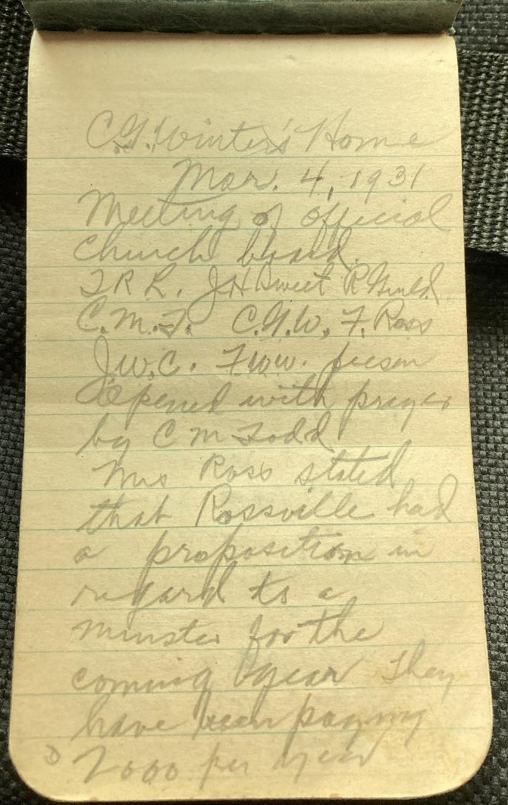
IMG_5967  the best they  could raise this  year was $1300.  Their proposition  was if they kept  the minister they  would pay $1000 and  he would give us  1/2 time and we  pay $600. or vice versa | 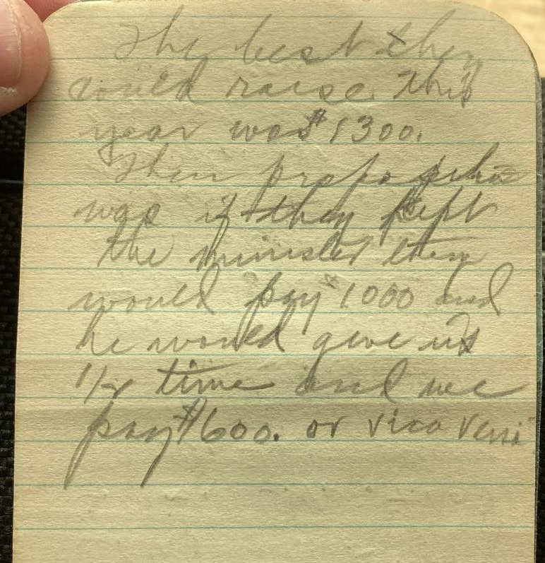

IMG_5968  main room seating  200 + 5 Sunday  School rooms  seating 25 people  each.  3 or 4 class rooms  in basement.  Moved the chair  appoint a com of  3 to look after  plans price etc  J. H. Sweet, C M Todd  C G, Winter! | 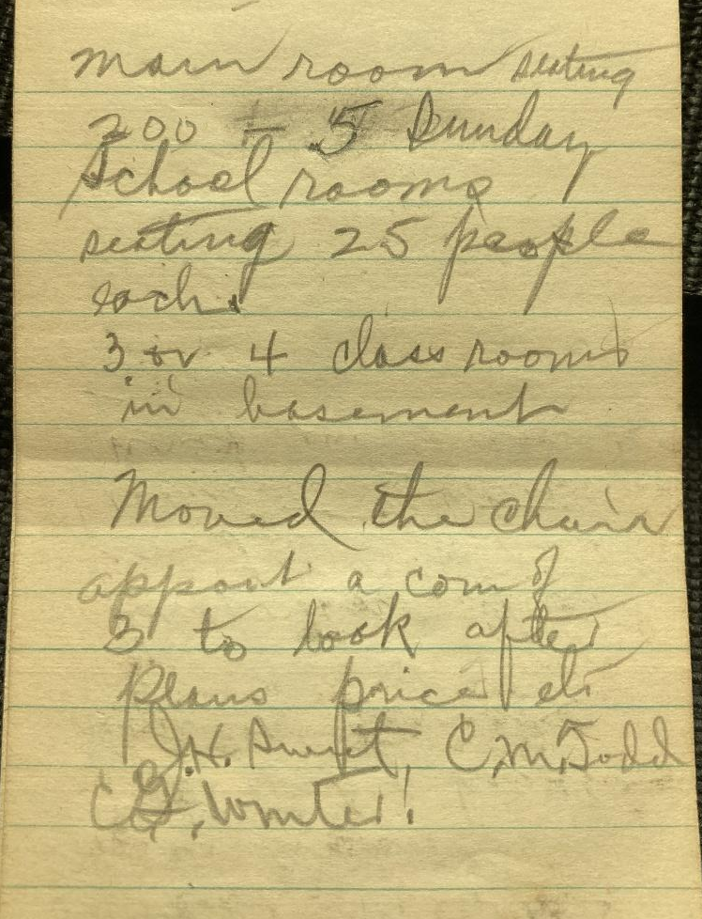
IMG_5969  Moved we  extend the M. E.  minister at Rossville  a call to the pastor  if the board has the  power, carried  Reading of letter  from Lloyd M Miller  requesting letters  moved and recommend  to church | 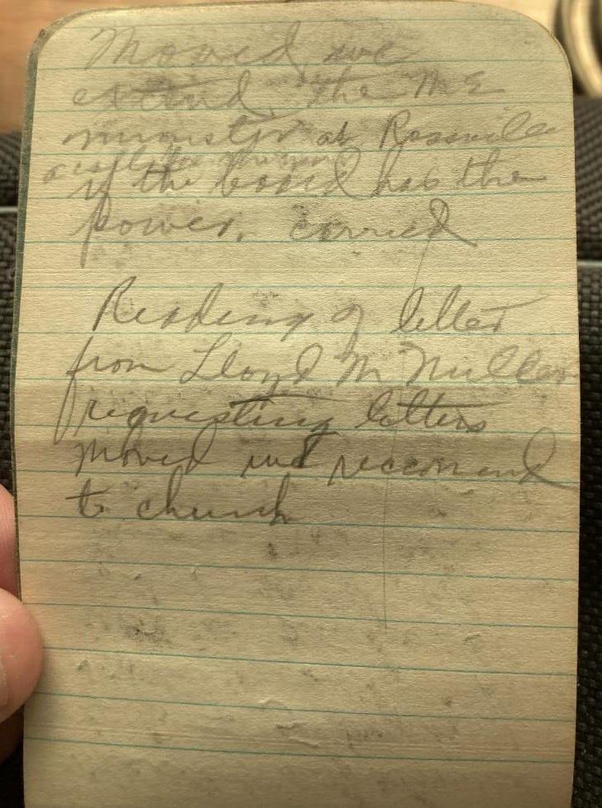

IMG_5970  meeting of church  body Sunday a.m.  after Sunday school  After prayer by  Bro. Corkill, Chairman  Ross stated the  proposition of pastor  open to discussion  moved by Chas Todd Jr  sec. by Mrs. F. M. McDonald  moved the chair  appoint a member  to look after the  entertainment of Bro  Foiles each Sunday  he is here  Chas Todd Jr appointed | 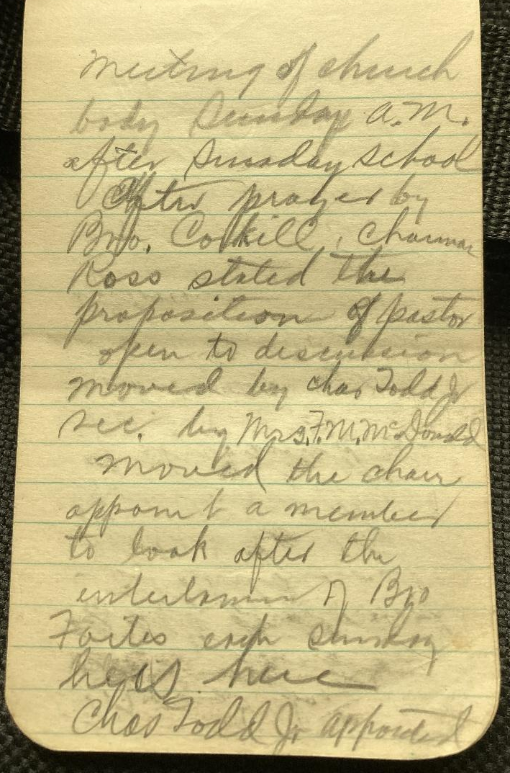
IMG_5971  moved by J. H. Sweet  we grant to  Lloyd Miller, wife  & 2 children  letters to the  Presbyterian Church  of Silver Lake.  Moved by Mrs  F Winter chair  appoint a com of 3  as soliciting Com.  Mrs F. D. Dutton  Mrs Aaron Winter  Mrs Maude Croyle  appointed  Raised 392.00  bal. on pre. Bro Sweet  F W W | 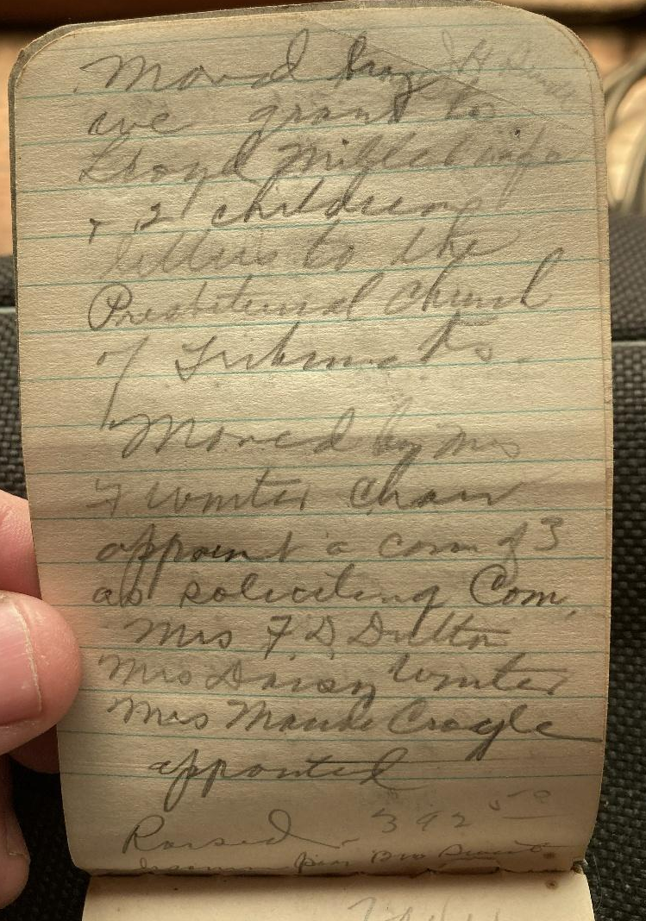

IMG_5972  May 24, 1931  meeting of board  C M T present  open with prayer  by the Pastor Rev.  Foiles. The question  of finding out  the cost of the  new building  using the old building  material  Saunders Auto?  & Phillips are | 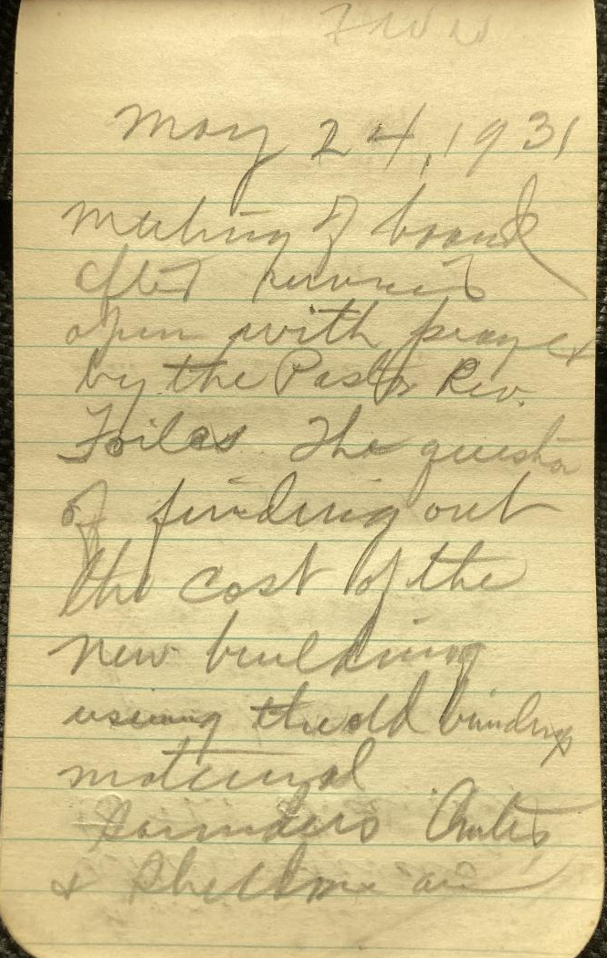
IMG_5973  likely givers  to the church.  passed. | 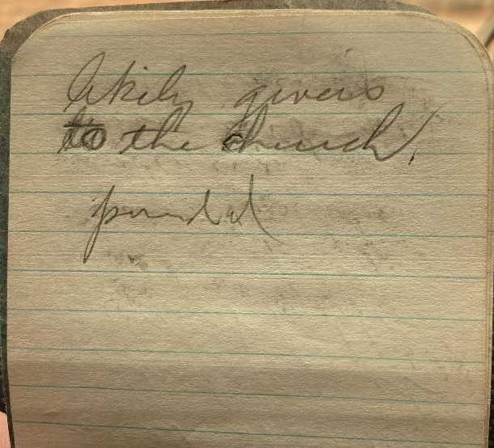

IMG_5974  June 7, 1931  meeting of  church body after  services to decide  on material for  new church.  J H Casson & Son 11973.  Amber glass 225  add for brick & tile  2600.  14798  Moved by F W W  & sec by Mrs Appleton  that we build  with brick and  tile at the price  14798. specified | 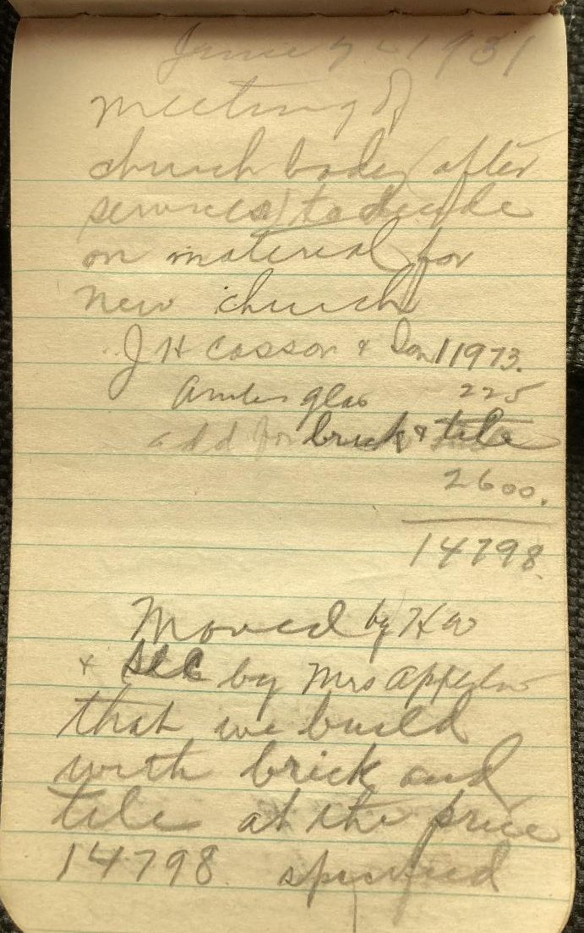
IMG_5975  motion carried  29 voted yes  none voted no.  Moved the  board ask for  5000, more  money to build  the church  Moved chairman  appoint com  of [blank] to solicit  the Dover Community  mrs. Appleton  " Berryman  chas Todd  John Ross  claude Ross | 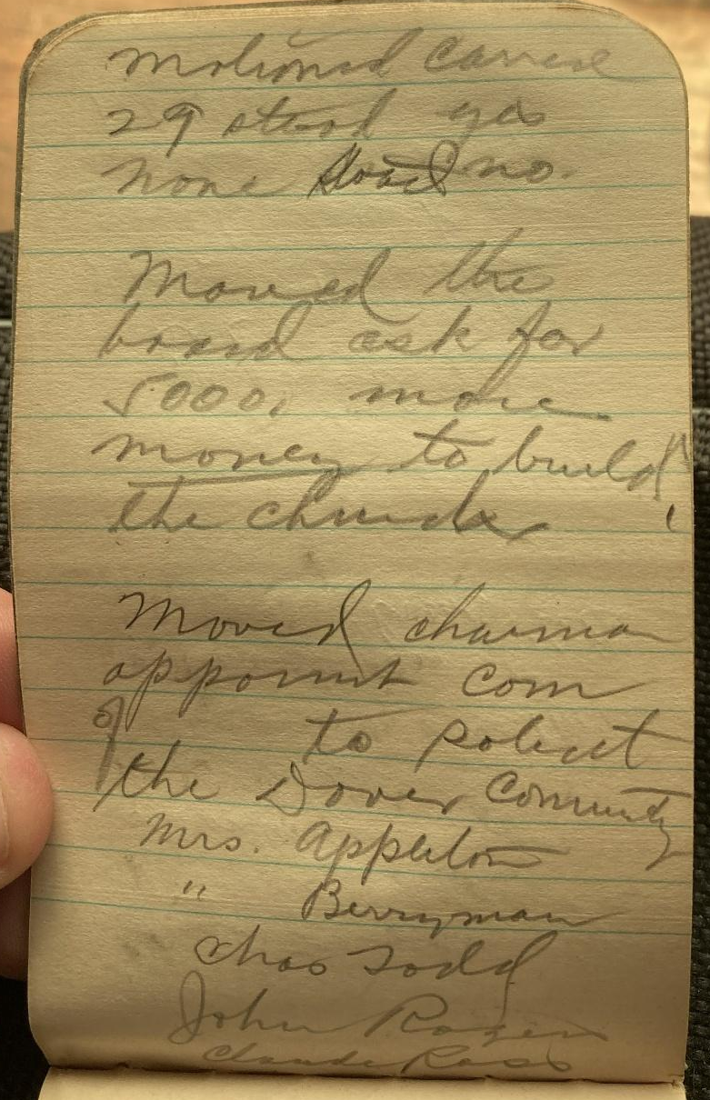
IMG_5976  moved chas  Winter. Floyd  Ross and a  third member  selected by them  act as soliciting  the Topeka members | 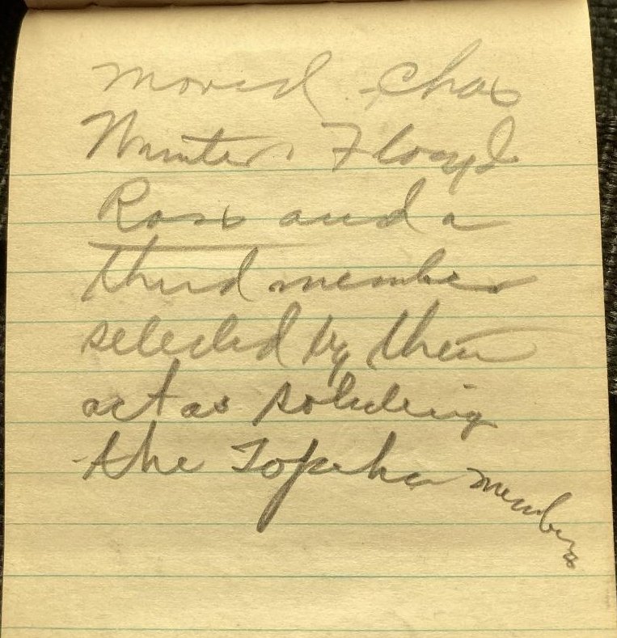
IMG_5977  June 21 - 1931  Reading of  minutes of  3 denominations  moved we  accept the  reports of the  3 Denominations  and that a  copy of the  report be | 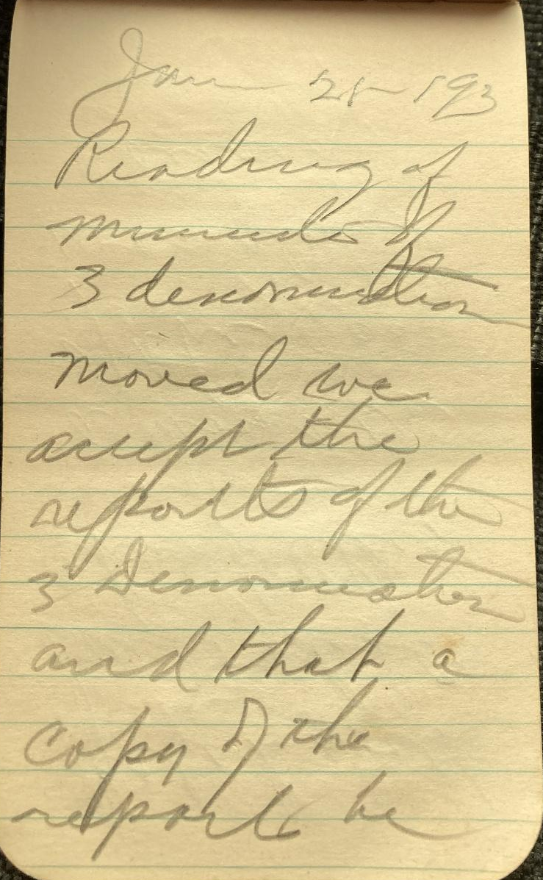

IMG_5978  filed with  our Federate  church clerk  a bout 1/2  of the 5000  was already  raised.  adjourned | 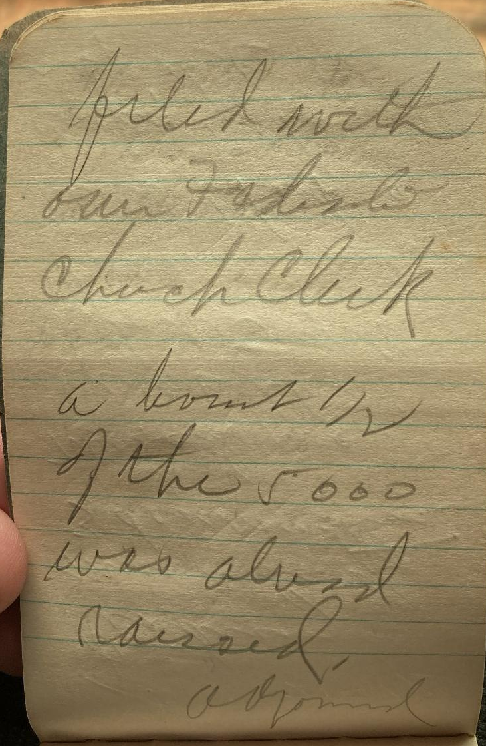
IMG_5979  Sun June 28, 31  Board meeting  6 percent  subject of charter  never filed (8 yrs)  making of new  application requested  $2.50 filing fee  $1 each year  Moved we  send out a  circular letter  giving info | 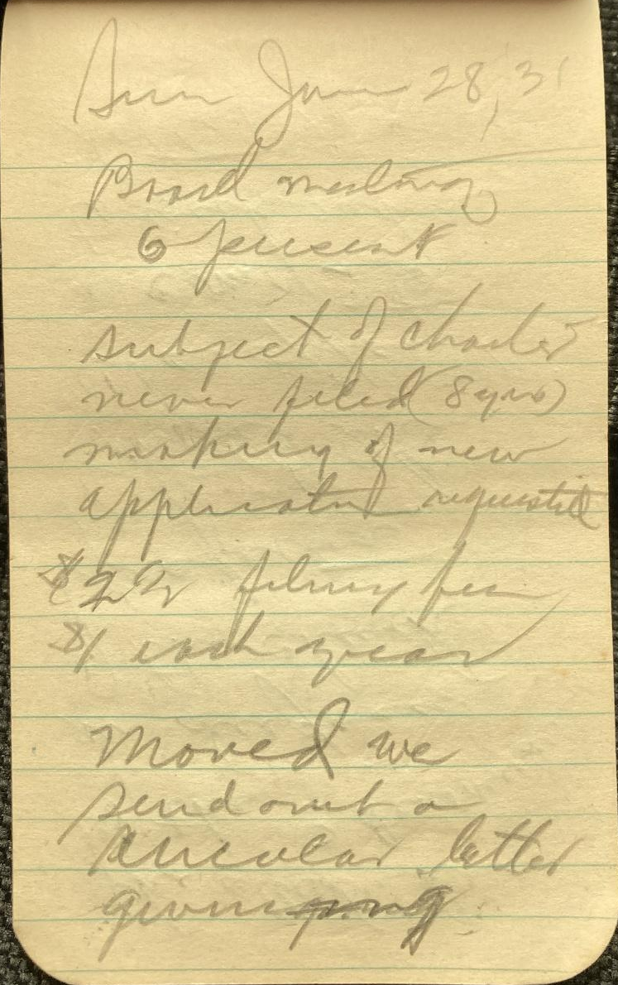

IMG_5980  the attitude  of the 3 denominations  in disposing  of the church  properties.  moved the  chair appoint  a com of 3  to work out a  letter to send | 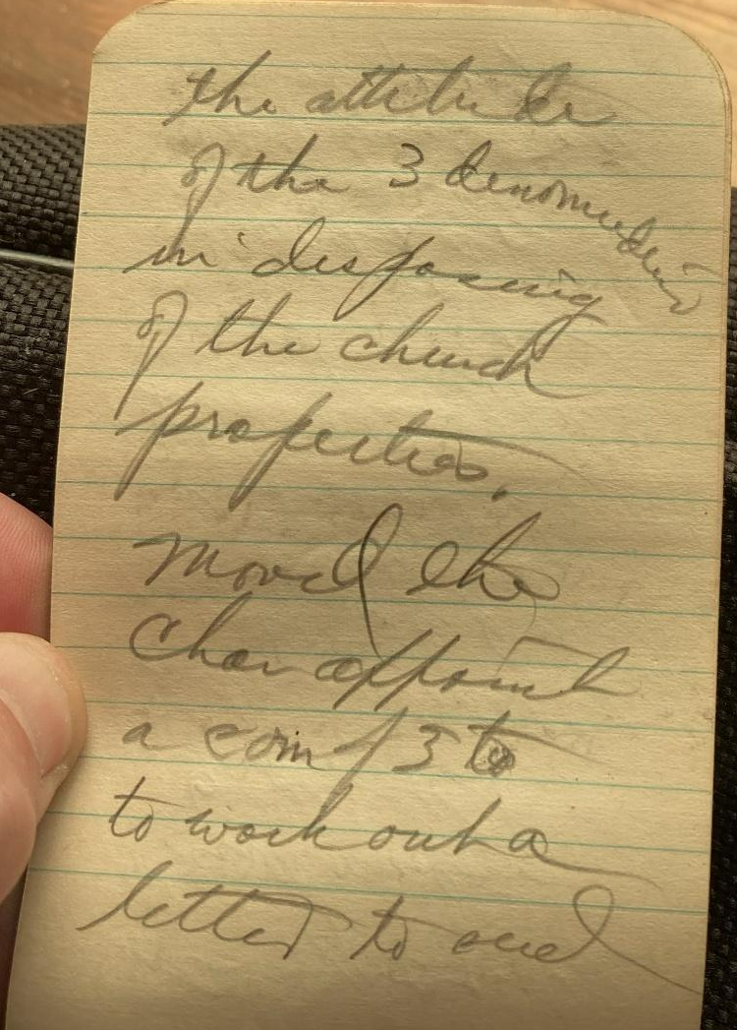
IMG_5981.jpg  C.G. Winter Mr Sweet  & F.W. Winter  Moved & second  to committee  to make a verbal  contract with  Mr Crosson & Son  reserving the right  to the old building  providing we can  get more for it  then otherwise | 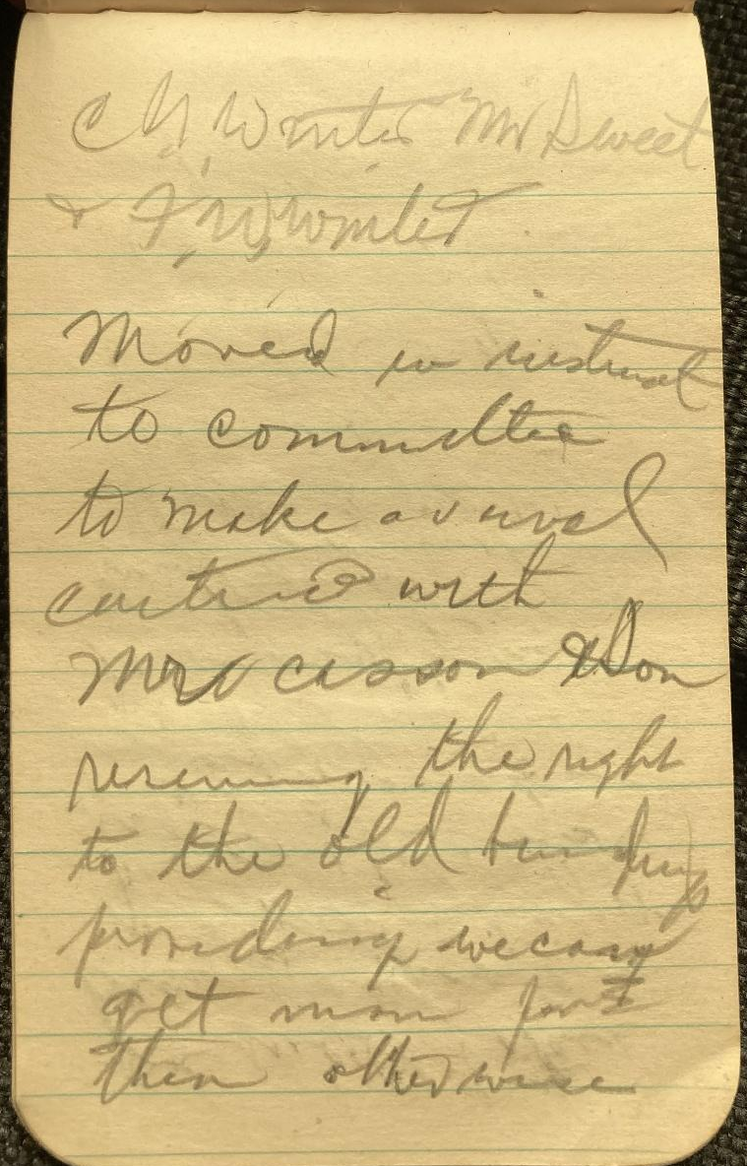
IMG_5982.jpg  we will take  his proposition  of 240.00 & the  use of the old  timber or NOT  to use all new  lumber  closed with  prayer | 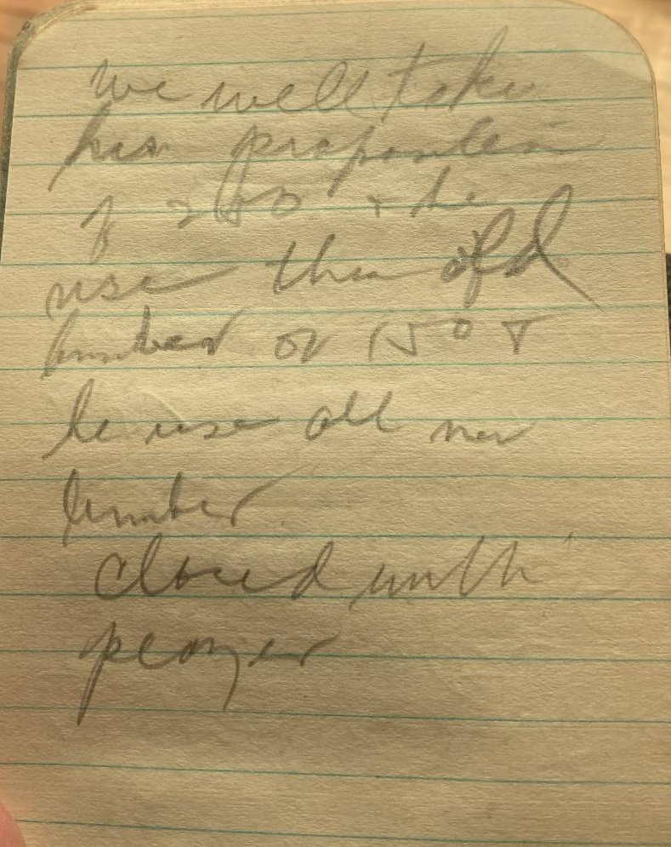
IMG_5983.jpg  July 12 - 1931  Meeting of  board after  S.S. present Mr Sweet  in matter of a  temporary agreement  with contractor  on new building  but after moved  the building com-  go ahead  and make  a tempo - agreement  in order that  the contractor | 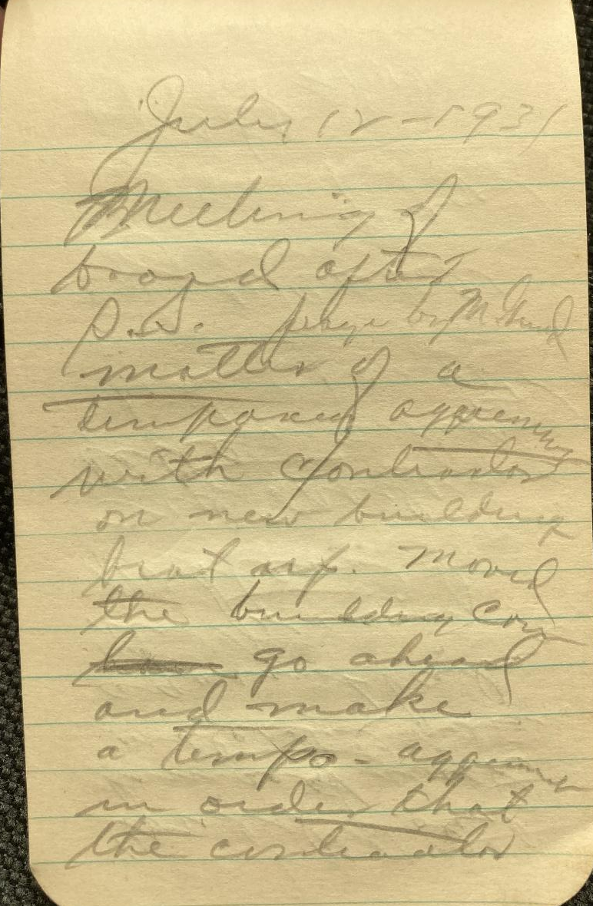
IMG_5984.jpg  could protect  himself with  material & price  against advance  in price of  material  Motion  carried  Bro Corkill  prayer  clerk  FWW | 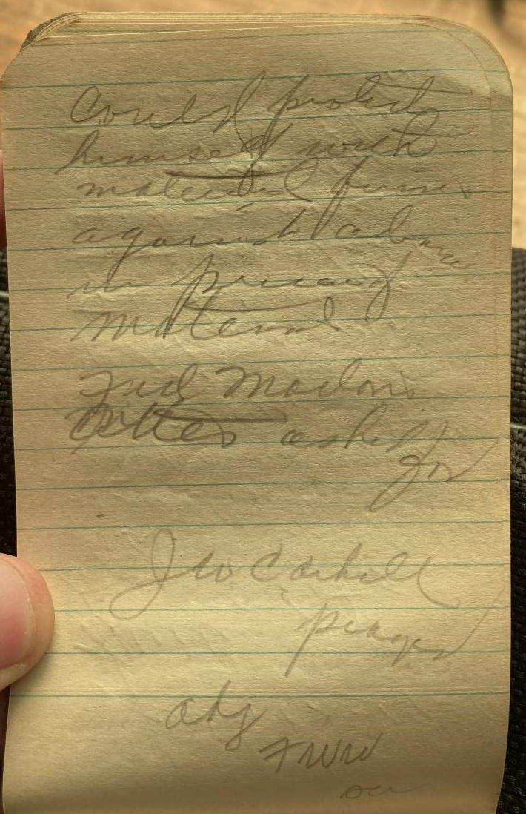
IMG_5985.jpg  Sunday Sept 20 - 1931  meeting of church  body opened  with Floyd Cox  in the chair  Bro Corkill  offered opened prayer  moved we  order a slab  with "Federated  Church 1931"  cut in face | 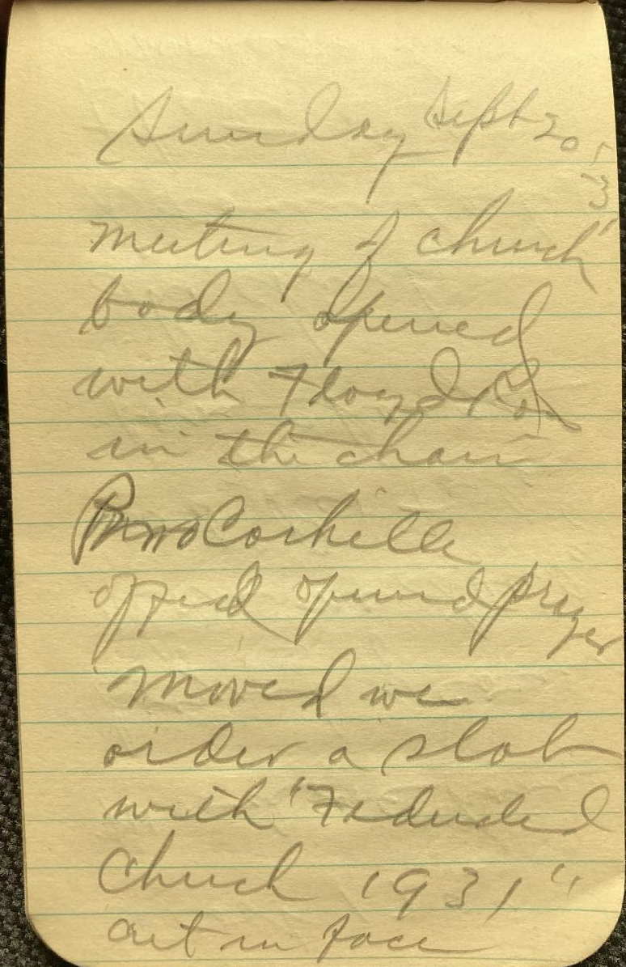
IMG_5986.jpg  to cost 17.00  Moved we have  laying of corner  stone next Sunday  and Rev Foiles  have charge  The church  treasurer asked  that all  moneys be | 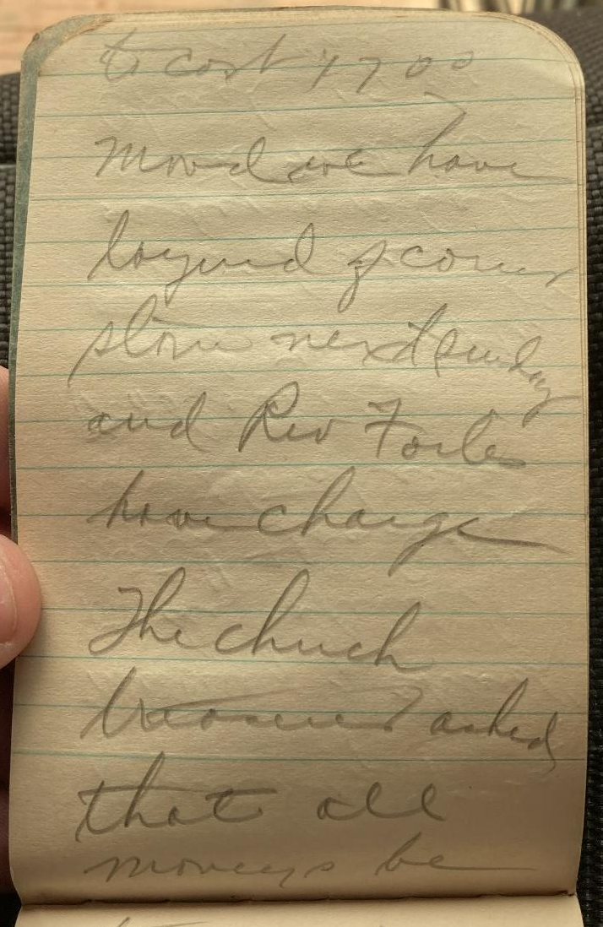
IMG_5987.jpg  turned in  as soon as  possible to  meet first  payment on  new church.  adjourned  with prayer  by Bro Sweet  FWW  clerk | 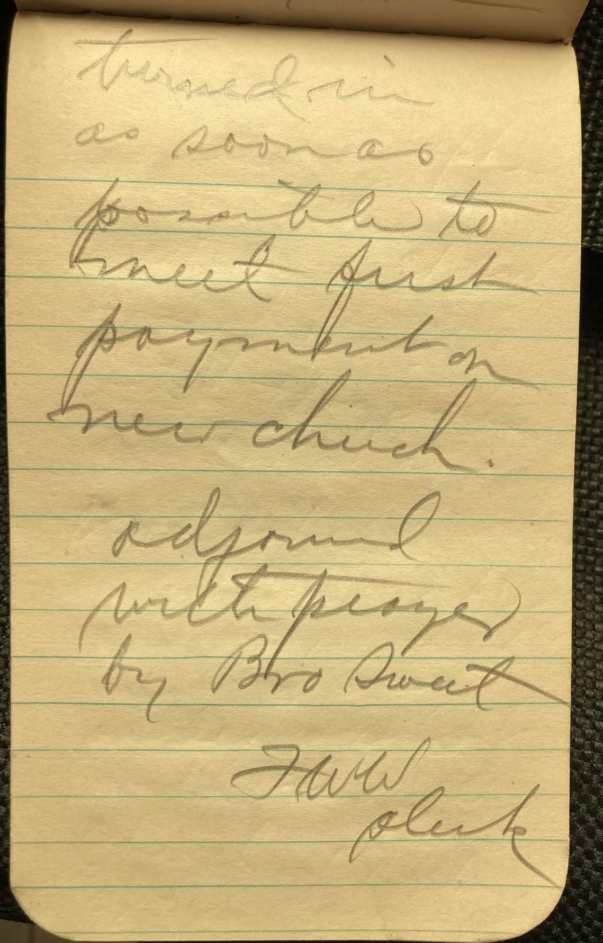
IMG_5988.jpg  Aug 23 - 1931  Meeting of board  after Sunday School  Meeting called  to order by Chairman  of building committ-  C.M. Todd  Clyde Winter  stated object of meeting  & report on funds  to date  also suggested  we have a start-off  Sunday next  sunday  Moved we | 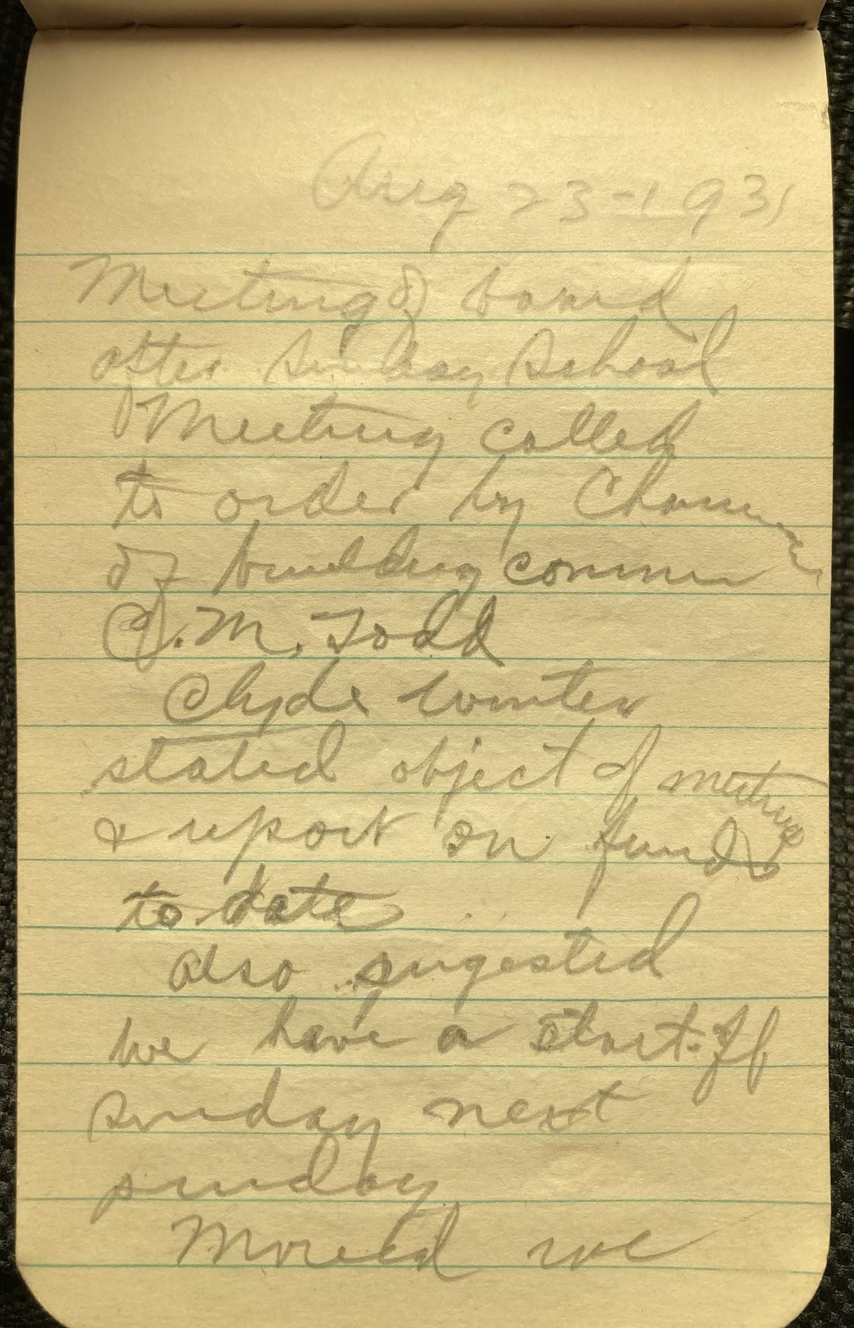
IMG_5989.jpg  passed to  carry out the  program as  outlined by  Clyde  Moved the church  board guarantee  the balance  lacking on the  5000; voted to  be pledged at  the time the  Building com.  are ready to  make contract | 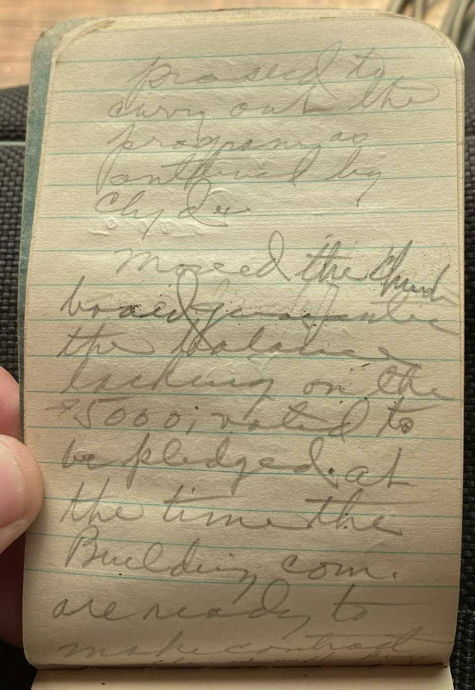
IMG_5990.jpg  closed with prayer  by C M Todd  adjourn  F W W  secy | 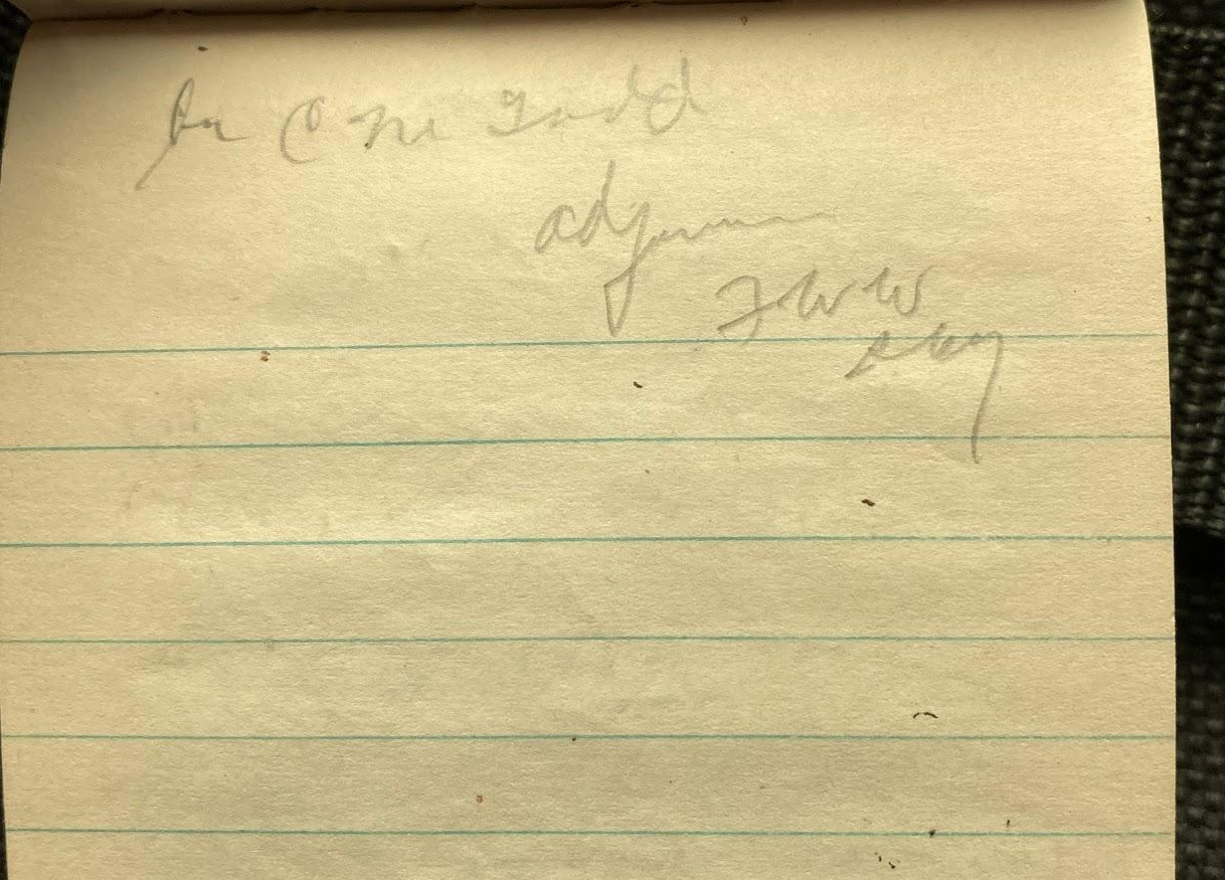
IMG_5991.jpg  Oct 18 - 31  Prayer Dwight  meeting of church  body, after  sunday school Report by Bro.  Chas. Todd  on the condition  of the building  com. financially  and that they  will have to  let the contractor  know in 2 weeks  whether to go  ahead and  finish the | 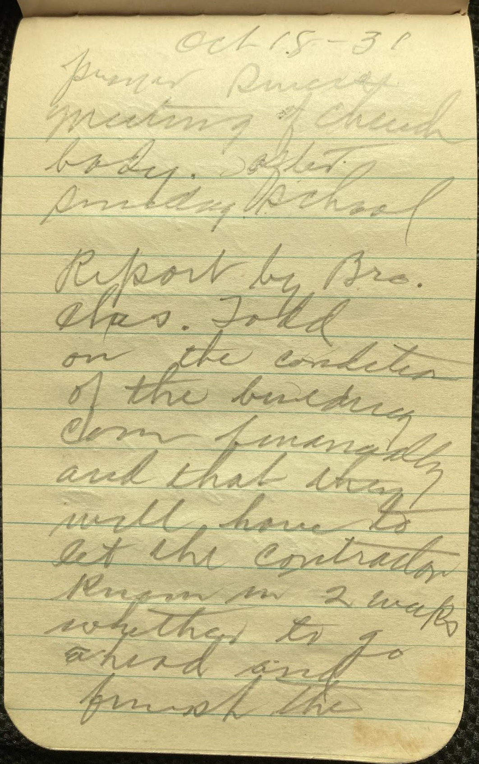
IMG_5992.jpg  the building  also reported  the funds were  $3000. short  & paying  $100 for the  building this  does not include  furnace & wiring  Report of sale  committee on  bids. Following  bids were received | 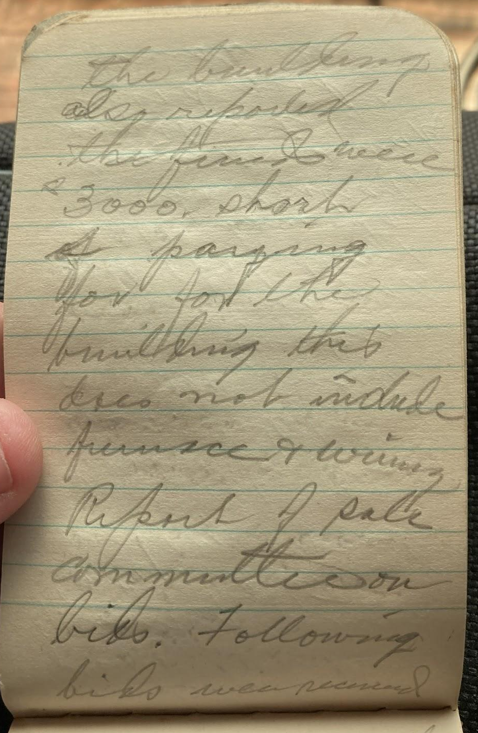
IMG_5993.jpg  Mr E A Underhill north  1/3 of Baptist church  lot $200.00  South 1/3 of Baptist  church Fred Winter  500.00 Middle  1/3 Baptist church  lot 500 by Fred  Winter.  M E, church lot  W. M. Randles  $190.00  Warren lot  W M Randles 90.00 | 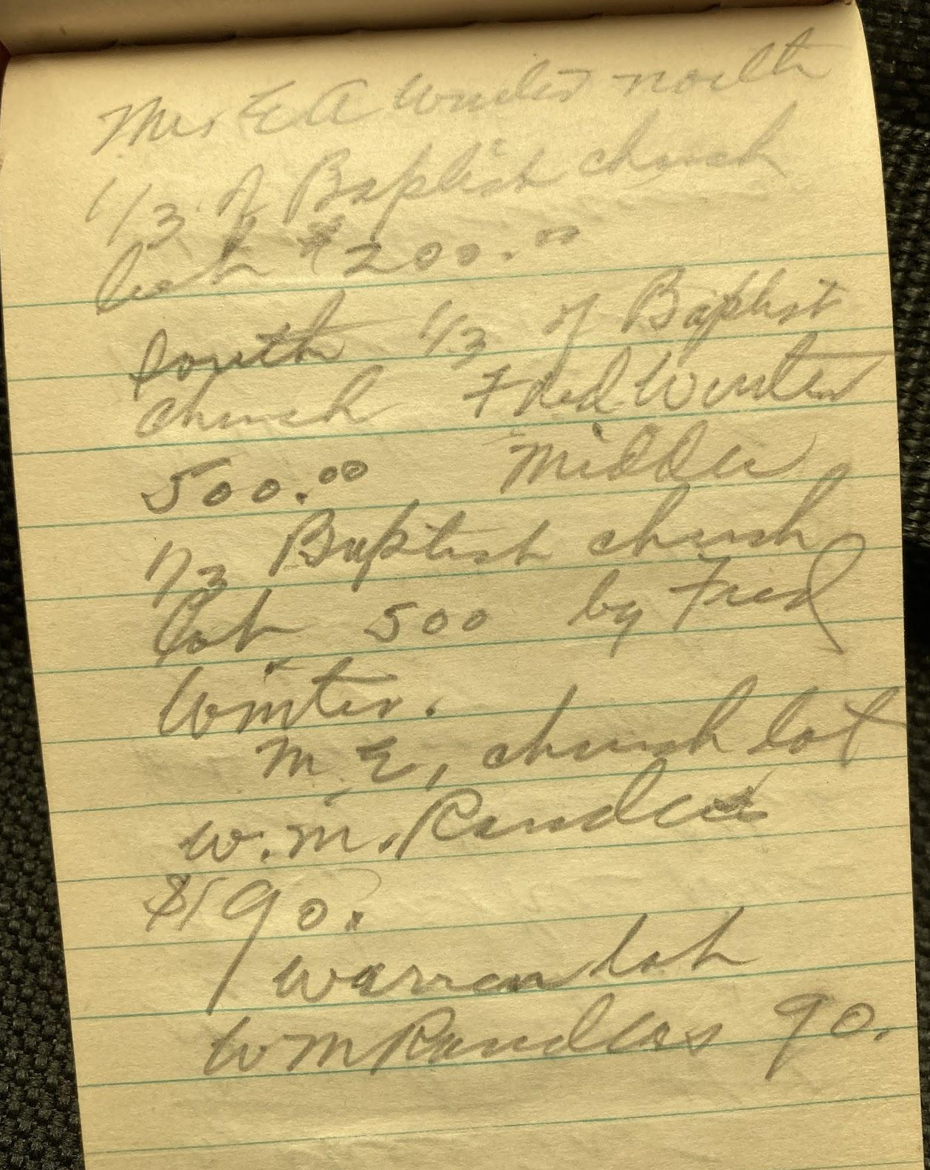
IMG_5994.jpg  Moved & carried  we recommend  to the M E  trustees that  they go ahead  and make sale  of the church lot  for 90.00 Mr  Randles take  a warranty deed  of it if he want  abstract he  stand expense  carried  moved we | 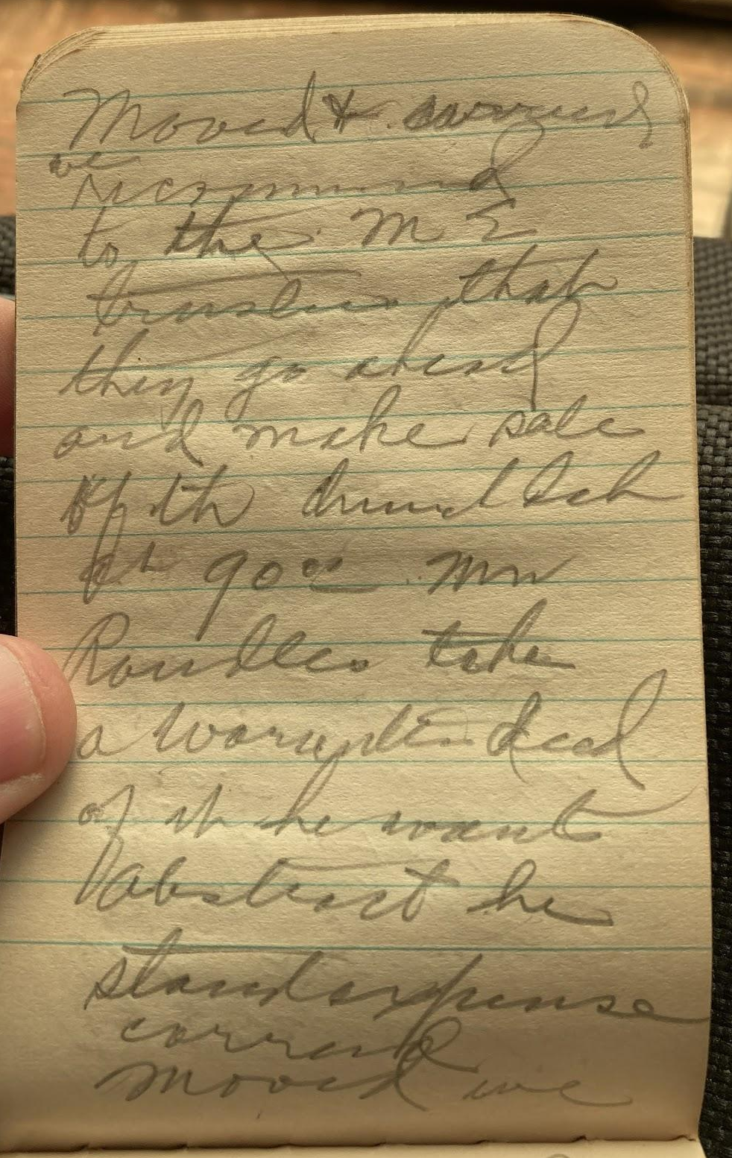
IMG_5995.jpg  recommend  to the Baptist  trustees that  they do not  take the bid  of 90 for the  Warren lot carried Moved we  do not accept  the bid bid  for Baptist  lot. carried | 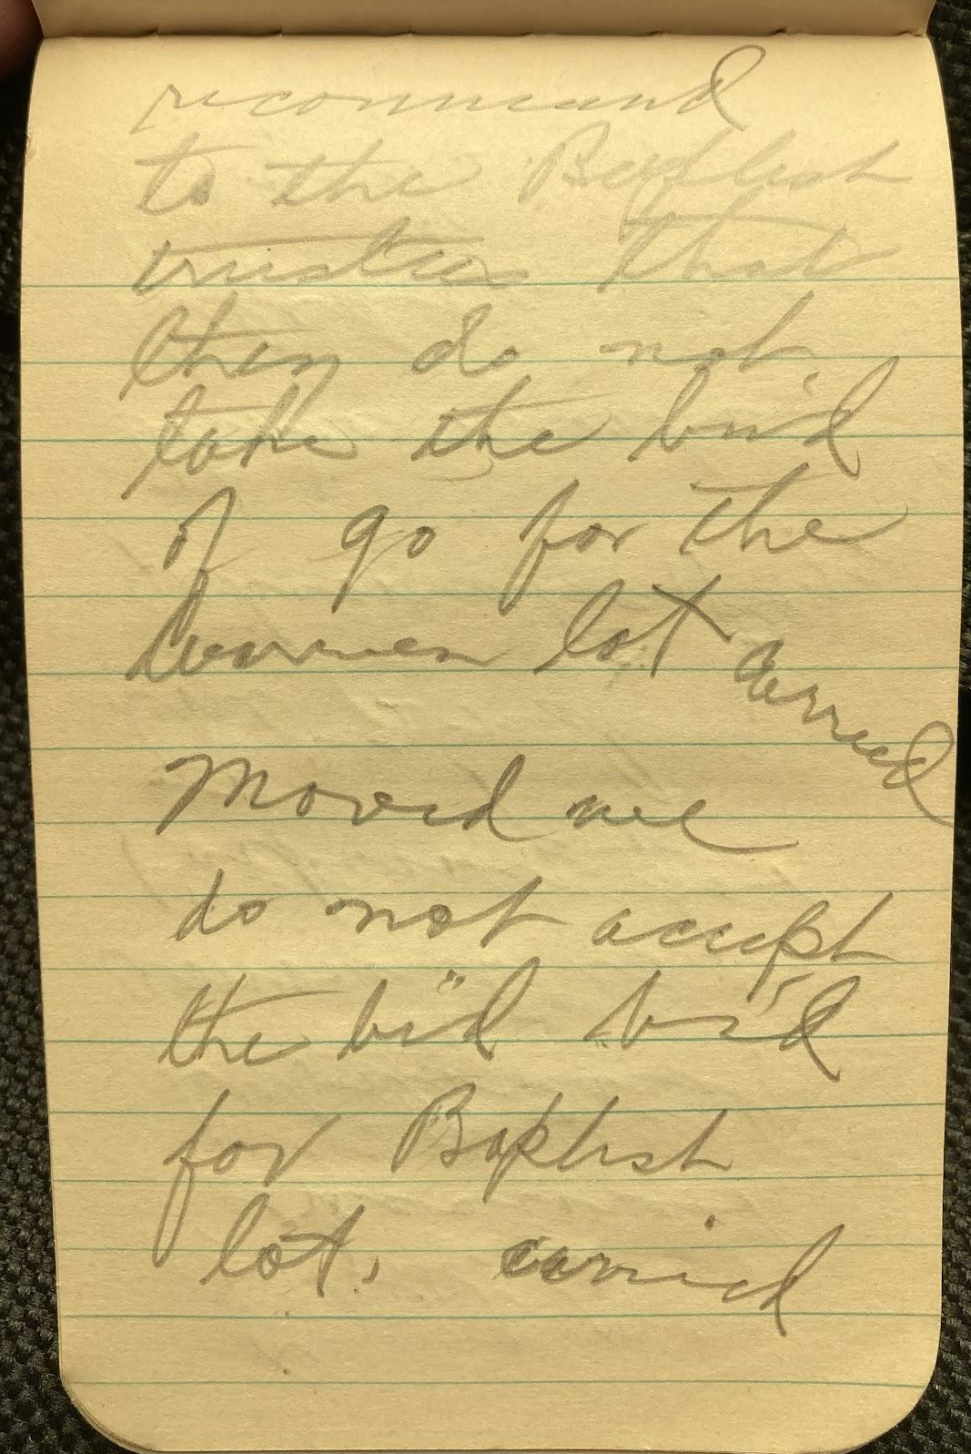
IMG_5996.jpg  Report of  Treasurer  submitted  amount is  lacking for  the 2nd  estimate payment  Those making  pledges be  urged. | 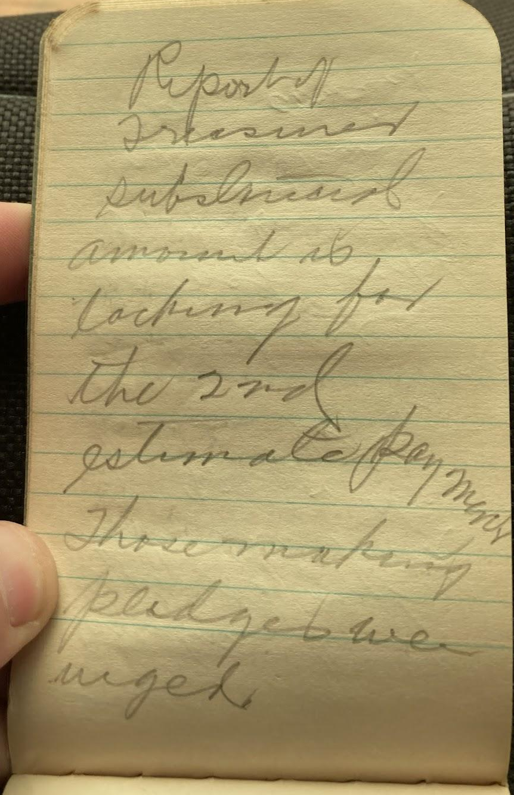
IMG_5997.jpg  Moved we  instruct the  building com.  and church board  to order the new  building completed  and to make  arrangement to  secure the money  to complete the  building. carried. | 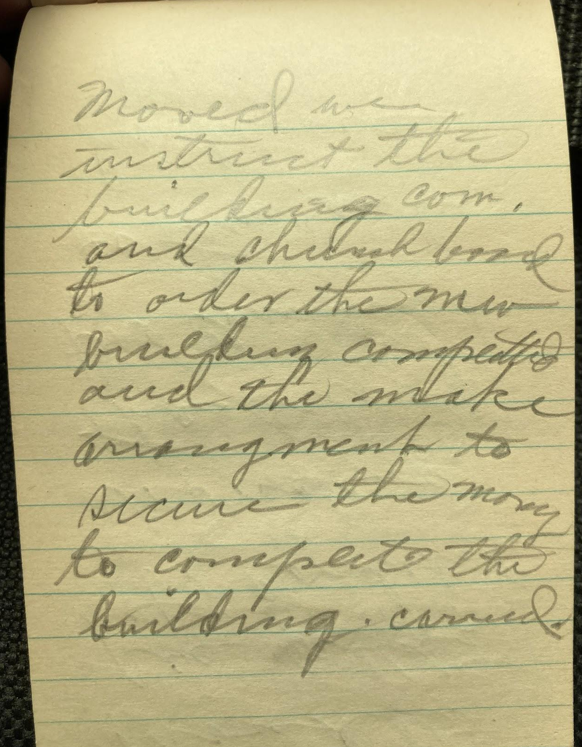
IMG_5998.jpg  moved to  sec notify  the contractor  at once of  the order of  the church  so they can buy  hardware.  prayer and dismissed | 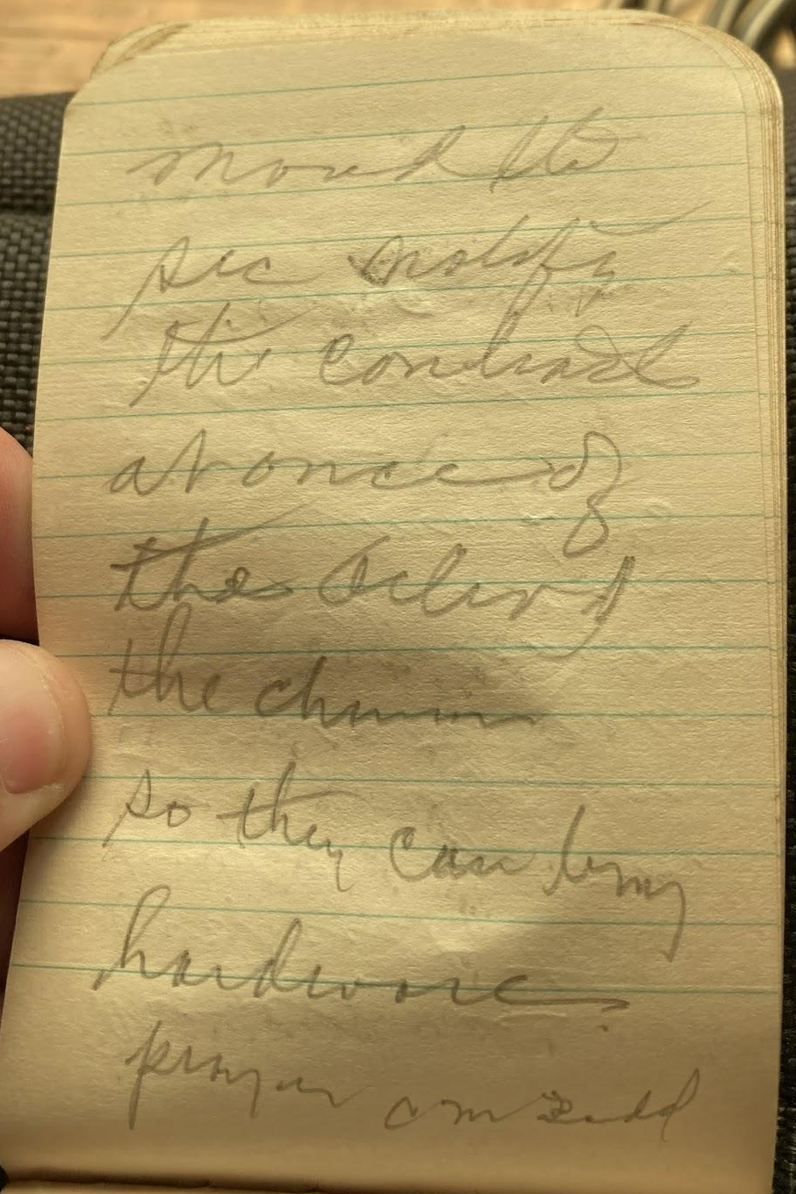
IMG_5999.jpg  Sunday 10/1/31  Meeting of church  body  prayer by Bro.  J. W. Corkill  Bro. Floyd Ross  announced the  object of the  meeting Bro  Guild moved we  rescind the motion  that we recommend  that we do not | 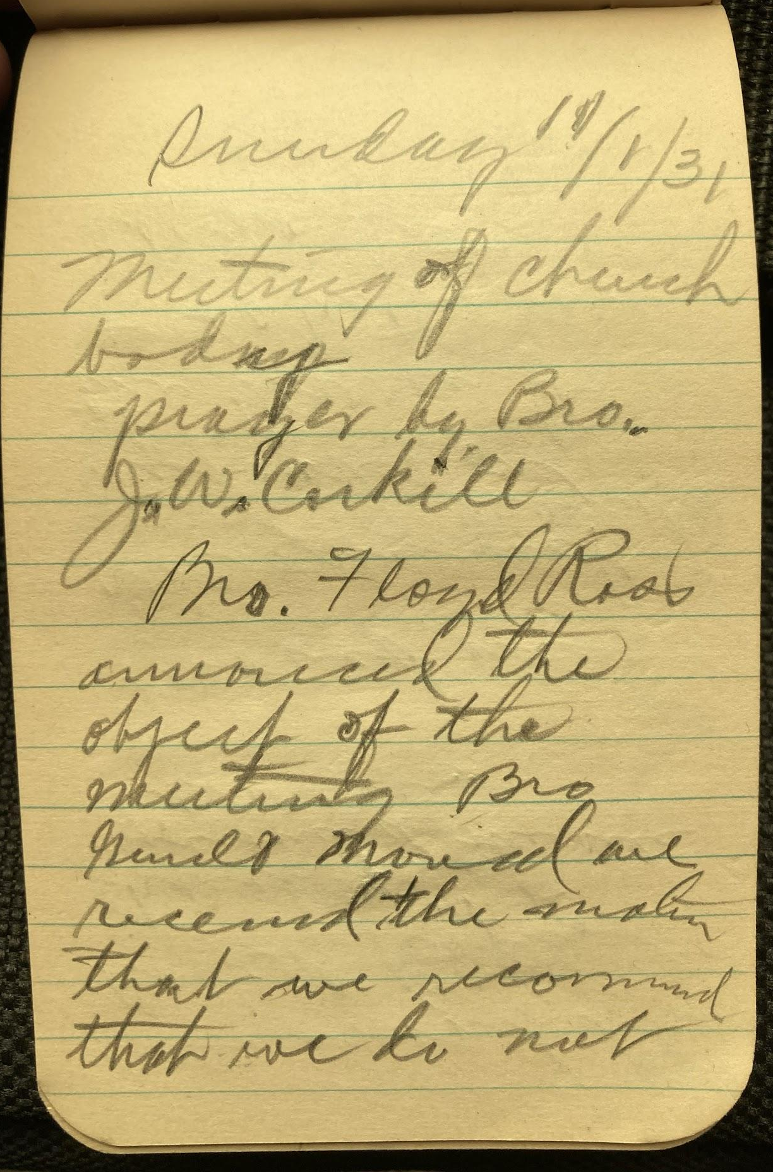
IMG_6001.jpg  recommend the  sale of Baptist  church lot  recommend this sale  Carried. moved we  recommend  the bid be accepted  on the Warren lot  & 40 feet of the  church lot  carried | 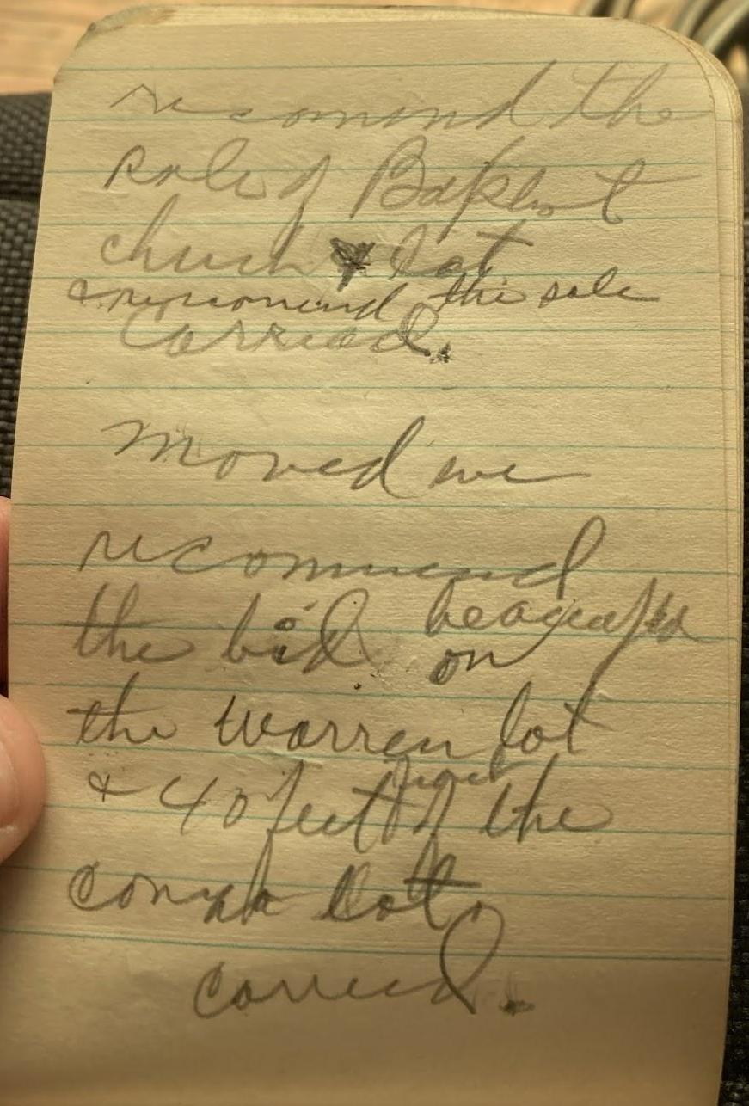
IMG_6002.jpg  Reading of 7 View  letter  moved the chair  appoint a committee  of 3 to look after  any memorial  donations & placing Mrs Appl Cora May  Mrs Berryman  carried.  pushed  adj. | 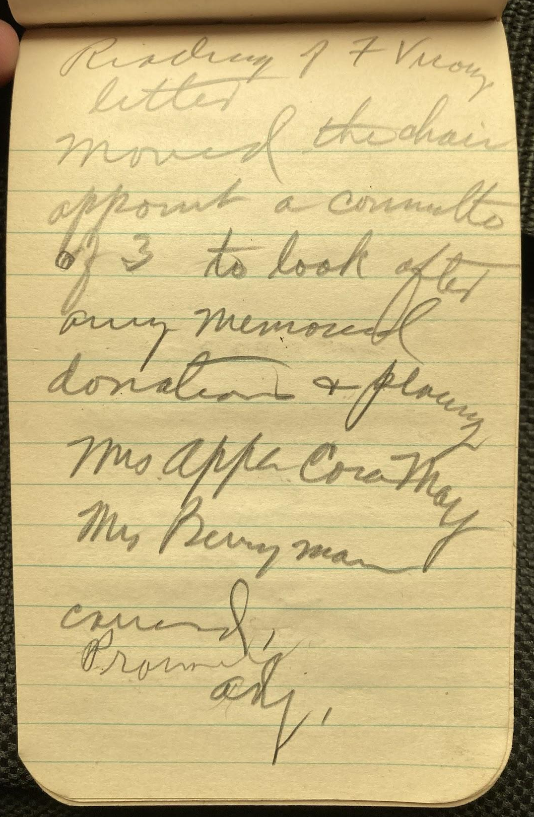
IMG_6003.jpg  Meeting of church  body Nov 22 - 31  Resolution authorizing  the Trustees  to make mortgage  for 3500. for  loan of equal amt On motion of  J H Sweet sec. by  C G Winter resolution  adopted  moved we have a  week of evangelistic  meeting preceding the  dedication | 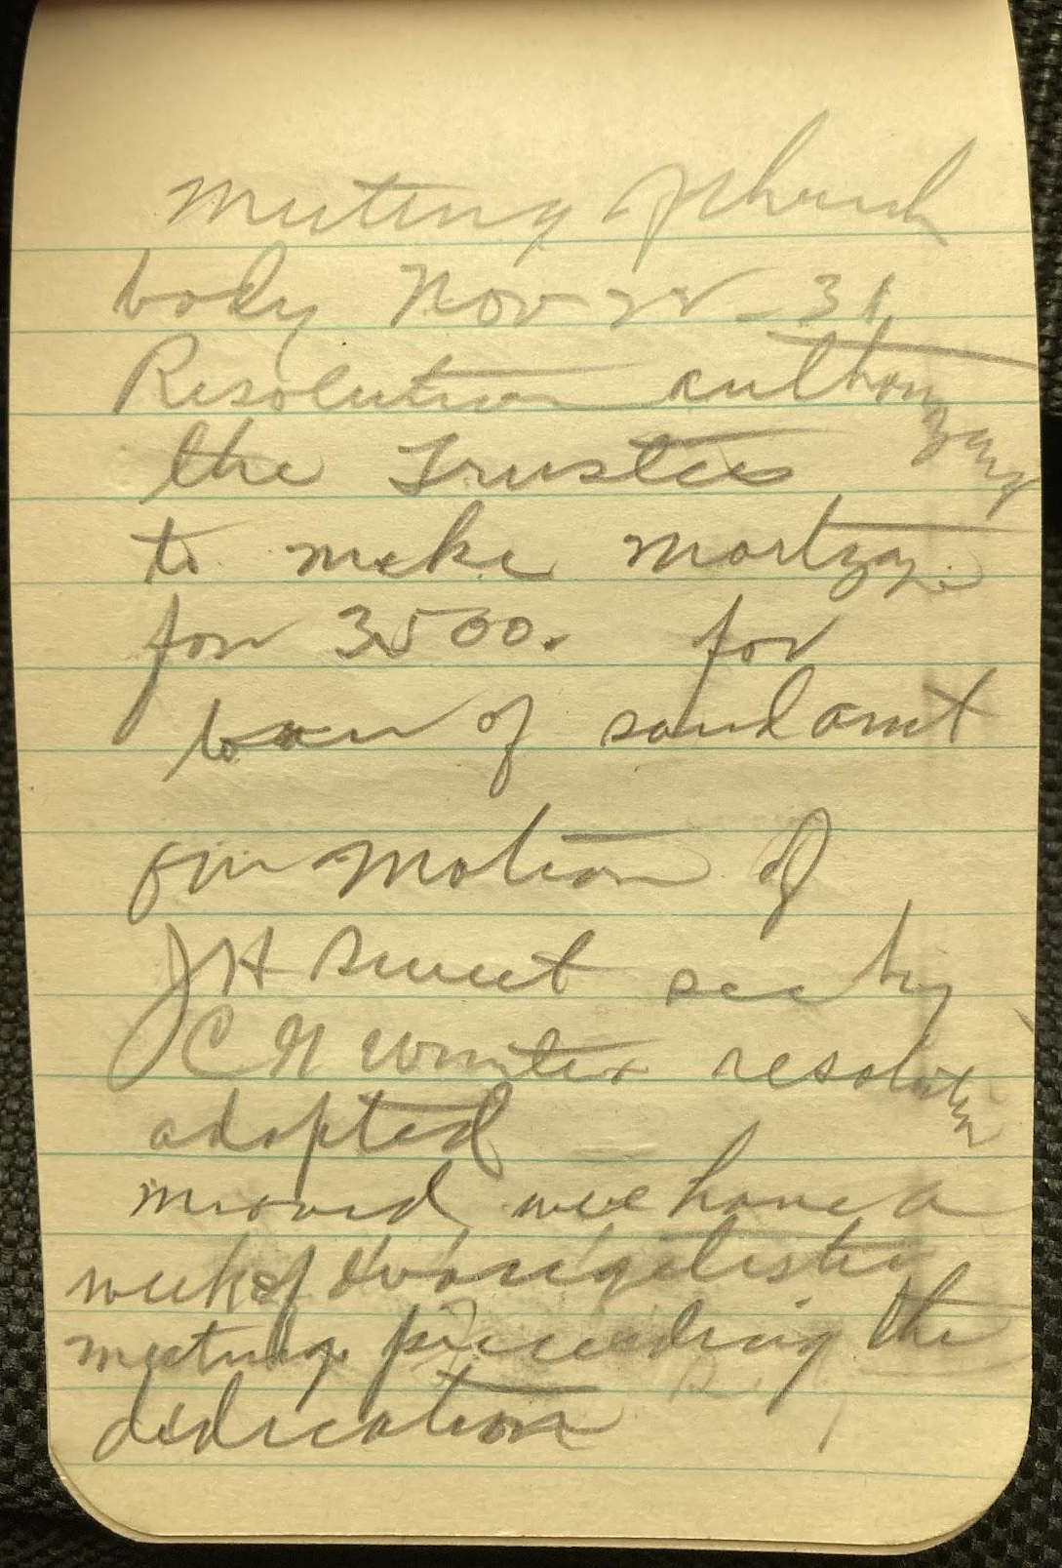
IMG_6004.jpg  Moved that  Rev. Foiles, J. H. Sweet  & F. W. Winter be  a com. to secure  speakers  Moved invitation  be extended Rev  Norman in overall  Moved a similar  place  be extended  Rev Randles  for dedication Reading of Baptist  members. meeting  of Nov 22 read F W W  secy | 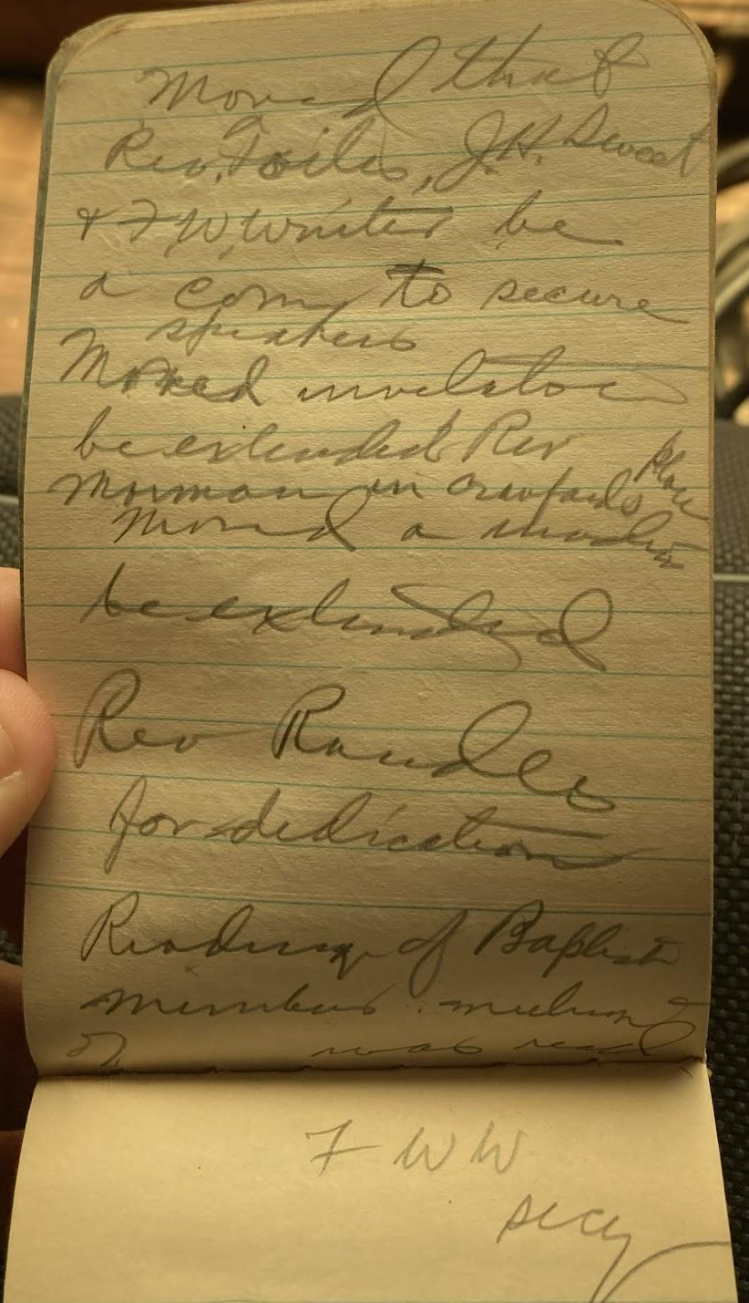
IMG_6005.jpg  Dec 6 - 1931  meeting of board  after  F R R Y C M T. J H S  F W. C H W. Reading of program  by Rev Foiles  moved its  adoption notify the  those designated  heads their  part on the  program | 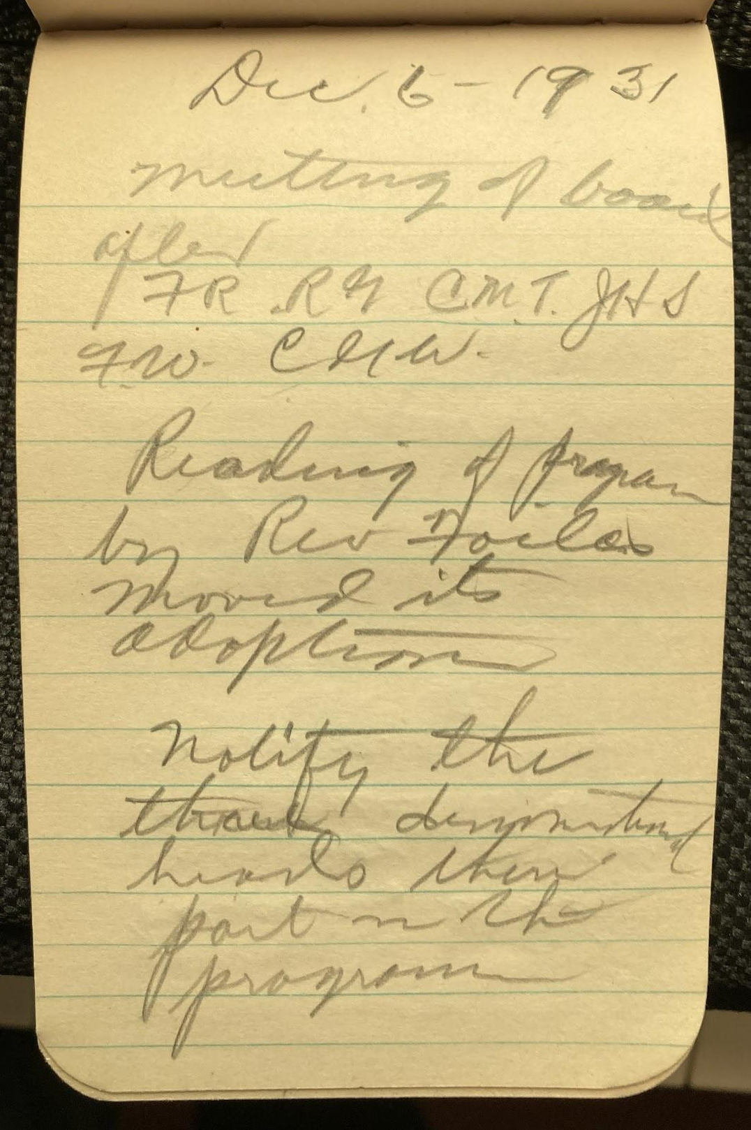
IMG_6006.jpg  Balcony used  only for overflow  and Sunday School  classes only. | 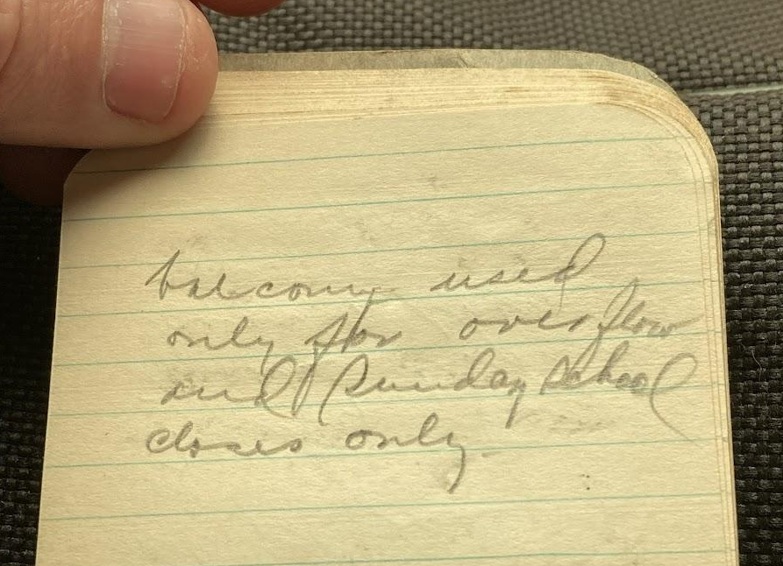
IMG_6007.jpg  31  Sunday Dec. 20  meeting of board  S. E. room. matter of Janitor Moved Mr Ross  be appointed chair.  of Com. of 3. he  to select the other  2 they to see  Mr. Bowers to  price etc  make rules  and reg. govern  the use of building  J H Sweet & F W Winter | 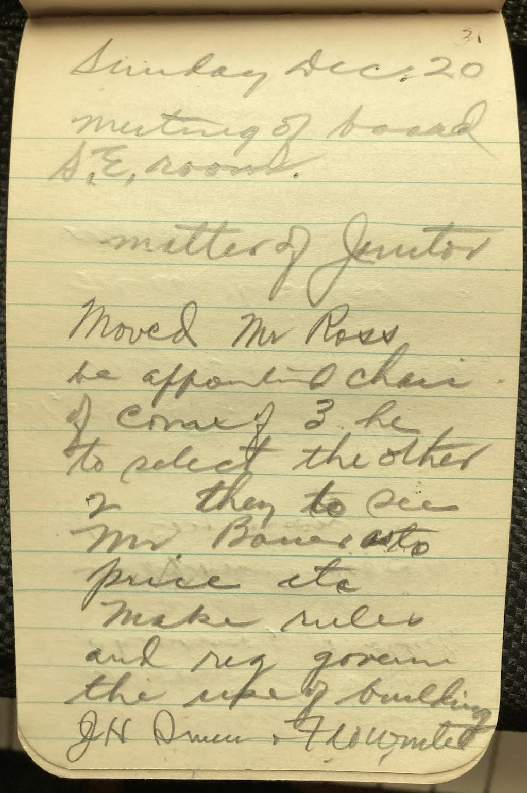
IMG_6008.jpg  Mr. Clyde Winter  appointed main  usher, & collector appointment  of Communion Com.  Mr Sweet, Mr. Corkill  Mr Todd. F Ross Fred Winter an  extra. Report from  architect read | 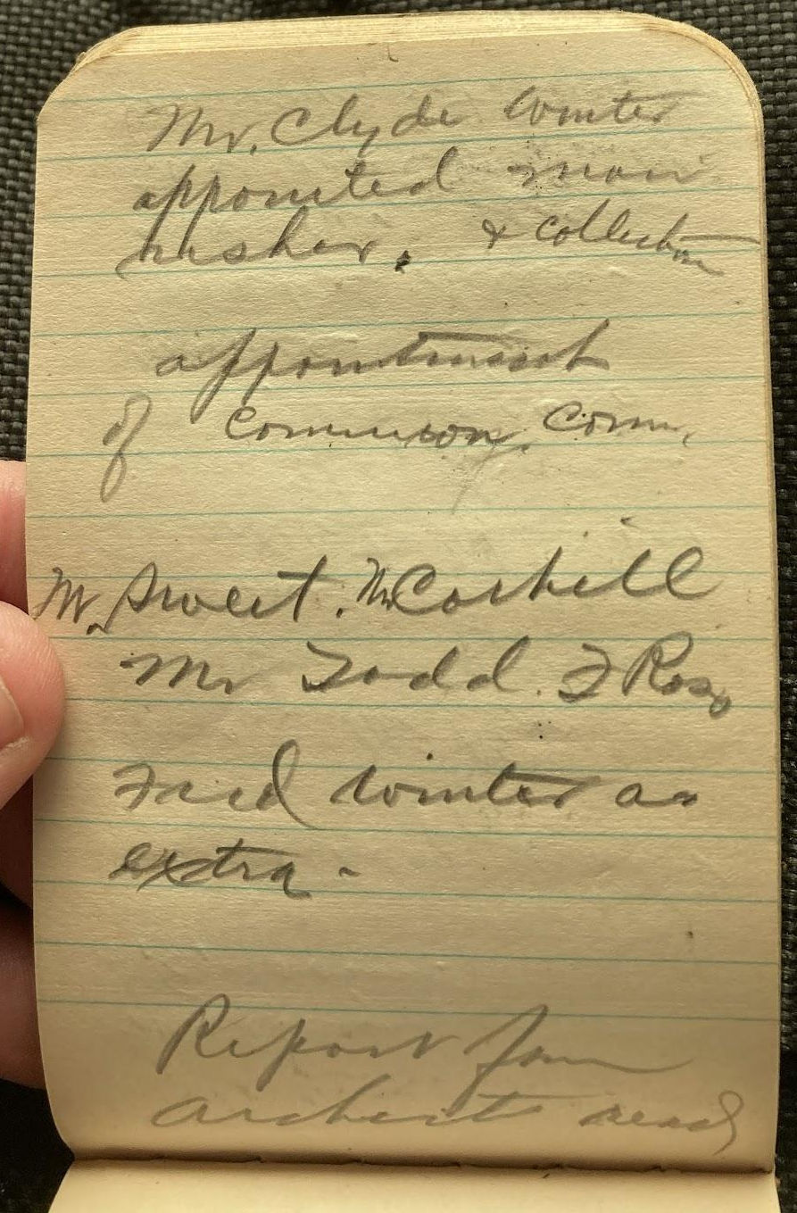
IMG_6009.jpg  Report from  architect read Bill from Mortgage  Co read 660.  3800.  219.  C H 100.  Fixtures 250.  L P 5135 3336.15  1200.  200.  adj. 4736.15  398.85 | 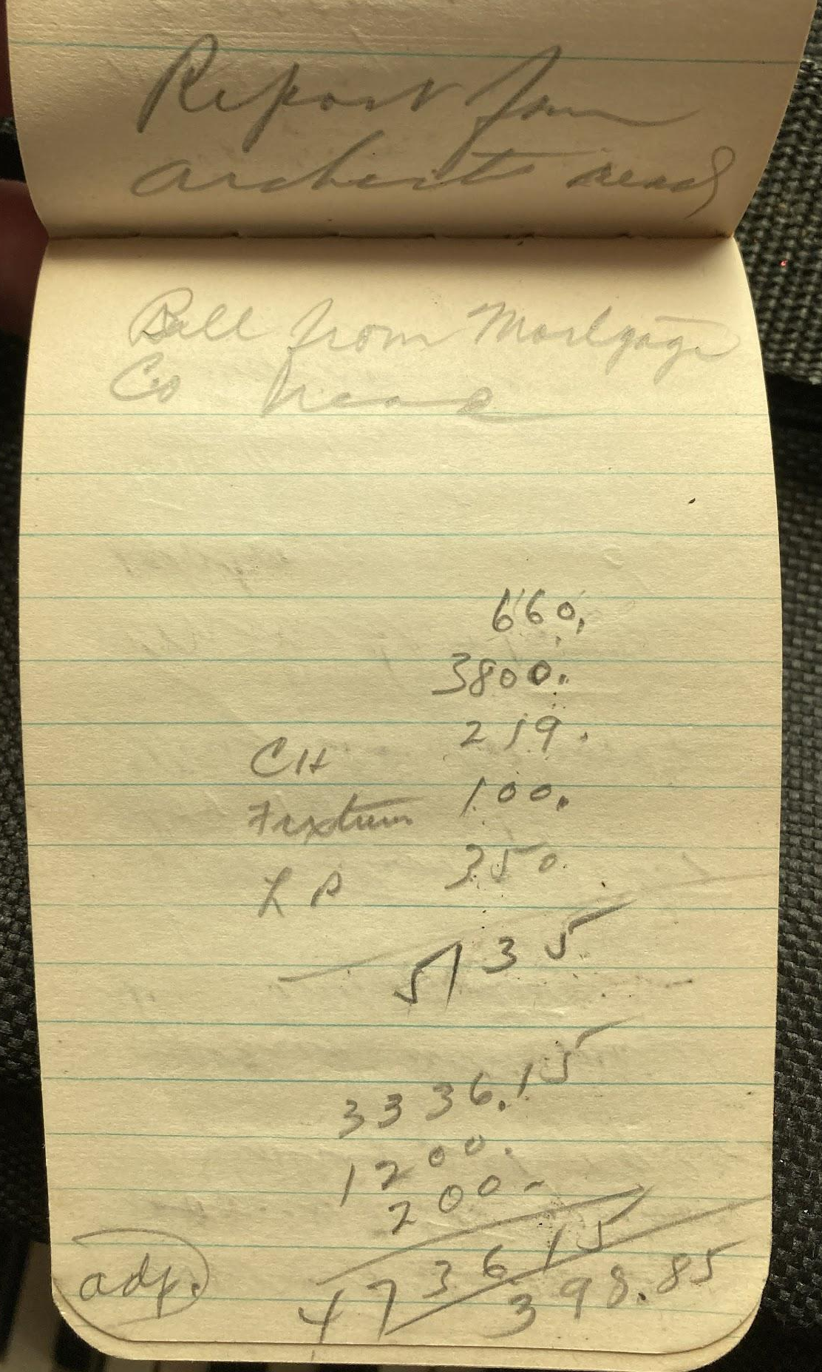
IMG_6010.jpg  Meeting of  board after service  Jan. 24, 1932  opened with prayer  by C G Winter  Proposition of pastor  for 1932.  Auburn proposition  Moved the chair  appoint a com. of 3  to attend services  at Auburn and  listen to the Auburn  minister  Rev. Cook of | 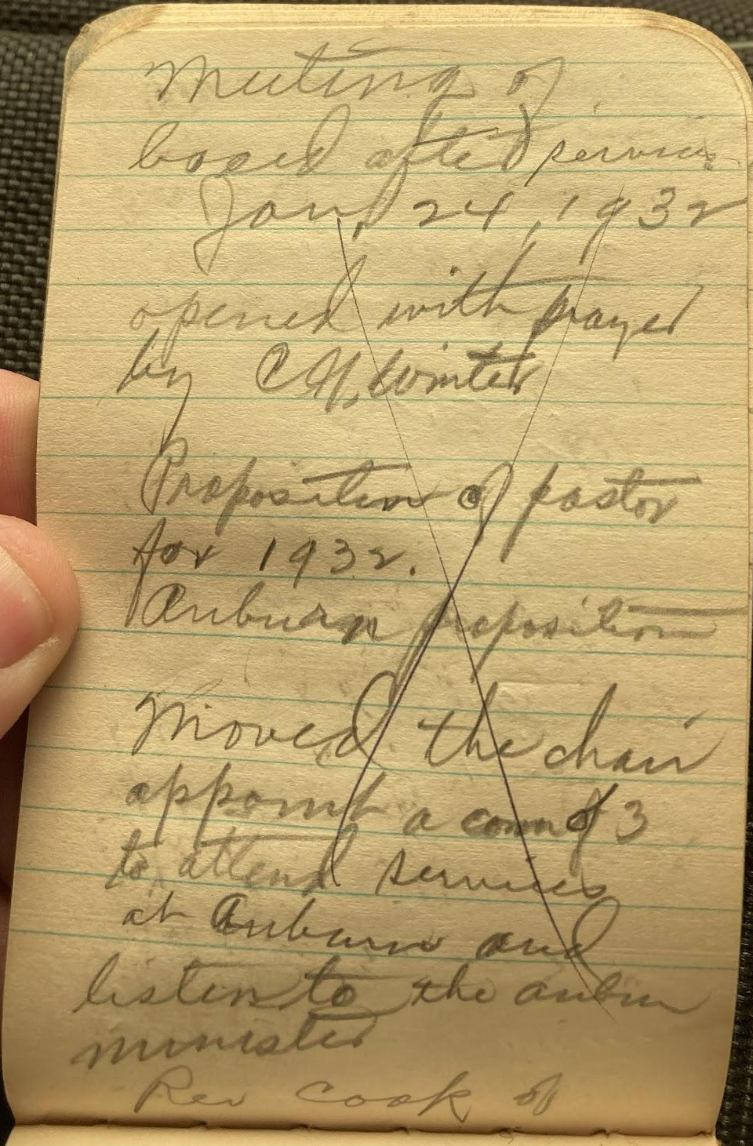
IMG_6011.jpg  Rev. Cook of  serey?  Jan 31 - 32  Meeting of board  after service  Treas of building  com. brought up  final bill $11.50.  due Powell for  lite plant  Moved we pay  Mr Powell Mr Sweet reported  on the final test of  furnace made Saturday  1/30 was satisfactory  Moved to accept | 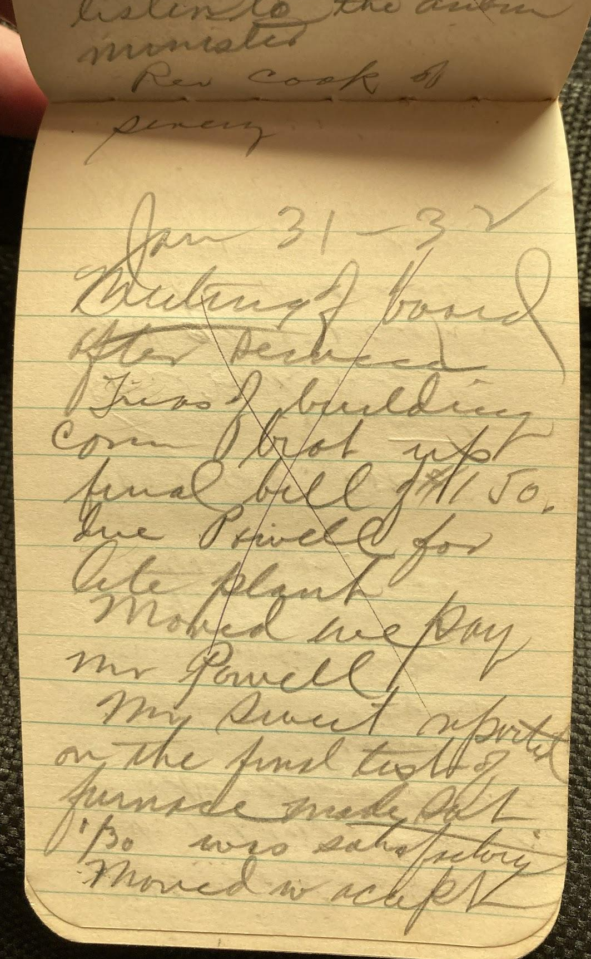
IMG_6012.jpg  the report of  Mr Sweet and  that they make  final settlement  with the Lenox  Furnace Co. &  Mr. Bossell  carried.  Moved we  extend to the  the Masonic  lodge the use  of the church  for their program  and banquet  Feb 1932 | 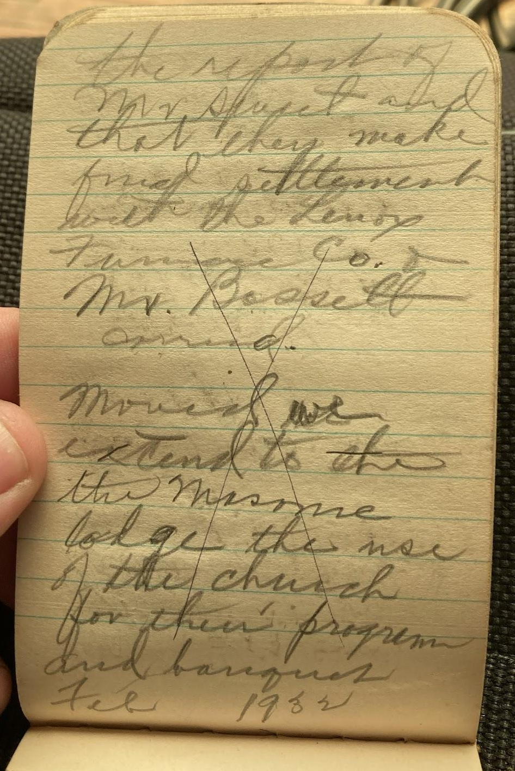
IMG_6013.jpg  Moved we  extend to the  teachers the  use of the church  building  for the use  their convention  in April.  Moved we on behalf  of church  that use of any  other program  approved by  the board.  adj. | 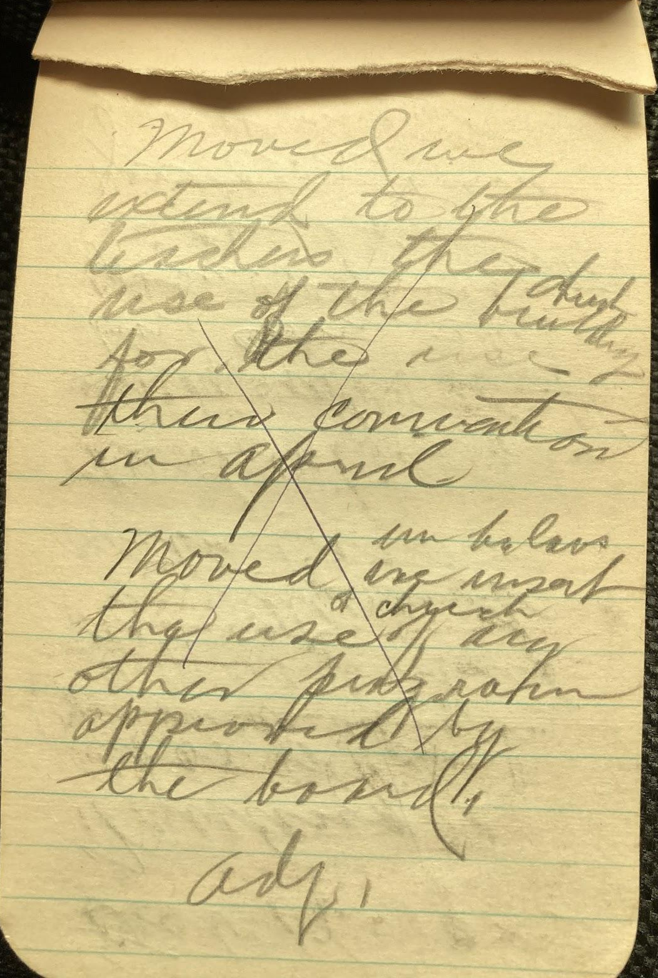
IMG_6014.jpg  Feb 9 - 32  Meeting of  board.  Mr Todd acting chairman  C H W brot up  q of settlement  with Casson  Moved we adopt  set of rules prepared  by com F Ross  J. H. Sweet & F. W. Winter  Joe Casson  met with us | 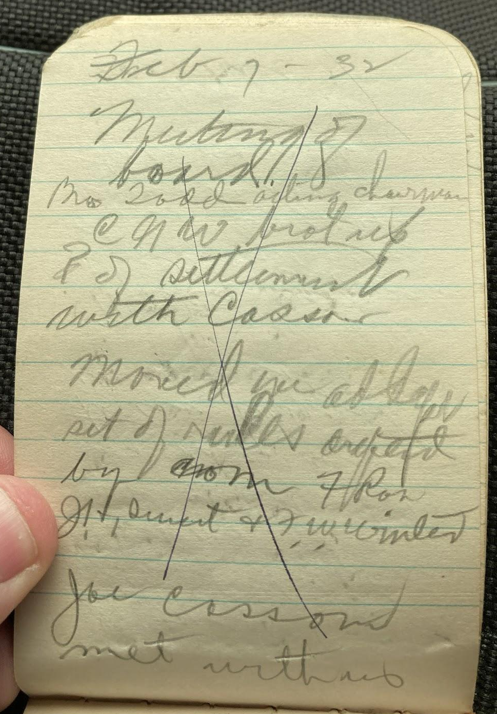
IMG_6015.jpg  Feb 21 - 32  Meeting of members  ch  Moved we  rescind our  proposition  sent in a  letter dated  Moved Mr  Ross notify  Mr Foiles | 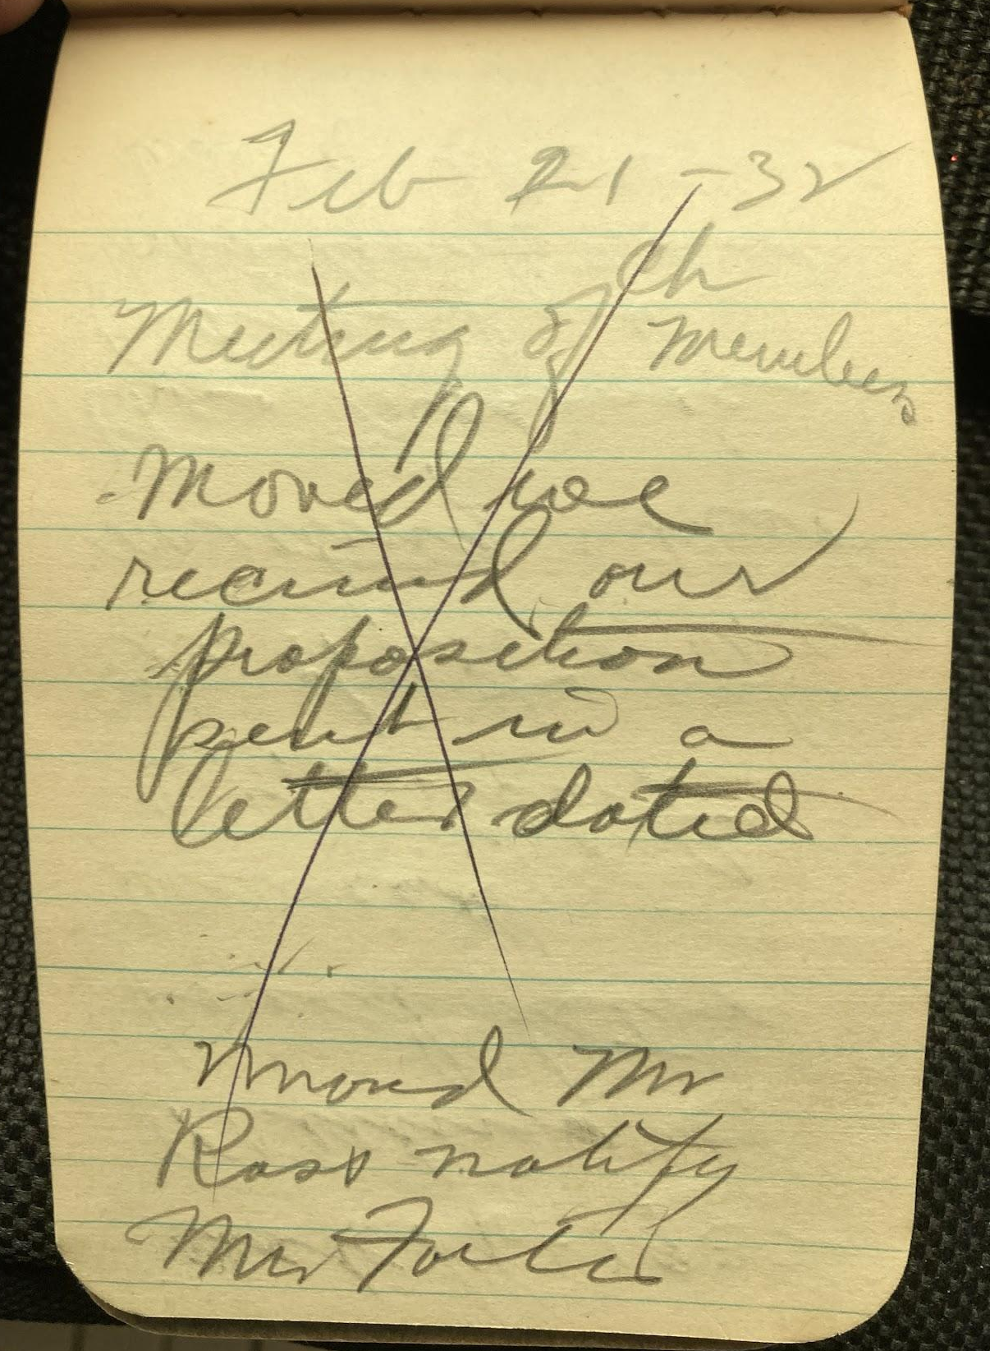
IMG_6016.jpg  Oct. 16 - 1932  Meeting of  board after  services  C. N. stated  the object of the  meeting. That  the Masonic  lodge had  advertised the  use of the church  building for | 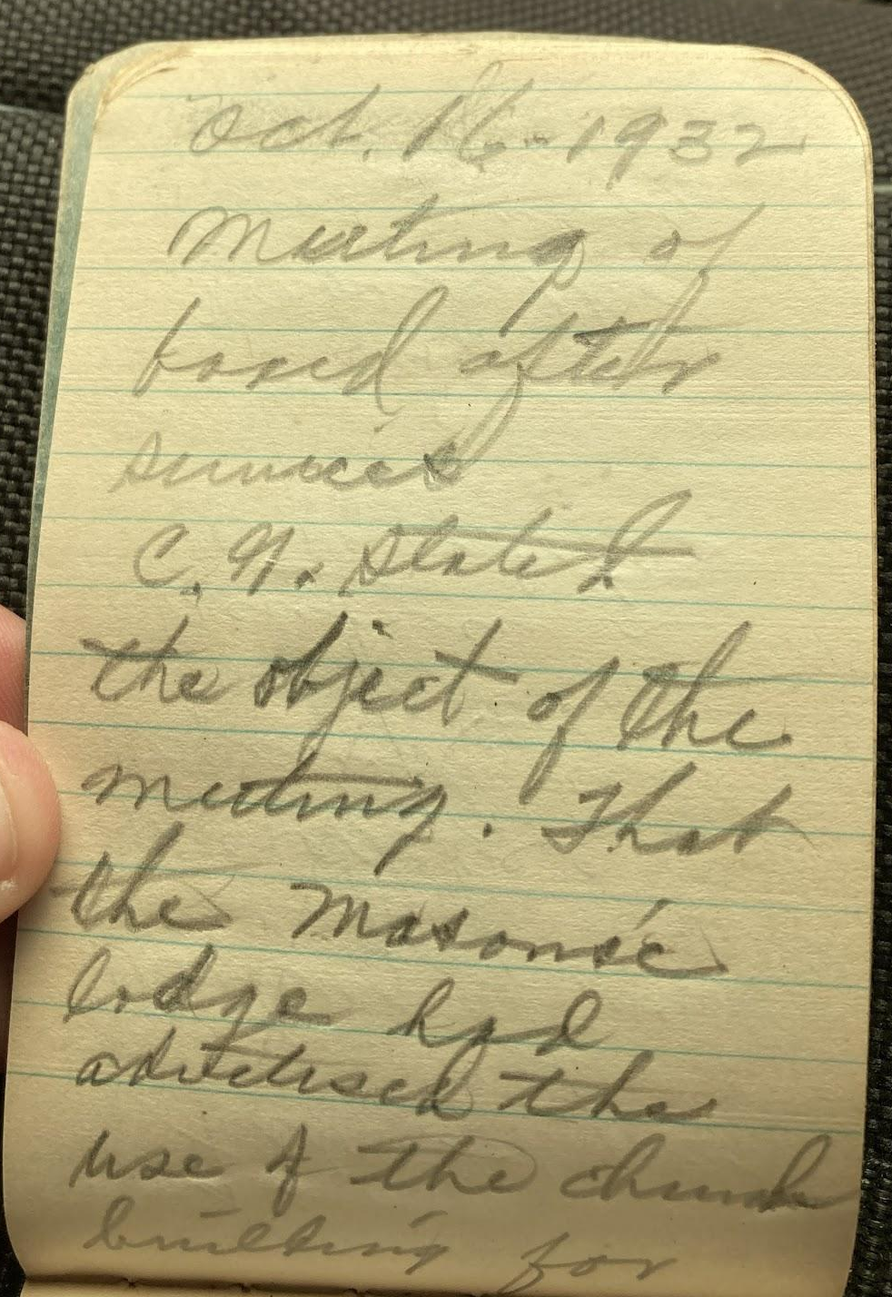
IMG_6017.jpg  their program  Oct 21st and  asked permission  for them to  go ahead and  use it as  advertised  Moved we allow  them the use  as they had  advertised. carried  Moved the board  the board reserve  for members & keep all | 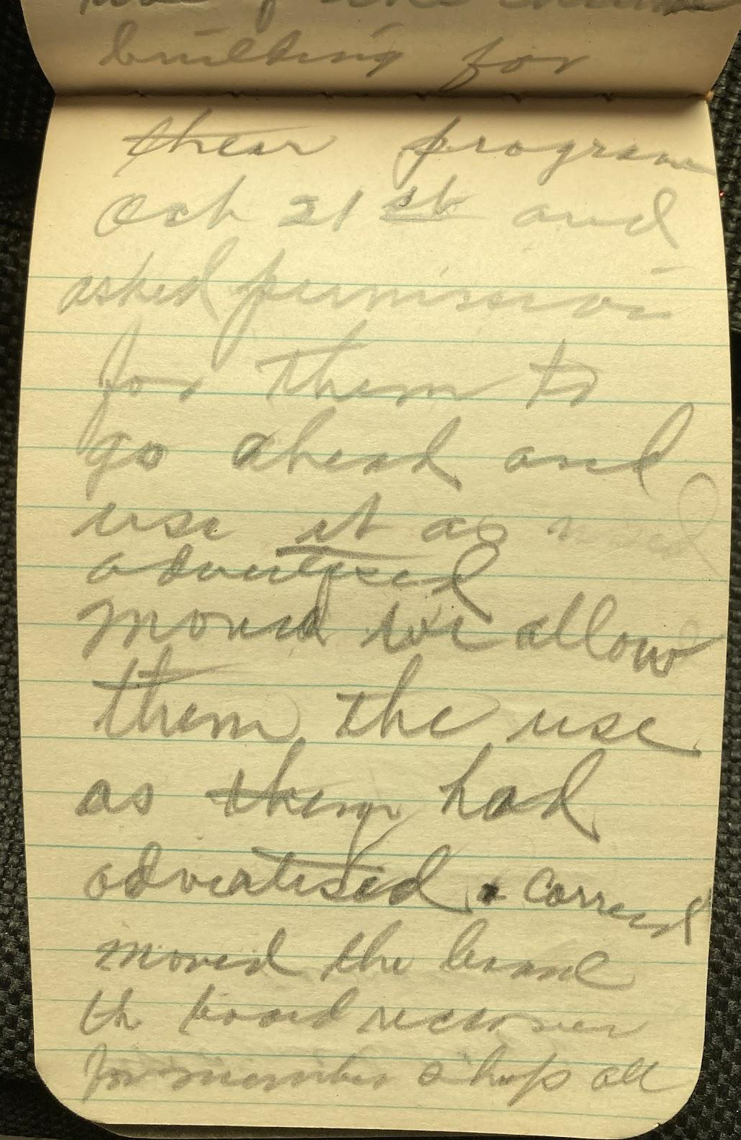
IMG_6018.jpg  names read  carried  adjourned  F W W  sec | 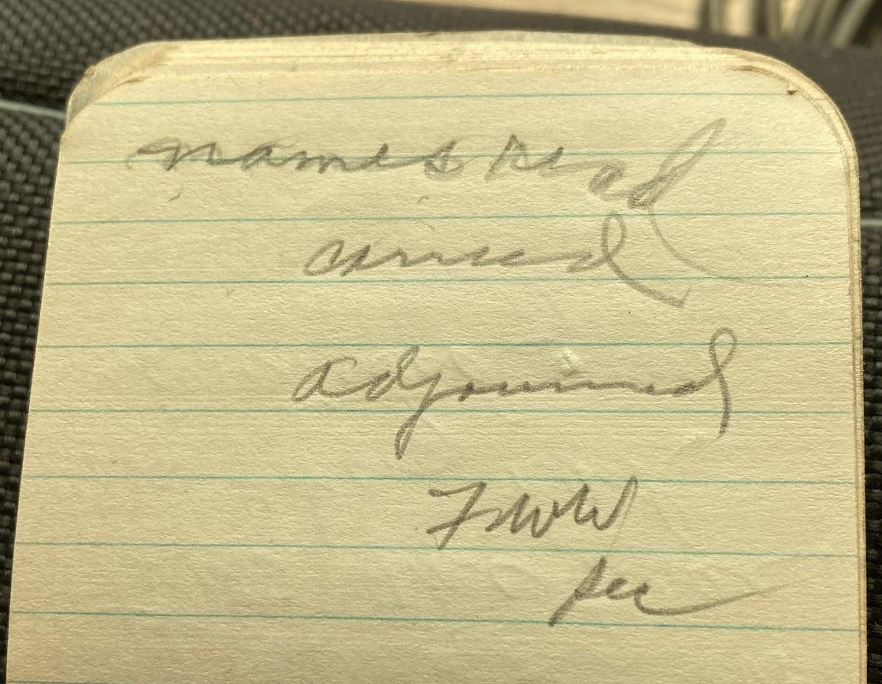
IMG_6019.jpg  July 17 - 1932  Meeting of board  after services  with Bro W B  Woodward who  had just preached  a sermon. | 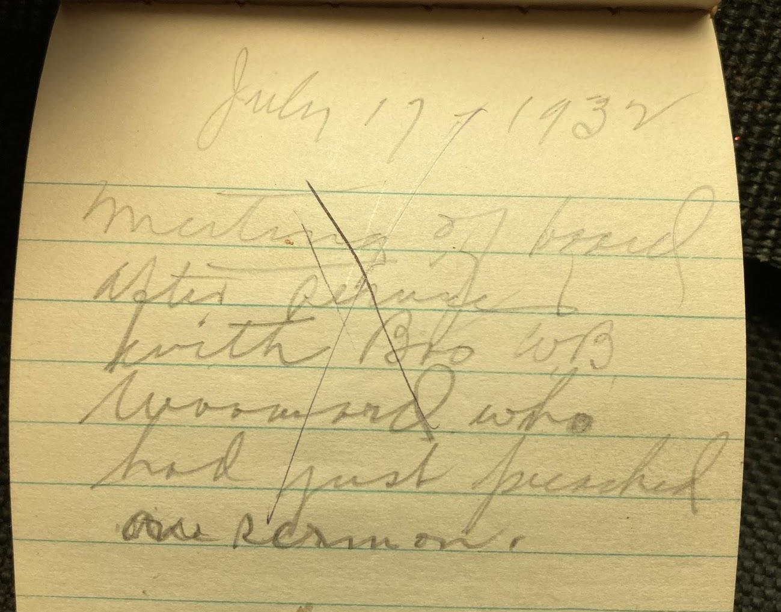
IMG_6020.jpg  Supt  asst "  Sect  assist sec  Treas  Pianist  asst. "  Librarian  Supt of Junior Dept  " Primary "  Supt Cradle Roll  asst "  Gen Com 3  Teachers Com 2  Music Com | 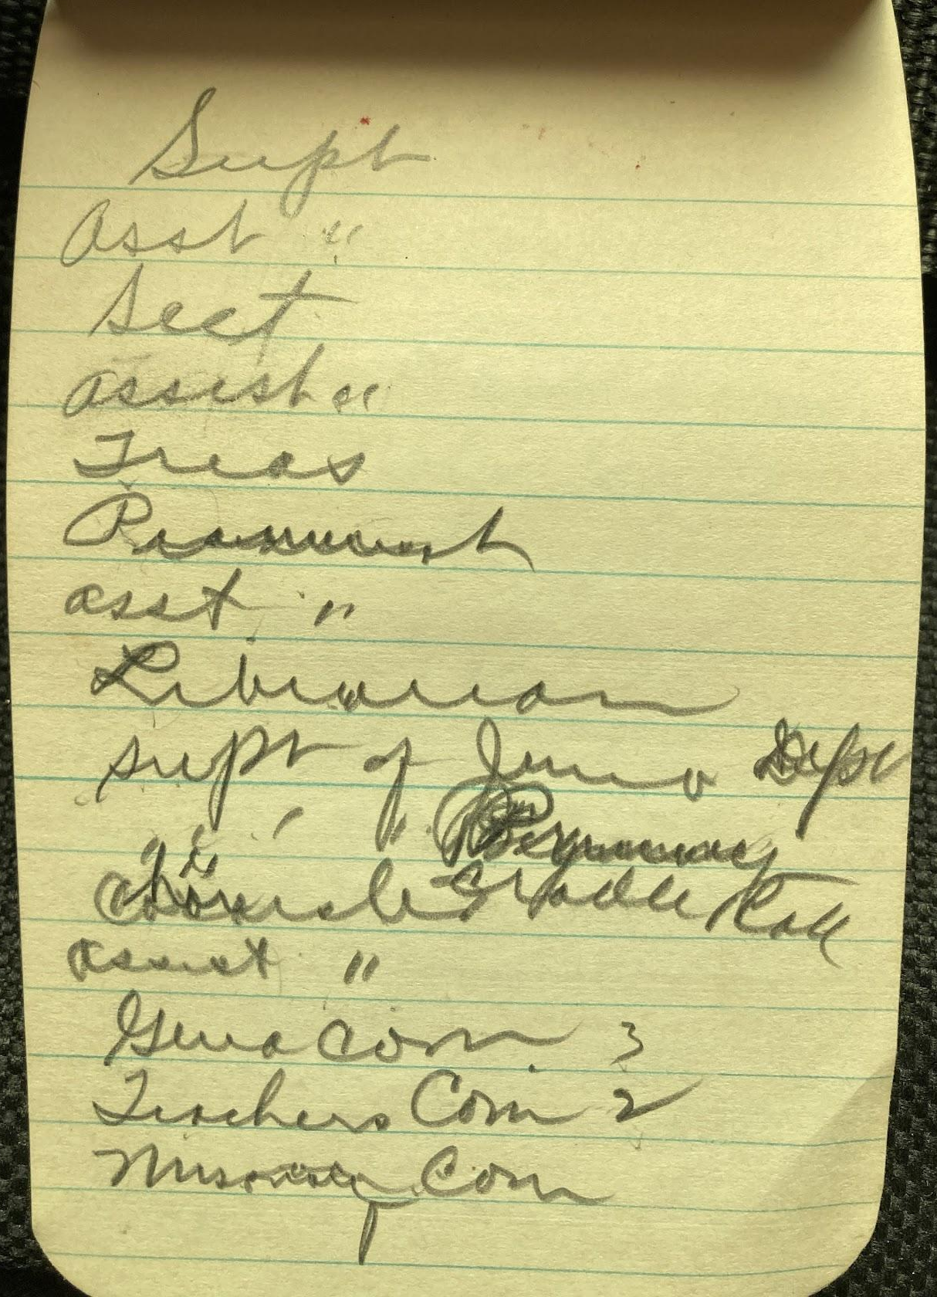
IMG_6021.jpg  Supt - Chas. Todd  assistant Chas Winter  Sect Harold Ginter  asst " Nolan Ginter  Treasurer Dwight Corkill  Librarian  Hazel Tomson  Pianist Ariel Bower  assnt Opal Croyle  Supt of Jun Dept  Monna Winter  Supt Primary Dept  Mrs Dutton  Supt of Cradle Roll  Effie Henderson | 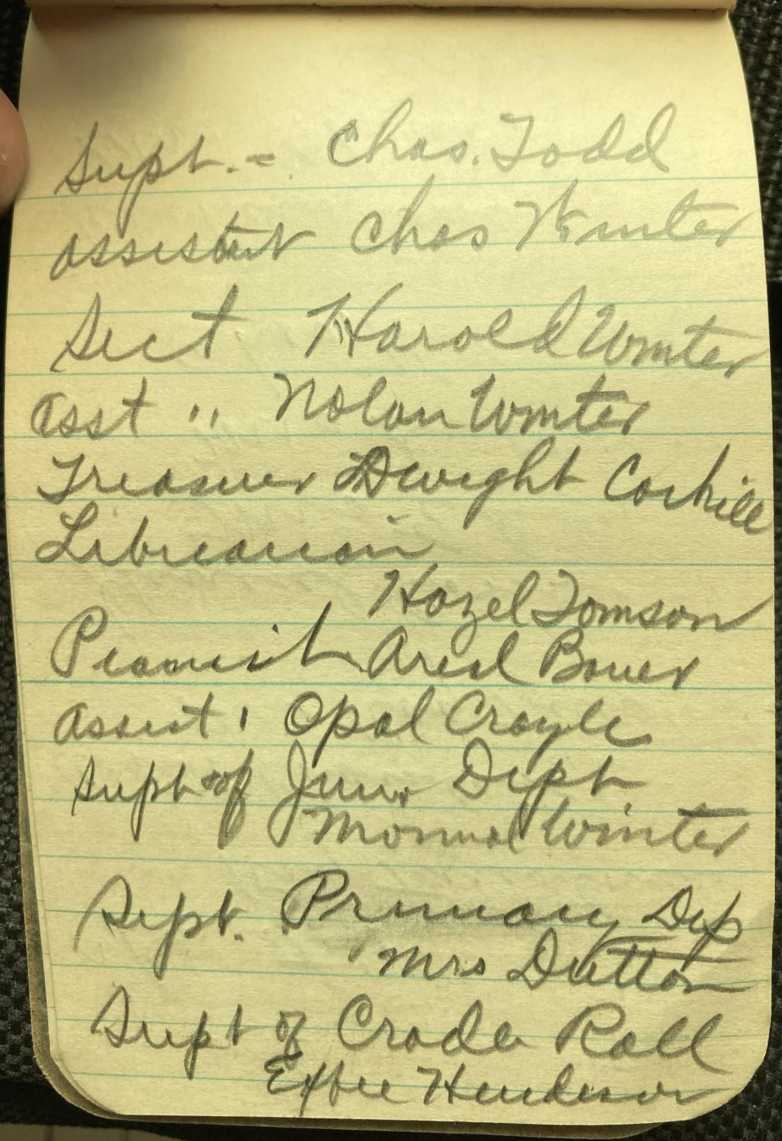
IMG_6022.jpg  Chorister  Roy Firestone  Assist Chorister  Mrs Roy Firestone  General Com  Mrs Eddy  Mrs Dutton  Chas. Holtwick  Teachers Com  Mrs Chesnut  Mrs Holtwick  Missionary Com  Mrs Appleton  Mrs Berryman | 