**Mission Fuge: Ridgecrest Conference Center!!**

**When:**  Sunday, June 23rd to Saturday, June 29th.

**Where:** 1 Ridgecrest Dr, Black Mountain, NC 28711 (Just outside Asheville, NC)

**Schedule:**

Sunday:

8:00 AM Arrive at FBC, load luggage

8:30 AM Depart FBC for lake house on Douglas Lake near Dandridge, TN

11:30 AM Lunch break stop (You need money for this!)

2:00 PM Arrive at Lakehouse

We will spend Sunday afternoon till Tuesday morning at this lake house. We will eat our meals there, have fun here, sleep there, etc. There are no plans to leave there during those 48 hours. All meals will be provided and cooked by our team. Feel free to bring snacks and drinks that you might like to have while you are there.

This 3 story cabin on the lake has a great outdoor space for lounging. I have rented a pontoon and wave runner. There are kayaks and canoes that we can use in their cove. They have a fire pit area and outdoor kitchen as well. The house has a hot tub. We will play board games and overall just have fun hanging out.

Rooming: This house has beds for about 20 people. We have 35 going. Do the math!! We will need some people to sleep on air mattresses. We will already have bedding with us for Fuge so we could use that bedding at the lake house as well. Rooms and bathrooms will obviously be divided up for girls and guys and our safety and privacy is of upmost importance. Let’s all plan to be flexible with the rooming!!

We generally do this after the week at Fuge, but this year since it runs Tuesday to Saturday we were not able to get 2 days in afterwards, so we are doing it before.

Fuge Opening Day (Tuesday)

11:00 AM Depart lake house and heads towards Ridgecrest.

12:00 PM Eat lunch on the way (you need money for this!)

1:00 – 4:00 PM Registration

5:00 PM Dinner

6:30 PM Opening Celebration

7:30 PM Missions Planning Time

9:30 PM Church Group Time

11:00 PM In Rooms

11:30 PM Lights Out

Days 2- 4(W,R,F) of Camp

7:00 AM Breakfast

8:00 AM Morning Celebration

8:45 AM Quiet Time/Bible Study

10:00 AM Depart for Ministry Sites

4:00 PM Hang Time

5:00 PM Dinner

6:30 PM Worship

8:00 PM Church Group Time

9:45 PM Night Life

10:15 PM Hang Time

11:00 PM In Rooms

11:30 PM Lights Out

Closing Day (Saturday)

7:00 AM Breakfast

8:00 AM Quiet Time/Bible Study

9:45 AM Closing Celebration

11:00 AM Churches Depart

**Lake house info:**

We will be staying for 2 nights. The address is 3024 Buck Horn Road, Sevierville, TN 37876. This house is a three story house on Douglas Lake.

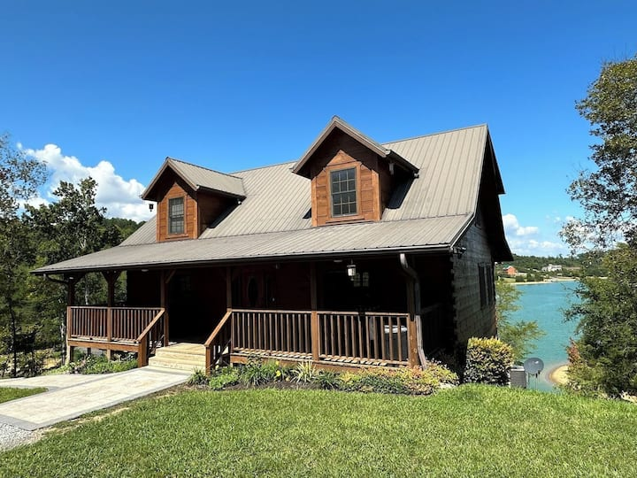

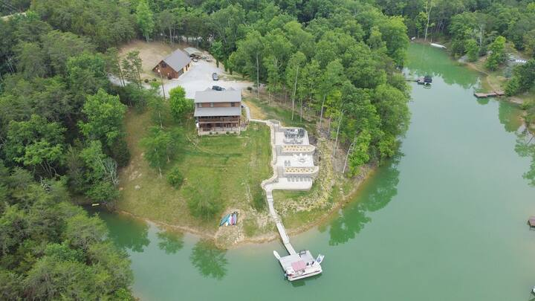

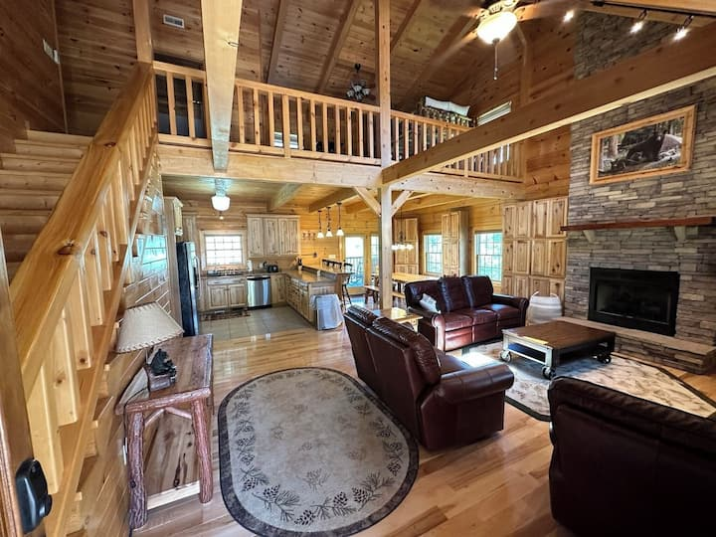

**(Below is info copied directly from Fuge camp information!!)**

**What to bring:**

• Linens, towels, pillows, blankets

• Water bottle you can refill and carry with you

• Closed-toe, closed-heel shoes (for outdoor activities)

• Bible, notepad, and pen

• Toiletries such as toothbrush and shampoo

• Sun protection

• Spending money for snacks, camp store, and missions offering (optional)

• Summer clothing (see dress code)

**What not to bring:**

• Alcohol, tobacco, illegal drugs, fireworks, water guns, or any kind of weapon

• We recommend no iPads, iPods, gaming devices, roller blades or skateboards. If students do bring cell phones or other electronics, they are not to be out and in use during programming elements: morning celebration, Bible study, worship, night life, recreation and track times / ministry tracks.

• Items that may be used for pranks such as water balloons, shaving cream, silly string, etc. Pranks are not allowed at camp. Your church will be charged for any damages or issues related to clean up.

**Dress Code:**

Students are NOT to pack anything that:

• Advertises alcohol, tobacco, or illegal drugs;

• Explicitly or implicitly promotes racism, sexism, or hatred of any group or person;

• Explicitly or implicitly refers to sexual actions or situations;

• Has spaghetti/small straps or open back, except for sleepwear;

• Is excessively short or tight fitting. While at camp, we ask that students:

• Wear modest shorts (when hands are extended to the back or the front, finger tips must touch fabric). Sleeveless shirts and tank tops are now allowed during day-time activities. Shirts with spaghetti straps, open backs or excessive armpit cutouts which expose torso and undergarments are NOT allowed.

• Wear closed-toe and closed-heel shoes while at recreation and track times and on ministry sites and during Mega Relay.

• Wear modest, one-piece bathing suits or two-piece suits covered with a dark colored t-shirt, if participating in water activities.

• Wear modest shorts, pants, jeans, or dresses for worship. Dresses with spaghetti or small straps, open backs, and excessively short lengths are unacceptable (when hands are extended to the back or the front, finger tips must touch fabric). Modest sleeveless tops are allowed in worship.

• Do not dress in a way that calls attention to underwear (sagging your pants, rolling down your waistbands, etc.) or wear pants or shorts with lettering on the bottom.

**Camp Rules For: (Cell Phones, Activities, Housing, and Worship)**

**Cell Phones:**

• The decision of cell phone usage at camp is in the hands of the group leader of each church.

• Throughout the week, some elements may allow students and adults to join in via social media (i.e., Twitter, Instagram, Facebook, etc.) However, these opportunities are optional and will not limit the camp experience for those who do not participate.

• Unless instructed by staff, students with cell phones are not allowed to have them out or in use during programming elements: morning celebration, Bible study, worship, night life, recreation and track times / ministry tracks. Ringers should be turned to silent or vibrate.

**Activities:**

• Participate in all activities and be on time.

• Drink plenty of water and eat three meals a day.

• Wear closed-toe and closed-heel shoes to recreation, track times and ministry sites.

• Wear your name tag at all times.

**Housing:**

• Be in your room by 11:00 PM with lights out no later than 11:30 PM, except on the last evening of camp when curfew is 11:30 PM.

• No guys in girls’ rooms and no girls in guys’ rooms.

• No public displays of affection.

• No practical jokes.

**Worship:**

• No gum, food, or drinks allowed in the worship center.

• No video and flash photography are allowed in the worship center before or during the worship service.

• Sleeveless tops are allowed but no tank tops during worship.

**(End of information copied directly from Fuge leader guide!)**

**NIGHT LIFE:**

**Night Life 1 (Silent Disco)**

We are bringing back the Silent Disco Night Life at all locations! If you are at a 6-Day location, you will also have a Variety Show.

**Mega Relay**

This summer’s Mega Relay theme is neon. Encourage students to bring neon colored attire to wear during Mega Relay.

**CHURCH GROUP & PARENT DEVOTIONS:**

Church Group Devotion is a time for each church group to be together in the evenings to debrief the

day. This time usually lasts 30 minutes or so. This is led by our adult chaperones by material that has been provided by lifeway. If you would like to follow along in the parent devo follow the link below. You can study what your student is studying during bible study and devo times.

<https://fugecamps.lifeway.com/wp-content/uploads/2021/08/2024-FUGE-Camps-Parent-Devos-Final.pdf>

**CENTRIFUGE TRACK TIMES:**

There are tons of tracks (classes) to choose from!! They will do 3 tracks each afternoon on the 3 full days of camp. Students will choose 6 options but will not participate in only 3. We will choose these when we arrive at camp. But use the link below for a full list of tracks and their explanation before we get there. Tracks are subject to change. All tracks listed may not be offered during your week at camp.

<https://fugecamps.lifeway.com/wp-content/uploads/2021/08/2024-Centrifuge-Track-Time-Explanations.docx.pdf>

**MISSIONS OFFERING:**

Every summer at FUGE Camps, we collect a missions offering. That offering is collected at each location every week and at the end of the summer is distributed between the International Mission Board (IMB), the North American Mission Board (NAMB), and local community ministries MFuge and XFuge on Mission work with throughout the summer.

This offering is optional for your student to participate in. It is usually collected and turned in during a church service.

**Contact numbers for Chaperones:**

|  |  |  |
| --- | --- | --- |
| 1 | Tim Hensiek | 423.557.6371 |
| 2 | Becca Rossman | 931.450.0960 |
| 3 | Jamie Daugherty | 931.273.5103 |
| 4 | Jon Bell | 615.604.2046 |
| 5 | Jennifer Bell | 615.604.2146 |

**A Few Rules to Follow:**

1. Please respect each other and personal property of other people.
2. Absolutely, positively no one in the sleeping quarters of the opposite sex for any reason at any time.
3. Please stay focused on the tasks that you are working on.
4. Treat the homes and locations where we are working with respect. Also be respectful to those we are serving. We will be coming to their city and to their homes!
5. Cell Phones: You CAN have them and can use them throughout the week. However, do not let them be a distraction during the work day (review rule #3) and cell phones need to stay put away during the Worship Gathering, quiet times, and church devotions. They will be confiscated if these rules cannot be followed!
6. Stay on your assigned vehicle or van during transportation unless otherwise told by Tim to change vans.

**A Note from Tim:**

A great attitude and a servant heart are a must for us to go and serve others and be an example of Christ to them. There will be times you will be tired, impatient, annoyed, bored, hot, etc. It will make the trip go a lot smoother if we just remember why we are going, who we representing, and who we are serving. Reality check: this isn’t a vacation, this is a mission trip.

Fuge has laid out clear guidelines. We WILL abide by the dress code, we WILL respect the campus and their property that we are staying in (no horse play!), we WILL respect each other and their personal belongings, and we WILL work hard to accomplish what we are called to do.

In return, we will be blessed by God, we will be stretched and grow in our walk with the Lord, we will develop greater friendships with one another, and we will have fun!! Get excited, Fuge Camp is less than two weeks away!! Be preparing your heart and mind to go.

There are two things that you will need money for during the trip: Meals travelling to and from Ridgecrest, NC. Fuge gear, snacks and missions offering while at camp are optional. The lake house is included in what you have already paid. .

As always, if you have any questions about anything, don’t hesitate to call me. That is after you have read this whole information packet, which is full of helpful, vital information. My cell number is 423.557.6371. Thanks and I can’t wait to be serving with you at FUGE!!

Tim