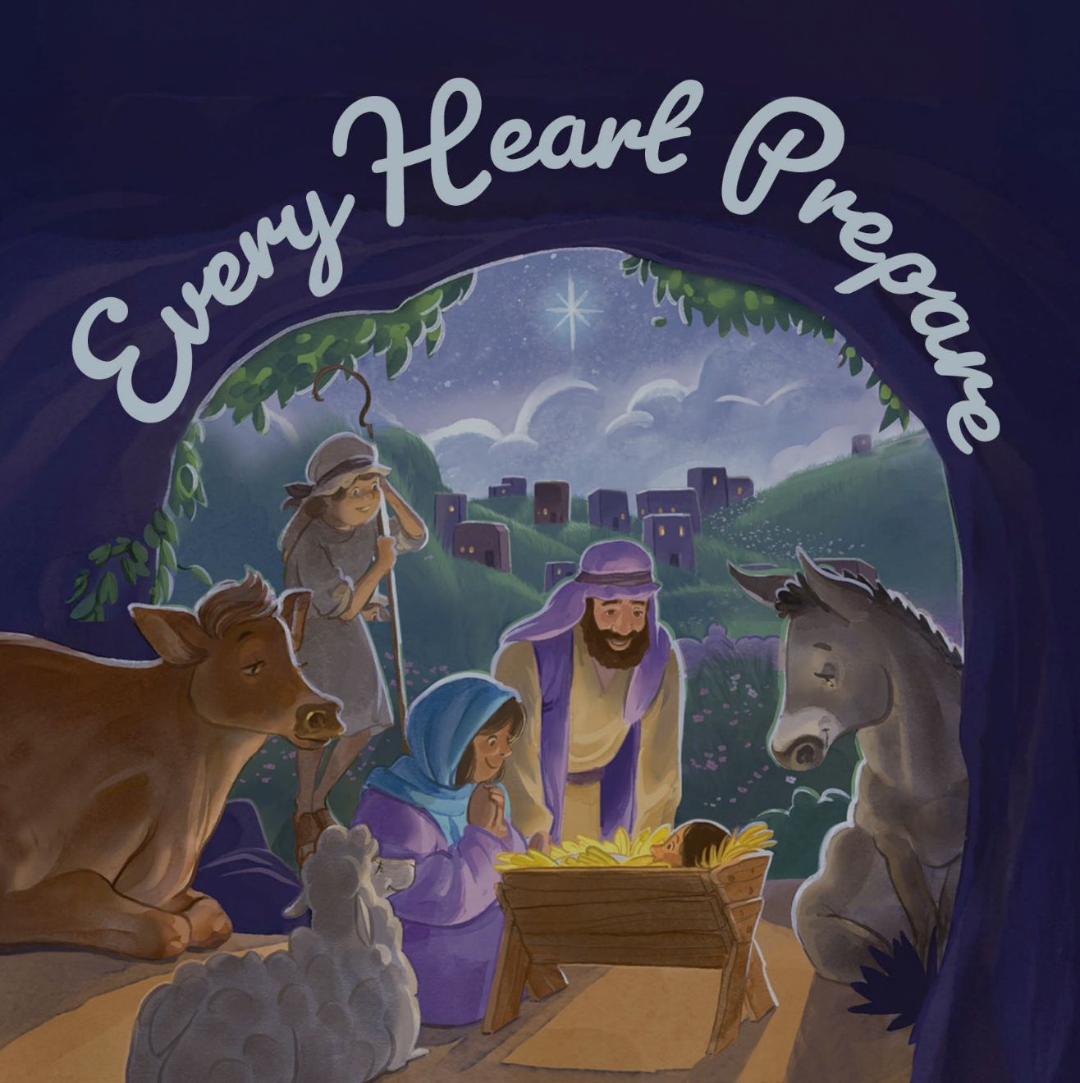

Midweek Advent Worship
Wednesday, December 17th, 2025
ADVENT 3
As We Gather
Tonight, we focus on the crèche—those miniature models of the nativity scene that abound each December. Unlike lights and evergreens, the symbols that aided our meditation these last two weeks, the crèche is distinctly Christian. In it, we behold Mary, Joseph, the shepherds, the Magi, the angels, the stable animals, and, at the center, baby Jesus. Some places introduce the characters in chronological order; others put them all out at once. Either way, the crèche represents a crucial, historical event: God taking on human form and human nature so that He could take our place and redeem us from all sin. We behold it with fresh eyes this evening.

332 Savior of the Nations, Come LSB 332 sts. 1–4
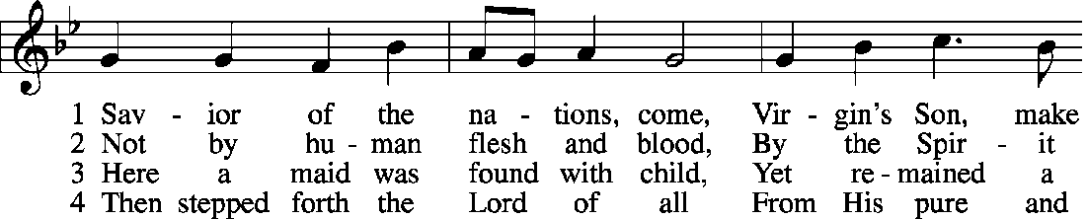
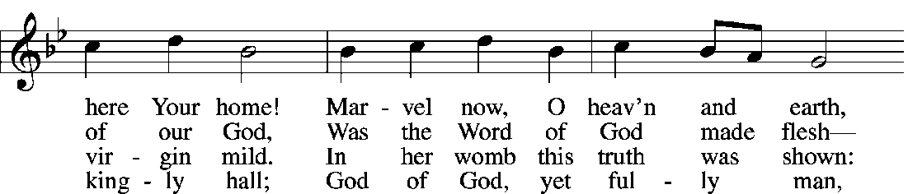
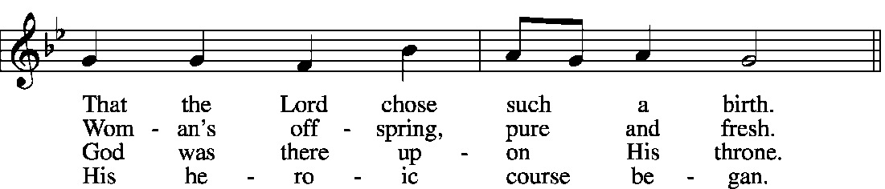
© 2006 Concordia Publishing House. Used by permission. © 1978 Concordia Publishing House. Used by permission.
Public domain


Invocation
P: In the name of the Father and of the Son and of the Holy Spirit.
C: Amen.

Call to Worship Isaiah 40:3, 5; Psalm 118:26
P: Prepare the way of the Lord;
C: make straight in the desert a highway for our God.

P: Blessed is He who comes in the name of the Lord!
C: We bless you from the house of the Lord.

P: And the glory of the Lord shall be revealed,
C: and all flesh shall see it together.

Prayer of the Day
P: The Lord be with you.
C: And also with you.

P: Let us pray.

Almighty, ever-living, and everlasting God, our help in ages past and hope for years to come, You sent Your Son into our flesh to live among us in our world and to walk with us in our times and places so that we would be saved from all sins in every time and place. As we survey anew Jesus’ journey from the manger to the cross, grant that we may draw great comfort and confidence in the reality of Your birth, that faith may again be kindled in our hearts; through the same Jesus Christ, our Lord, who lives and reigns with You and the Holy Spirit, ever one God, world without end.
C: Amen.


357 O Come, O Come, Emmanuel LSB 357 sts. 1, 5
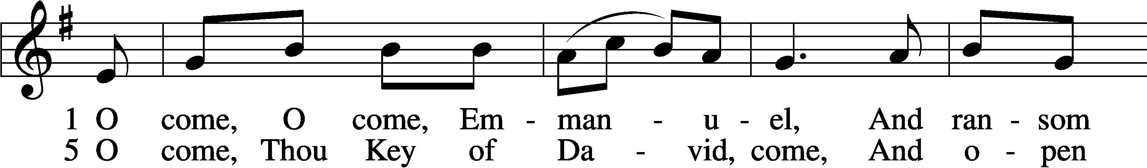
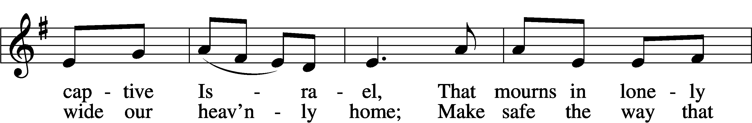
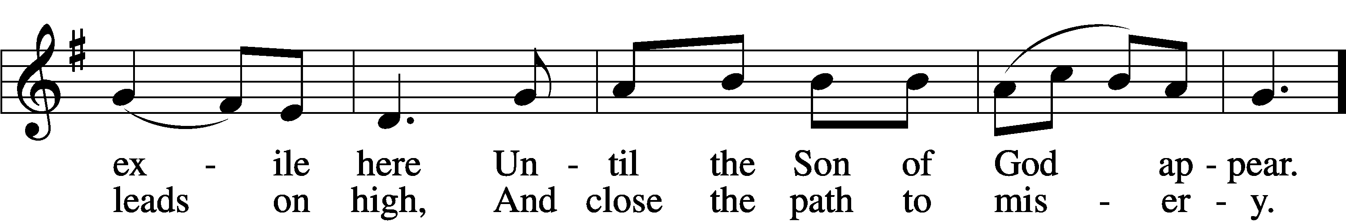
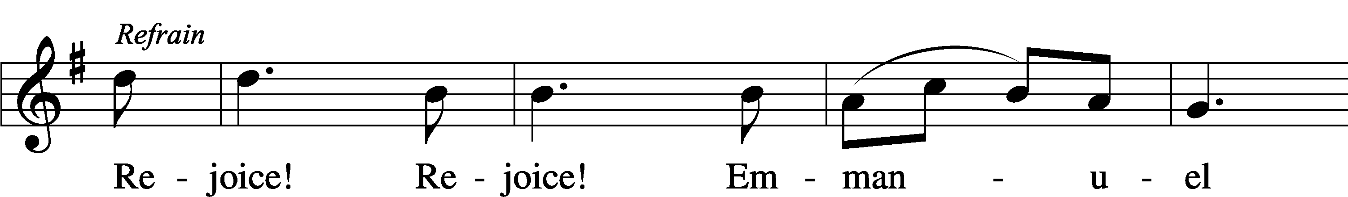
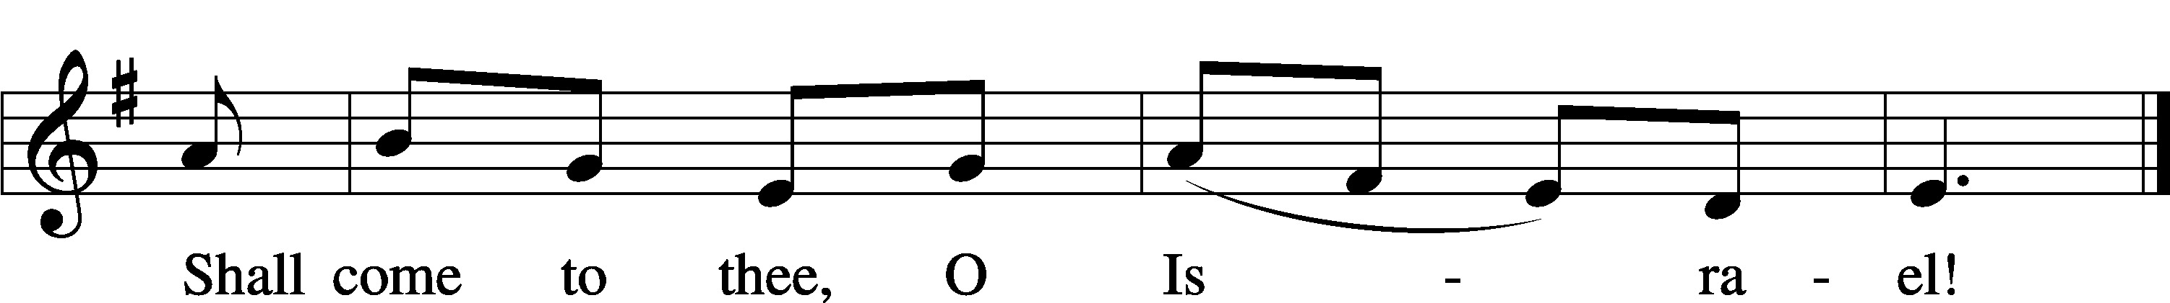

Text and tune: Public domain

First Reading 1 John 1:1–4
Epistle Reading Philippians 2:1–8
Gospel Lesson Matthew 1:18–25

Reading Response
P: In many and various ways, God spoke to His people of old by the prophets.
C: But now in these last days, He has spoken to us by His Son.


338 Come, Thou Long-Expected Jesus LSB 338
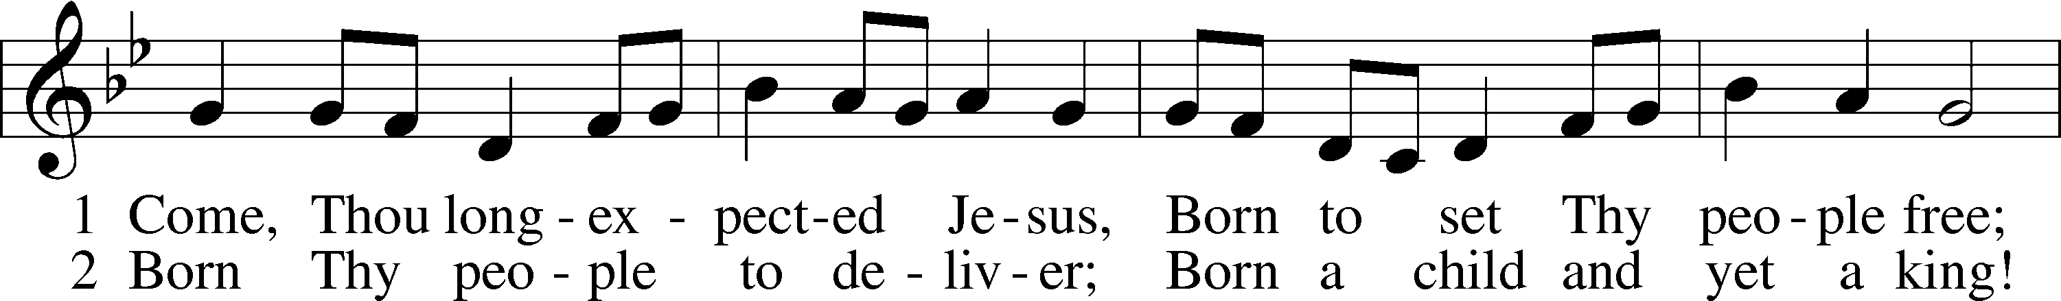
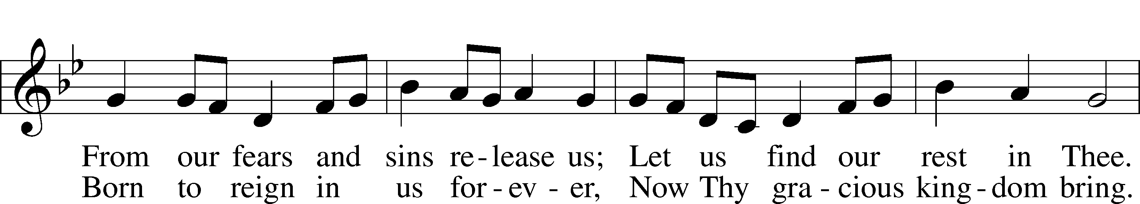
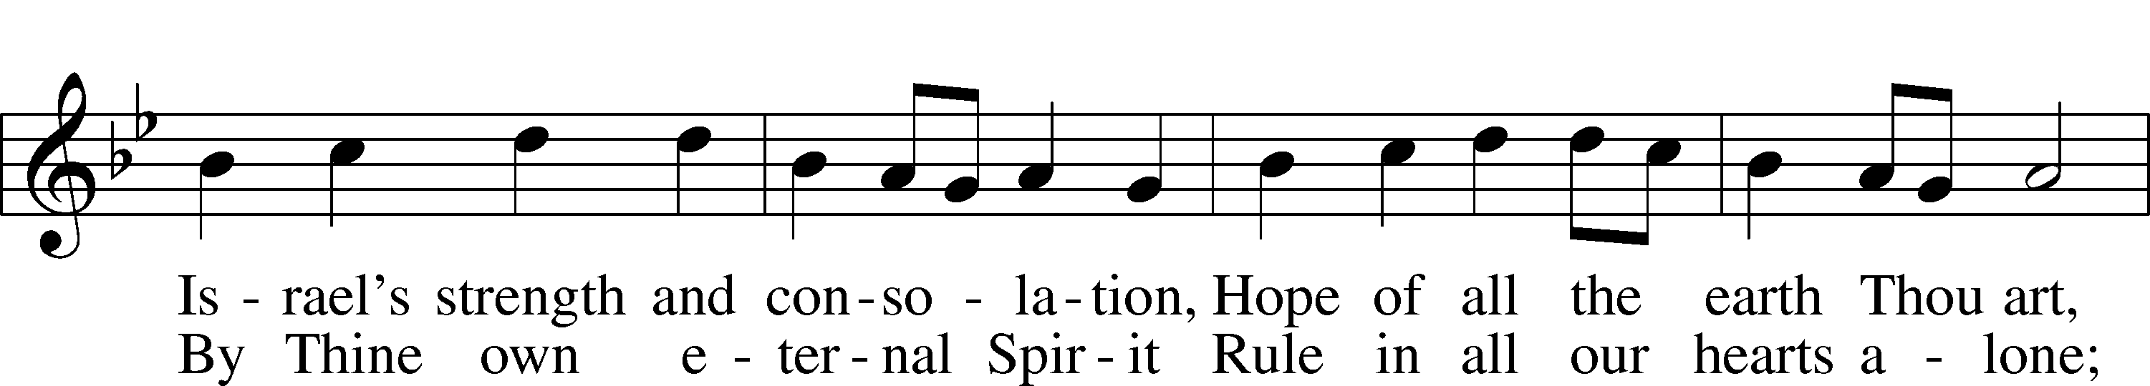
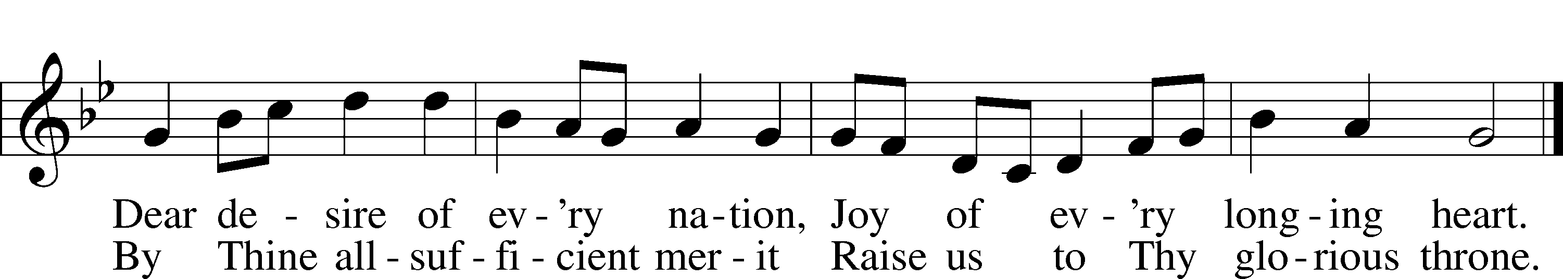

Homily
Crèche

We decorate in preparation for Christmas. Our decoration preparation includes the use of the crèche—the miniature model of the nativity scene. The crèche is a distinctively Christian decoration in that it depicts the characters involved in the nativity of Christ: Mary, Joseph, the shepherds, the Wise Men, the angels, the stable animals, and—most important of all—the infant Jesus. As we view this manger scene, we recall the timeless story of God coming to earth as a baby to redeem us from our sins.

Our Offerings

Thank you for your continued support of the ministry Mt. Olive Lutheran Church.
If you are a guest (or if your contact info has changed), please fill out a Connect Card
found in the pew rack and place it in the offering plate.
Advent Litany
P: In peace, let us pray to the Lord:
C: Lord, have mercy.

P: For eyes to behold the Father’s hand in all creation, let us pray to the Lord:
C: Lord, have mercy.

P: For awareness of beauty and the living traditions of the church that bring Christ to our eyes through arts and crafts, let us pray to the Lord:
C: Lord, have mercy.

P: That we may see the signs of Christ’s return even as we celebrate His birth and encourage one another all the more as we see the Day drawing near, let us pray to the Lord:
C: Lord, have mercy.

P: That we may be living testimonies of new life in Christ through our loving service to our neighbor—both in word and in deed, let us pray to the Lord:
C: Lord, have mercy.

P: That we may be thankful for the bountiful harvest we enjoy amid the many festivities of this season, and be generous to the poor, let us pray to the Lord:
C: Lord, have mercy.

P: That we may love one another as God so loved us, forgive one another, and work together in the unity we have in Christ Jesus, let us pray to the Lord:
C: Lord, have mercy.

P: That we may not be lured into temptation or despair or be distracted by the false Christmases around us, but always hold the true meaning of Christmas in our hearts, let us pray to the Lord:
C: Lord, have mercy.

P: O Most High, our rock and our salvation, You have never abandoned us but have always come to the aid of Your people. Grant that the eyes of our hearts would see You just as Your people of old saw Your Son when He came to this world, walked and taught among us, and gave His life for us. Give us such faith that we may trust all that our fathers and mothers of old saw, touched, and heard—just as it has been revealed to us through Your Word. For Your Word became flesh and dwelt among us, full of grace and truth, and comes to us even now by Your Spirit’s power; through Jesus Christ, the Word made flesh, who lives and reigns with You and the Holy Spirit, ever one God, world without end.
C: Amen.
The Lord’s Prayer
Our Father who art in heaven, hallowed be thy name,
thy kingdom come, thy will be done on earth as it is in heaven.
Give us this day our daily bread; and forgive us our trespasses
as we forgive those who trespass against us;
and lead us not into temptation, but deliver us from evil.
For thine is the kingdom and the power
and the glory forever and ever. Amen.

Luther’s Evening Prayer
I thank You, my heavenly Father, through Jesus Christ, Your dear Son, that You have graciously kept me this day; and I pray that You would forgive me all my sins where I have done wrong, and graciously keep me this night. For into Your hands I commend myself, my body and soul, and all things. Let Your holy angel be with me, that the evil foe may have no power over me. Amen.

Benediction
P: The grace of our Lord Jesus Christ and the love of God and the communion of the Holy Spirit be with you all.
C: Amen.

Acknowledgments
Every Heart Prepare ©2025 Concordia Publishing House. Scripture: ESV®. Permission granted to purchaser to reproduce this page for use in congregational settings. All other rights reserved. Created by Lutheran Service Builder © 2006 Concordia Publishing House. Unless otherwise indicated, Scripture quotations are from the ESV® Bible (The Holy Bible, English Standard Version®), copyright © 2001 by Crossway, a publishing ministry of Good News Publishers. Used by permission. All rights reserved.
878 Abide with Me LSB 878
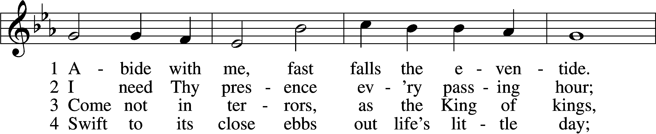
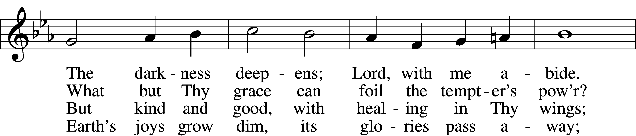
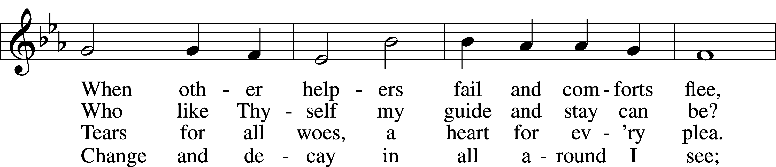
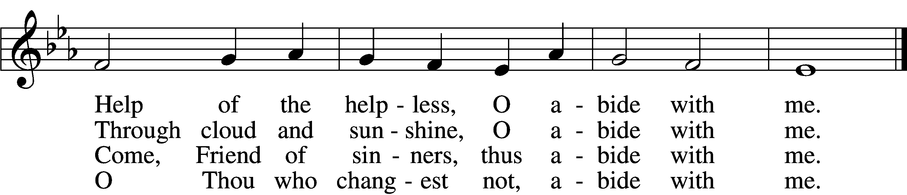

5 I fear no foe with Thee at hand to bless;  Ills have no weight and tears no bitterness.  Where is death’s sting? Where, grave, thy victory?  I triumph still if Thou abide with me! | 6 Hold Thou Thy cross before my closing eyes;  Shine through the gloom, and point me to the skies.  Heav’n’s morning breaks, and earth’s vain shadows flee;  In life, in death, O Lord, abide with me.
Public domain
