

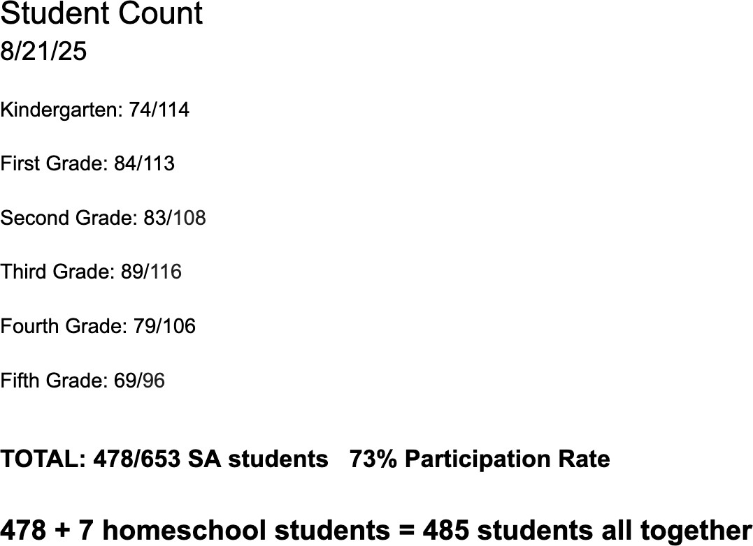BOARD MEETING AGENDA

**August 25, 2025**

**Prayer & Praise**

**Start of School Update**

* Brooke and Kathy
* Finish Bibles discussion

**Board Training**

* Update
* How are we doing?

**Fundraising**

* Financial Update - Dustin
* Trustraising Update - Dustin
* Sponsor a donor flyer? Email? Thoughts?

**Transportation**

* Haven’t heard back from Luke Liechty yet on board discussion about FMC vehicles
  + Need to reach out Mike Wilson and Gabe Bailey if FMC approves vehicle leases
* Josh Maller is getting me the vehicle information for West Missionary’s bus and van.
* Orlyn Lehman would like to be removed as substitute bus driver.
* Brad said another guy is applying for a sub bus driver position. Brian Loyd
  + Haven’t seen his name come through Applicant Center
* Matt Rupp is going through the process to be a sub driver.

**LifeWise Open House**

* Review from Michelle

- Total Cost: $1,541.83

(Bouncy Houses = $859.04)

(Food and Supplies from Troyers) = $682.79

* Reflection about the event. Any suggestions?
* Appreciation
* Everance Sponsored: $1500
* Special thank you - Thoughts? Ideas?
  + Everance
  + Derik Bailey (DJ)
  + Volunteers
* THANK YOU BOARD MEMBERS WHO MADE THIS POSSIBLE!! 😀

**Other?**

**Personnel**

* Should we follow up with Jenn on her board interest? Who did she express that to?
* Prayer team update
* Bonuses for staff (PTO)
* Pay rate increase for Brad; possibly other long term staff?

**Prayer**

**Next Meeting:**

**September 29, 2025 at 1:00**