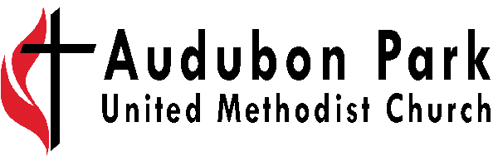

Revised 8/2025

Youth Ministries Intern

Position: Part-time/Non-Exempt

Reports to: Senior Pastor, Coordinator of Ministries with Children & Youth
Supervision: N/A

Job Summary: To identify and/or cultivate a call to ministry for the participant through hands-on experiences in a church setting while also providing valuable leadership to our church’s ministries and programs. This intern will work primarily with our ministries with youth but will have the opportunity to preach once a semester and will have opportunities to experience a wide variety of ministry while also focusing on a particular aspect or area of ministry.

Qualifications: (To perform this job successfully, an individual must be able to perform each essential duty satisfactorily. The requirements listed below are representative of the knowledge, skill and/or ability required. Reasonable accommodations may be made to enable individuals with disabilities to perform the essential functions).

• Be a committed follower of Jesus Christ, seeking to know, love and serve God.
• Have an awareness of the need for boundaries in life, relationships and ministry.
• A love for people, especially families and young people and a willingness to connect with them and facilitate their spiritual growth.
• Flexible, dedicated, dependable and highly motivated personality.
• History of self-direction and being a self-starter
• Capable of effective, relevant communication with students, parents, volunteers and staff.
• Comfortable speaking to and leading large groups and meeting one-on-one with youth and other leaders.
• An ability to work as a part of a team with other staff and volunteer leaders

Essential Duties and Responsibilities:
• Establish and keep ministry work schedule/hours as approved by supervisor.
• Attending Sunday morning worship consistently.
• Assisting in leadership/teaching of the Sunday Afternoon/Evening Youth Group.
• Assisting in leadership/teaching of the Sunday morning youth Sunday School programs.
• Assisting in planning and execution of Youth Ministry special events.
• Taking opportunities to contact students through social media, texting, and in-person contact.
• Assisting in some administrative tasks with Youth Ministry staff.
• Meet regularly with pastor to discuss call to ministry, work in the church, issues related to the internship
• Meet regularly with the Coordinator of Ministries with Children, Youth, and Families to discuss and plan for the practice of ministry, work in the church and issues related to the internship.
• Help youth to connect with the larger life of the church through participation in other church events and programs.

Compensation: $425 a month for 5-7 hours a week ($4,050 for the year)

To apply send us a resume and a cover letter that includes a paragraph telling us about each of the following: your previous experience of church and what you hope to get out of the internship. Please be sure to identify in your cover letter which internship you are applying for. Send resumes and cover letters to geoff@audubonparkumc.org.

