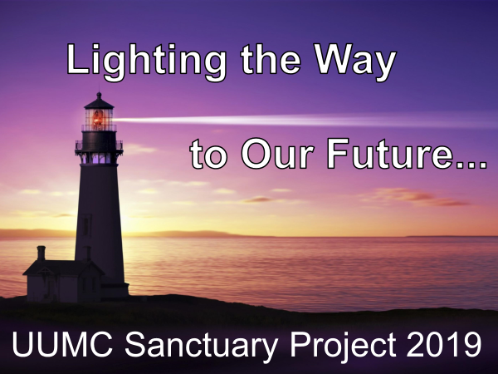

UUMC is currently celebrating the 50th Anniversary of our church at the corner of University and Culver in Irvine. Like all 50-year-old buildings, upgrades and basic maintenance are necessary. The time has come to address the need for improved and safer lighting in and out of our sanctuary. We need your help… we need the help of the entire congregation.
Thanks to the church leadership and trustees, much work has already been done. The following information might answer many of your questions about this Capital Campaign.
UUMC Sanctuary Electrical/Lighting Retrofit Need
What is included?
- Enhanced lighting and controls. Chandeliers and ceiling fixtures.
- Repair/replace deficient electrical wiring to code.
- More attractive Sanctuary.
- Reduced energy costs.
- New exterior lighting.
Why now?
- Safety - Danger of electrical fire.
- Deteriorating light fixtures may fall.
- Poor lighting quality with high electric bills.
- Enhanced video capability for events and services. (HI TECH/HI TOUCH)
What is the cost?
Cost Estimate $400,000
Funds Available
-Clark Bequest $ 50,000
-50th/Early Funds committed thru July: $ 50,000
-Atsuko Cutcher Bequest $100,000
-Matching funds Pool thru July $100,000
Funds Needed (Goal) $100,000
Work Plan?
To achieve best outcomes and the best value, research and consultation has been extensive; involving lighting experts, church members, electrical engineers, well-known church architect Bridget Williams, https://www.bridgetwilliams.com, and others. Included in this work are drawings and extensive cost estimates. We are continuing cost reduction analysis to ensure the best outcome for the best value. The project is scheduled to begin in January and completed in time to celebrate Easter.

How can you help?
Your support is critical to create a safer, brighter, and more inviting sanctuary. Currently, several church members have already committed to donate approximately $100,000 to be used as a dollar for dollar match to your donation. With this match, your donation doubles!!!, (i.e.$250 becomes $500). We have approximately 100 families. If each family donates $1000 we would reach our goal and will proceed with this most necessary project. Donations could take many forms; cash, stock, IRA’s, or tax refunds, depending upon what is best for you.

Please take a moment to consider your Capital Campaign donation (above and beyond your regular annual pledge amounts for 2019/2020). Donations can be paid over 12 months, September through August, 2020. Please note your total donation amount on the attached card and return it in your envelope, after specifying how you plan to deliver these funds, e.g. lump sum in first month and the balance paid monthly over 12 months, etc. As a bonus, donors are invited to attend a Financial Management/Tax Planning & smart giving seminar UUMC will offer later this fall.
Thank You!
