UNIT 4  The Means of Grace and Christian Life  Family of Christ Lutheran Church  16345 Polk St. NE  Ham Lake, MN 55304  Foclutheran.org | 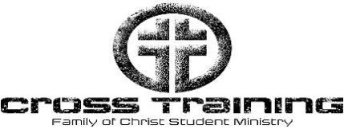 | 2026 Schedule  Date: Lesson: Topic:  Jan 14 Lesson 1 Means of Grace Introduction  Jan 21 Lesson 2 The Nature and Blessings of Baptism  Jan 28 Lesson 3 The Power of Baptism  Feb 4 Lesson 4 Confession and Absolution  Feb 11 No CrossTraining (Staff Conference)  Feb 18 Lesson 5 Nature and Benefit of Communion  Feb 25 Lesson 6 Power of Communion  Mar 4 Lesson 7 Martin Luther Part 1  Mar 11 Lesson 8 Martin Luther Part 2  Mar 18 Lesson 9 Missional Living  Mar 25 Lesson 10 Christian Household and Vocation  April 1 No CrossTraining - Easter Break  April 8 Lesson 11 Stewardship of time, talents, treasures  April 15 Lesson 12 Worship and Church Year  April 22 Lesson 13 What is the Rite of Confirmation  April 29 Lesson 14 Review and Evaluate  May 6 Lesson 15 CT Cross Exam and Backyard Bonanza  Last Class and Faith Formation Booklets Due  May 13 8th Grade Rite of Confirmation Meeting

