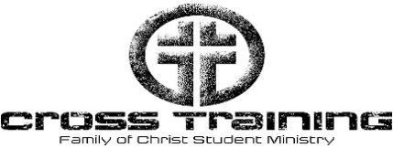  UNIT 2  The Creed and the Triune God  Family of Christ Lutheran Church  16345 Polk St. NE  Ham Lake, MN 55304  Foclutheran.org |  | 2026 Schedule  Date: Lesson: Topic:  Jan 14 Lesson 1 Intro to Apostles Creed  Jan 21 Lesson 2 First Article Part 1  Jan 28 Lesson 3 First Article Part 2  Feb 4 Lesson 4 First Article Part 3  Feb 11 No CrossTraining – Staff Conference  Feb 18 Lesson 5 Second Article Part 1  Feb 25 Lesson 6 Second Article Part 2  Mar 4 Lesson 7 Second Article Part 3  Mar 11 Lesson 8 Third Article Part 1  Mar 18 Lesson 9 Third Article Part 2  Mar 25 Lesson 10 Third Article Part 3  April 1 No CrossTraining - Spring Break  April 8 Lesson 13 Salvation Outline  April 15 Lesson 11 Faith and Science  April 22 Lesson 12 Big Questions  April 29 Lesson 14 Review and Evaluate  May 6 Lesson 15 CT Cross Exam and Backyard Bonanza  Last Class and Faith Formation Booklets Due

