Where Jesus Prayed Lent 2020
Colfax Lutheran Church, PO Box 425, Colfax, WI, 54730
Pastor Les Walck
The series makes use of Danielle Schroyer’s book, Where Jesus Prayed: Illuminating The Lord’s Prayer in the Holy Land, Brewster, MA: Paraclete Press, 2015. The book came out of her meditations and prayers while on a trip for church leaders to the Holy Land.
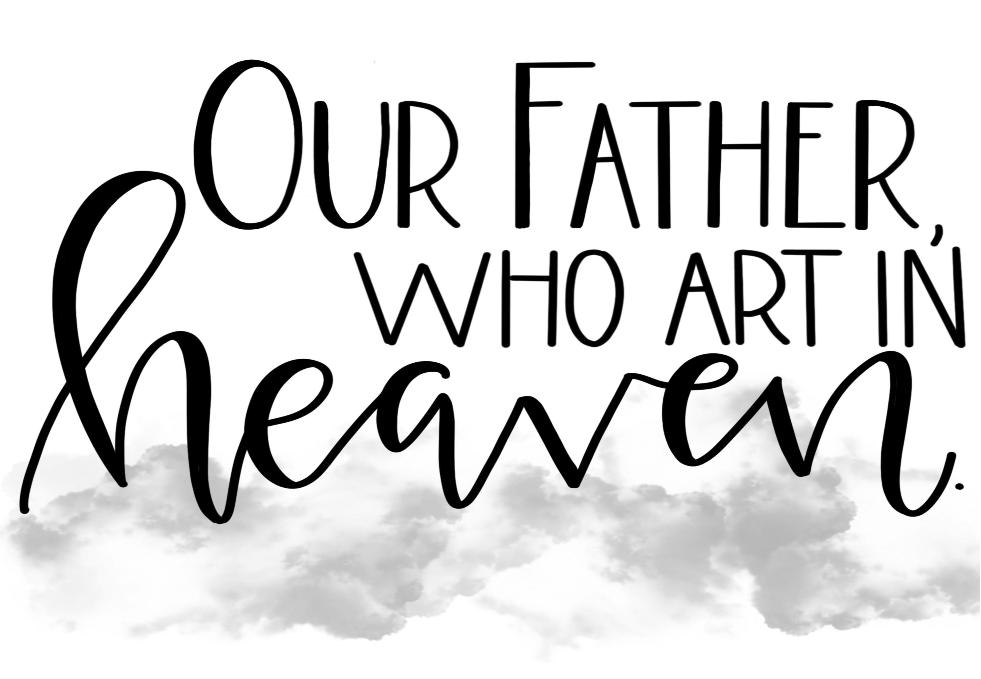
The Where Jesus Prayed Lenten Series explores holy sites in Israel where Jesus walked and taught, while meditating on the petitions of the Lord’s Prayer. Photos of various holy sites and connections to the story of Jesus will set the context, while lay members share insights on “Faith and …” with such topics as fishing, bread, storms, togetherness, and parenthood
- 2/26/20 – Faith and Healing Mark 1:21-33 – On Ash Wednesday we hear about God’s healing power through Christ in his ministry around Capernaum.
- 3/4/20 – Faith and Fishing Mark 1:16-20 – As Jesus called his first disciples to “fish for people,” we are called to invite others to know Christ in our daily lives.
- 3/11/20 – Faith and Bread Mark 6:34-43– As Jesus met the needs of the crowd through the Multiplication of Loaves, we are urged to respond to those who are in need.
- 3/18/20 – Faith and the Storms of Life Mark 4:35-41– As Jesus stilled the storm on the Sea of Galilee, we are reassured that he still stills the storms in our lives.
- 3/25/20 – Faith and Community Mark 15 40-41 –Jesus’ traveling ministry was supported by many women. Women and men today join in that community of the faithful in serving Christ through serving the needs of others.
- 4/1/20 – Faith and Parenthood Matthew 1:18-21– As Joseph and Mary were called by God to be Jesus’ parents, we too are called to show parental love to the least among us.
- 4/9/20 – Faith and Weeping Luke 19:29-30, 41-42a – Jesus wept over the city of Jerusalem and its inhabitants for their faithlessness, revealing the all-encompassing grace of God. On this Maundy Thursday, we too are invited to receive Christ’s mercy and to pour out our hearts for those in need.
- 4/10/20 – Faith and the Stations of the Cross John 18-19 – On Good Friday we remember how the crucified Christ accomplished the salvation of the world.
- 4/12/20 – Faith and the Resurrection Matthew 28:1-10 – On Easter Sunday we celebrate Christ’s resurrection, and rejoice that we are called to run to tell the good news of his triumph over sin and death.

