**THANKSGIVING DAY**

**November 27, 2025 - 9:00am**

**Jenna Erdmann / Kim Berndt / Karla Stark**

**READINGS:**

**1 Kings 8:55-61** Give God thanks, blessing, and praise for doing wondrous things on earth. The Lord God grants joy of heart and peace among all people.

**1 Corinthians 1:3-9** Paul gave thanks to God for the saints of the church at Corinth because Christ endowed them richly with gifts of speech and knowledge. Paul called them to fellowship with the Lord.

**Luke 1:39-55** Jesus cured ten people, and only one, a Samaritan, came back to give thanks and praise to God in a loud voice. Jesus told him, “Stand up and go; your faith has saved you.”

**Prelude:** Musician’s Choice

**GATHERING RITE**

**Gathering Song:** For the Beauty of the Earth NG #633

**Glory to God:** None (daily Mass)

**LITURGY OF THE WORD**

**Psalm 145:** I Will Praise Your Name NG #92 vs. 1,2,3

**Gospel Acclamation:** Mass of Christ the Savior with chanted Verse

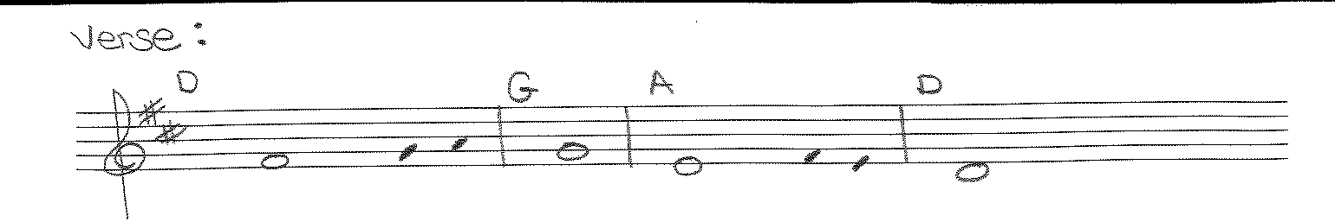

**In all circumstances, *give thanks,* / for this is the will of God for you *in Christ Jesus.***

***Liturgy of the Eucharist***

**Preparation of the Gifts:** We Come to Your Feast NG #938

OR Solo Song of Choice

**Eucharistic Acclamations:** **Heritage Mass**

**Communion Songs: Sanctuary - 2X**

Table of Plenty S&S #163

We Give You Thanks NG #631

**CONCLUDING RITE**

**St. Michael Prayer**

**Closing Song:** Sing of the Lord’s Goodness NG # 610