PENTECOST SUNDAY, YEAR C
May 23/24, 2026 - Memorial Day Weekend
READINGS:
Acts of the Apostles 2:1-11 On Pentecost, the Holy Spirit was sent to the disciples in the form of fiery tongues. They began to speak in different tongues, “as the Spirit enabled them to proclaim.”
1 Corinthians 12:3b-7, 12-13 The apostle Paul wrote that there are many gifts but the same Spirit, different ministries but the same Lord.
John 20:19-23 Jesus appeared and told the disciples, “Peace be with you. As the Father has sent me, so I send you…Receive the Holy Spirit.”

Prelude: Musician’s Choice
GATHERING RITE
Gathering Song: Send Down the Fire NG # 557
Come Holy Ghost NG # 559
Penitential Act: recited
Glory to God: Heritage Mass

LITURGY OF THE WORD
CLOW: Dismissal at the 10am Mass
Psalm 104: Lord Send out Your Spirit (Francesca) (Music in Workroom)
Sequence: Come Holy Spirit, on Us Shine Missalette #261 (verses only)
Alleluia: Mass of Christ the Savior- with chanted verse
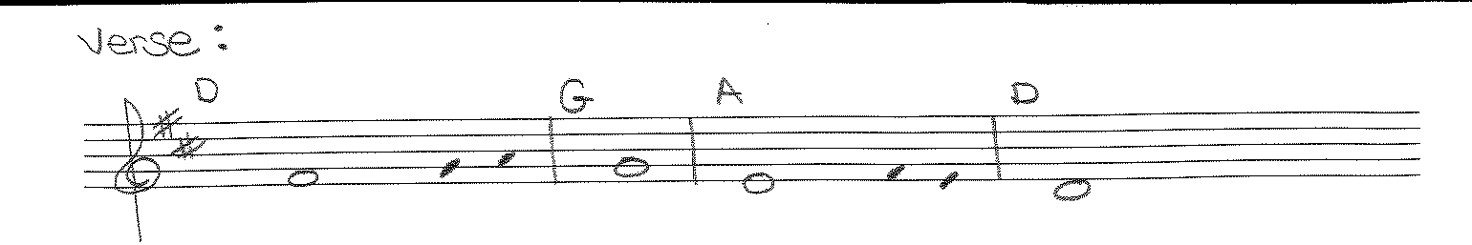
Come, Holy Spirit, fill the hearts of your faithful / and kindle in them the fire of your love.
Creed: Apostle’s Creed
Liturgy of the Eucharist
Preparation of the Gifts: Holy Spirit (Music in workroom)
Shine, Jesus Shine S&S I # 202
Eucharistic Acclamations: Heritage Mass
Communion Songs: Sanctuary – 2X
Dm Gm Dm
They were filled with the Holy Spirit / and spoke of the marvels of God, alleluia.
We Are One Body S&S I #165
We Are Many Parts NG # 834
Pan de Vida NG # 920
CONCLUDING RITE
Deacon: “Go in peace, Alleluia, Alleluia” Sing: “Thanks be to God, Alleluia, Alleluia”
St. Michael’s Prayer
Closing Song: America the Beautiful NG #984

