THE OCTAVE DAY OF CHRISTMAS (Updated 12/11/25)
MARY, the HOLY MOTHER OF GOD, YEAR A
December 31, 2025 - January 1, 2026 - NO BOOTH at either Mass Time
Please announce songs at each Mass time (except for Mass parts and the Psalm)
READINGS:
Numbers 6:22-27 “The Lord bless you and keep you! The Lord let his face shine upon you, and be gracious to you! The Lord look upon you kindly and give you peace!”
Galatians 4: 4-7 When the time had come, God sent the beloved Son, born of a woman so that we might become adopted children. We are no longer slaves, but heirs of God whom we call, “Abba, Father!”
Luke 2:16-21 On the eighth day, Mary’s child was circumcised and was given the name Jesus, that is, “God saves.” Mary “kept all these things, reflecting on them in her heart.”

Prelude: Musician’s Choice
GATHERING RITE
Gathering Song: Hark the Herald Angels Sing Miss. #215 / NG # 424
Glory to God: Heritage Mass

LITURGY OF THE WORD
Psalm 98: A Light Will Shine Vs. 1, 3 and 4
Gospel Acclamation: Mass of Christ the Savior with Chanted Verse
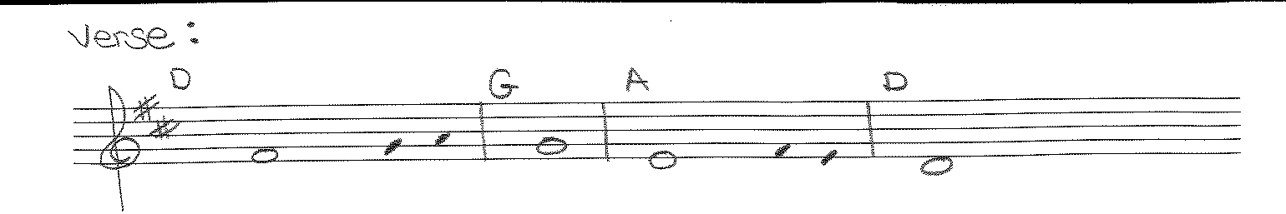
In the past God spoke to our ancestors through the prophets/
in these last days,he has spoken to us through the Son.
Liturgy of the Eucharist
Preparation of the Gifts: Immaculate Mary Miss. #397 (text from Miss.)
Solo of choice

Eucharistic Acclamations: Heritage Mass
Communion Songs: Communion Antiphon - 2X (sheet in workroom)
Mary’s Song (All Masses) Miss. # 396 (melody of Amazing Grace)
(music in work room)
Angels We Have Heard on High Miss. #213 / NG # 430
What Child is This Miss. #208 / NG # 466

CONCLUDING RITE
St. Michael’s Prayer
Closing Song: Sing of Mary Miss #. 390 / NG # 457

