**THE EXALTATION OF THE HOLY CROSS, YEAR C**

**September 13/14, 2025**

**READINGS:**

**Numbers 21:4b-9** During their journey from Egypt, the Israelites complain against God and Moses and the travelers are plagued by deadly serpents. Realizing the sin of their complaints, they plead with Moses to pray for their deliverance. God instructs Moses to “make a seraph” and “if any who have been bitten look at it, they will live.”

**Philippians 2:6-11** Paul uses a hymn of praise to tell the Christian community of Philippi about Christ’s concealing his divinity and assuming the rule of servant during his life. Christ humbled himself completely, “becoming obedient to the point of death, even death on a cross.” This led to his being exalted by God.

**John 3:13-17** Jesus tells Nicodemus that God gave his Son that those who believe in him will not die but live eternally. He came, not to condemn, but to save it.

**GATHERING RITE**

**Gathering Song:** The Cross of Jesus (All Masses) NG #482

**Glory to God:** **Heritage Mass**

**LITURGY OF THE WORD**

**CLOW Dismissal:** 10:00am Mass

**Psalm 78 : Do Not Forget the Works of the Lord (NEW!) All 4 verses**

**Gospel Acclamation:** Mass of Christ the Savior - with Chanted Verse

We adore you, O Christ, and ***we bless you***, / because by your Cross you have re***deemed the world***.

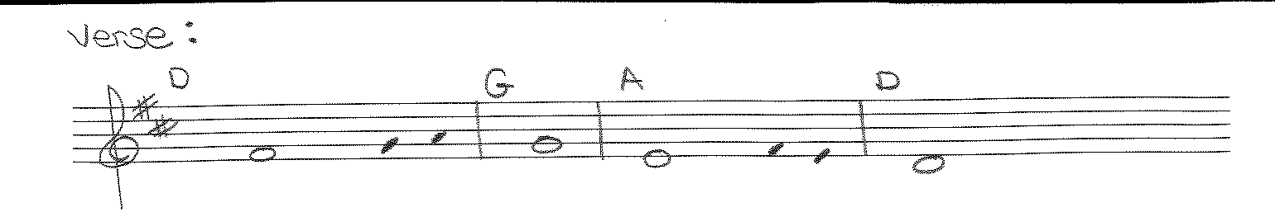

**Liturgy of the Eucharist**

**Preparation of the Gifts:** Jesus, the Lord NG #491

Song of the Body of Christ NG #924

Once Again VAO#325

**Eucharistic Acclamations:** **Heritage Mass**

**Communion Songs: Sanctuary - 2X**

How Great Thou Art NG #578

We Have Been Told NG #784

What Wondrous Love NG #642

The Old Rugged Cross (Music in Work Room)

**St. Michael Prayer**

**CONCLUDING RITE**

**Closing Song:** I am the Bread of Life NG #945