**THE DEDICATION OF THE LATERAN BASILICA, YEAR C**

**November 8/9, 2025**

**READINGS:**

**Ezekiel 47:1-2, 8-9, 12** Saving water flowed from the temple, and all who were touched with it were saved.

**1 Corinthians 3:9c-11, 16-17** We are God’s temple and the Spirit of God dwells in us.

**John 2:13-22** “Zeal for your house will consume me.” The temple to be raised up, in three days, is the temple of Christ’s body.

**GATHERING RITE**

**Gathering Song:** All Creatures of Our God and King NG #611

**Glory to God:** **Heritage Mass**

**LITURGY OF THE WORD**

**CLOW Dismissal: 10am Mass**

**Psalm 46: The Waters of the River (NEW! - Sheet in copyroom)**

**Gospel Acclamation:** Mass of Christ the Savior – with chanted verse

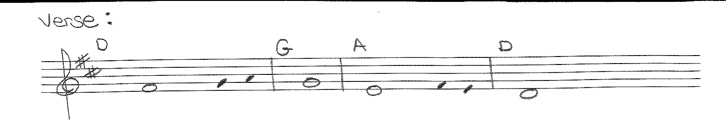

I have chosen and consecrated this house, ***says the Lord*** / that my name may be ***there forever.***

**Liturgy of the Eucharist**

**Preparation of the Gifts:** Come to the Water NG #584

Shall We Gather at the River NG #873

Dwelling Place NG #678

We Walk by Faith NG #680

**Eucharistic Acclamations:** **Heritage Mass**

**Communion Songs: Sanctuary - 2X**

Be Not Afraid NG #683

We Are Many Parts NG #834

We Are One Body S&S #165

Eye Has Not Seen NG #728

**CONCLUDING RITE**

**St. Michael Prayer**

**Closing Song:** Though the Mountains May Fall NG #689

The Church’s One Foundation NG #742