SOLEMNITY OF OUR LORD JESUS CHRIST, YEAR C
November 22/23, 2025– Feast of Christ the King
READINGS
2 Samuel 5:1-3 Because David was loved as a leader, the elders of all the tribes anointed him king of Israel at Hebron. King David shepherded the people from then on.
Colossians 1:12-20 God’s Son brought the people into the reign of forgiveness and love. He heads the body, the church, and has primacy in all things, making peace through the blood of his cross.
Luke 23:35-43 The soldiers made fun of Jesus on the cross, offered him bitter wine, told him to save himself if he was the Christ, and told him to put an inscription over his had: “This is the King of the Jews.”

Prelude: Musician’s Choice
GATHERING RITE
Gathering Song: Crown Him with many Crowns NG #574
Glory to God: Heritage Mass

LITURGY OF THE WORD
Dismissal of CLOW: 10am Mass
Psalm 122: Let us go Rejoicing to the house of the Lord (NEW!) Vs. 1, 2, 3
Alleluia: Mass of Christ the Savior with chanted verse
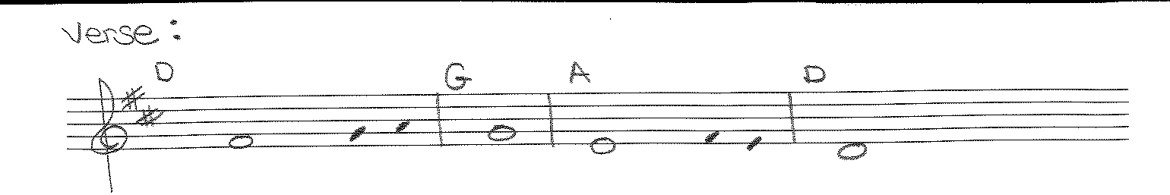
Blessed is he who comes in the name of the Lord / Blessed is the kingdom of our father David that is to come!
Liturgy of the Eucharist
Preparation of the Gifts: Ubi Caritus NG # 696
He Is Exalted S&S #179
Eucharistic Acclamations: Heritage Mass

Communion Songs: Sanctuary - 2X
Now We Remain NG # 785
How Great is Our God Music in Work Room
Amazing Love/You Are My king VAO #382
Christ Be Our Light NG # 590
Shout to the Lord S&S #396

CONCLUDING RITE
St. Michael Prayer
Closing Song: Soon and Very Soon NG # 865
Lord, I Lift Your Name on High NG # 602

