ASCENSION OF THE LORD, YEAR A
May 16/17, 2026

READINGS:
Acts of the Apostles 1:1-11 Jesus promised they would soon be baptized with the Holy Spirit.
Ephesians 1:17-23 God has put all things under Christ’s feet.
Matthew 18:16-20

Prelude: Song of Choice
GATHERING RITE
Gathering Song: Hail the Day that Sees Him Rise NG # 543
Crown Him With Many Crowns NG # 574
Glory to God: Heritage Mass

LITURGY OF THE WORD
CLOW Dismissal: 10am Mass
Psalm 47: God Mounts His Throne (Music in workroom)
Alleluia: Christ the Savior (with Chanted verse)
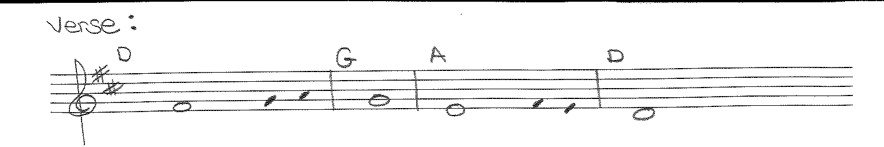
Go and teach all nations, says the Lord; / I am with you always, until the end of the world.
Liturgy of the Eucharist
Preparation of the Gifts: In Christ Alone (Sheet music in office)
The Servant Song NG #751
Bread of Angels (Sheet music in office)
Eucharistic Acclamations: Heritage Mass

Communion Songs: Communion Antiphon - 2X
Behold, I am with you always, even to the end of the age, alleluia.
I am the Bread of Life NG # 945
Open the Eyes of My Heart S&S # 415
We Are Many Parts NG # 834
How Great is Our God (Sheet music in office)
CONCLUDING RITE
St. Michael Prayer
Closing Song: Blest be the Lord NG #686
How Can I Keep From Singing NG #685

