**COMMEMORATION OF ALL THE FAITHFUL DEPARTED**

**November 1/2, 2025**

**All Soul’s Day Celebrated at all weekend Masses**

**Note: Reading of names will take place at Mass of Remembrance on Thursday, November 6th at 6pm**

**READINGS:**

**Wisdom 3:1-9**

**Romans 5:5-11**

**John 6:37-40**

**Prelude:** Musician’s Choice

**GATHERING RITE**

**Gathering Song:** Jerusalem, My Destiny NG #492

O God Our Help in Ages Past NG #688

**Glory to God: Heritage Mass**

**LITURGY OF THE WORD**

**Clow Dismissal: 10am Mass**

**Psalm 23:** Shepherd Me, O God NG #35 - vs. 1, 2, and 3

**Gospel Acclamation:** Mass of Christ the Savior with chanted Verse

I am the resurrection and the life, ***says the Lord*** / whoever believes in me will ***never die***.

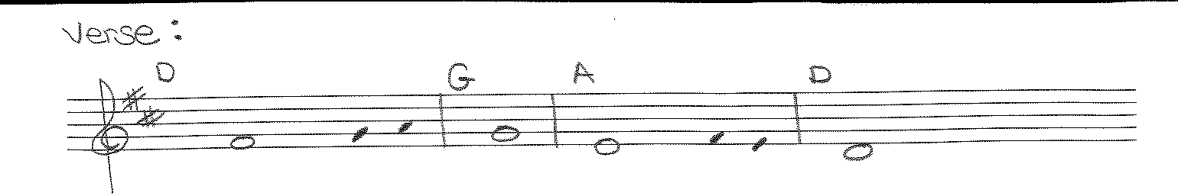

**Liturgy of the Eucharist**

**Preparation of the Gifts:** Precious Lord, Take My Hand NG #955

Just a Closer Walk With Me (Workroom)

**Eucharistic Acclamations:** **Heritage Mass**

**Communion Songs:** Sanctuary – 2X

I Am the Bread of Life NG # 945

Bread of Angels(Solo - Sheet Music)

Amazing Grace NG # 645

**CONCLUDING RITE**

**St. Michael’s Prayer**

**Closing Song:** Sing With All the Saints in Glory NG #539

I Heard the Voice of Jesus Say NG #724