**FOURTH SUNDAY OF ADVENT, YEAR A**

**December 20/21, 2025**

**READINGS:**

**Isaiah 7:10-14** The Lord offered Ahaz a sign, Ahaz answered, “I will not ask! I will not tempt the Lord!” Nevertheless, the Lord gave a sign: “The virgin shall conceive, and bear a son, and shall call him Emmanuel.”

**Romans 1: 1-7** Paul told the Romans he was called to be an apostle and set apart to proclaim the gospel of God about Jesus Christ. He said to them, “We have received the grace of apostleship” that we may spread the name and bring to faith all those called to belong to Jesus Christ.

**Matthew 1:18-24** Mary was betrothed to Joseph, but before they wed, Mary became pregnant through the power of the Holy Spirit, Joseph decided to break the engagement. He changed his mind when an angel in a dream told him to receive Mary as his wife.

**Prelude:** Musician’s Choice / Brief Silence before Mass begins

**GATHERING RITE**

**Gathering Song:** O Come, O Come Emmanuel NG #395 (D minor / workroom)

**Glory to God:** No Glory to God during Advent

**LITURGY OF THE WORD**

**CLOW Dismissal: 10am**

**Psalm 24:** We Long to See Your Face NG # 37 **Refrain II**

* Refrain II- Open wide your gates let the King of Glory in!

**Gospel Acclamation:** Mass of Christ the Savior with Chanted Verse

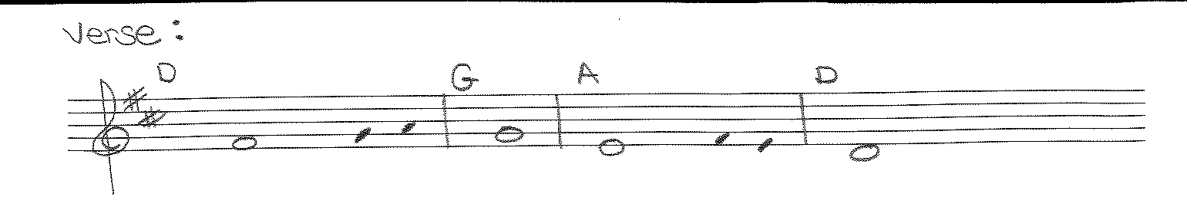

Verse: The Virgin shall conceive , and bear a son, / and they shall name him Emmanuel

**Liturgy of the Eucharist**

**Preparation of the Gifts:** Hail Mary, Gentle Woman NG # 889

Mary’s Song (melody of Amazing Grace) Work Room

**Eucharistic Acclamations:** **Heritage Mass**

**Communion Songs: Chanted Communion Antiphon - Week 4 - Sing 2X (workroom)**

Maranatha NG #397 Vs. 4, 5, 6 and 7

Like a Shepherd NG # 402

God of All People NG # 412

**CONCLUDING RITE**

**St. Michael Prayer**

**Closing Song:** Wait for the Lord NG #406 (refrain only)