THIRD SUNDAY OF ADVENT, YEAR A
December 13/14, 2025 – Gaudete Sunday – Rejoice!

READINGS:
Isaiah 35:1-6a The deserts exult and burst into flower. The hills ring with joyful song. The feeble grow strong; the frightened take courage. The Lord comes to save us.
James 5:7-10 “Be patient until the coming of the Lord,” said the author of the letter of James. “The judge is standing before the gates.” Take the prophets as your models in facing hardship. They spoke in the Lord’s name.
Matthew 11:2-11 John sent his disciples to ask Jesus, “Are you the one who is to come, or should we look for another?” Jesus answered them affirmatively, pointing to the blind who see, the lame who walk, the lepers who are cured, and the poor who hear from him good news of hope.

Prelude: Musician’s Choice / Brief Silence before mass begins
GATHERING RITE
Gathering Song: O Come, O Come Emmanuel NG # 395 (D Minor / Workroom)
Glory to God: No Glory to God during Advent

LITURGY OF THE WORD
CLOW: Dismissal at 10am
Psalm 146: Lord, Come and Save Us (Francesca with modified Refrain)
Gospel Acclamation: Mass of Christ the Savior with Chanted Verse
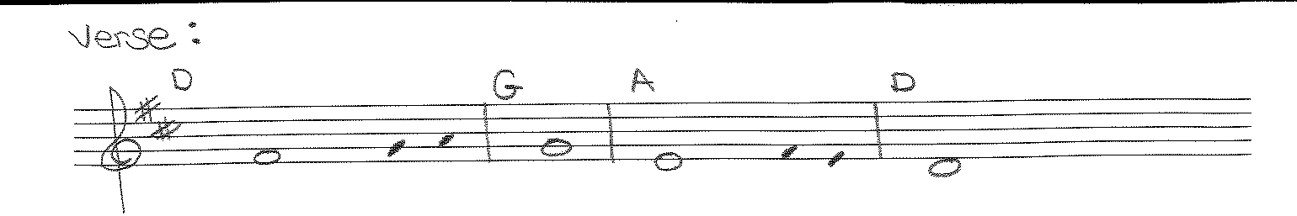
Verse: The Spirit of the Lord is upon me, / because he has anointed me to bring glad tiding to the poor.
Liturgy of the Eucharist
Preparation of the Gifts: You Have Anointed Me NG # 773
I Hear a Sound (Work Room)
Is Your Heart Prepared for a King (Work Room)
Eucharistic Acclamations: Heritage Mass
Communion Songs: Chanted Communion Antiphon - Week 3
Maranatha (All Masses) NG #397 Vs. 4, 5 , 6 and 7
Christ be Our Light NG # 590
Christ Circle Round Us (Music in Workroom)
My Soul in Stillness Waits NG #415
CONCLUDING RITE
St. Michael Prayer
Closing Song: Soon and Very Soon NG # 865

