SECOND SUNDAY OF ADVENT, YEAR A
December 6/7, 2025

READINGS:
Isaiah 11:1-10 “A shoot shall sprout from the stump of Jesse,” prophesied Isaiah. “The spirit of the Lord shall rest upon him” through wisdom, understanding, counsel, strength, knowledge, and awe in the presence of God.
Romans 15:4-9 The Scriptures were written for our instruction, that we might draw encouragement from them and that “we might have hope.”
Matthew 3:1-12 John the Baptist came as a preacher in the Judean desert: “Repent, for the kingdom of heaven is at hand!” Many people flocked to him for baptism and conversion to prepare for the one who will baptize with the Holy Spirit and fire.

Prelude: Musician’s Choice
GATHERING RITE
Gathering Song: Maranatha, Lord Messiah NG # 397 Vs. 3 and 4
Glory to God: No Glory to God during Advent

LITURGY OF THE WORD
CLOW Dismissal: 10am
Psalm 72: Every Nation on Earth NG # 60 – Vs 1, 2 and 4
Refrain #2: In his days justice will flourish; in his days fullness of peace forever more.
Gospel Acclamation: Mass of Christ the Savior with Chanted Verse
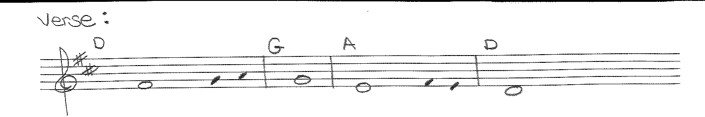
Verse: Prepare the way of the Lord, make straight his paths / all flesh will see the salvation of God
Liturgy of the Eucharist
Preparation of the Gifts: There is a Longing (All Masses) NG # 653

Eucharistic Acclamations: Heritage Mass
Communion Songs: Chanted Communion Antiphon - Week 2 - Sing 2X (workroom)
My Soul in Stillness Waits NG # 415
Change Our Hearts NG # 493
Cry of the Poor NG # 47
Like a Shepherd NG # 402
Is Your Heart Prepared for a King Music in Workroom
CONCLUDING RITE
St. Michael Prayer
Closing Song: Christ Be Our Light NG # 590

