FIRST SUNDAY OF ADVENT, YEAR A
November 29/30, 2025
READINGS:
Isaiah 2:1-5 On that day, “they shall beat their swords into plowshares and their spears into pruning hooks” prophesied Isaiah. “One nation shall not raise the sword against another.” He went on: “Come, let us walk in the light of the Lord.”
Romans 13:11-14 Paul urged the Romans: “It is the hour now for you to awake from sleep. For our salvation is nearer now than when we first believed. Let us put on the armor of the light. Put on the Lord Jesus Christ.”
Matthew 24:37-44 Matthew’s Jesus said that the Son of Man will come at an hour no one can expect. Therefore, all people must stay awake, keep a watchful eye, and be prepared.

Prelude: Musician’s Choice / Brief Silence Before Mass begins
GATHERING RITE
Gathering Song: Maranatha, Lord Messiah NG #397
Glory to God: No Glory to God during Advent

LITURGY OF THE WORD
CLOW Dismissal: 10am
Psalm 122: Let us Go Rejoicing (Francesca LaRosa / Workroom)
Gospel Acclamation: Mass of Christ the Savior with Chanted Verse
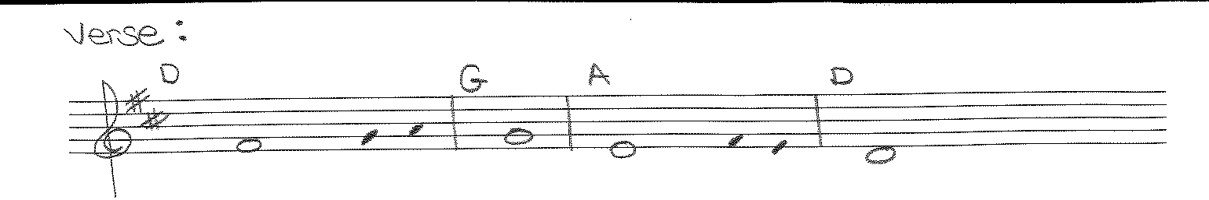
Verse: Show us, Lord, your love / and grant us your salvation.

Liturgy of the Eucharist
Preparation of the Gifts: The King Shall Come NG #414
God of All People NG # 412
Is Your Heart Prepared for a King (Work Room)
Eucharistic Acclamations: Heritage Mass
Communion Songs: Chanted Communion Antiphon - Week 1 (sheet in workroom)
Like the Bread S&S I #156
Christ be Our Light NG # 590
My Soul, In Stillness Waits NG #415

CONCLUDING RITE
St. Michael Prayer
Closing Song: Sing Out, Earth and Skies NG # 577
City of God NG # 766

